Pickit Add-on
Pickit is used as a Microsoft Office Add-on to gain unlimited access to licensed photos and clipart. You must have Microsoft Office 2013, 2016 and 365 to utilize the add-on feature.
There are a few steps involved with accessing and adding Pickit:
- Submit Pickit request
- Receive Invite from Pickit
- Go through Pickit password reset process
- Access Powerpoint to search for and insert Pickit add-on
Receive Invite from Pickit & Reset Password
1. If you have yet to do so, submit a request for Pickit (https://form.jotform.com/mcconnel/pickitrequest).
2. Once request is received and processed an “Invite” email will be sent to your BC address containing a login and password. This password must be reset.
3. To reset the password: Open Pickit invite email and click on the URL link OR you can open a web browser and type in https://brazosportcollege.pickit.com.
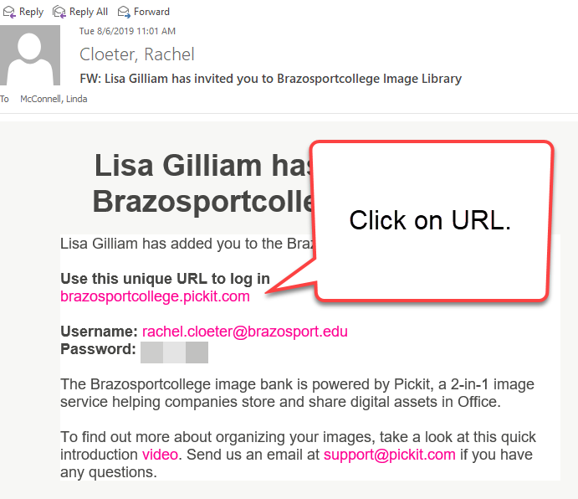

4. DO NOT LOG IN you just want to reset the password, so click on the link for Forgot password? A password reset email will be sent to your BC email address right away.
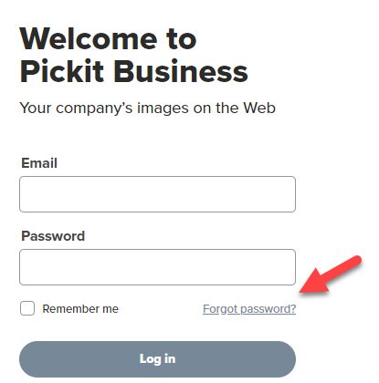
4. Open password email and click Reset password.
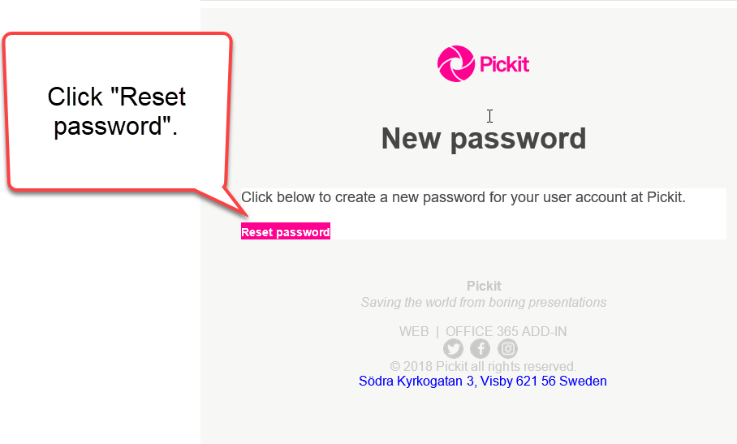
5. Type in new password, confirm password and click the Change password button. DO NOT LOG IN, you are now done and can close the browser.
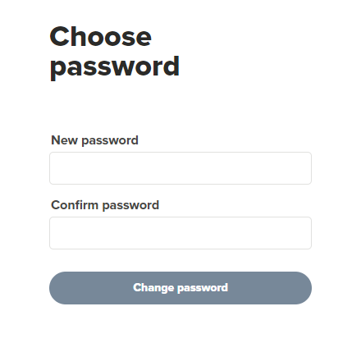
Search For and Insert Pickit add-on
1. Open PowerPoint and start a new blank presentation. Click on the Insert tab.
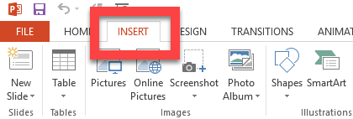
2. Click on the Store link. NOTE: For Office 365 you will need to click on Get Add-ins.
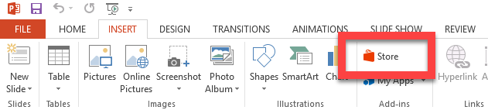
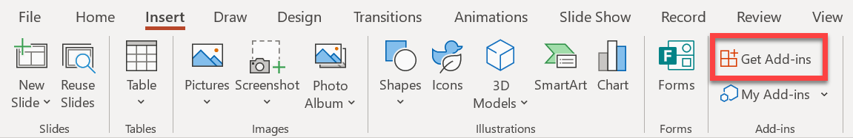
3. You should find Pickit at the top of the list (if not, use the Search feature to locate the add-on).
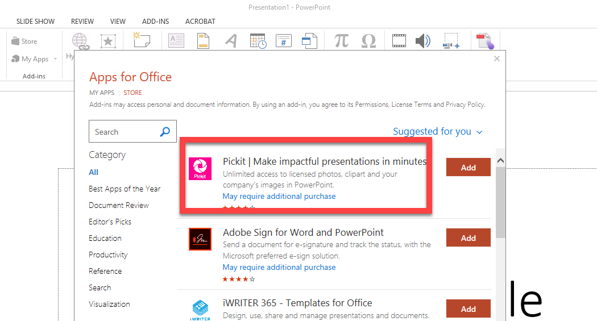

4. Click the Add button for Pickit.
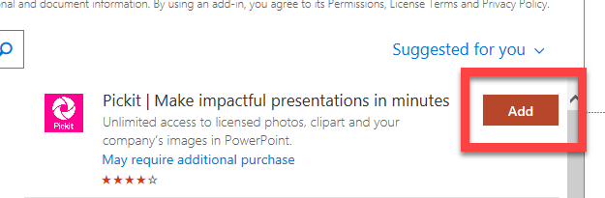
5. Check the box to agree to terms and conditions and click Add.
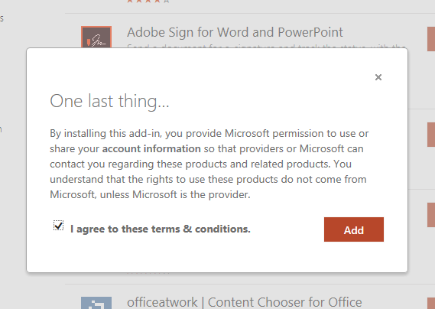
6. On the right of the PowerPoint slide click on I already have an account.

7. Click Continue with Email.
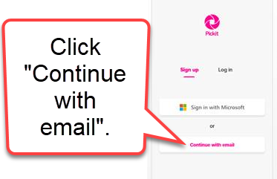
8. Enter your BC email address and newly reset password from eariler. Once done check the box to agree to terms and privacy policy and click the Sign up button.
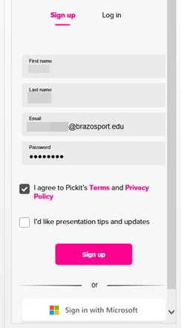

9. Click on Public Images or Pickit Stock to access image database.
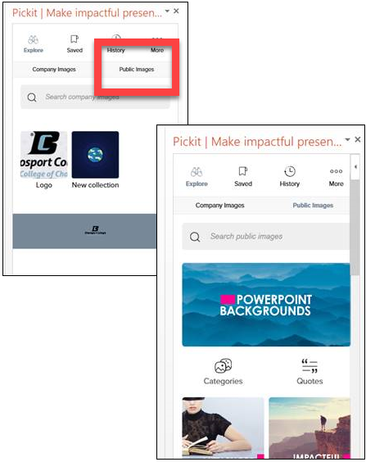
You should now be able to browse, select images and add to a slide just as you would in the older version of PowerPoint.
How to Access Pickit after Closing PowerPoint
1. When you want to use the add-on again, open PowerPoint, create new Blank slide, click on the Insert tab, click on My Add-ons and select Pickit.
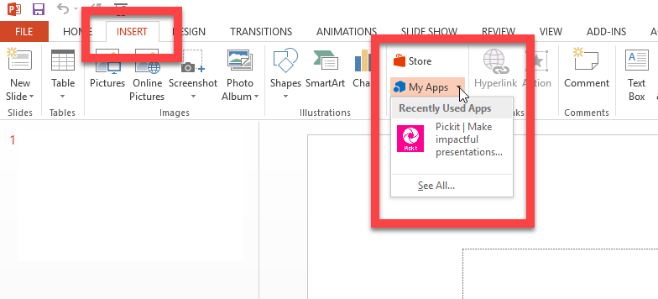
2. If using Office 365, a shortcut to Pickit is located on the Home toolbar.
Pickit can be added to any Office product, for example open Word and then follow the same steps described above to Insert/Store/Add In/Pickit. As long as you are still logged into Pickit, it will install and become available for you to use.

