Once you have installed Pickit, (Adding Pickit to Microsoft Office) you can begin searching and inserting images.
- Open Pickit.
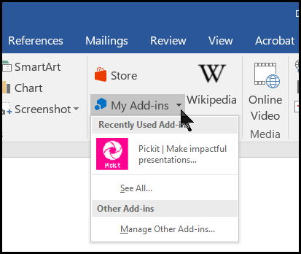

- Click on the Media dropdown, then click Pickit Media.
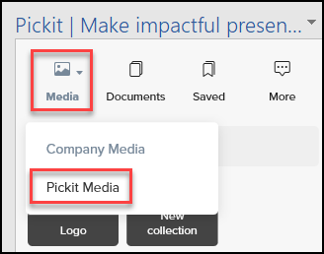
- Available collections will appear:
- Scroll down for more options:
- Click inside the Search bar to search for specific things:
- Click a category to search within that. Here is a search for Labrador Retrievers:
- Click the Filter button to narrow down search options:
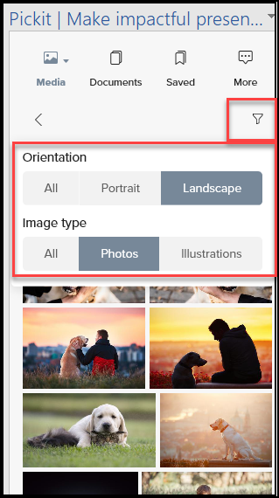
- If you find a picture you want to work with, click either Save to Collection, or Insert Image.
Save to collection:
The pop-up opens, choose to add to an existing collection, or create a new collection:
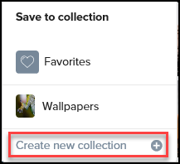
Insert Image:
Clicking Insert Image will add the image to your current document.

For more information about using Pickit visit Pickit User Guide

