# Importing a Word document or a CVS file into a Quiz

Before doing below import process, you must format text properly following guidelines for either importing a **Word document** ([Formatting for Word Doc Template](http://oakleaf3.brazosport.edu/bcdl/Formatting%20for%20Word%20Doc%20Template.docx)) or a **CVS file** ([Formatting for CVS Template](http://oakleaf3.brazosport.edu/bcdl/Formatting%20for%20CVX%20Template.txt)). NOTE: It is easier to properly format a Word document than a CVS file.

Once a file is formatted correctly you can either import questions into a Quiz or the

Questions Database (the process is similar). The following is for importing into a Quiz.

1. Go to **Assessments** in the course menu, click on **Quizzes**.

2. Click on **New Quiz**.

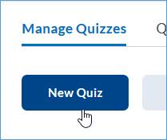

3. Enter a **Name** for Quiz.

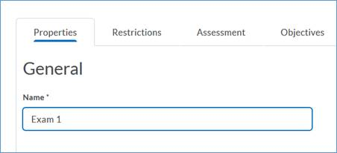

4. Click on **Add/Edit Questions**.

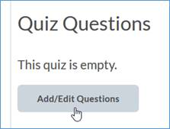

5. Click Import and select **Upload** **a File**.

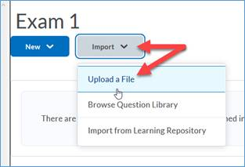

6. **Drag and drop** or browse for either the CVS or Word document file that has been properly formatted.

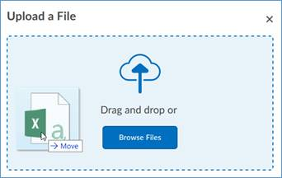

7. Wait for file to load and an Upload Complete check, then click **Import All**.

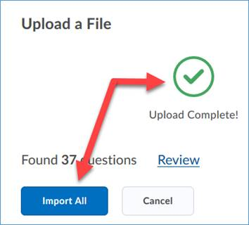

8. Questions should be loaded (if not, there is something wrong about the formatting), click **Done Editing Questions** and proceed to finish setting up quiz.

