Creating & Working with Groups
Create Groups, enroll students and add workspaces such as Lockers for students to share and collaborate on project files.
Instructor: Adding Groups and Enrolling Students
There are two ways to get to Groups. The first is Step 1.
1. Click on Groups under the Communication menu in the course navigation bar.
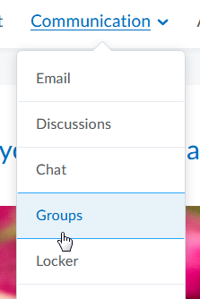
The second way to get to Groups is Step 2.
2. Click on Groups
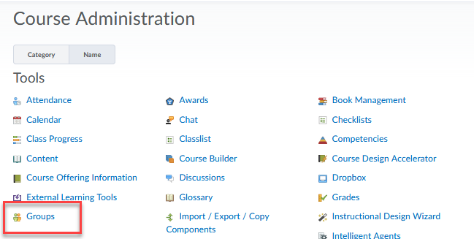
3. Click on New Category
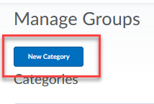

4. Enter a title in which all these groups will fall under, such as Course Groups
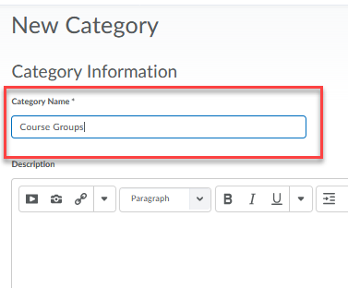
5. Scroll down, leave Enrollment Type at the default, enter the number of groups you want (keep group numbers small) (1), select group workspace such as Lockers (2), click Save and Done when prompted (3).
If prompted again, click Save.
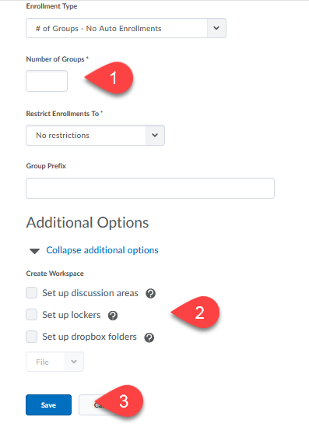
It may not be necessary, but if you want each group to have their own Discussion topic and Dropbox you can select these options as well. Only those folks who are members of the group will be able to see them.
6. To enroll students into each group, click on the Group title
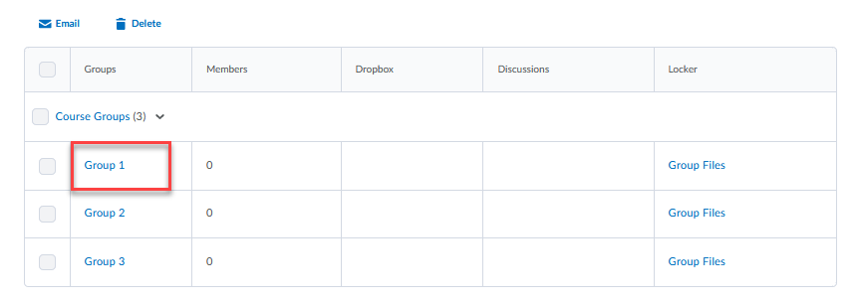
7. Click on Enroll Users
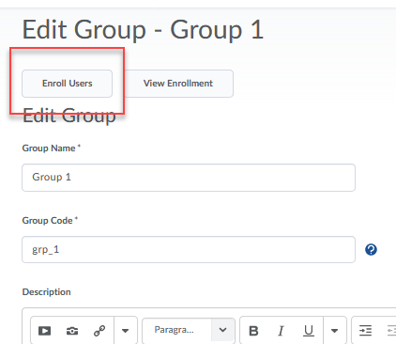
8. Scroll down and check boxes next to students you would like to have enrolled in this group and click Save.
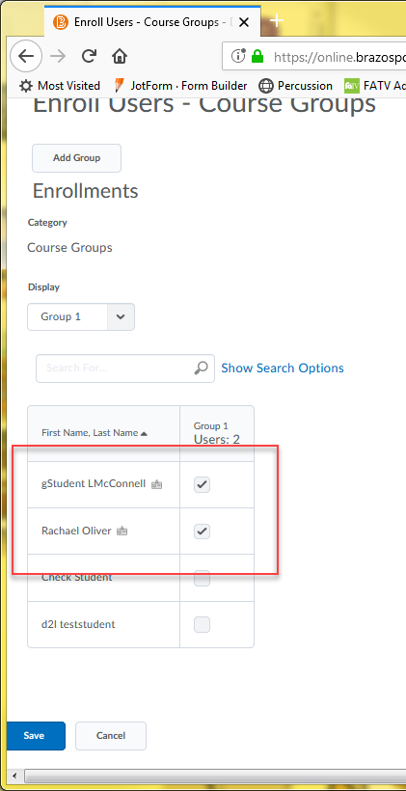

9. Group 1 now has 2 members. Click on your next Group title, enroll students, save, etc. till all students have been enrolled in all your groups. NOTE: as the instructor you can access the files uploaded to group Lockers by clicking on the Group Files link under the Locker column.
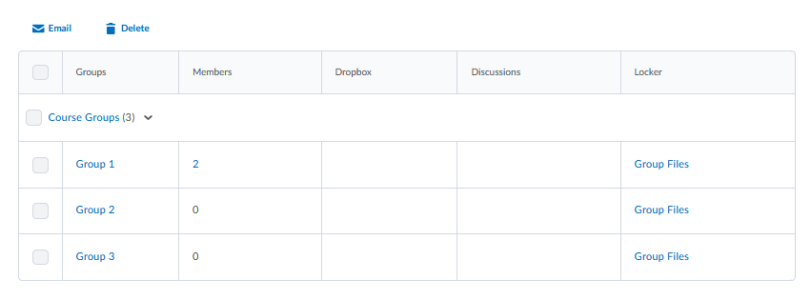
If you created Discussions and a Dropbox for the groups they would be accessible in this area as well under the Discussions and Dropbox columns.

