LockDown Browser/Monitor Fixit Errors & Re-confirming Exam Settings
For those who use Respondus Lockdown Browser and Montor for proctoring an exam, AFTER you have copied a course from one semester to the next, you must go to Assessments, Quizzes and click on the LockDown Browser tab and proceed to follow directions within the attached document.
This process is important in that after copying the course the browser/monitor connection needs to be reset. Sometimes this resetting causes a loss of the password originally entered into the Lockdown Browser/Monitor settings. Following directions set out in the attached document will help eliminate any issues during proctoring.
Directions
1. Using the course navigation menu click on Assessments and then Quizzes.
2. Click on the LockDown Browser tab.
3. IF you are prompted with the following click on “Do not ask me again for this application” and Continue.
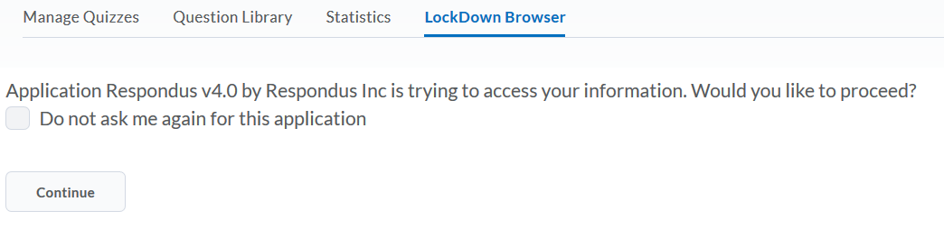
4. IF you are prompted with the following, click checkbox in the lower left course for “Don’t show this page again” and then select “Continue to the LockDown Browser”.
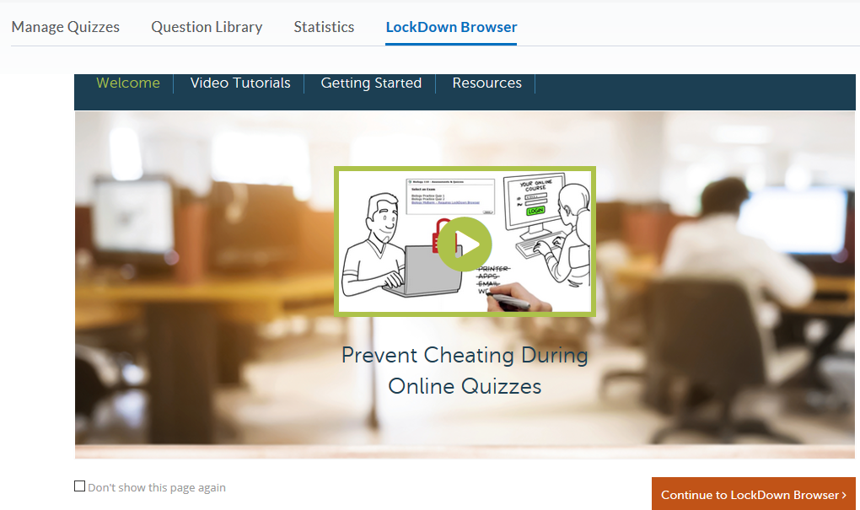

5. If there are any issues you will be prompted with a notification indicating settings were not copied. Click OK and then check the X in the upper right corner of the next prompt to close.
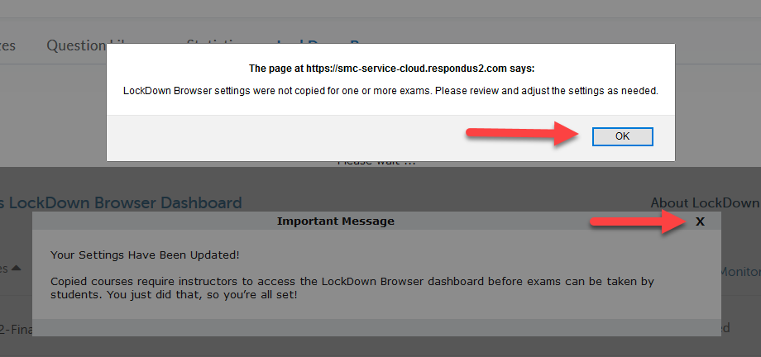
6. Look for “Error” prompts and click the “Fix it” button to repair. It is best to fix each one separately.
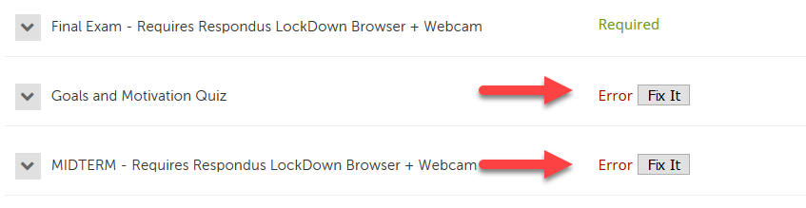
7. IF you had an error for an exam set for Lockdown Browser and/or Monitor, such as a MIDTERM or FINAL go to Settings and make sure your original configurations are still intact.
Click on the down arrow in front of exam and select Settings.
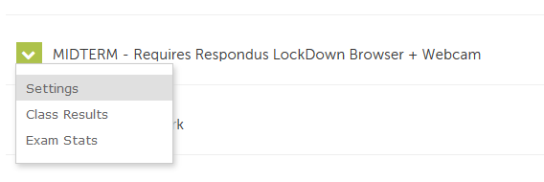
8. You may need to re-enter a password as well as re-select the option for “Either Respondus Monitor or a proctored lab can be used to take this exam if those were the original settings.
