You Attend | Quick Start Guide
You-Attend is an attendance tool used with supplemental courses to track and manage student attendance.
Access
1. Log into the Virtual Campus (D2L) at https://online.brazosport.edu using your BC credentials.
2. Enter a course, in the course navigation bar click on Assessments and then You-Attend. (If a message pops up just hit continue)
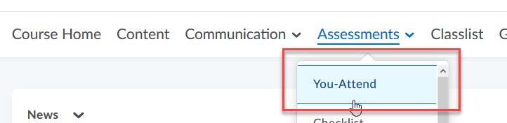
General Settings
1. Start Date, End Date and Record Type should be kept at the default. If required though, click and enter alternative start and end date.
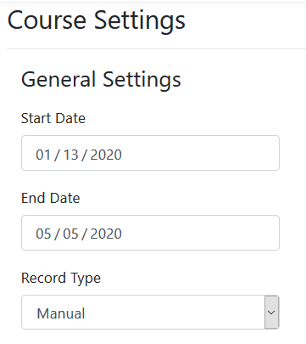
2. Check boxes for days of the week the course meets throughout the semester.
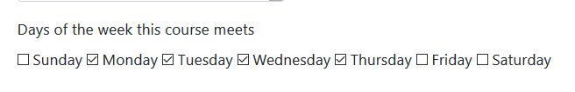

3. Under Excluded Dates, click “Add Date” link to enter a day which attendance will not be taken, such as during holidays or breaks. Click “Add Date” for each date to exclude.
4. By default, there are three Attendance Codes: P for Present, A for Absent, and T for Tardy. If needed, add additional codes by clicking on the Add Code link at the bottom.
Percentage value is automated, but it can be changed to any value BELOW 100, for example, Tardy is worth 50.
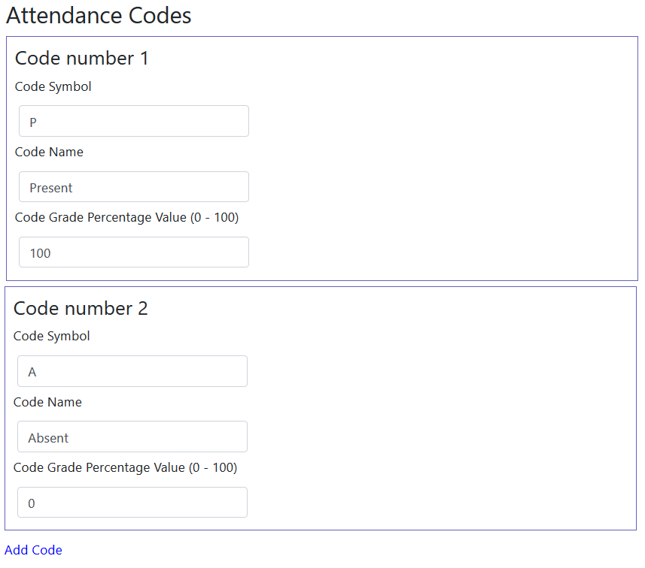
5. Select the checkbox for “Create Grade Book Entry” if you plan on providing an overall Attendance grade. This will automatically create an Attendance gradebook item (note, you can move the item to any category within the gradebook).
NOTE: make sure you DO NOT already have an “Attendance” grade item in your Gradebook. If you do, delete the item BEFORE checking this option.
If you select to create a Grade Book Entry, enter “Points Per Entry”. The default is 1, but you can decrease or increase value using the up/down arrows. It really depends on how many points you want a student to get for each attendance count.
Enter the “Max Grade Book Points” or maximum points that could be earned for attendance. Click on the Calculate Max GB Points to compute what the final grade could be based on number of attendance entries. DO NOT go over the number of days you are taking attendance, you can go less, but not over.
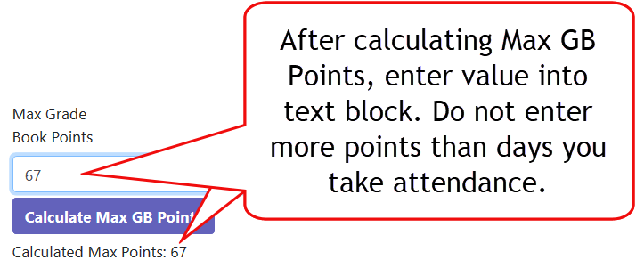
6. Check box for “Use Simple Entry Method” and click the “Save” button. Simple Entry allows for quick updates to student entries without waiting for processing…it is faster with it selected.
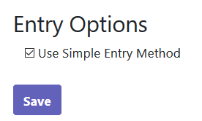

Taking Attendance
To enter attendance, click on Assessments then You-Attend in the course navigation bar. Click on the blue dash in the date column for a particular student and select “P” or “A” from the dropdown menu and click “OK” when prompted.
If you have difficulty clicking on the dash, click on the students name and then enter attendance. Skip down to section on “To View as Student, Edit and/or Add Notes” for directions.
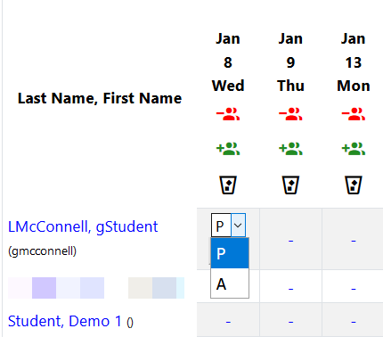
Click on Course Home within the navigation bar to exit You-Attend.
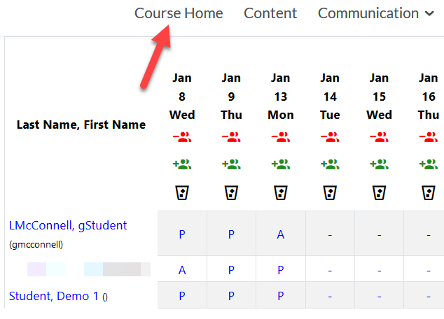

To View as Student, Edit and/or Enter Notes
Click on You-Attend in the course navigation bar and click on student name. In the “Status” column click an entry (P or A) to edit, or the dash to enter attendance and notes. Notes can be viewed by the student.
Make sure to click “Update Entry” and scroll down to bottom of page and click the “Done” button when you are finished.
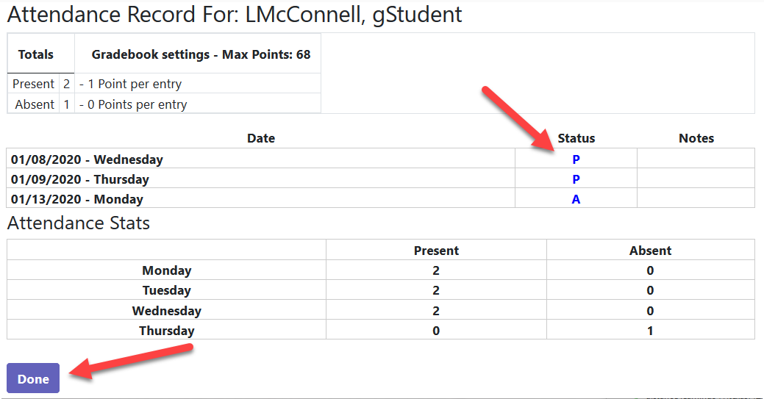

Understanding How You-Attend Works
Marks in You-Attend only shows a percentage of the student’s attendance for the week/semester. Anything with a weight above 0 will count as attending (this includes P (participation=100%) or any additional Attendance Codes you may have added such as T (tardy=75%). You-Attend and the coding system was created to give you a quick view of how students are doing and does not show a grade percentage.
To view You-Attend as a graded item, it MUST be connected to the Gradebook. Once it is integrated with the Gradebook it will use these Attendance Code percentages (from the P (participation) or T (tardy) to calculate the correct grade within the Gradebook.
View Example on next page…

In the below image (Pic 1) a short semester is displayed in You-Attend. Briggs has a perfect attendance (P=Participated or 100%). The other students do not have a perfect attendance, including Williams who has one Tardy, but it still shows her % of sessions attended as 100 (this is because anything with a weight above 0 in You-Attend is counted as attending).
Pic 1
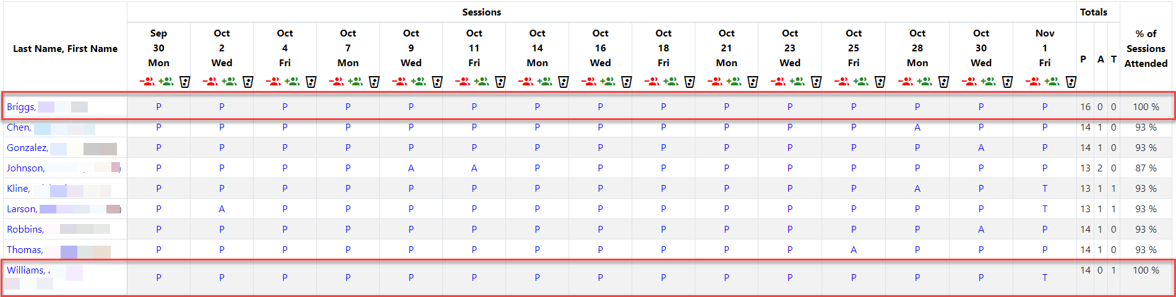
In the Gradebook, attendance is worth 15 points, 1 point per session. In the below image (Pic 2) Williams grade is 14.75 or 98.33% because the Attendance Code in You-Attend was set to be weighted at 75%.
Pic 2
