Competency Tool
Competencies help track information about knowledge, skills and abilities as students participate in your course. Use manual alongside video illustrating Competency tool setup.
Brightspace Competency tool enables you to create competency structures to help assess students learning outcomes to determine if they acquired the intended knowledge, skills, and abilities from a learning experience/activity.
Competency structure
A hierarchy composed of:
1. Competency (is a broad outcome which isn’t directly measured, it can be a program outcome or course goal)
2. Learning objective (also known as a Learning Outcome, represents what needs to be learned to be “competent” in a given area. A learning objective or outcome is written in “measureable” terms)
3. Activity (an instrument of measurement which either teaches or assess whether the student has learned what is needed to meet the objective)
A competency structure can be as simple as containing one competency, objective, and an activity while complex ones contain multiple competencies, objectives, and activities. You can have a single competency for an entire course, multiple learning objectives to represent specific modules, and then associate activities from within each to create an entire course hierarchy.
Create a Competency
1. Using the course menu select Edit Course.
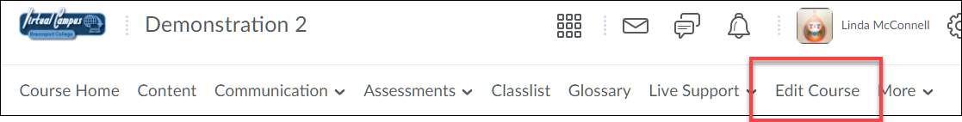
2. Under the Assessment header select Competencies.
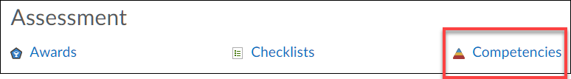

3. Select New Competency.
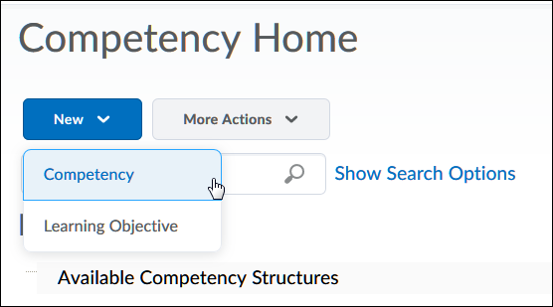
4. Enter a title, using a name which clearly identifies the competency (description is optional), but is a good place to list out all objectives which fall under it.
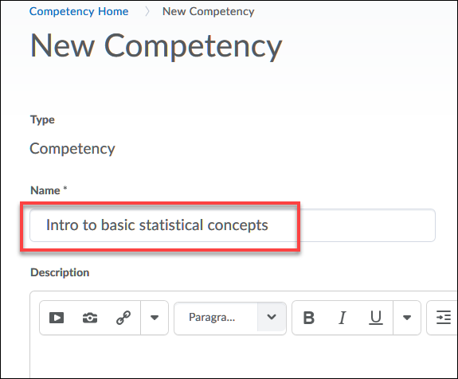
5. Scroll down and leave Status as Draft and other settings as they are at this time since they can be changed later. Click Save.
Never select Status as Archive; this prevents the ability to make changes.
Make competency and its children visible to users option allows students and your students to view competency achievement results in My Progress. This can changed later.
Allow re-evaluation of users who have achieved this competency option can be selected so if you modify structures users are working on, it will automatically re-evaluate each user’s progress to determine if they meet new requirements and update their results. This can be changed later.
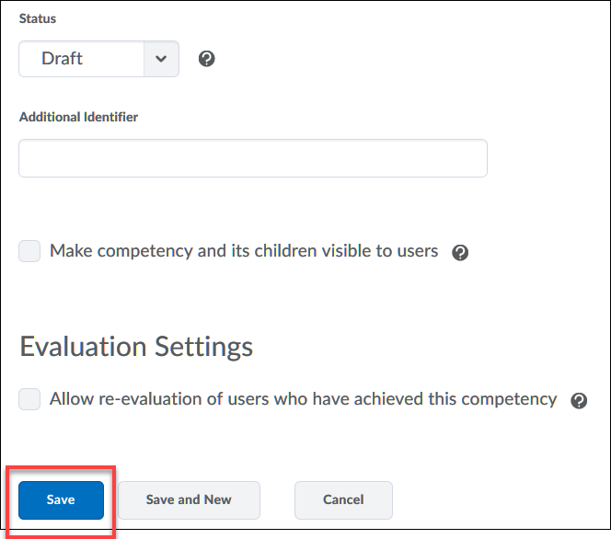
Create a Learning Objective
1. Click on the competency title that was just created.
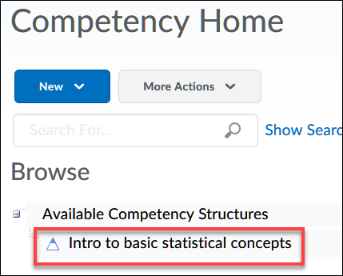
2. Click the Structure button.
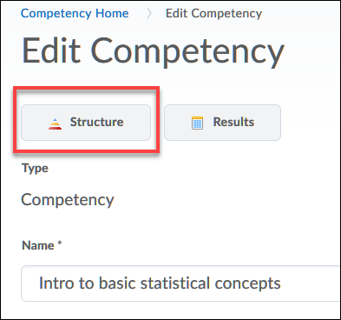
3. Click the Edit Structure tab.
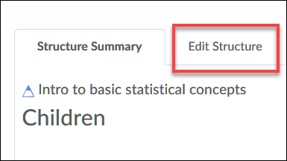
4. When a competency structure is created the components (competency, learning objective, and activity) have a “parent”-“child” relationship. For example, a Learning Objective would be considered a “child” and the Competency in which is falls under would be a “parent”.
With this in mind, scroll down and under the Children header select “New Learning Objective” (you may need to click on the arrowhead icon to view this option).
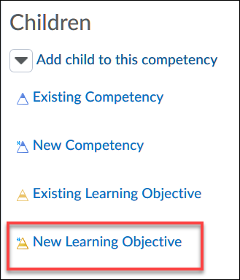
5. Enter a title for the objective (description is optional).
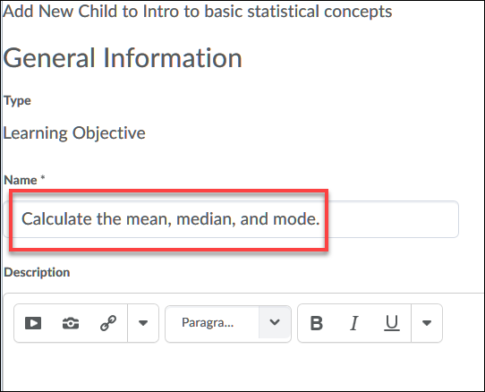

6. Scroll down and leave Enforced Assessment Method at “No” (this will give you more flexibility to assign these later) and under Ready for evaluation select “Yes”. Click Add when done.
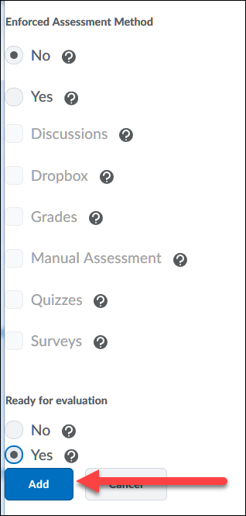
7. Repeat process till all Learning Objectives for Competency have been added.
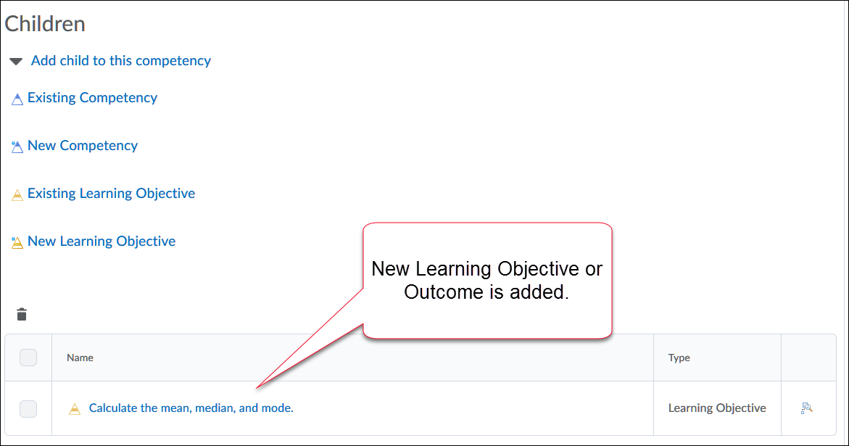

Create Activity
It is a best practice to create activities outside of the Competency Tool and then associate the activity to a Learning Objective.
1. Create your assessments or activities using course tools such as the Dropbox, Discussions, Quizzes, etc. When creating activities make sure you use the most appropriate assessment tool for that Learning Objective (outcome). If the outcome says “Discuss”, a multiple-choice quiz would not be the best tool to use as a measurement; discussion, dropbox, or a long answer question quiz would be more appropriate.
The following chart provides some examples of tools to use for verbs used in Learning Objectives.
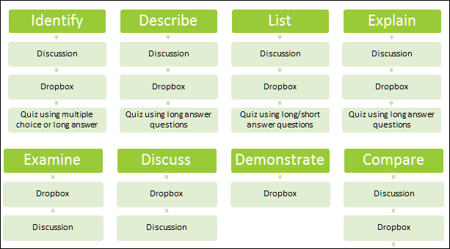

2. Once an activity is created it then needs to be associated with a Learning Objective.
In your course, click on an activity title, in this case I am associating a quiz to the learning objective. Note: Other tools you might use for an activity (Discussions or Dropbox) would follow this same process.
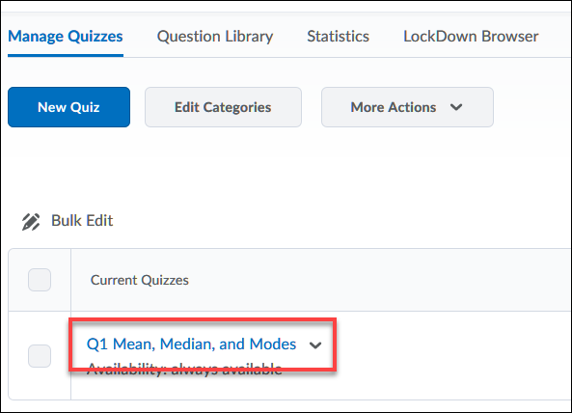
3. Click on the Objectives tab.
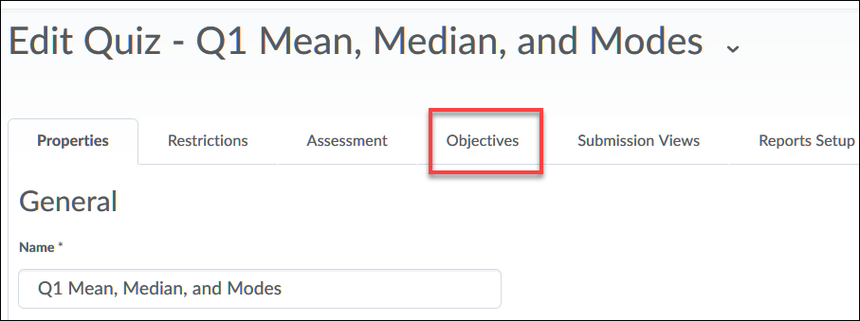
4. Click on Associate Learning Objectives.
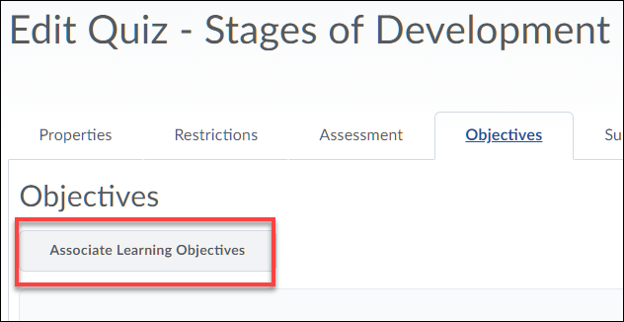

5. Click the + sign next to the desired competency and click the selection box next to the appropriate Learning Objective. Click Add Selected when done.
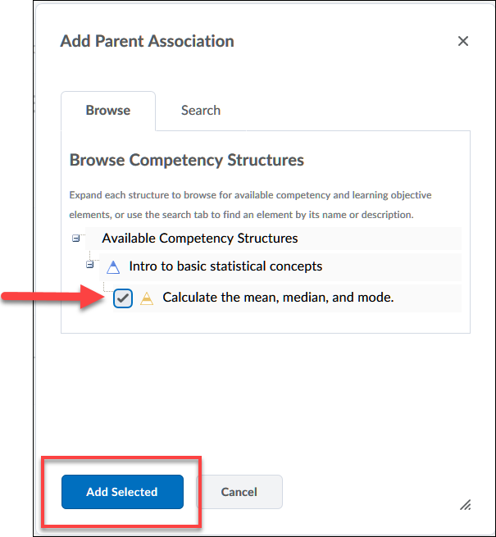
6. In general, this activity is now aligned with the objective, but we now need to determine the trigger for achievement or how the performance on the learning objective is going to be measured.
Click on the arrowhead to the right of the objective title and select the option to “Add Assessment”.
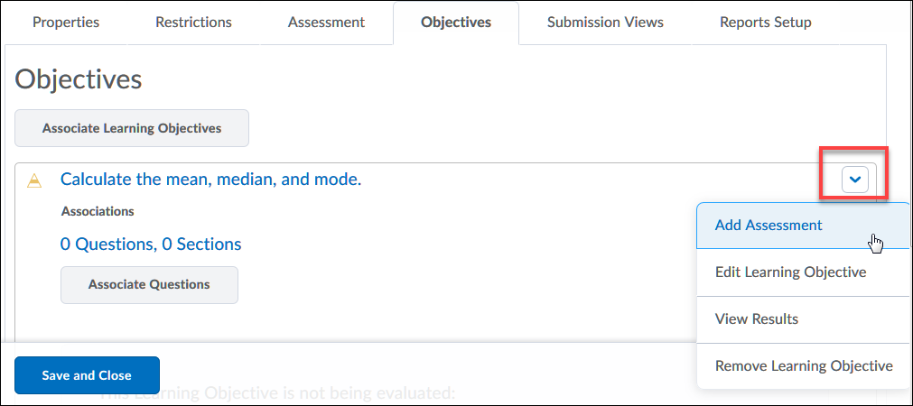

7. At this step there are a few options which need to be selected:
A. Assessment type (the quiz in this case) can be numeric or rubric based. Since this is a quiz activity, leave at the default of Numeric.
B. Assessment Method can be based on the total score of the quiz or specific question(s). For this example, I am going to choose to “score on selected questions”.
C. Select the box for this activity to be required in order to complete the learning objective.
D. Enter a “Threshold” or what level must achieved.
Click Save when done.
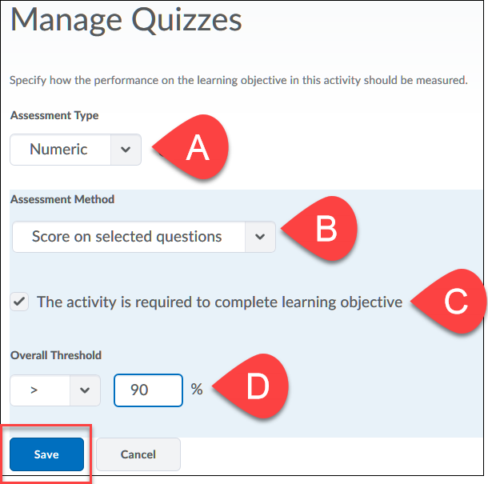
8. Since the assessment method is based on selected questions, we need pick which questions will be used. If you base the assessment on just the total score of the quiz this last step does NOT need to be done. Click on Associate Questions button.
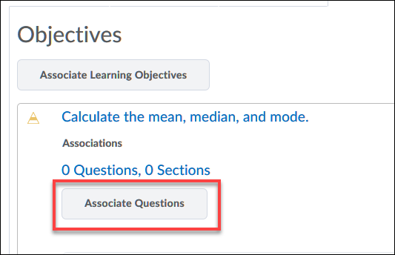
9. Scroll down and check off a question or questions to associate with the objective and click the Associate questions button.
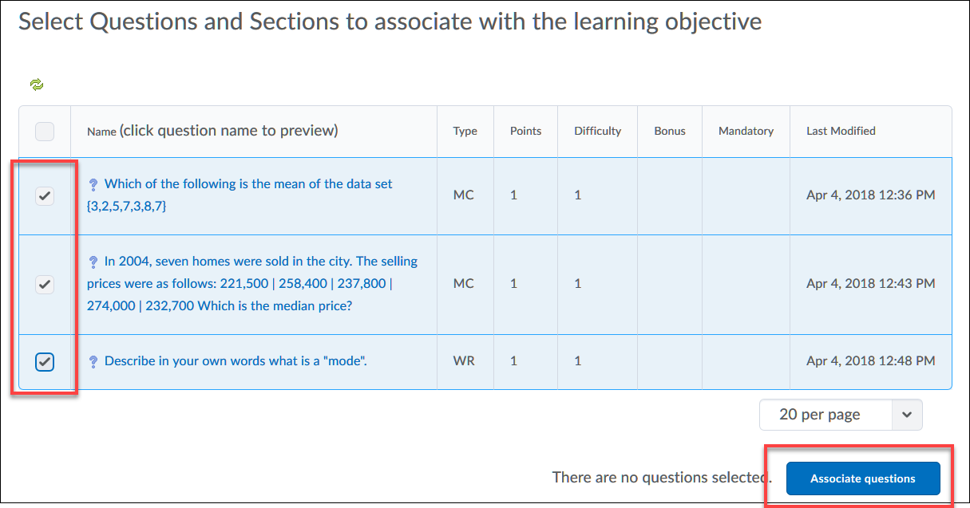
8. Click Save and Close when done.
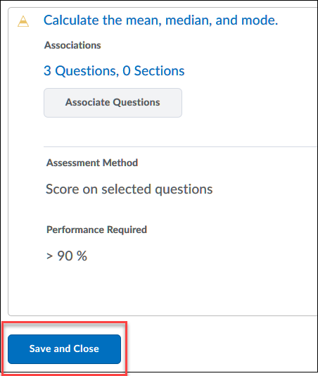
9. If needed, continue with this process till all activities are associated with the Learning Objective(s) within the Competency.

Approve Competency
Once all objectives and associated activities have been added to a Competency you need to “Approve” or publish the Competency.
Return to the Competency Homepage by going to Edit Course, select Competencies. Click on the Competency title, scroll down to change Status menu from Draft to Approved, check box for
“Make competency and its children visible to users” and click Save when done.
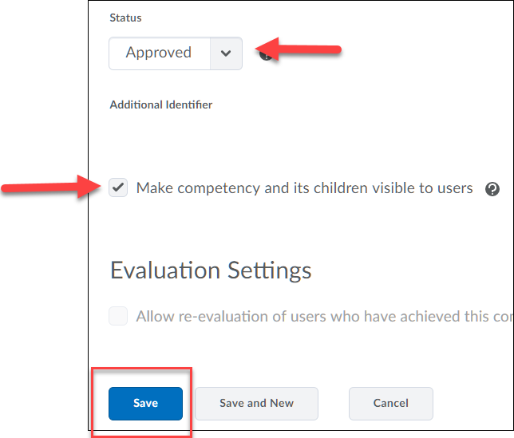
Viewing Results
Results after activities have been submitted and graded can be viewed either in the Competency tool or the My Progress area.
NOTE: if you want to view results of an objective via My Progress, you MUST allow students to view the Competency. To do this return back to the Competency tool (Edit Course, Competencies, click on Competency title and check the box for “Make competency and its children visible to users”.
View Results via Competency Tool
1. Go to Competency Tool (use course menu and select Edit Course, Competency and click on Competency title)
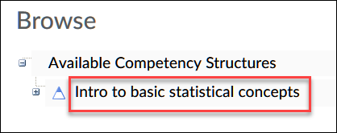
2. Click on Results.
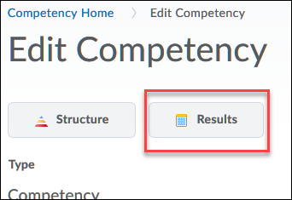
3. Check mark indicates completion of competency. NOTE: completion at the competency level will only occur when Learning Objectives associated with it have been completed.
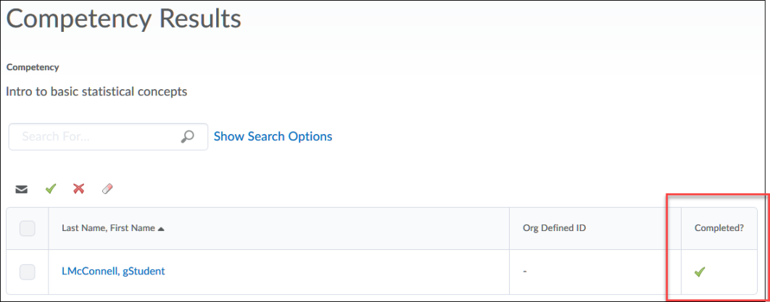
4. Click on students name to view completion status of associated learning objectives and activities.
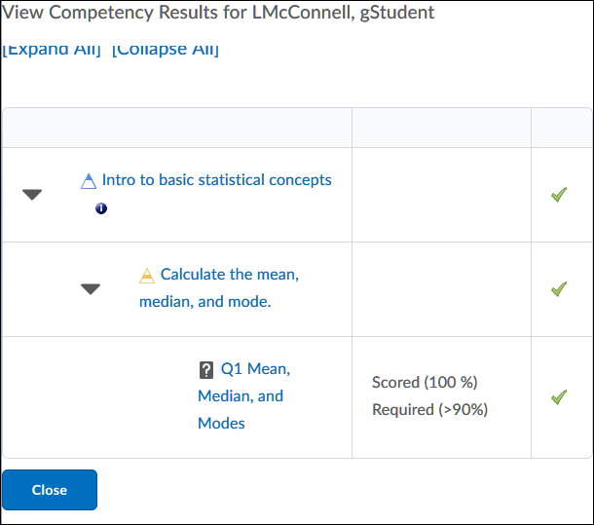

5. Click on the “i” icon to view last evaluation date of competency.
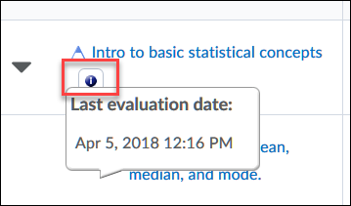
View Results via My Progress
1. Using course navigation menu click on Assessments and then your Progress.
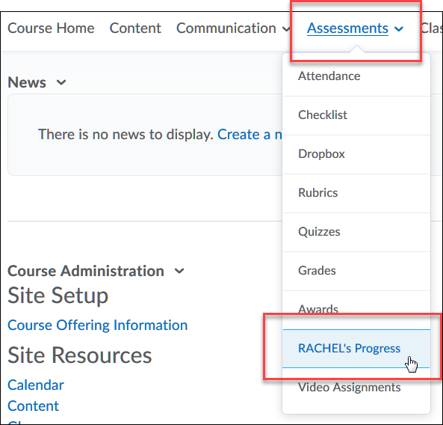
2. Note the Objectives column indicated completed for the student. Click the completed status bar.
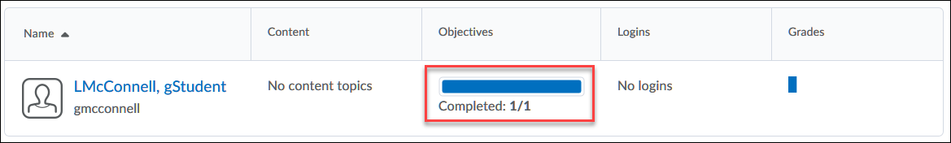
3. Note the indicator shows the objective has been “Passed”. Click on the word “Passed”.
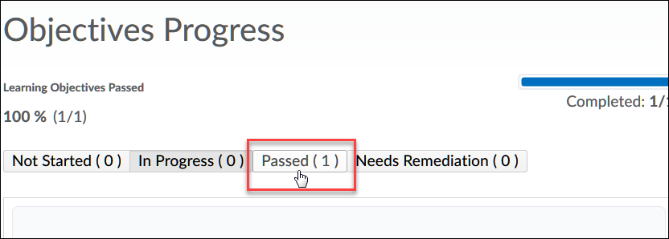
4. This opens the competency and allows you to click on the Competency title to view the associated objective information OR click on the arrow head next to “1 Activities, 0 Objectives” to view the activity score.
