How to log in and access the COVID-19 Emergency Assistance course to complete application.

1. Enter your BC username and password and click the Log In button. BC username is first initial+last name+last 4 digits of your BC ID (example: jdoe1234) and password (if you have not reset it) will be bc+6 digit PIN (example: bc123456)
If you are unable to login, contact BC Helpesk (Phone: 979-230-3266 | Email: helpdesk@brazosport.edu).
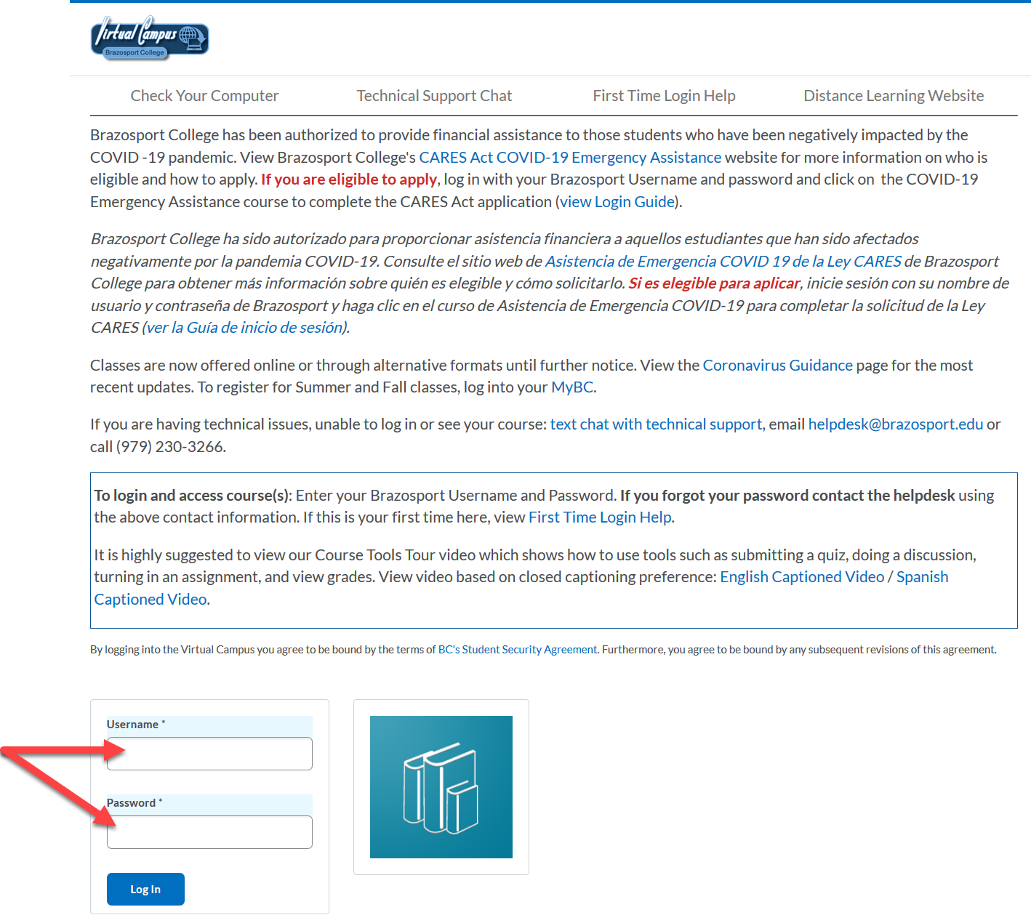

2. Click on the COVID-19 Emergency Assistance course.
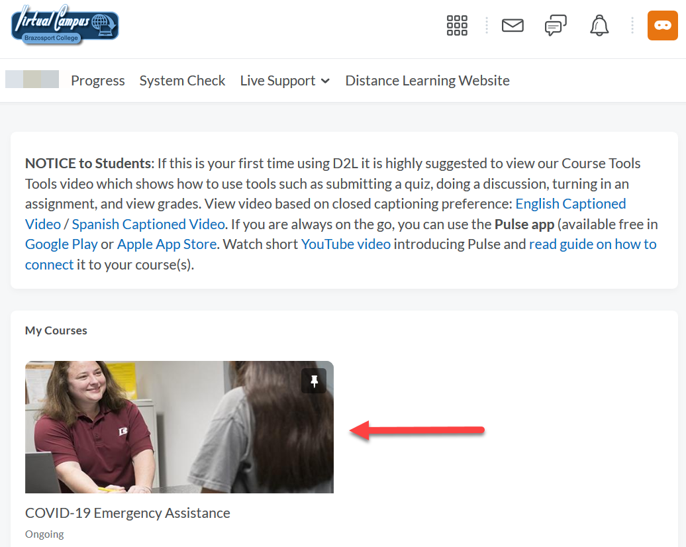
3. Click on the CARES Act Financial Aid Emergency Grant Application link.
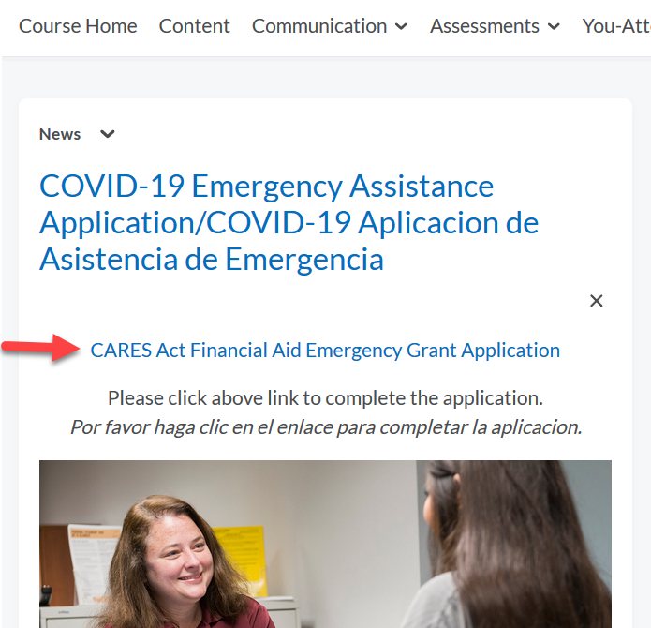
4. Answer all 10 survey questions by either typing in or selecting responses.
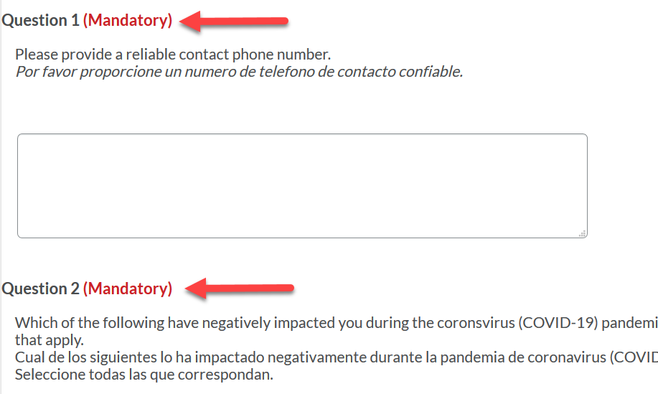
5. Once done with survey, click Save Responses and then click Submit Survey button.
