The Grades tool is used to set the grading system, final grade release, calculation, grading scheme and display views for student grades in the course.
Creating a Scheme
Use schemes to create a letter grade which will be associated with your final score in the Gradebook. Schemes can be created prior to going through the Grades Wizard (easiest method) OR at the end before releasing the Final Grade.
1. Enter Grades using the Grades link under the Assessments drop-down menu located on the course navigation bar.
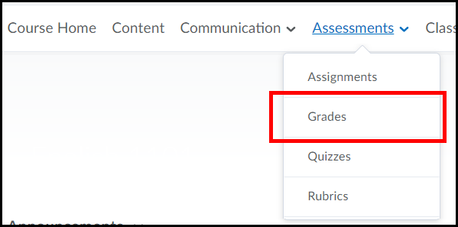
2. Click on the Schemes link.
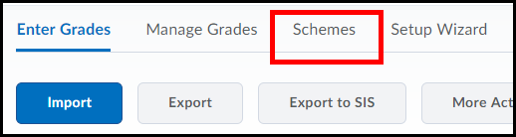
3. Select the button for New Scheme.
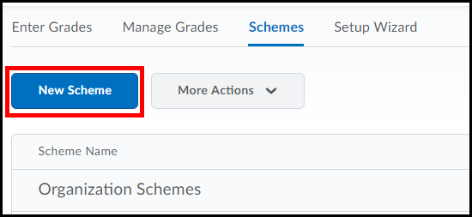
4. Enter a title for the scheme (1), as well as the symbol to represent the lowest grade for the Start range, in this case I entered an F for 0 points (2), and select a color (3).
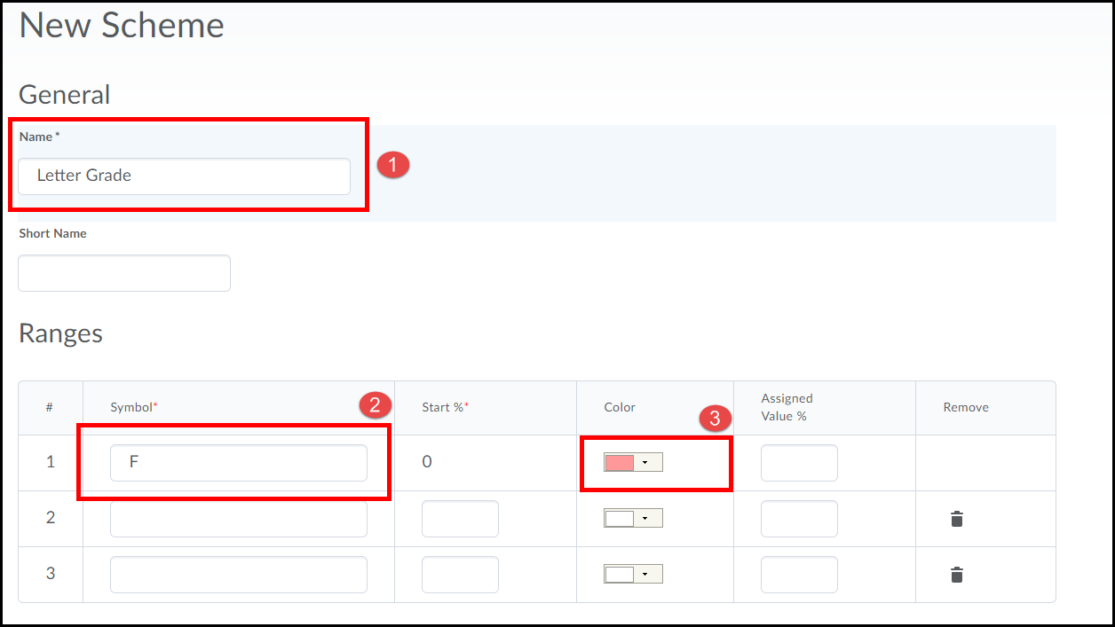
5. Continue this process for letter grades D at a start range of 60% and C at a start range of 70% (1). To add additional boxes for grades B and A type in a number 2 in the Add Ranges box and click the plus symbol (2).
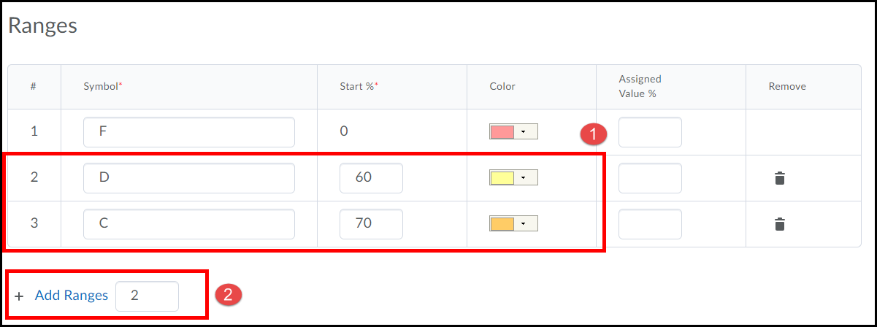

6. Complete the scheme by adding the letter grades B at a start range of 80% and A at a start range 90% (1). Click the Save and Close button when done (2).
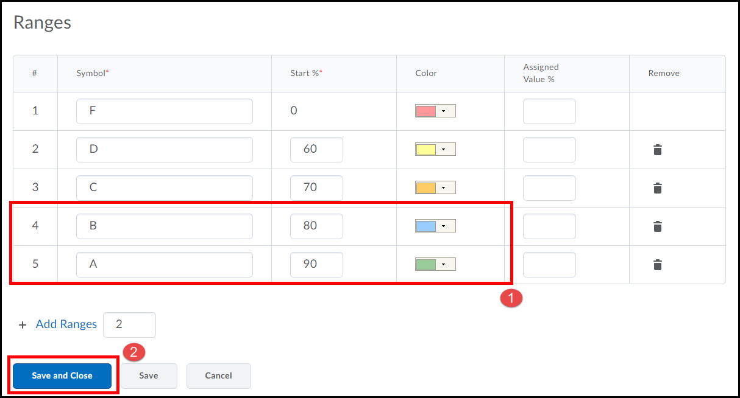

Grades Wizard
The Grades wizard is used to define the settings for your gradebook.
1. Enter Grades using the Grades link under the Assessments drop-down menu located on the course navigation bar.
1. Click on the Setup Wizard (1) link located under the course navigation bar and click the Start button (2).
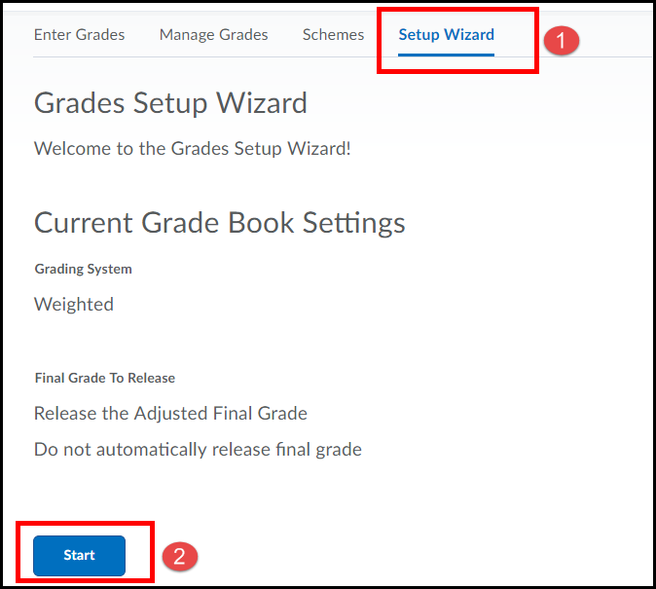

3. Select Weighted for your grading system (1) [selections can be edited] and click the Continue button (2).
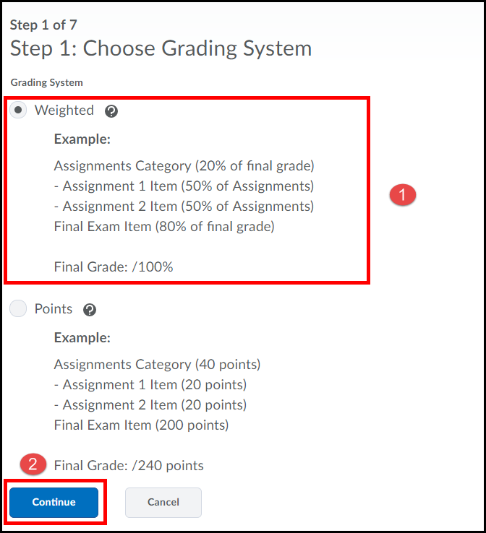
4. Select Calculated Final Grade (1) and click the Continue button (2).
NOTE: To allow for future editing of students’ grades, such as rounding a student’s final grade score, select Adjusted Final Grade.
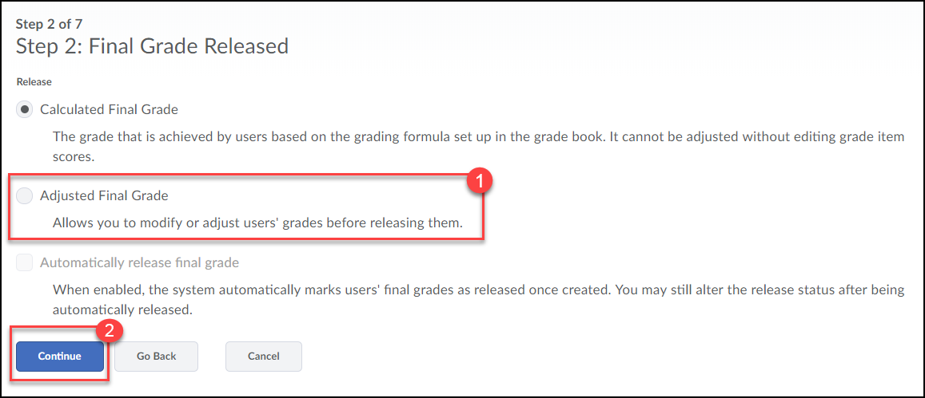
5. Select to Drop ungraded items (1) [this option prevents students from viewing an inaccurate final grade based on incomplete items, but you do need to remember to add zero’s in the grade book yourself for items students do not complete prior to releasing final grades] and check the box for Automatically keep final grade updated (2). Click the Continue button (3).
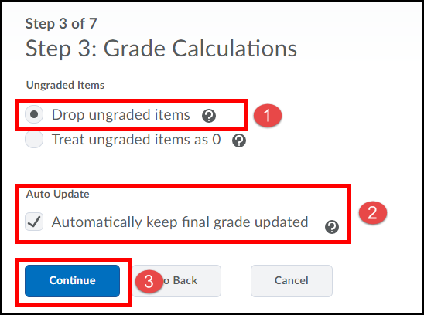
6. If you created a scheme earlier select it, if not just click the Continue button.
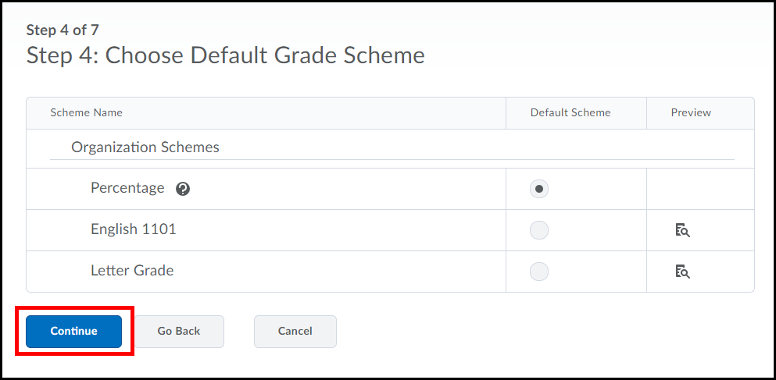
7. Enter the number of decimal places you want displayed in your gradebook and then click the Continue button.
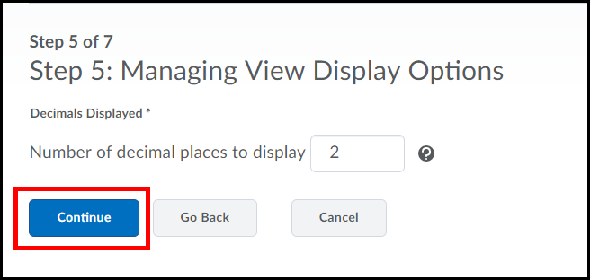
8. Select the checkboxes for Point grade, Grade scheme symbol and Grade scheme color, DESELECT the checkbox for Weighted grade (1) [these settings allow students to view point values for their assignments and quizzes along with a Letter grade for each graded item and the Final Grade]. Click the Continue button (2).
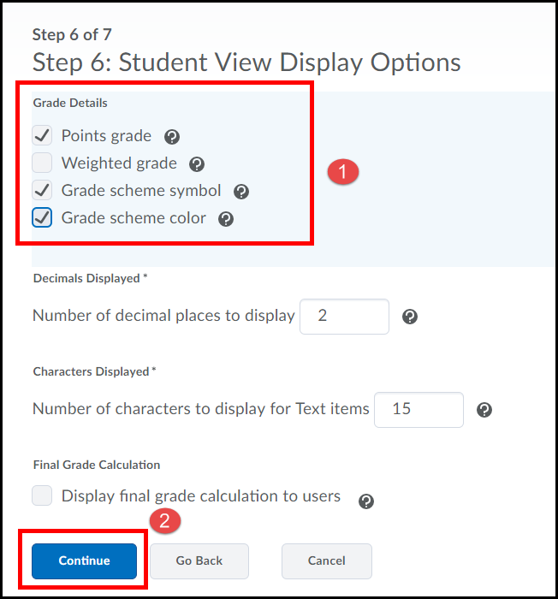
9. Click the Finish button.
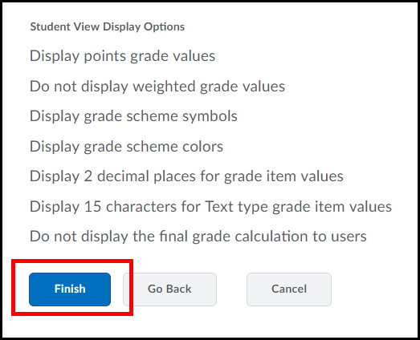

Manage Grades
Now that we have defined our settings we need to populate the gradebook with various items such as activities, assignments, and quizzes.
1. Click on the Manage Grades link below the Navigation bar.
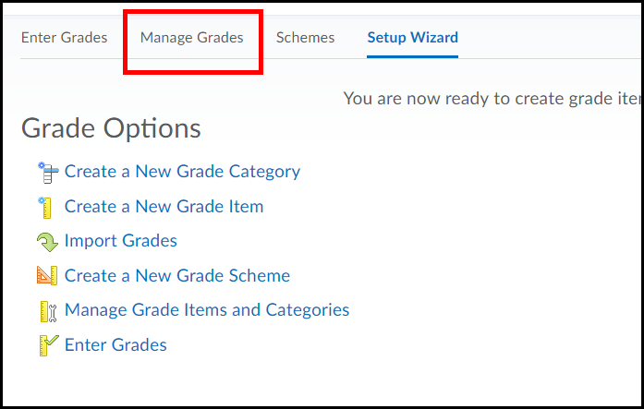
2. Select Category from the New drop-down selection menu [we are going to add “weighted” folders that will hold several associated items which helps make the grade book work for us, instead of the other way around]
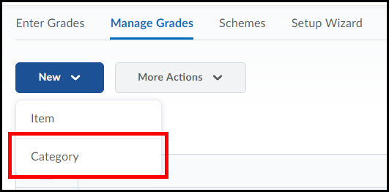
3. Enter a Name such a Quizzes or Assignments (1). Input the Weight (2) [this is the amount you want the category to contribute to the final grade]. Select the checkbox for Allow category grade to exceed category weight (3) [this will allow for any possible extra credit points to be added later]. Click the radio button for Distribute weight evenly across all items (4) and click the Save and New button (5).
Continue with this process till you have all your Categories created [you can add categories later, but the more you do now to finalize your grade book the better].
When done, click the Save and Close button (6) to return the Manage Grades area.
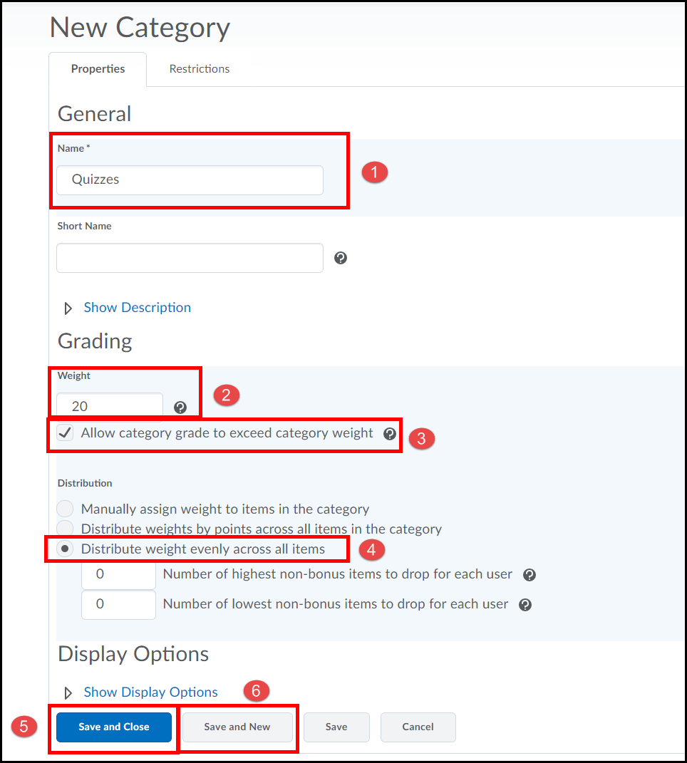
NOTE
To drop the lowest grade a student receives on an item(s) enter the number of item(s) you want to drop in the field for the Number of lowest non-bonus items to drop for each user.
NOTE
The total weight of all your Categories MUST add up to 100. Keep in mind since the weight will be equally divided in a category you can add multiple items which exceeds that amount.
New Items
We now need to add individual grade items to each category.
1. Select Item from the New drop-down selection menu. *Note: in the following image I created categories for Quizzes, Assignments, Participation and Presentations.
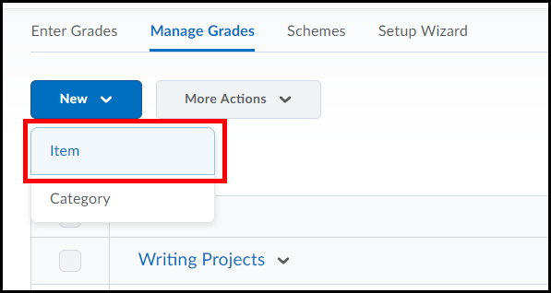
2. Select the Numeric text link.
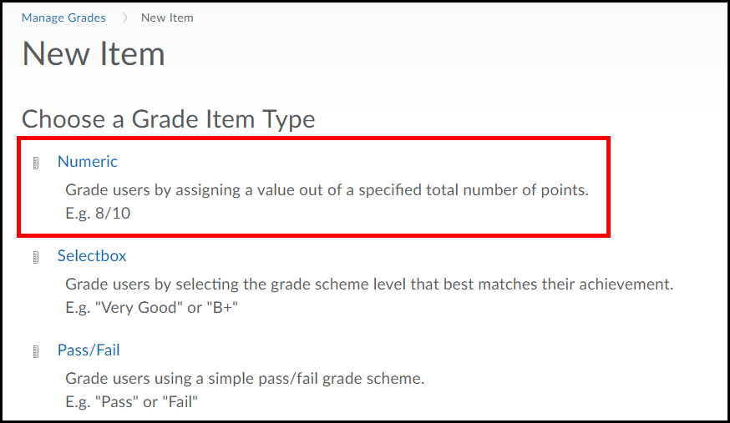
3. Enter a Name (1) such as Quiz 1 or Assignment 1, use the drop down menu for Category and select the appropriate folder (2) and enter a Max. Points value for the item (3). Select the Save and New button (4). [Continue with this process till all grade items have been added [you can always add more at a later date]. Select the Save and Close button (5) to return to the Manage Grades area.
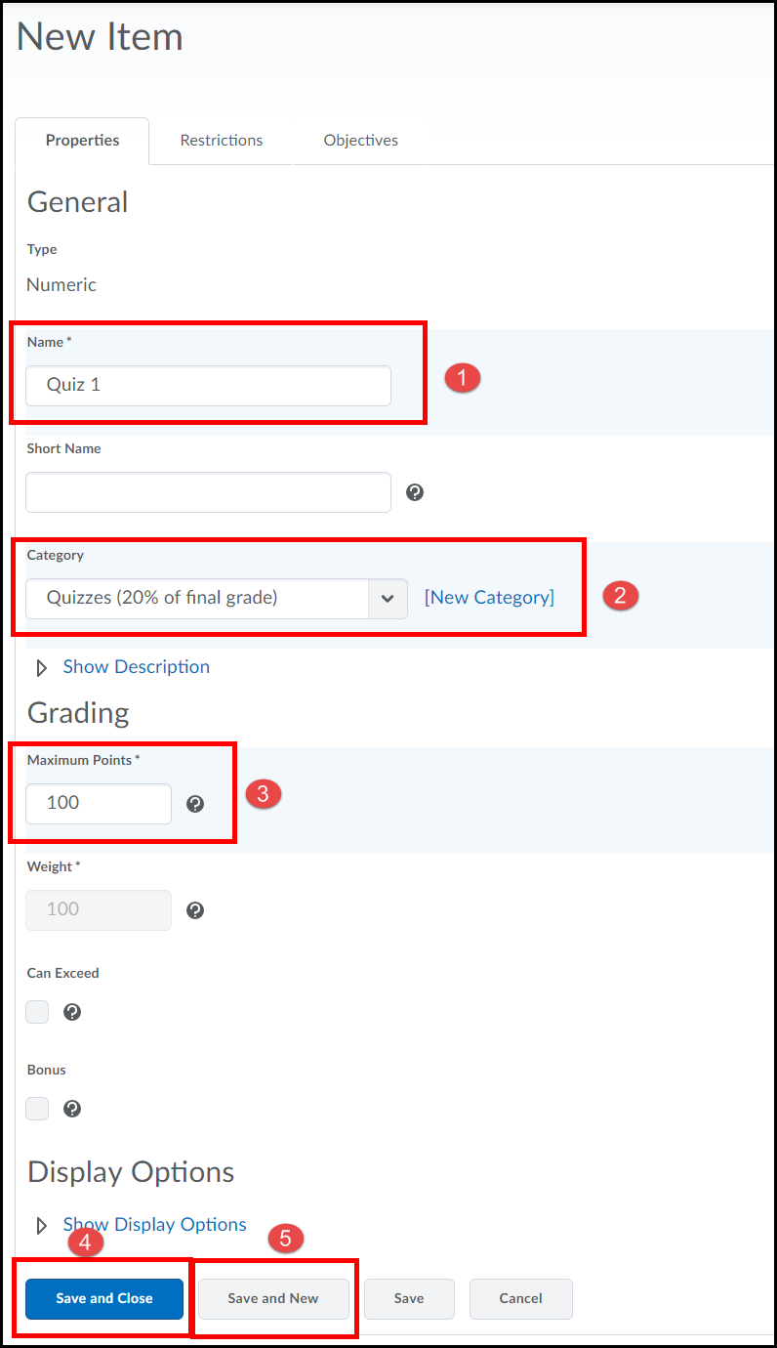
The following image shows an example of created Categories and associated Items. If the Grade List indicates errors at the top, it may be due to the Categories not totaling 100 or items not being properly associated with a Category.
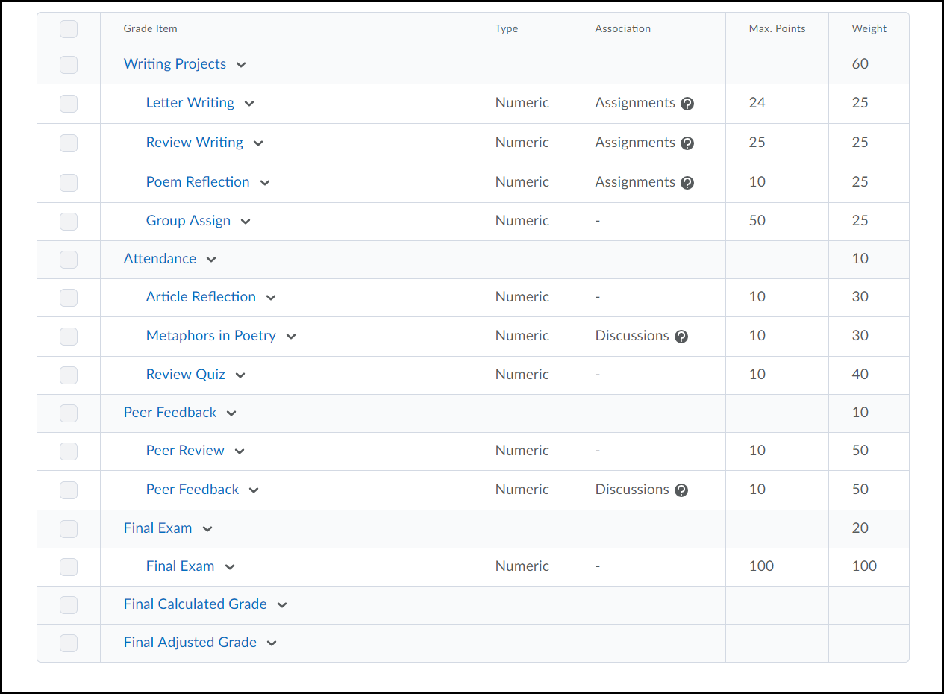
The weight for each grade item under a category is automatically determined using the following formula:

100 ÷ number of grade items added to the category = weight of each grade item

Bringing it all together for the Final Grade
At the end of the semester you need to finalize grades and reveal them to the students.
1. Select Grades from the Assessments drop-down menu on the course navigation bar.
2. Select Enter Grades on the left-side of the page.
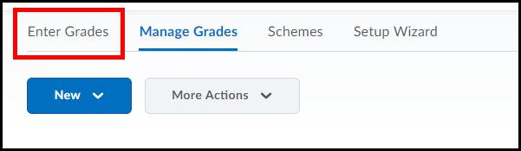
3. Scroll all the way to the right to the Final Grades column and select Grade All from the Adjusted Grade drop-down menu.
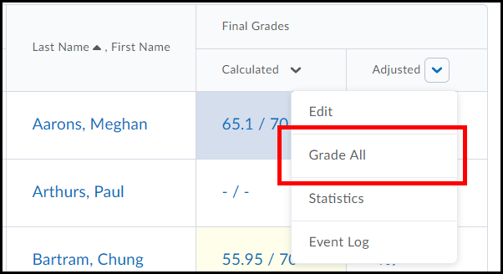
4. Select Recalculate All (1) from the Final Grades drop-down menu, select all grade items you want to have calculated into the final grade (2) [use the checkbox at the very top of the list to choose all] and click the Calculate button (3).
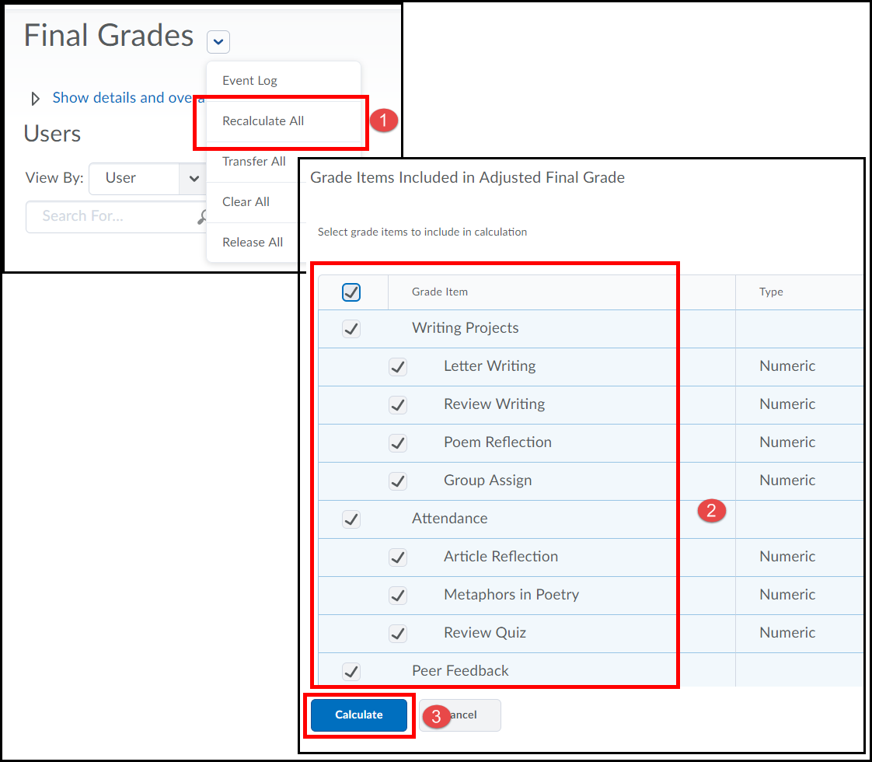
5. Select the Yes button and click the Save button [saving is automatic, but always nice to be sure]
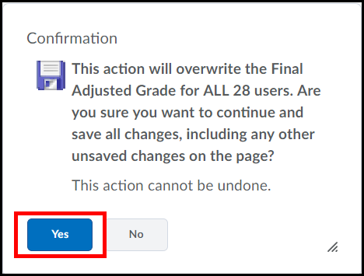
Reveal Final Adjusted Grade
We now need to allow students to see their final grade.
1. Select Release All from the Final Grades drop-down selection menu.
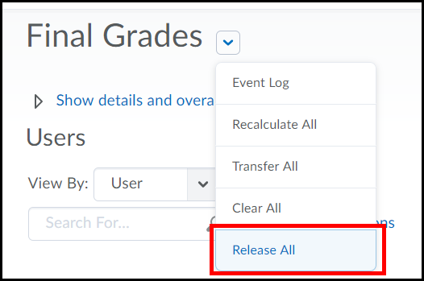

2. Click Yes to the confirmation.
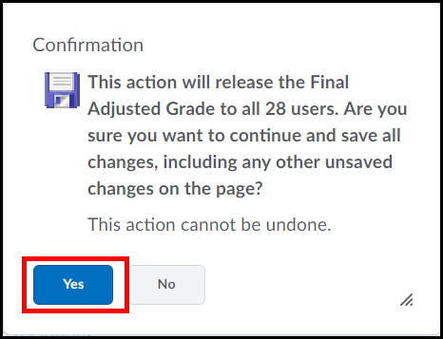
3. If you return to Enter Grades [link located on the left of the page but not pictured in the following image] you should notice an icon for all users in the Final Adjusted Grade column [this indicates the column is viewable to students].
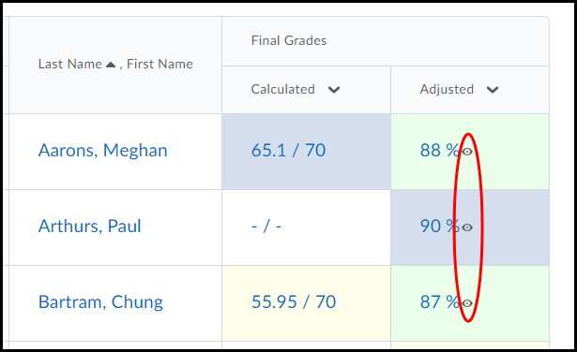
Student View
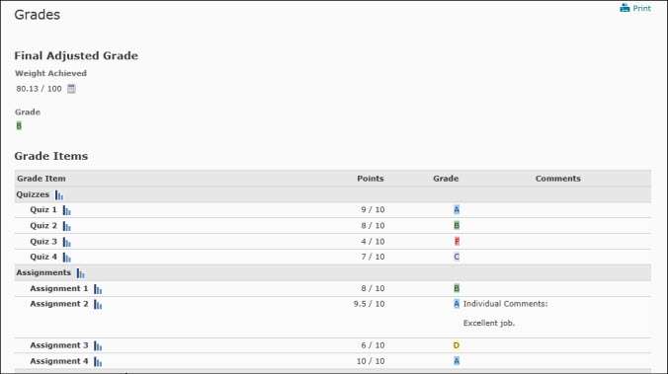
Student Progress
The Student Progress tool allows you to view a student’s course progress. This tool can be accessed from within the Classlist or Enter Grades section of a course.

Student Progress through the Classlist
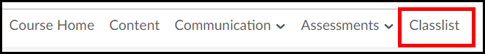
- Select the drop-down menu next to the student whose progress you would like to view (1). Then select the View Progress icon (2).
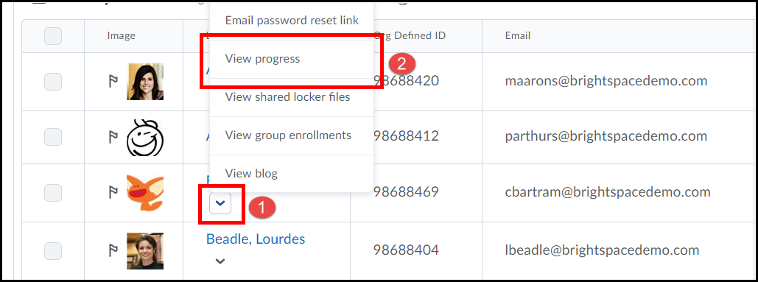

Student Progress through Enter Grades
- Click on Assessments from navigation bar (1) and select Grades (2).
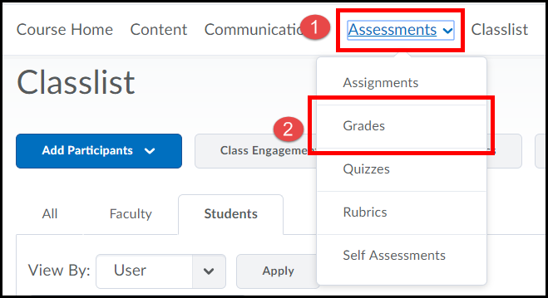
- From within the Enter Grades section, select the View Progress icon next to the student’s name you would like to view progress for.
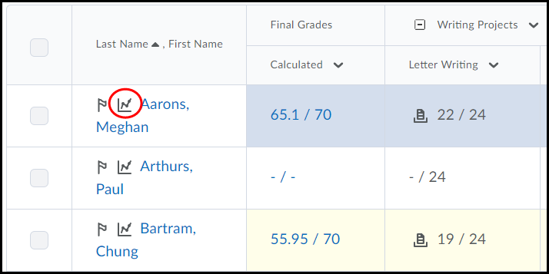

Student Progress
Displays a progress summary for course content.
Displays the percentage% of a module a student has viewed along with the number of topics.
Displays the percentage% of all course content the student has completed.
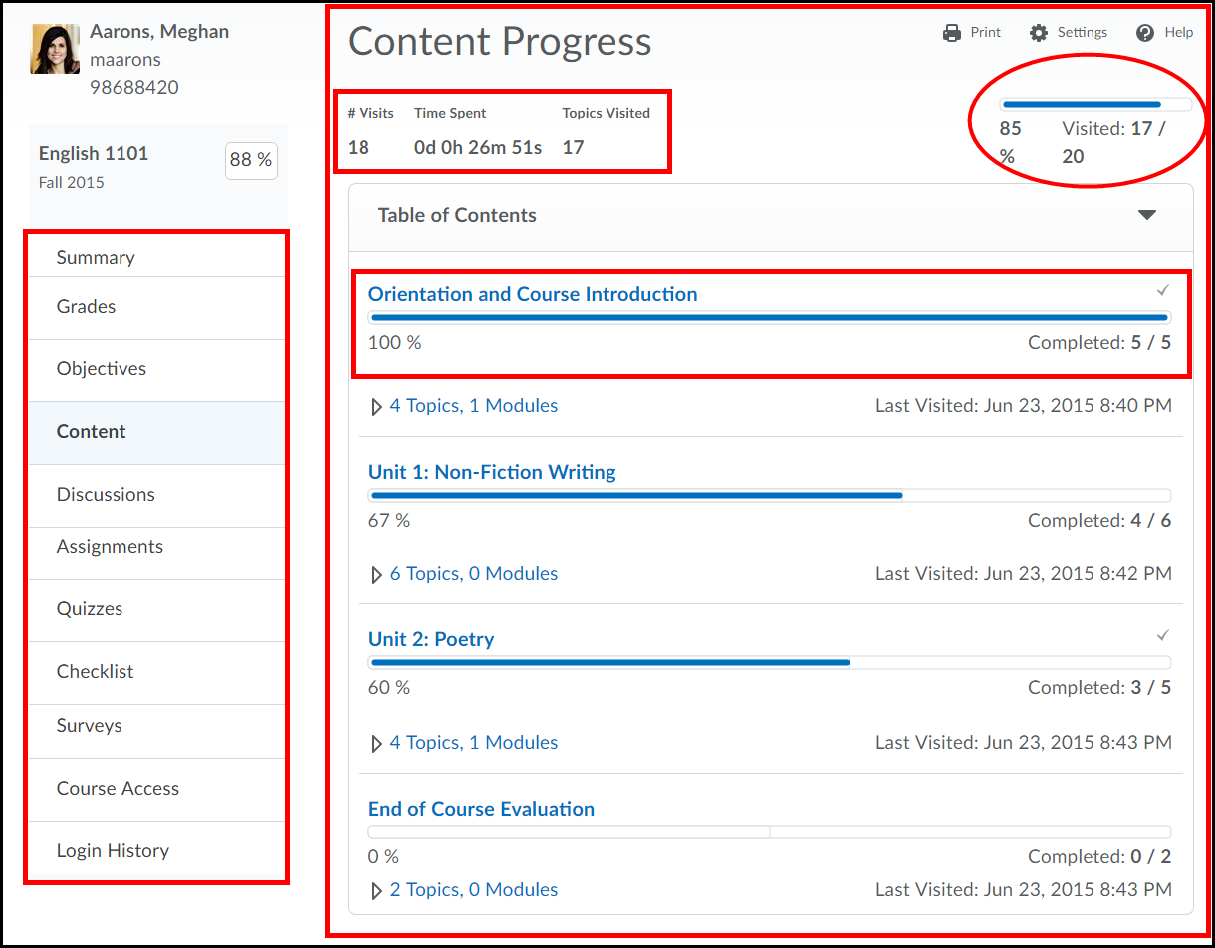
Displays all topics in the module and whether or not the student has viewed it.
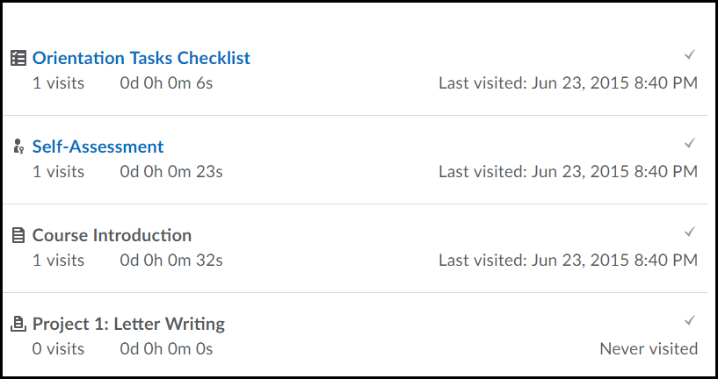
Progress preview pane.
Displays details on a student’s progress for a selected tool.

