The HTML Editor, in BrightSpace, allows you to create files on the fly without having to create and upload them from another program (i.e., Microsoft Word). It allows you to insert images, media, and create hyperlinks (known as Quicklinks in D2L).

This manual focuses on the HTML Editor in the Announcements section. However, everything mentioned about the editor can be applied to the HTML editors in all BrightSpace tools (Content, Grades, Discussions, Dropbox, etc…).

- Click on the Announcement pull down menu and select New Announcement to access the HTML editor.
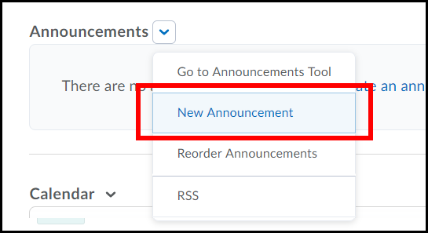

- The HTML Editor is located near the center of the page.
NOTE:
For additional information, on creating and/or working with Announcements, see the Announcements, Checklist, and Notification Tools manual.

- When using the Editor if you click the button with the three dots 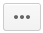 it provides more editing features.
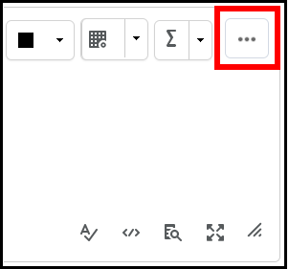

- Now go ahead and begin typing your desired content.
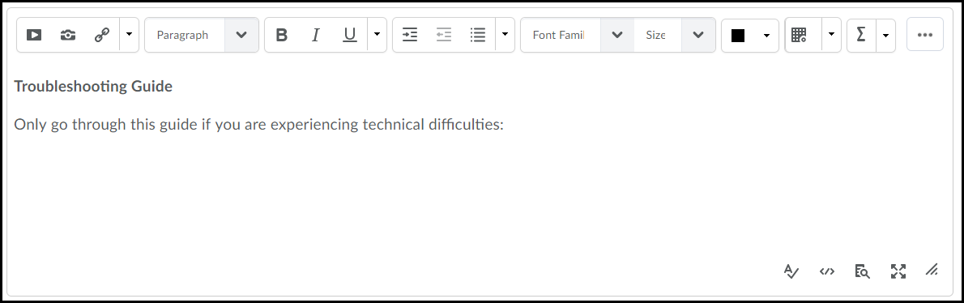

Inserting an Image
Just as in Microsoft Word you have the ability to insert images.

- To insert an image, position the cursor in the desired location you would like it to appear.
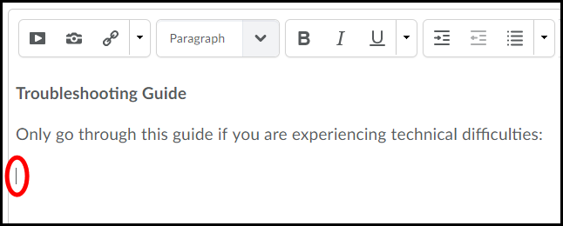
- Click the Insert image icon on the toolbar.
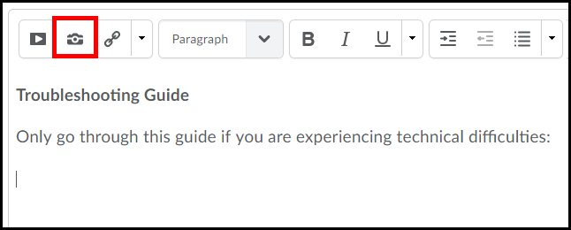

- Now, click the Upload button.
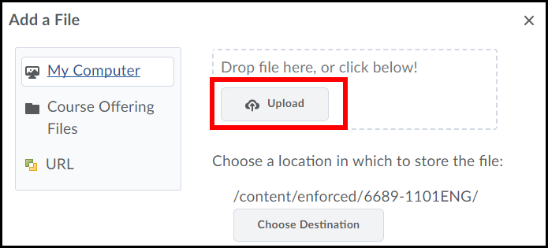

- Locate the image file on your computer, click on it once to select it (1) and click the Open button (2).
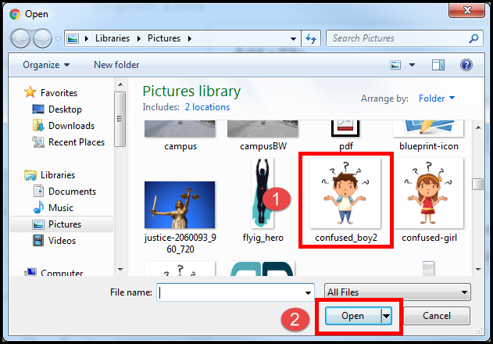
- Click the Add button.
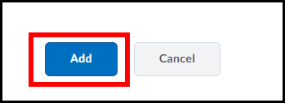

- Enter a short description of the image (i.e., pic, image or map) (1) and click OK (2).
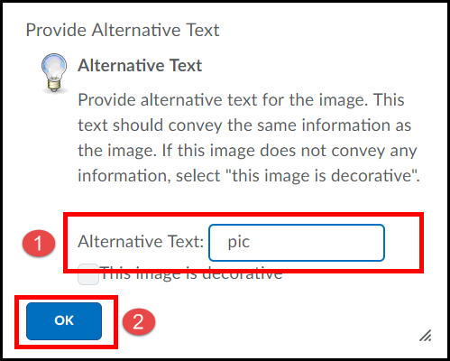

- The image will now be inserted into the text editor.
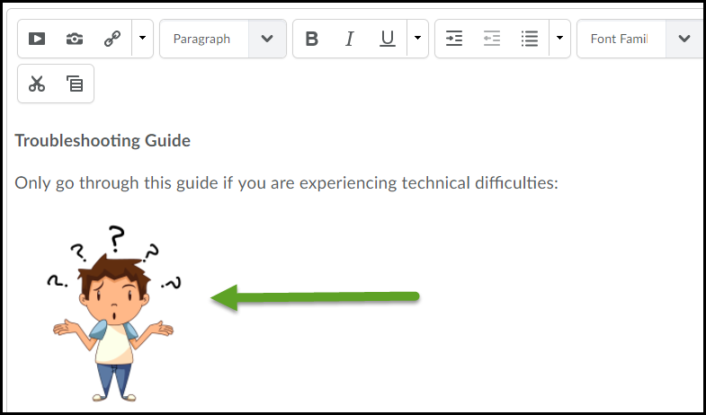
- You can re-size the image by highlighting it. The image will then be surrounded by small squares and you will need to place your cursor near a corner of the image till the cursor turns into a 2 sided arrow. Then hold down the cursor button and pull in (to make image smaller) or pull out (to make image larger).
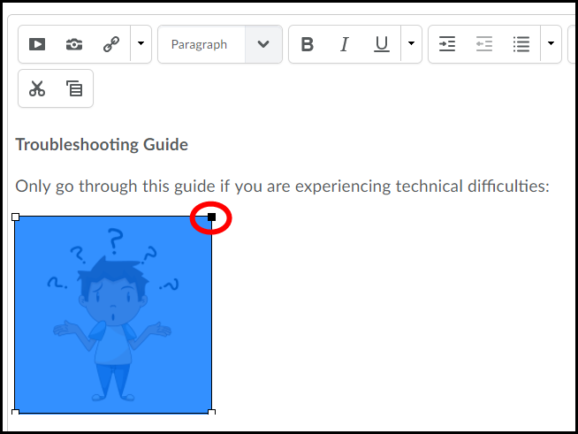

Insert Stuff
The Insert Stuff feature in the HTML Editor allows you to insert links to files and input YouTube videos.

Inserting a Link to a File
You can insert links to Microsoft Office files such as Word, PowerPoint or Excel, plus PDF’S and many others. To create a link you must have your file already created and saved.
Keep in mind that when linking to files, other than those that are web-based, users will need to have those particular programs installed or have a reader in order to open them. For example, if linking to a PowerPoint file, users have to have Microsoft PowerPoint or a PowerPoint player installed.

- In the HTML editor, position the cursor where you want to insert a file link.
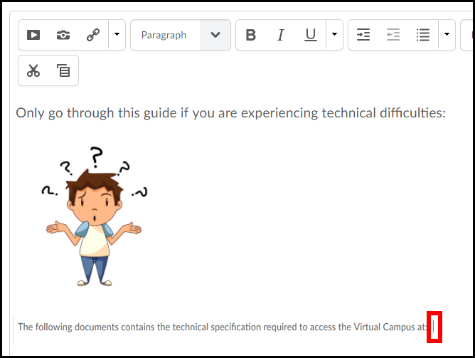

- Click the Insert Stuff icon.
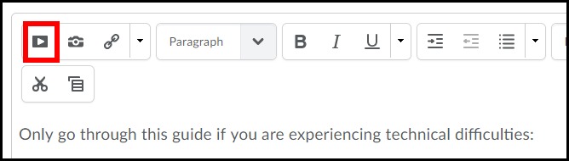
- Click the Choose File button.
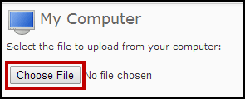

- Locate the file you want to create a link to, click it once to select it (1) and then click Open (2)
. 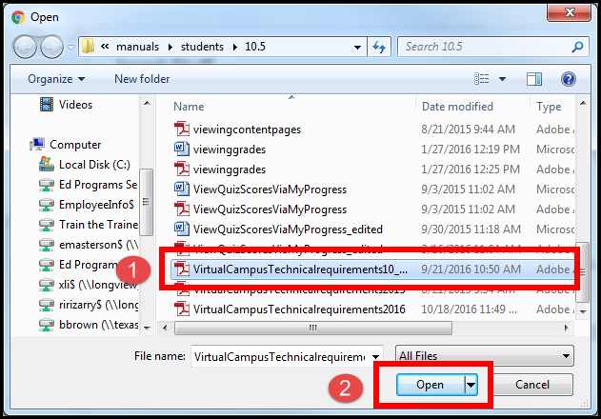

- Click the Upload button.
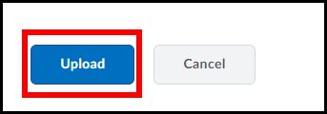

- Enter the text you want displayed for the link. [NOTE: This text is what the user will click on to open the file.]
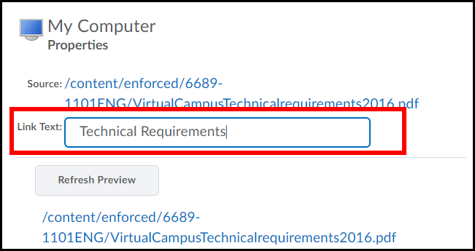

- You can click the Refresh Preview button to be shown as a preview of your link.
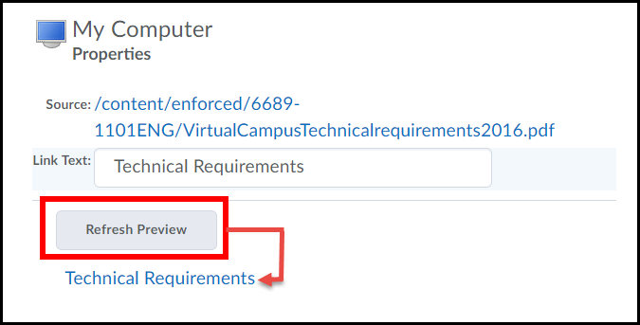

- Click the Insert button to finish the process.
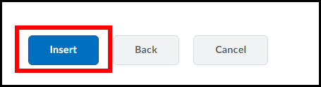

- A link to the file is now inserted and is indicated by the text turning blue and being underlined. 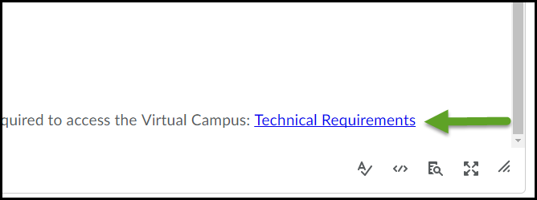
NOTE:

A copy of the file, you created the link for, will be stored in the Managed Files section of D2L.

Inserting YouTube Videos
You have the ability to search and insert YouTube videos directly through D2L, without having to visit YouTube.com.

- In the HTML editor, position the cursor where you want to insert a YouTube video.
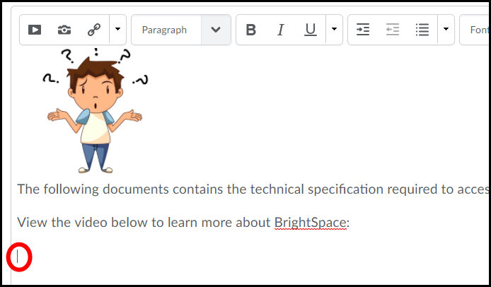

- Click the Insert Stuff icon.

- Click on the YouTube icon located on the left side of the page.
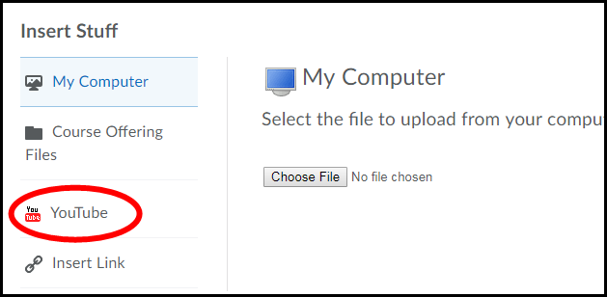

- Search for a desired video by using the D2L YouTube search feature.
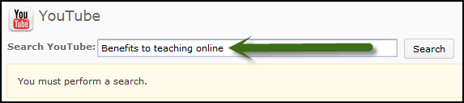

- When you find a video you want, click on it once to select it (1) and click the Next button (2).
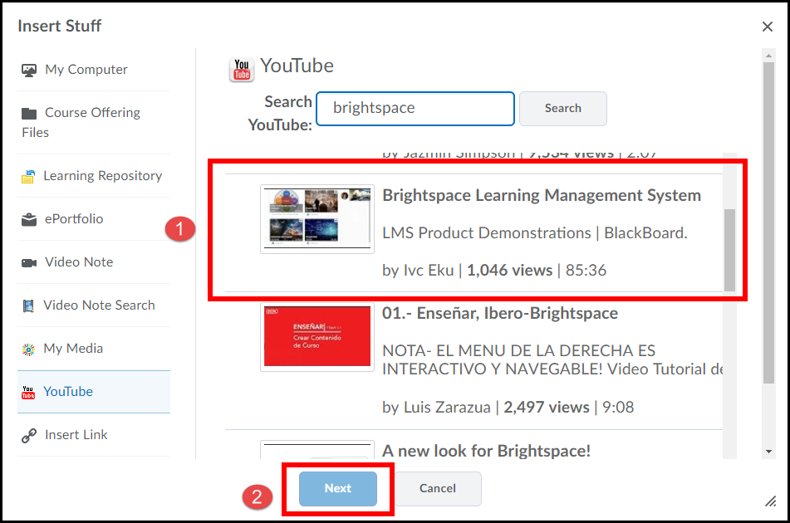

- A preview of the video will appear. Click the Insert button to add it.
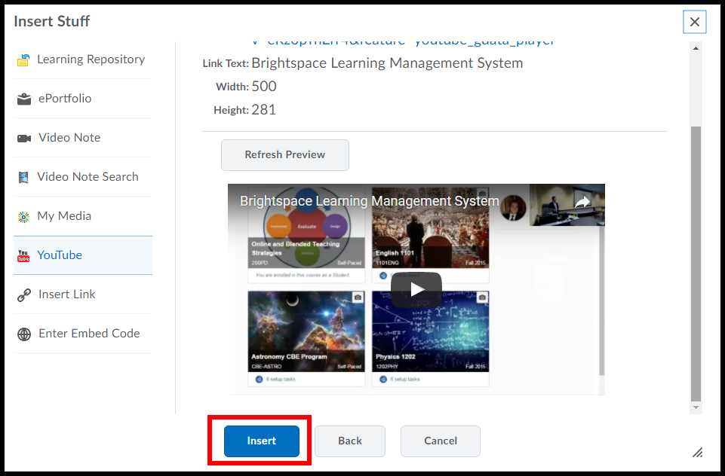

- The YouTube video is now inserted.
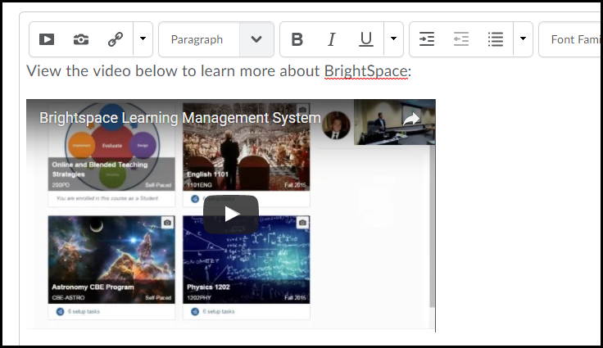
- To get a better view of how the video will look, click the fullscreen mode icon. 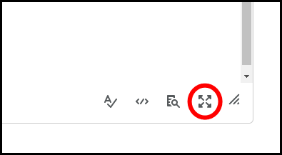

- The HTML editor will now be in Fullscreen mode displaying everything you have done so far. 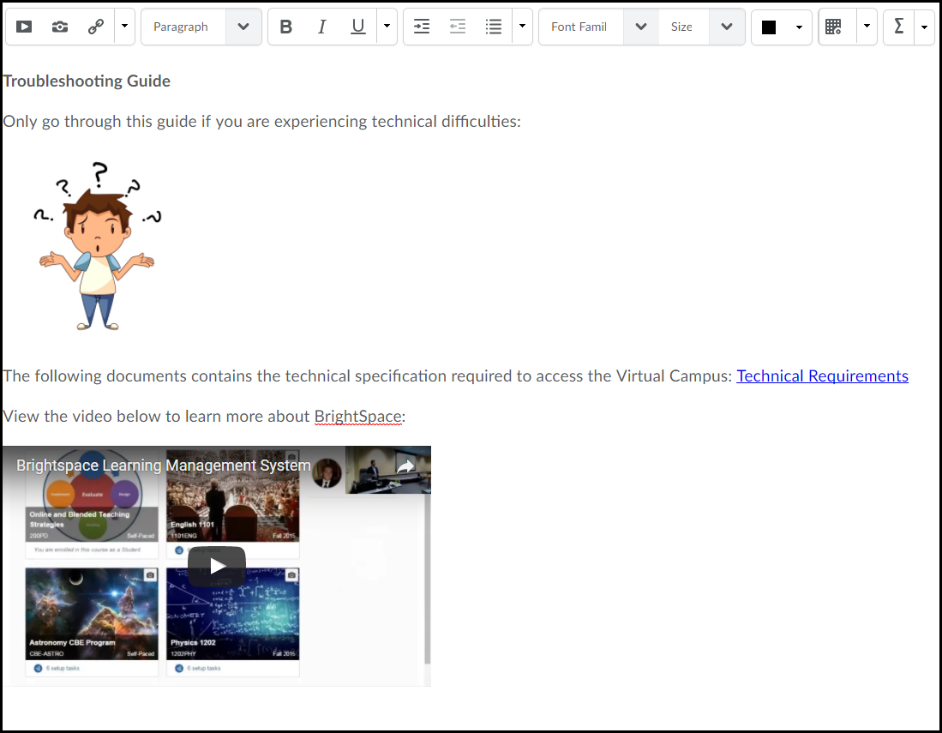
NOTE:

You can use the HTML editor in fullscreen mode whenever editing or creating content.

Inserting Links
There are two types of Quicklinks (hyperlinks) that can be inserted into the Text Editor. This manual will show you how to insert a quicklink to a website and a D2L course component such as a Discussion topic, Dropbox or Quiz item.

Inserting Quicklinks to Websites
You can insert Quicklinks to websites that you would like your students to visit.

- To insert a Quicklink to a website, copy the website’s address by highlighting the address, then right-clicking your mouse and selecting Copy.
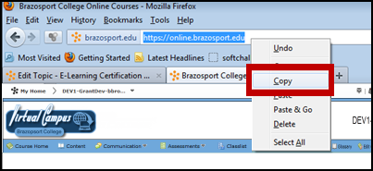

- Back in the HTML editor, position the cursor where you want to insert the website’s quicklink.
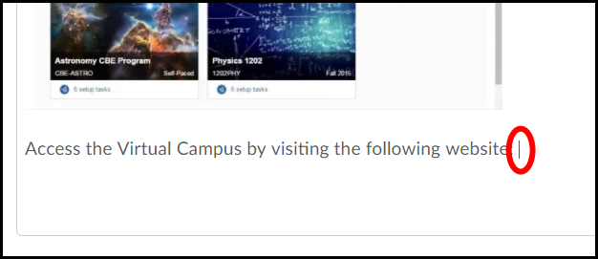

- Now, click the Quicklink icon.
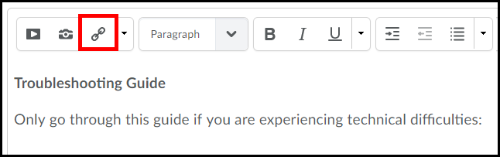

- Select URL from the list of options.
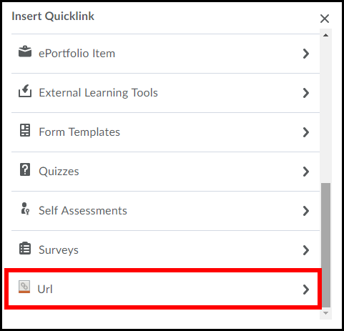

- Delete whatever is in the URL box and then right click your mouse and select paste to input the website address (1). Enter the text you want displayed for the link in the Title box (2) (this text is what the user will click on to open the file). Click the Insert button (3).
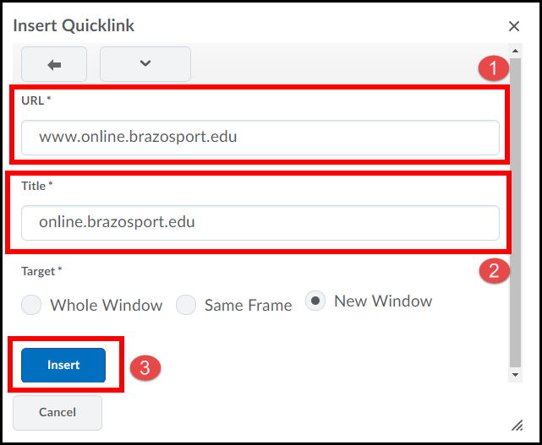

- A Quicklink to the website will now be inserted, and is indicated by the text turning blue and being underlined.
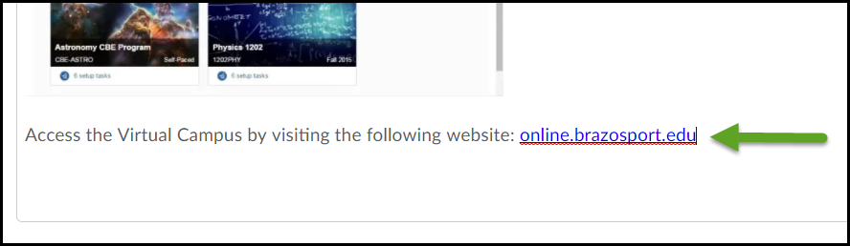

Inserting Quicklinks to D2L Components
You can create links to other components you have previously created in your D2L course (such as; discussions, content, announcements, etc…).

- In the HTML editor, position the cursor where you want to insert a link to a course component. 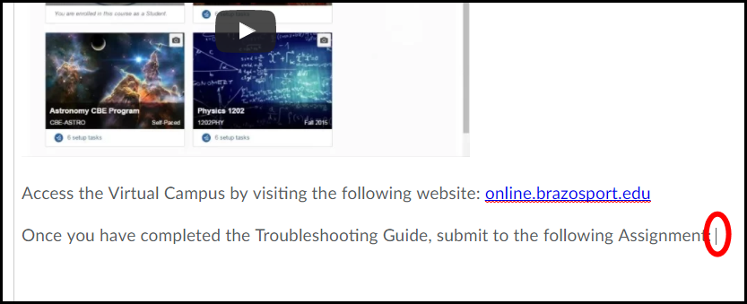

- Now, click the Quicklink icon.

- Select the Type of the course component; you would like to create a Quicklink to. In this case we are going to create a Quicklink to a discussion forum, so we will select Discussions.
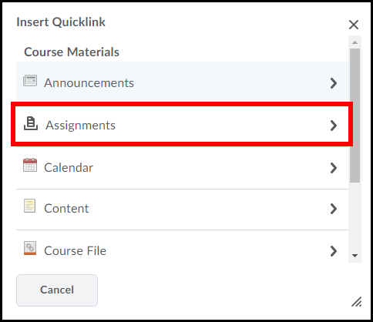

- Click on the specific D2L course component you are creating a link to. In this case it is an Assignment folder I have created called Project 1: Letter Writing.
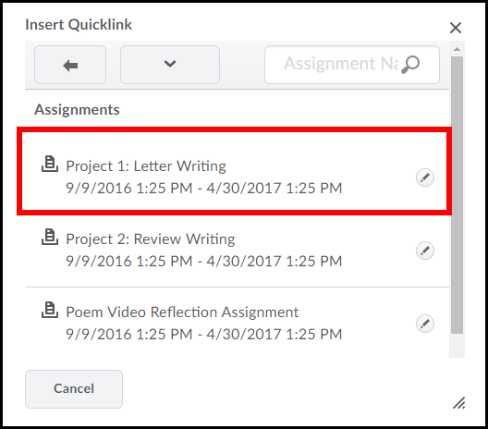

- A Quicklink to the course component will now be inserted and is indicated by the text turning blue and being underlined.
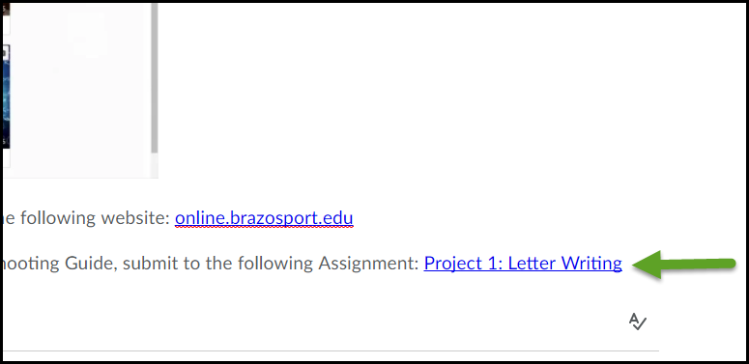

Inserting Emoticons

Emoticons are available for use in the HTML Editor, allowing the ability to express moods or feelings in announcements, instructions, discussion posts, and anywhere else the HTML Editor is available.

- When the HTML Editor is open, click the down arrow next to the insert quicklink button, and then Insert Emoticon.

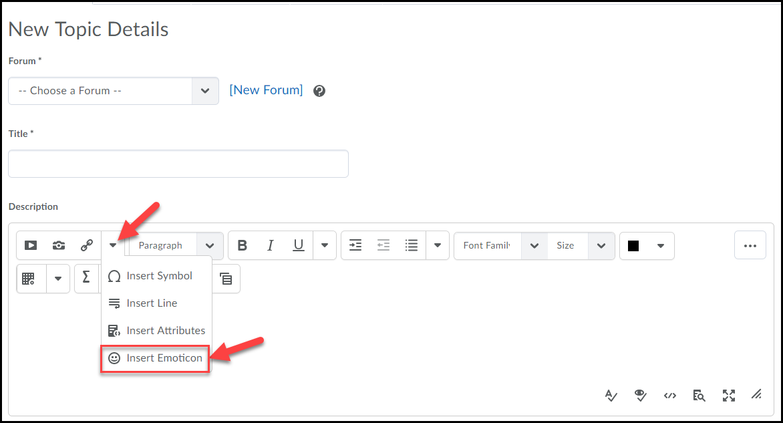
- When the popup box opens select an Emoticon.

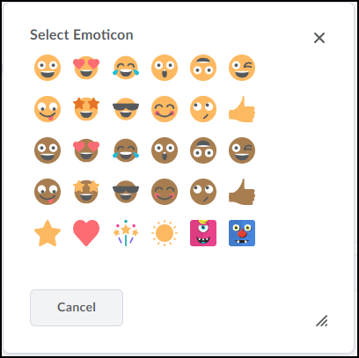

- The Emoticon will now be inserted into the text editor.
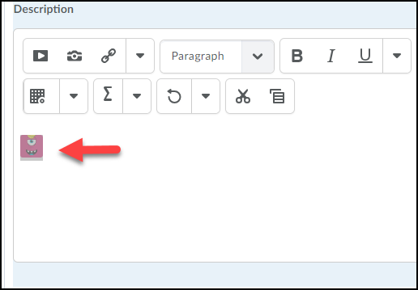

- You can re-size the image by clicking on it. The image will then be surrounded by small squares and you will need to place your cursor near a corner of the image till the cursor turns into a 2 sided arrow. Then hold down the cursor button and pull in (to make image smaller) or pull out (to make image larger).
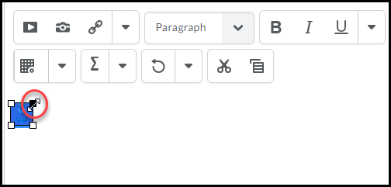

Checking Spelling
You have the ability to check the spelling and grammar of the text you input in the HTML Editor.

- To check spelling, click the Check spelling icon.
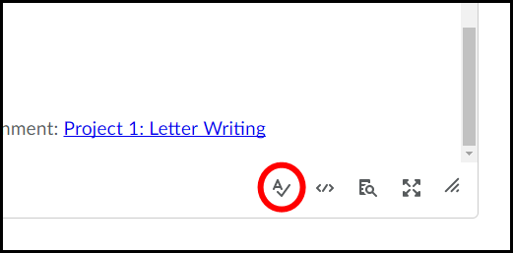

- Each misspelled word will be highlighted in yellow (1). Use the Suggestion drop-down menu (2) to select the correct spelling of the word. Click the Replace Once button (3).
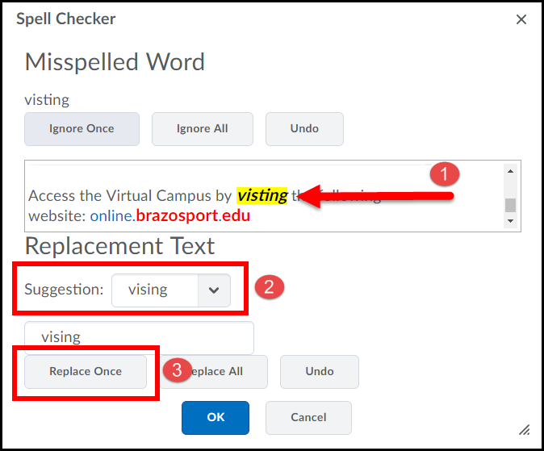
NOTE:

Once you have corrected the spelling of a word, if there are any other misspelled words they will be displayed after you click the Replace Once button (just like this example).

- When you have finished all spell checking click the OK button.

