Intelligent Agents monitors a course to find activity that matches criteria you set and then sends an email to the user (student). You can run multiple Agents at any one time. The criteria that the agents can search for are:
- login activity (refers to logging into D2L)
- course activity (refers to login to a specific course)
- release conditions in D2L (refers to a criteria based on a tool)

This manual provides directions on how to set an Agent to notify any student who has not logged into a course over a specified period of time. Set an Agent to run during the first 2 weeks of the course, so you would know which students have yet to log into your course by either the first or second week of class.
1. Access the Intelligent Agent tool by selecting Edit Course on your course navbar.
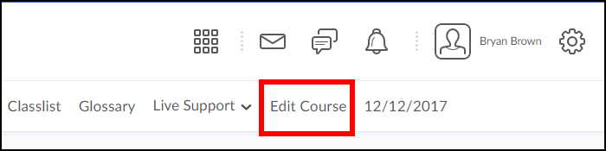
2. Click on Intelligent Agents from the list of options.
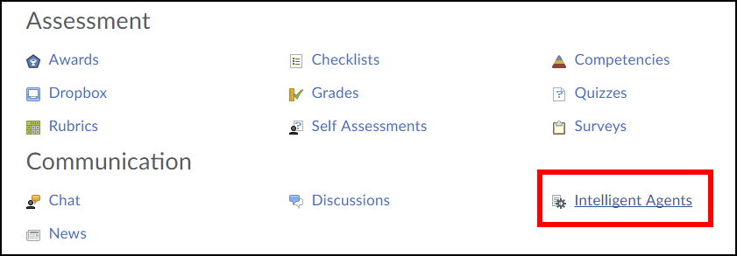
3. Click the New button.
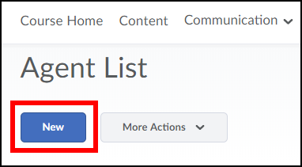
4. Type in an Agent Name and Description. The description will help you manage your Agent list later on. For example: Agent Name: Login with Description: Alert me when a student has not accessed the course for 1 week.
Click the Status checkbox so Agent is enabled.
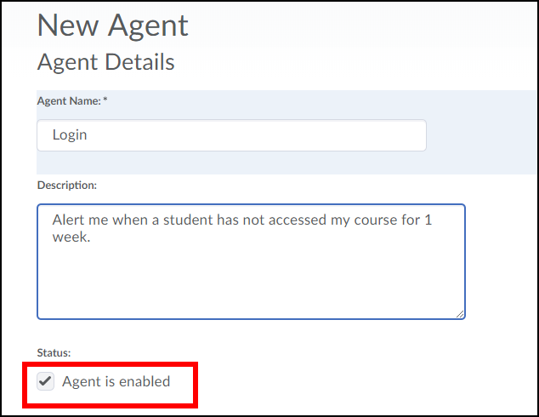
5. Under Course Activity, select the checkbox for Take action when the following course activity criteria are satisfied and click the radio button for User has not accessed course for at least ____ days (type in how many days you would like, I chose 7 in this example).
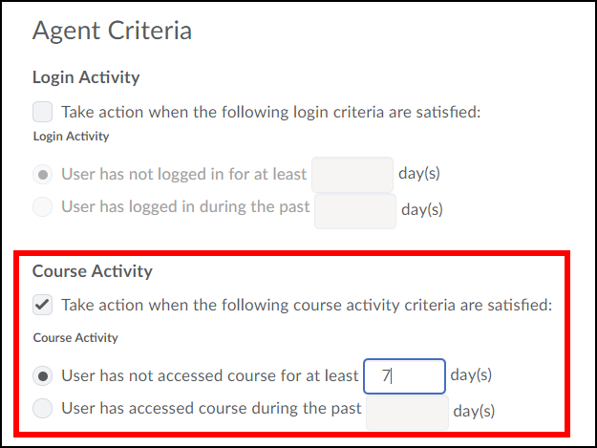
6. Under Agent Action, select the radio button for Take action only the first time the agent’s criteria are satisfied for a user (you could also choose the second option for each time, but for this example I am only looking for those who have not logged in during the first week of class).
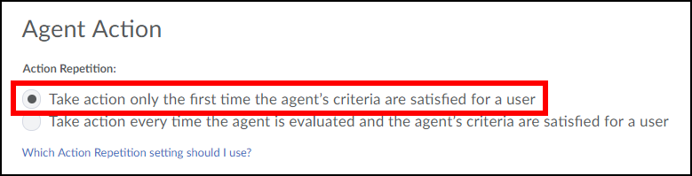

7. In the To: header type the following exactly as indicated here, including the: {InitiatingUser}
This will send an email to all students who have not accessed your course for 7 days.

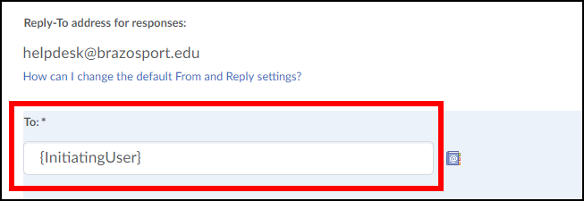
8. In the CC: header, type in your D2L username@online.brazosport.edu (example: jsmith@online.brazosport.edu). If you would like these notifications sent to an outside email address, go to Email in the course navbar, click on the drop-down menu for your name located at the top right-corner of the page. Select Account Settings, click the Email tab and scroll down to "Forwarding Options", type in a correct email address and click Save and Close.
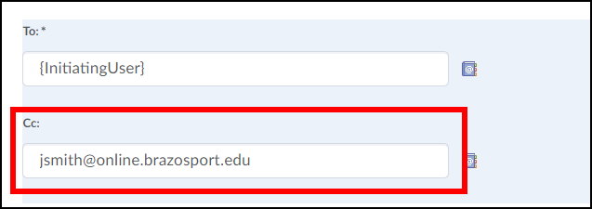
9. Type in an Email Subject header, such as Attendance Report for ENGL101.
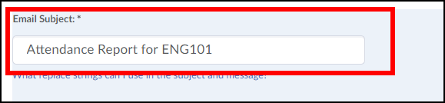
10. Type your message. If you want to have the user first and last name included in the message you must enter the following exactly as indicated here, separated by a single space and including the braces:
{InitiatingUserFirstName} {InitiatingUserLastName}
For example: Hello {InitiatingUserFirstName} {InitiatingUserLastName}, rest of message goes here.
Click the Save and Close button when done.
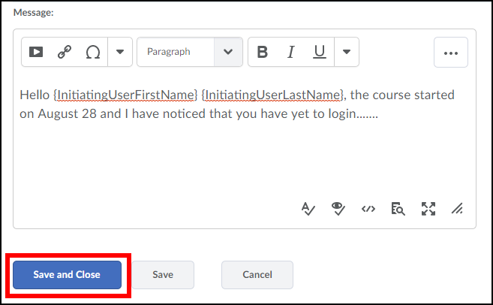
11. By the end of your first week of class OR 2 weeks if that was your criteria, return to Edit Course, click on the drop-down menu of the Intelligent Agent you created and select Run Now.
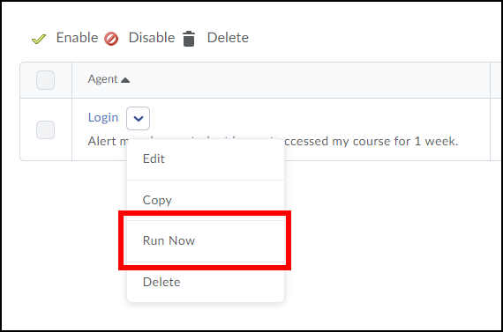
12. Click the Run button.
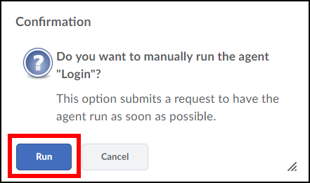
13. Click the Done button. After the Agent runs, you will receive a confirmation email from helpdesk@brazosport.edu in either D2L email or your email client entered in your Email's Forwarding Options.
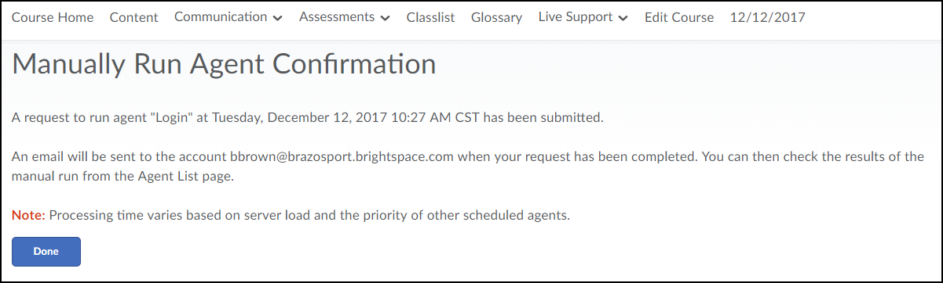
14. In the confirmation email you will see Action Taken: is Yes or No.
A Yes indicates there were students that met your criteria and an email has been sent to them and CC’d to you. A No means no student met your criteria at the time the Agent was ran.
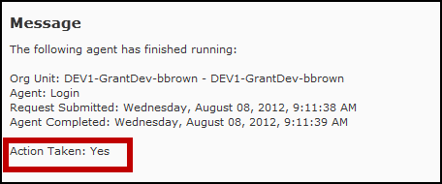
15. Don’t forget to take a look at the emails you had CC'd to you from the Agent. These will show you which student has yet to log in.

