News
The News tool is used to post a Welcome message or announcement concerning updated activities and materials for a course.

Create a News Item
1. From the course homepage, click New News Item from the News drop-down menu.
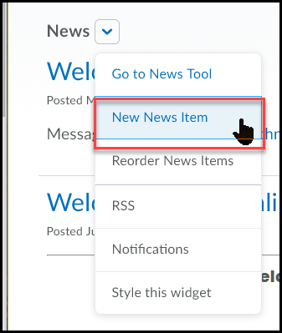

2. In the Headline text block type in a title (for example: “Welcome” or “Announcement for mm/dd/yy”) (1) and enter your message in the Content area (don't forget to do a spell check) (2).
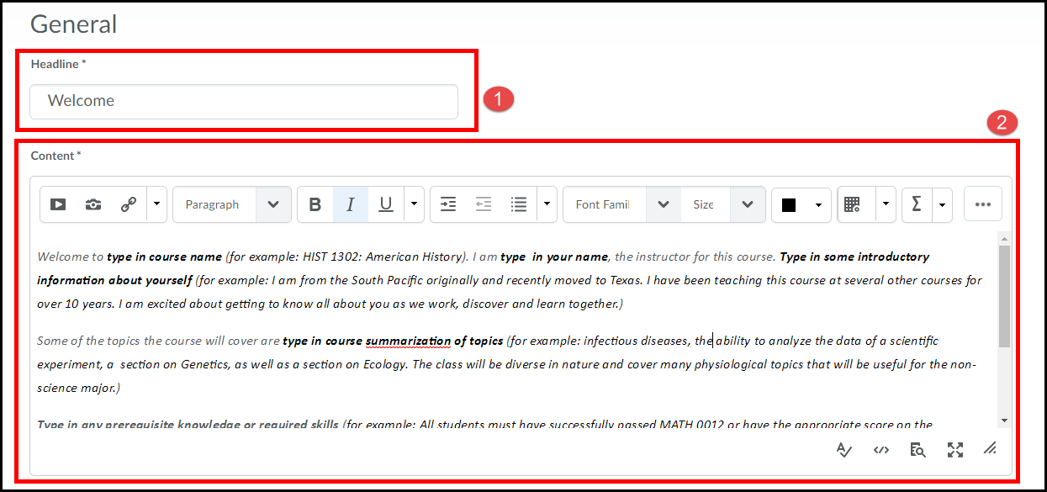

The following is an example of the welcome message I used in the earlier screen shot.
Welcome to type in course name (for example: HIST 1302: American History). I am type in your name, the instructor for this course. Type in some introductory information about yourself (for example: I am from the South Pacific originally and recently moved to Texas. I have been teaching this course at several other courses for over 10 years. I am excited about getting to know all about you as we work, discover and learn together.)
Some of the topics the course will cover are type in course summarization of topics (for example: infectious diseases, the ability to analyze the data of a scientific experiment, a section on Genetics, as well as a section on Ecology. The class will be diverse in nature and cover many physiological topics that will be useful for the non-science major.)
Type in any prerequisite knowledge or required skills (for example: All students must have successfully passed MATH 0012 or have the appropriate score on the placement test. If you are unsure, please speak with the instructor.)
Again, I look forward to working with you this semester. If you have any questions please email me at type in your email address.
Read ALL the following Navigation and First Week Assignments information before entering other course areas.

3. You can include a Start and End date for the announcement if you prefer (1). Once the message is the way you want it, click on the Publish button (2).
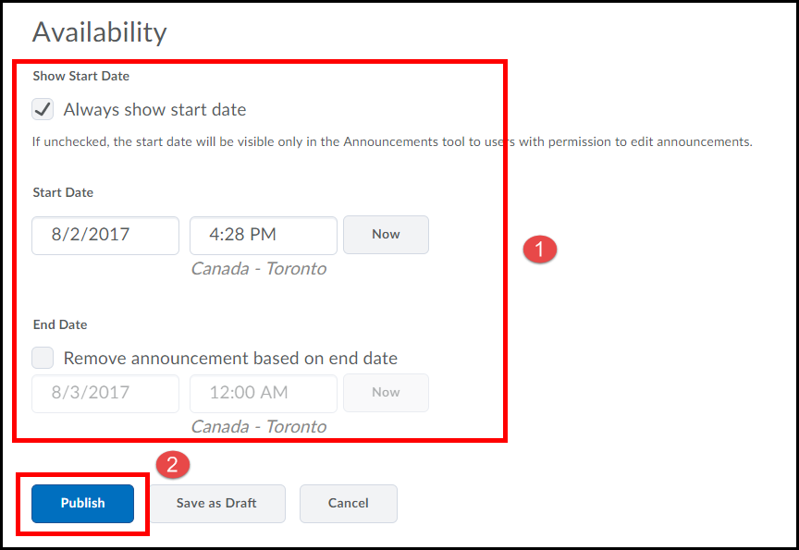
4. To return back to the course homepage click on Course Home from the navigation bar.
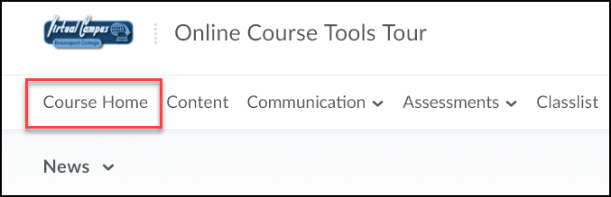

Edit a News Item
To edit a News Item, click on Edit from the drop-down menu of that News item.
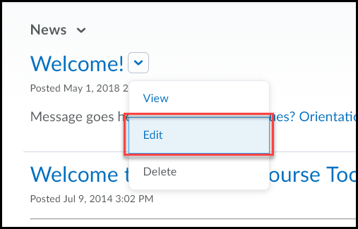

Edit the News item as necessary [if you are editing an item that was posted for more than just a minute or so, check the box for "Major edit" so that it will restore the item for those who may have dismissed it]. Click the Update button when done.
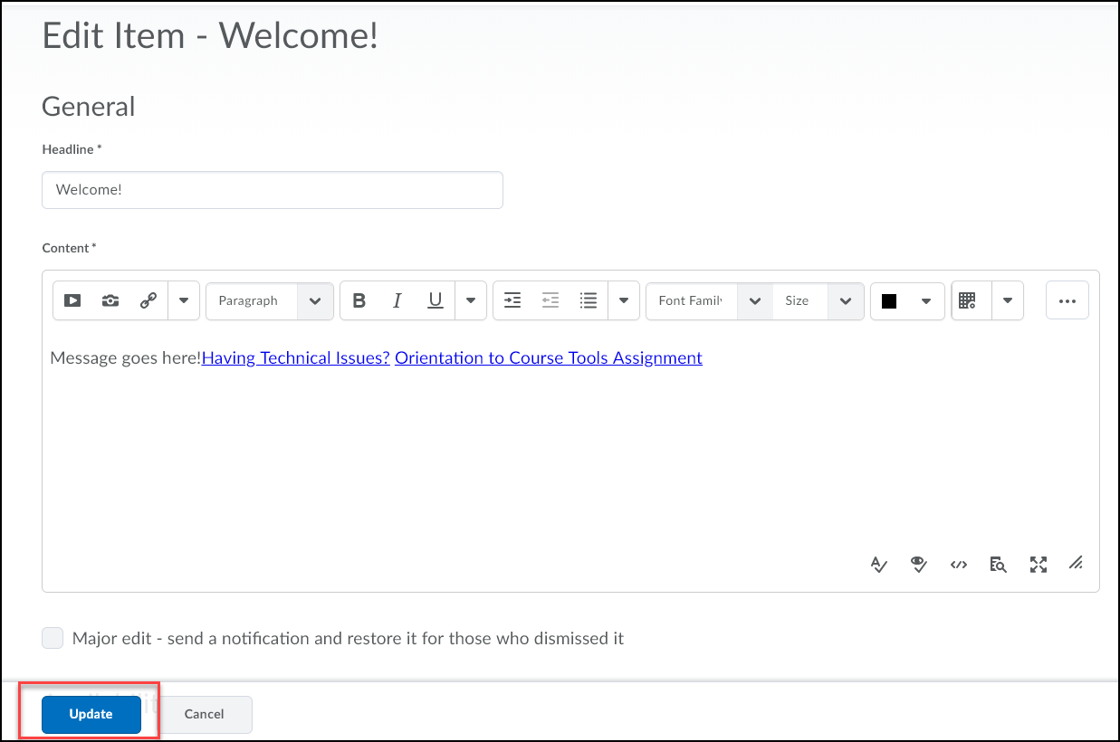
Dismiss option
Everyone has the ability to dismiss an Announcement. Dismissed items can be accessed at any time.
To dismiss an item, click on the X link located to the right of the New’s title.
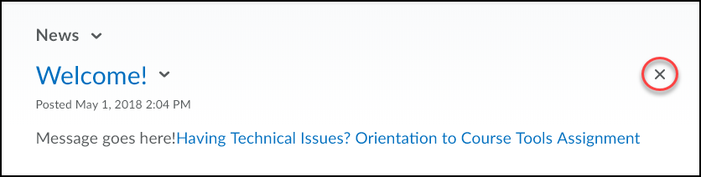
To view Dismissed items, click on the pull down menu next to "Announcements" and select Go to News Tool.
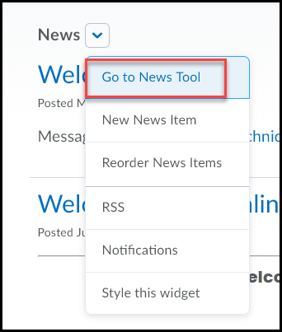
Here you can view all dismissed News item (along with all News items you have created).
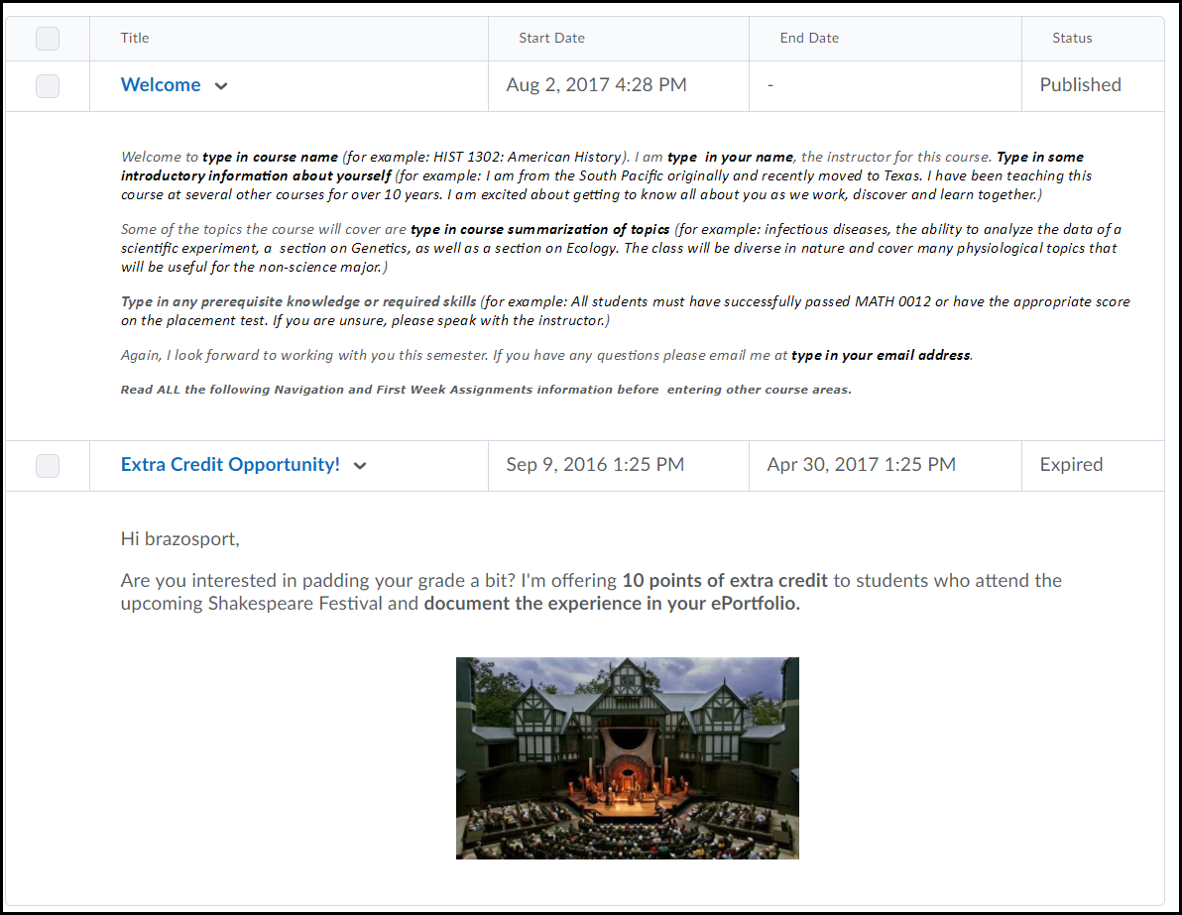
To Restore a Dismissed News Item click on the pull down menu next to its name and select Restore.
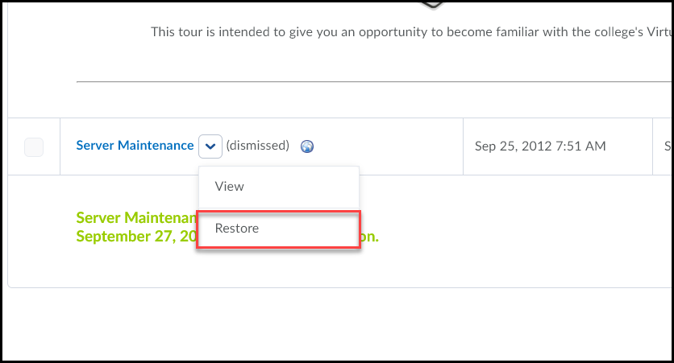

Checklists
Checklists are used to highlight important items such as assignments, quizzes, and readings which need to be completed by the student.

Add a Checklist

1. Click the Checklist link in the Assessments drop-down selection menu on the navigation bar.
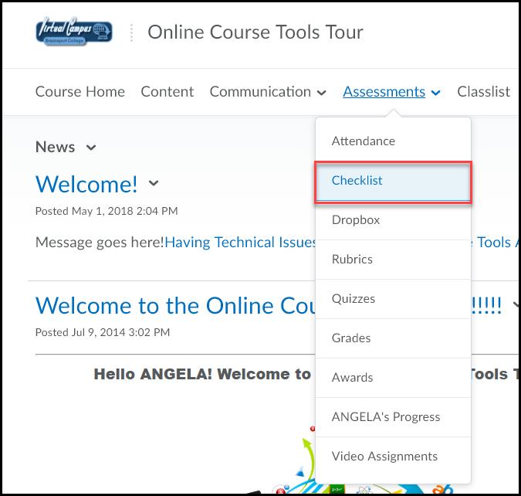
2. Click the New Checklist button.
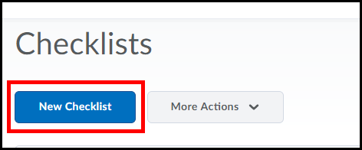

3. Enter a Name for the list such as “First Week Activities” or “Assignment 1” (1) and enter a Description (2). Check the box to Open this checkbox in a new window when viewed, this option will allow students to have the checklist open as they work in the course (3). Click the Save button (4).
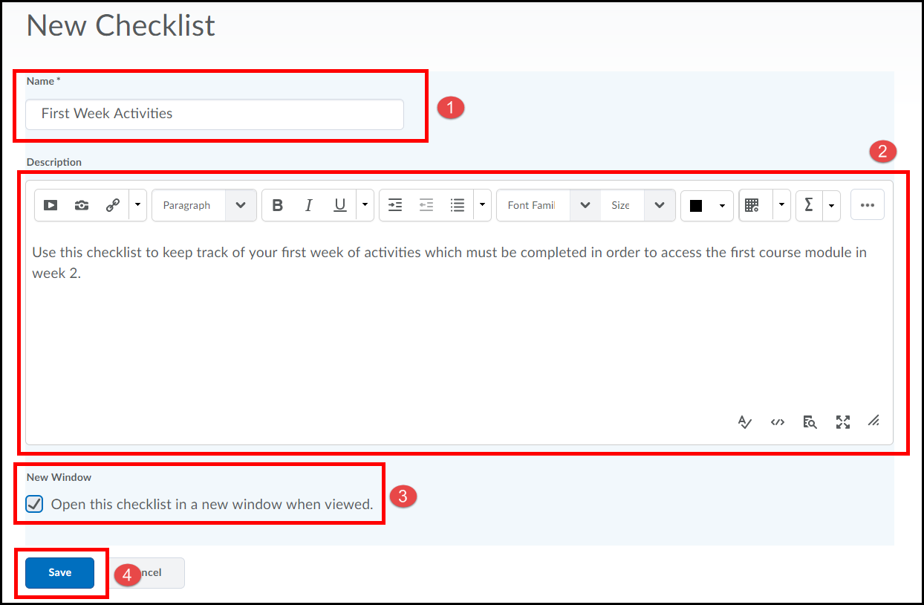
Add a Category to the Checklist
1. Click the New Category button near the bottom of the page.
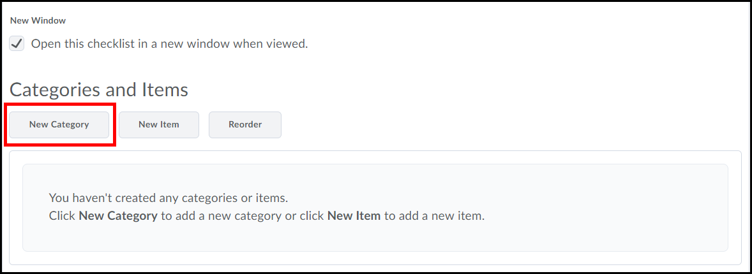
2. Enter the Name of the category [In this case it will contain all items that need to be read for the first week of class, so we will call it "Weekly Readings"] (1). Click the Save button when done (2).
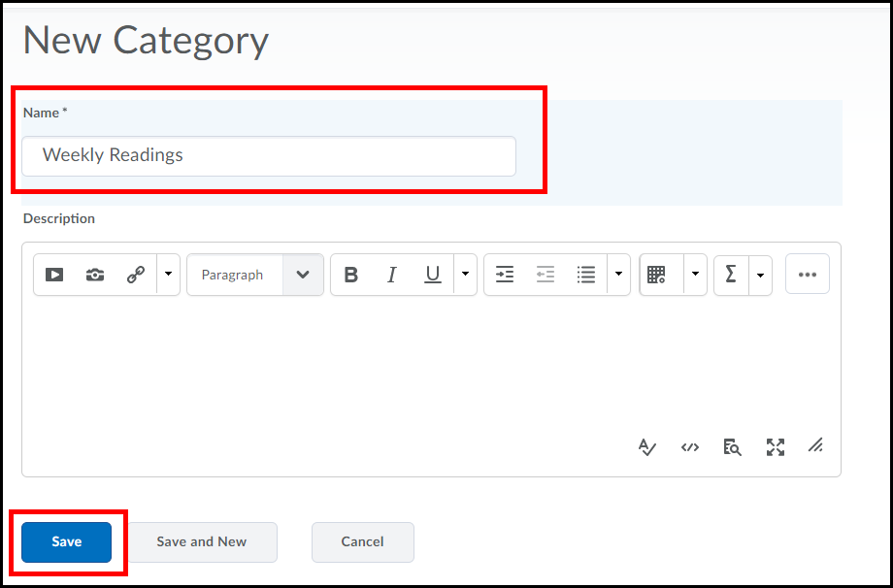

Add a New Item
Now that we have our category, we need to add the actual items we want students to complete.

1. Click the New Item button located near the bottom of the page.
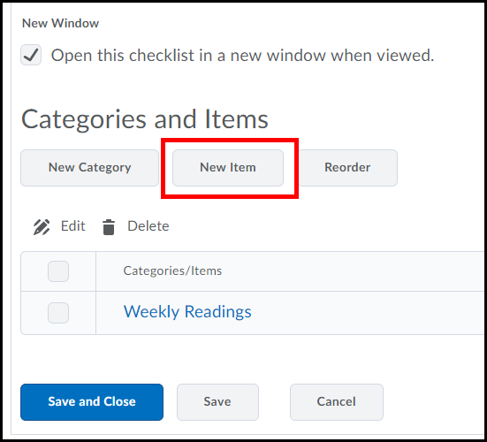
2. Enter a Name for the item (example: Read Course Announcements) (1), add a Description (2), enter Due Date information (if applicable) (3), select the Calendar checkbox to “Display in Calendar” (4), and click the Save button (5).
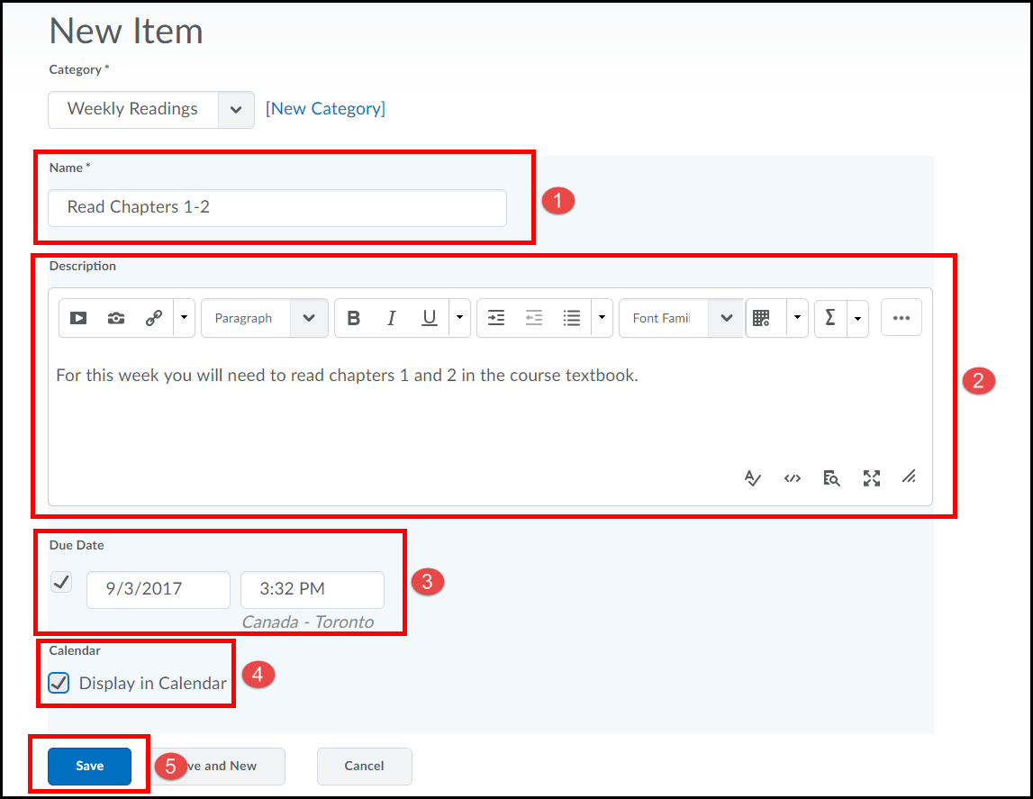

3. Continue to add New Item(s), as you did in the previous step, to your checklist category. In the following image I added 2 more items: Read Article on Present Day Literature, and Read Shakespeare’s Romeo and Julie (1). Click the Save and Close button when done adding each item (2).
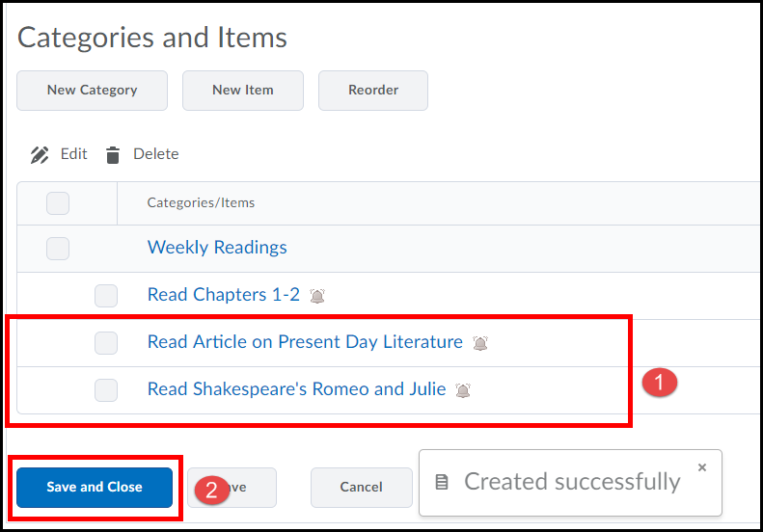

To edit a Checklist
1. Click on the drop-down menu next to the Checklist name and select Edit.
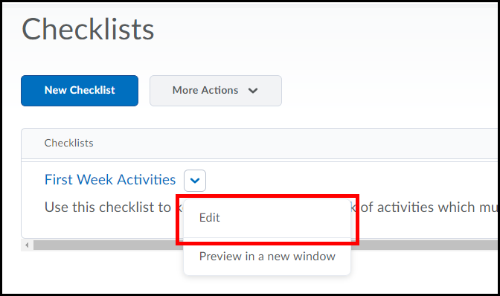
2. Edit the checklist as necessary and click the Save and Close button when done.
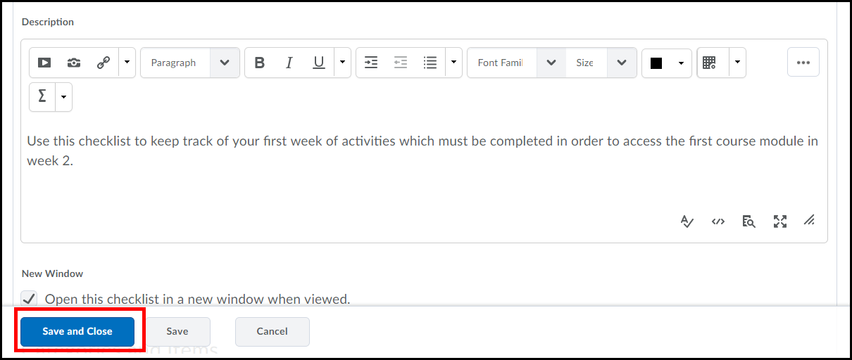

Notifications
The Notification tool allows users to receive instant notifications about course activities such as grades, new discussion posts, upcoming quizzes, Assignments due dates and Announcements
Setting Notifications
Email Notifications
1. To enable notifications click on your log in name located on the right of the mini bar.
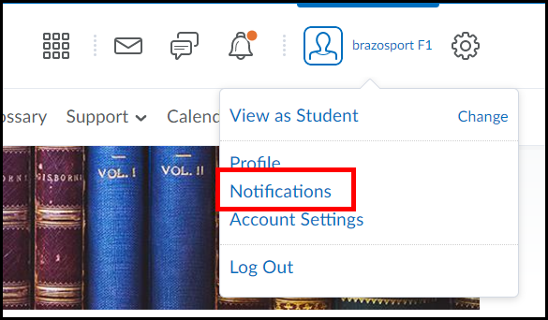
2. Click Enable email notifications.
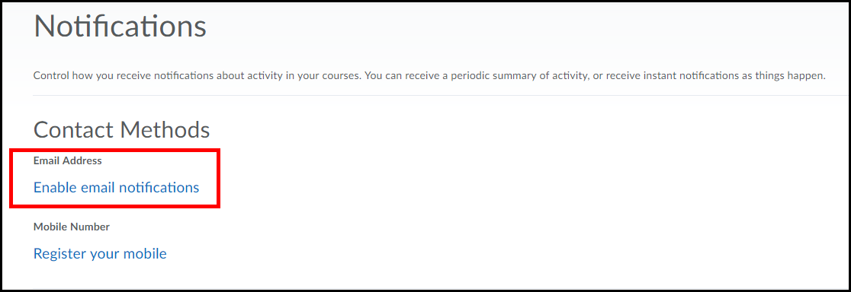

3. Click the radio button for Use custom email: and enter an external email address (Gmail, Yahoo, etc.) (1). Click the Save button when done (2).
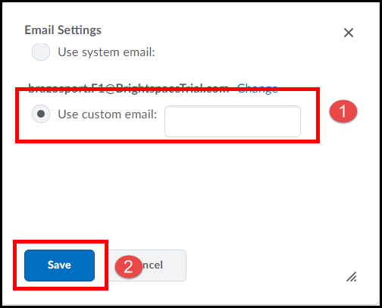

4. Under the header for Instant Notifications, check the checkbox(s) for each instant notification you would like to receive.
Note: you MUST have enabled Email in order to check notification boxes.
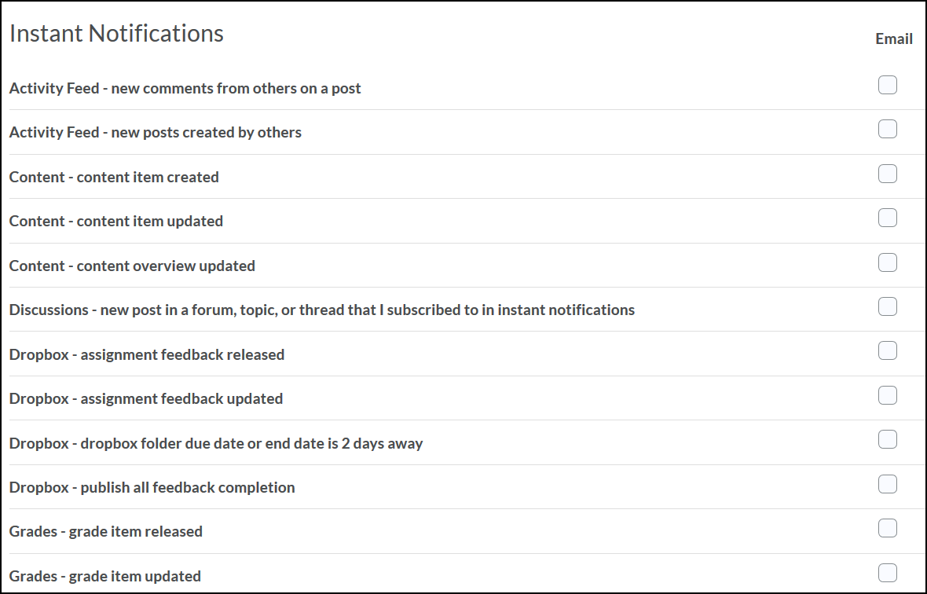
5. Under the header for Customized Notifications (1), make desired selections and click the Save button (2).
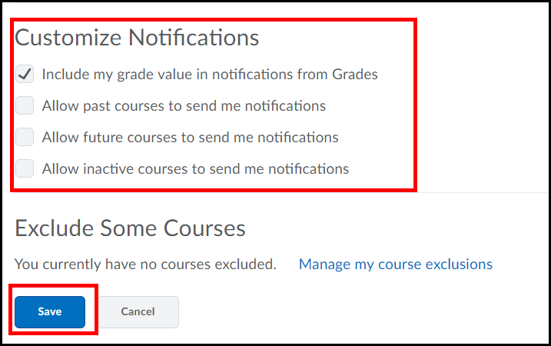
Subscribing to a Discussion Forum
Note: if selecting to receive an instant notification from Discussions you MUST enter the Discussions area and select to "subscribe" to a particular Forum or discussion topic in order to receive your notification.
To subscribe in Discussions, click on the Drop-down menu next to a discussion topic or forum and select Subscribe (NOTE: You will receive a notification each time someone makes a post.).
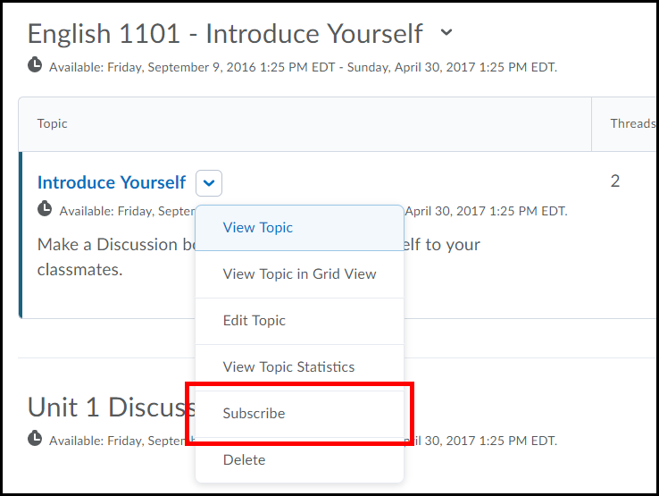
Notification Alerts
Update Alerts
Update alerts show new instant notification you subscribe to such as grades, Announcements items, Assignments, Quizzes, etc….
- Whenever you receive a new Update alert you will see an orange dot appear above the Update alerts icon, in the alert minibar located near the top right corner of the page.

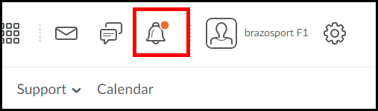

- Click on the Update alerts icon to view the new alert(s).

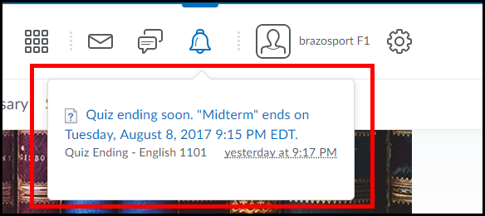
- Clicking on a listed alert will take you to the specific tool (Quiz, Assignments, Announcement, etc.) that the alert is for.

Message Alerts

Message alerts shows notification alerts for any new emails or Pager messages you have received.

- Whenever you receive a new Message alert you will see an orange dot appear above the Message alerts icon, in the alert minibar located near the top right corner of the page.

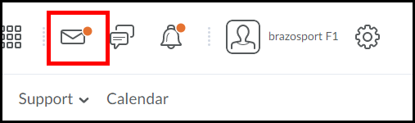

- Click on the Message alerts icon to view the new alert(s).
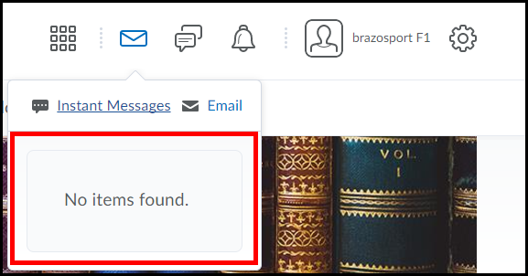

- Clicking on a listed alert will take you to the specific tool (email or pager) so you can read or reply to the message you received.

Subscription Alerts
Subscription alerts show new discussion posts in forums, topics, and specific message threads to which you have subscribed.
Whenever you receive a new subscription alert you will see an orange dot appear above the Subscription alerts icon , in the alert minibar located near the top right corner of the page.

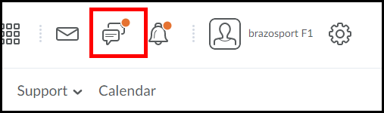

- Click on the Subscription alert icon to view new posts to the discussions you have subscribed to.

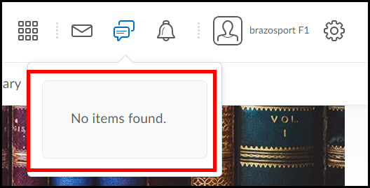

- Clicking on a listed alert will take you to the forum, topic, or specific message to which you have subscribed and a new message has been posted to.

