Creating questions in the Question Library allows you to share questions among quizzes and choose sets of questions to be added to a quiz. Creating sections of questions in the Question Library helps to organize, manage and edit questions at a later date.
Creating questions in the Question Library
Creating Sections
1. Select Quizzes from the Assessments drop-down menu on the navbar.
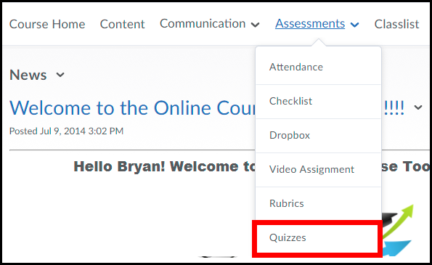

2. Enter the Question Library by selecting the Question Library link located underneath the Navbar.
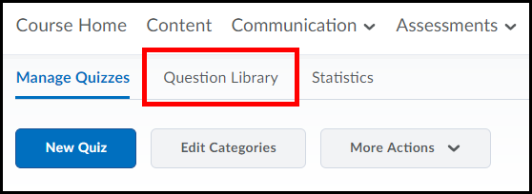

3. Click the New button.
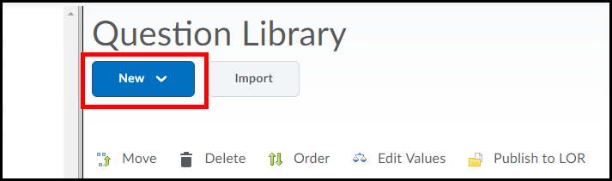
4. Select the Section link.
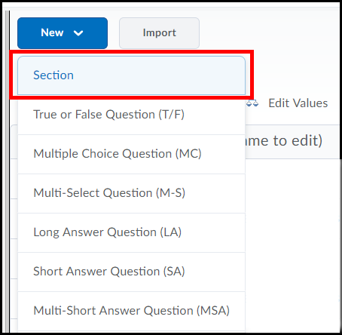

5. Enter a Section Title (1) such as “multiple-choice questions” or “unit 1 questions”. If desired, enter Section Text (2) as a description about what is contained in the section and click the Save button (3).
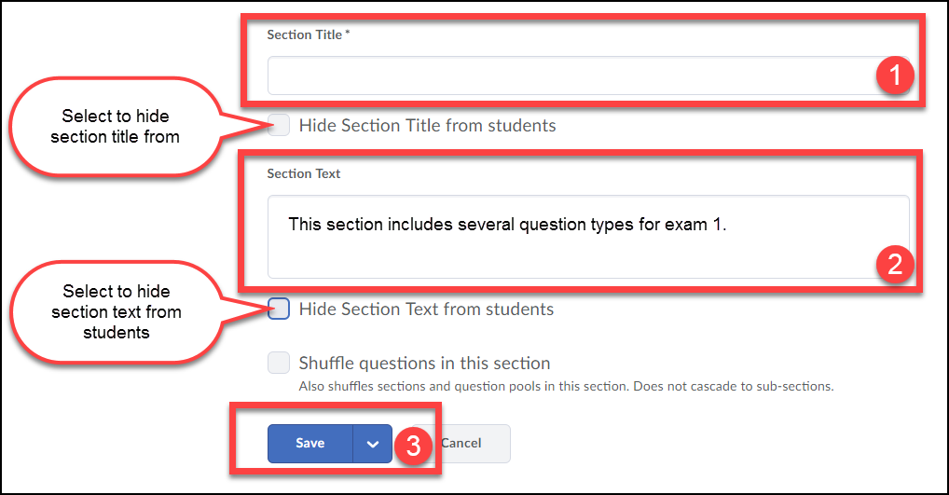

7. To add questions to the new Question Library section click on the section’s name text link.
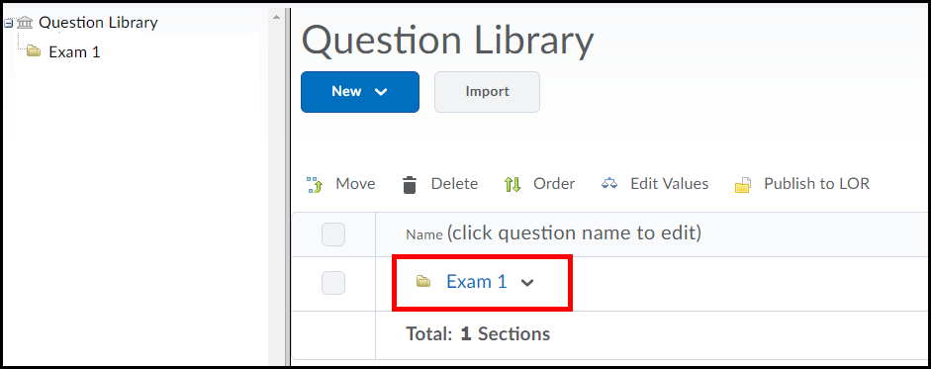

8. Use the New pull down menu to select a question type.
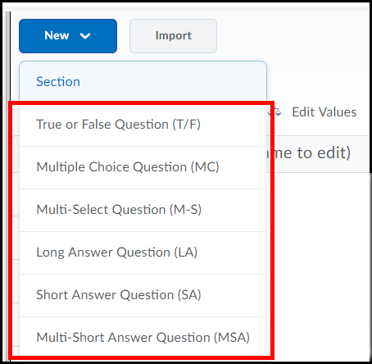

The following section describes how to create True/False, Multiple-choice, Matching, Short Answer and Written Response question types.
NOTE: Clicking on the Question Text or Answers choice (MC questions) fields will produce the toolbar that allows you to format text, inset links & images, and more.
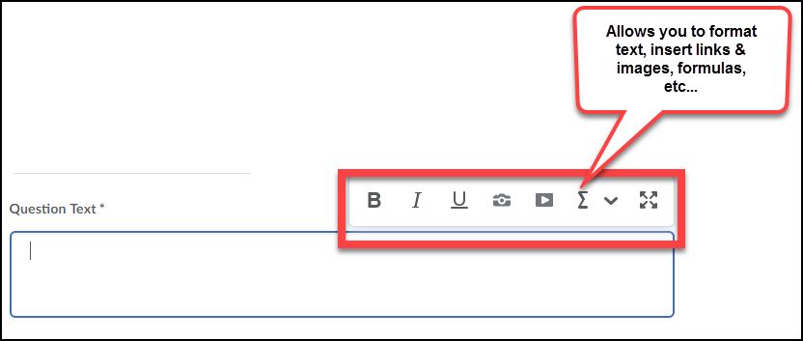

Question Types
True False Question Type (T/F)
1. Type a question in the Question Text (1), select the correct answer (2), enter a Points value [this can also be altered later] (3), and click the Save button (4). A preview of the question is shown in the panel on the right (5).
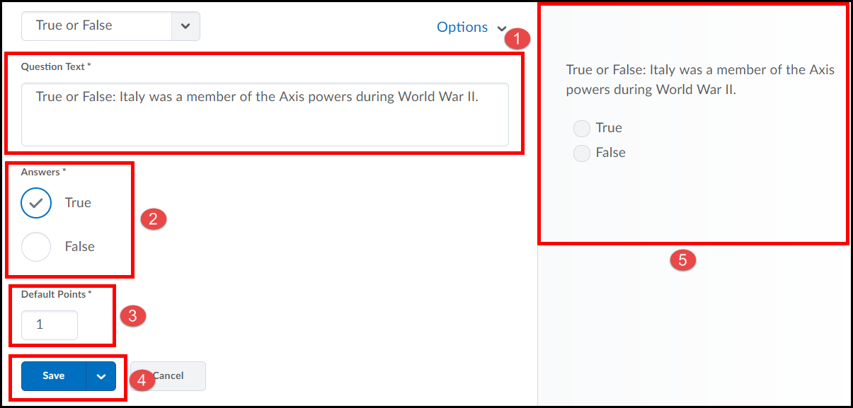

Multiple Choice Question Type (MC)
1. Type a question in the Question Text field (1); enter the answer choices for the questions [if you want to remove an answer choice, click on the next to it]. (2), if you need additional answer choices click on the Add Answer link (3), select the option for Randomize answers for each student [this ensures each user taking the quiz will receive question options in a different order] (4). Then enter a Points value [this can also be altered later] (5) and click the Save button (6).
NOTE: To add feedback for each question choice, click the Options (A) link and select Add Feedback (B).
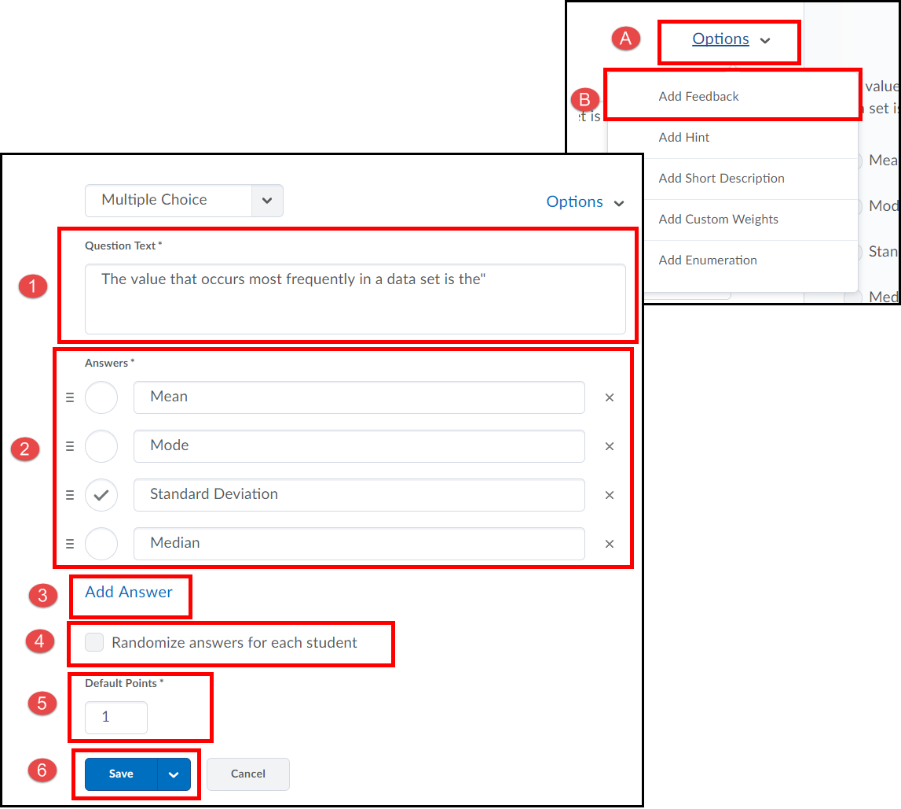
Matching Question Type (MAT)
1. Enter a question title in the Title field (1) [it is optional but does help during future editing]; enter the Points value [this can also be altered later] (2) and type a question in the Question Text field (3).
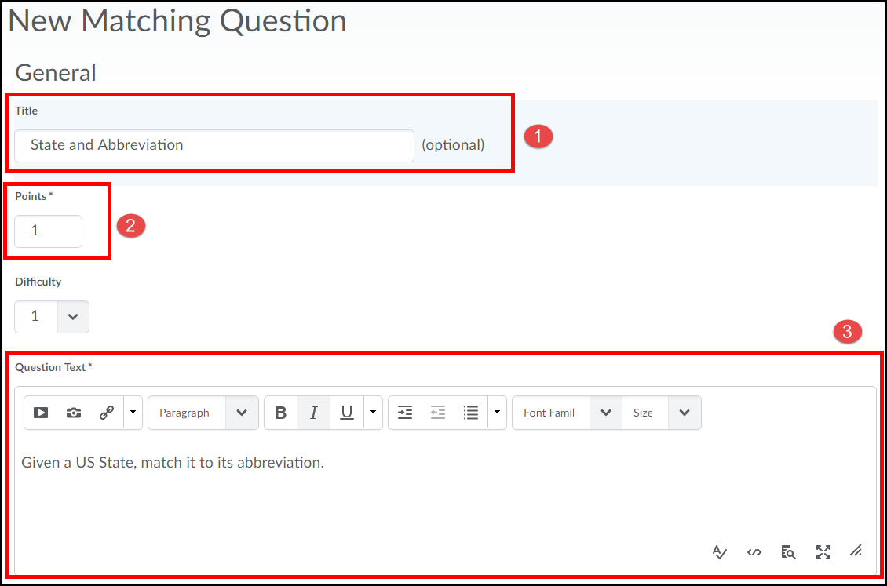
2. Select a Grading option.
- Equally weighted: User receives marks for each correct answer.
- All or nothing (this is the Default): User must have all the possible correct answers or else they receive no marks.
- Right minus wrong: The number of right answers chosen is subtracted from the number of wrong answers chosen to get an overall mark for the question.

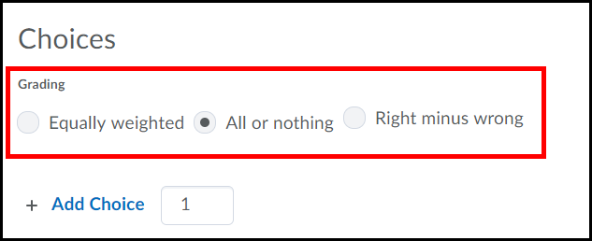
3. Enter Choices [choices show on the right of the page and should be the short for better onscreen reading] (1), if you need additional choice boxes click Add Choice [you can enter more choices than matches which helps correct responses based on elimination] (2). If you want to remove a choice, select the Trash icon (3).
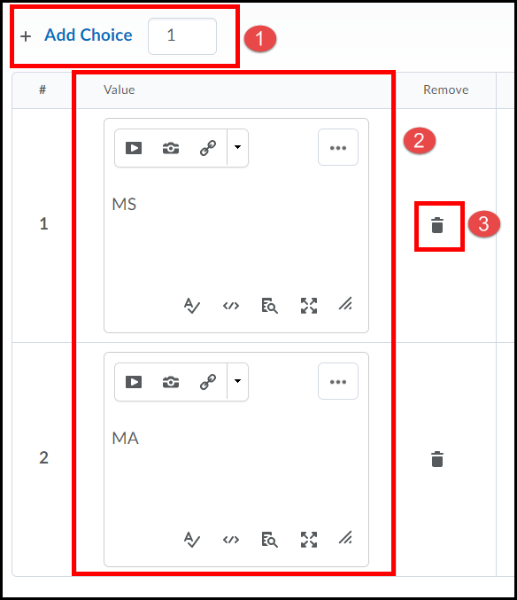

4. Enter Matches (1) [matches show on the left of the page]. Use the pull down menu to select the correct Choice option for the Match (2). If you want to remove a match, select the Trash icon (3), type in overall question Feedback (4) [it is optional but it is a great way to provide guidance] and click the Save button (5).
If you need additional match boxes click Add Match.
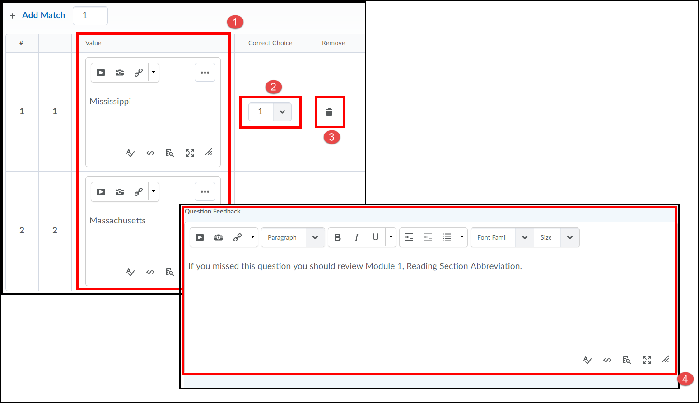

Short Answer Question Type (SA)
[Short Answer types require you to enter ALL acceptable responses for each item response in the question]
1. Type a question in the Question Text field (1). Enter your first acceptable answer in the Answer for Blank 1 text block (2), to add additional answer blanks click the Add Blank link (3). Enter the Points value for the question [this can also be altered later] (4). Click the Save button when done (5).
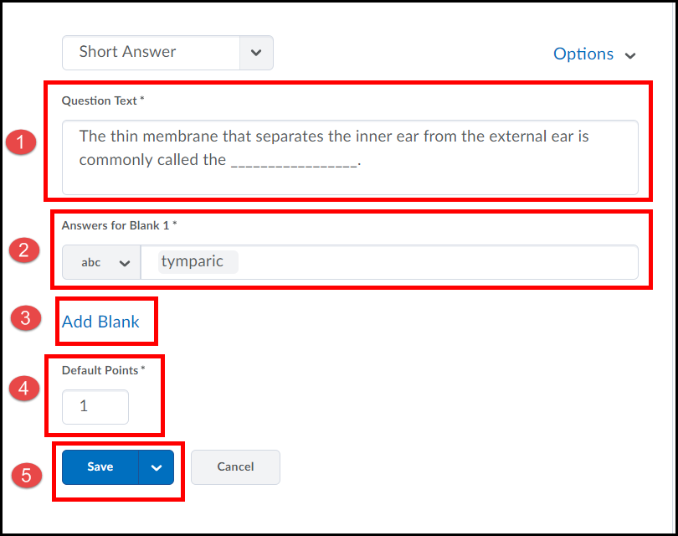

Written Response Type (Formerly Long Answer Question)
1. Type the question in the Question Text field (1) and enter the Points value [this can also be altered later] (2).
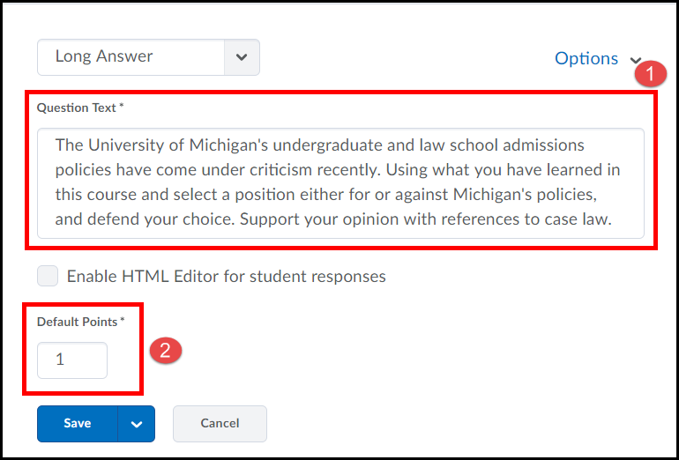
2. If you are looking for a verbose response click the Options link (1) and select Add Custom Response Box Size (2) use the Custom Response Box Size drop down menu to select a size (3).
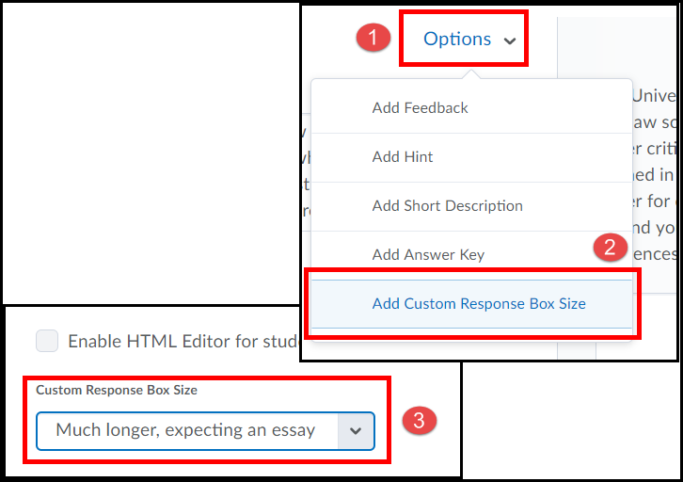
3. To add overall question Feedback [it is optional, but a great way to provide guidance] click the Options link (1) and then click Add Feedback (2).
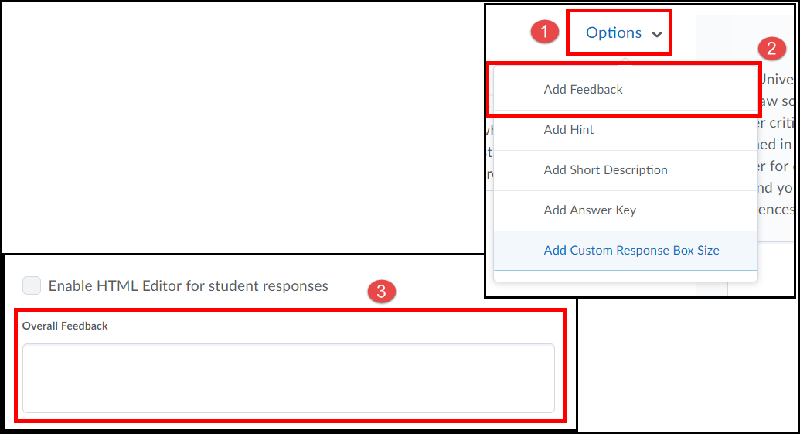

Create Quiz
Once you create a New Quiz you will attach or link to desired question(s) from within the Question Library.

1. Select the Quizzes link from the Assessments drop-down menu on the navbar.
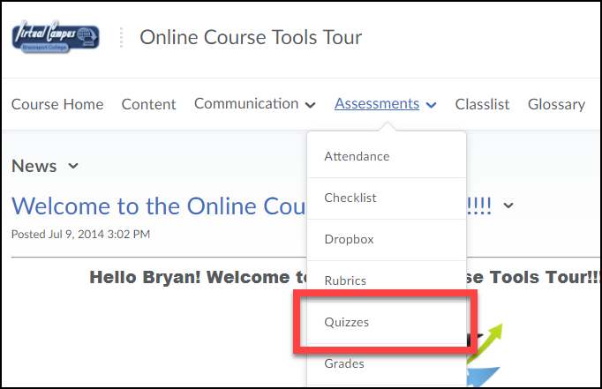
2. Click the New Quiz button.
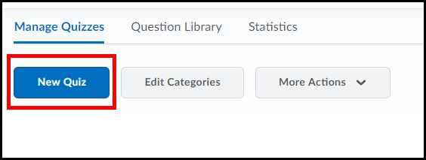

3. Enter a title for the quiz in the Name text block (1) and click the Add/Edit Questions button (2).
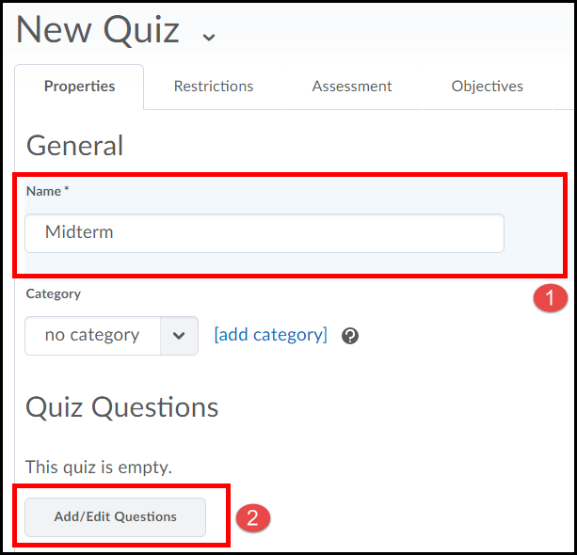

4. Click the Import button [we are going to associate the questions we created in the Question Library to this quiz].
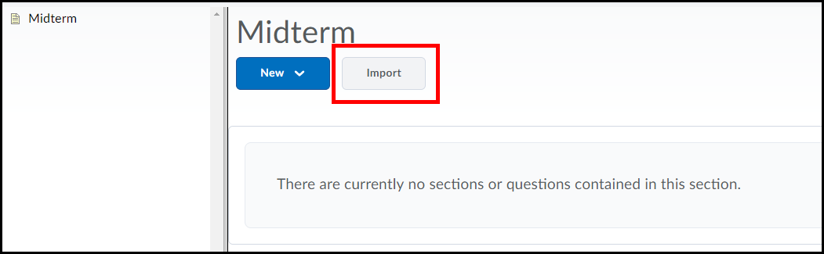
5. Choose Browse Question Library.
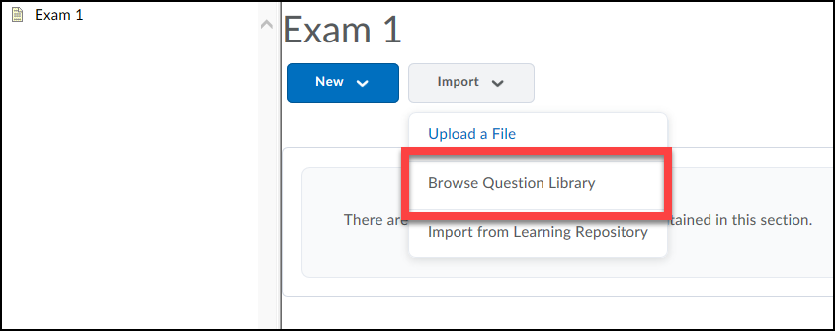
6. To import all the questions from a folder you created in your question library, select the section from the list (1). Click the Save button when done (2).
NOTE: To import specific questions from a section, expand it (click on) and select the questions you want to import.
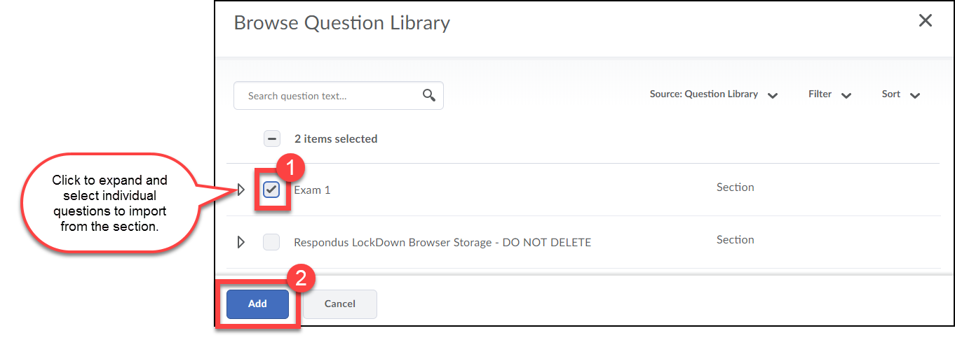

Set Questions Points for Quiz Score
At this time the total points for the quiz is determined by the point values given at the time the questions were created.
1. To edit the quiz question values click on the section’s Name link.
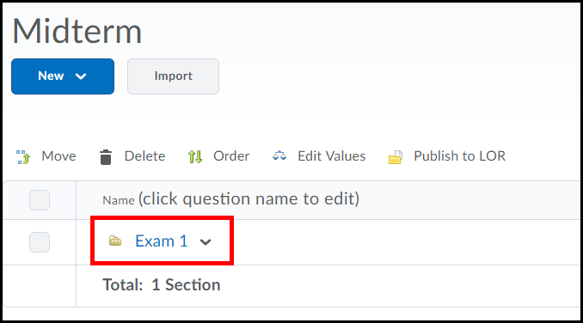

2. Select the checkboxes for each question (1) [could also choose the check all checkbox at the top of the list] and click the Edit Values (2) link.
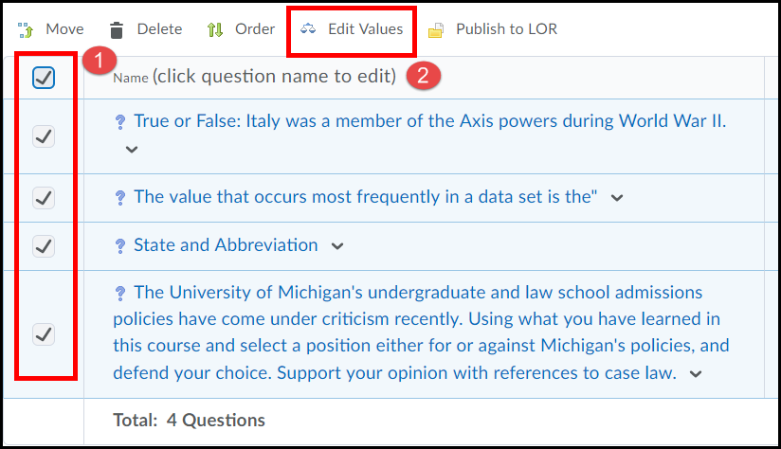
3. Enter desired values in the Points box (1) and click the Save button (2).
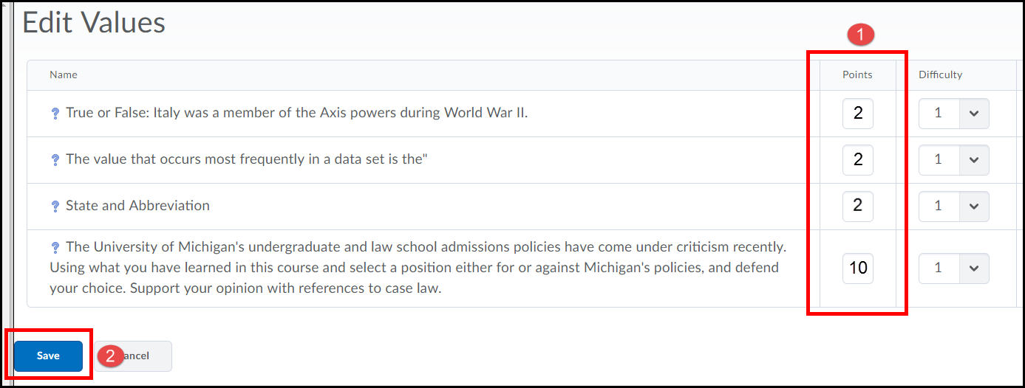
4. Click the Done Editing Questions button near the top right-hand side of the page.
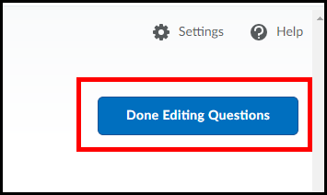
5. Click on the Restrictions tab.
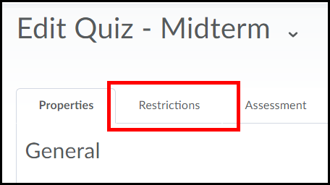
4. Select a Start and End Date [End Date is optional, if you do not select an end date the quiz remains accessible till the student selects to start the quiz] (1). Set the Status to Active (2).
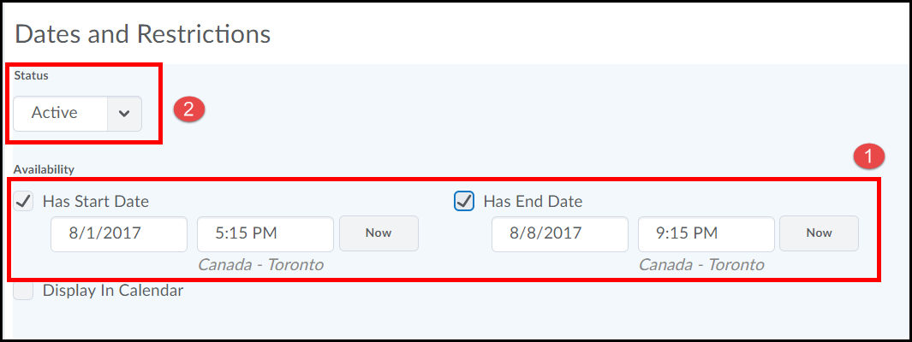
5. select the option for Enforce a Time Limit [is optional, yet enforcing your time will show all late submissions in red] (1), enter in a Time Limit for the quiz (2), enter a Grace period (3) [optional, yet does allow a bit of time for technical issues], select desired option for Late Behavior (4) [The default is set to the first option. This option means that a student’s attempt on the quiz will be graded even if they exceed the time limit, however, their attempt will be flagged as late. The second option means that once a student exceeds the time limit for the quiz they cannot answer any more questions are make any changes to the quiz, they can only submit it. The third option means that when a student exceeds the time limit for the quiz they can continue to complete the quiz, but they will automatically receive a grade of a zero.].
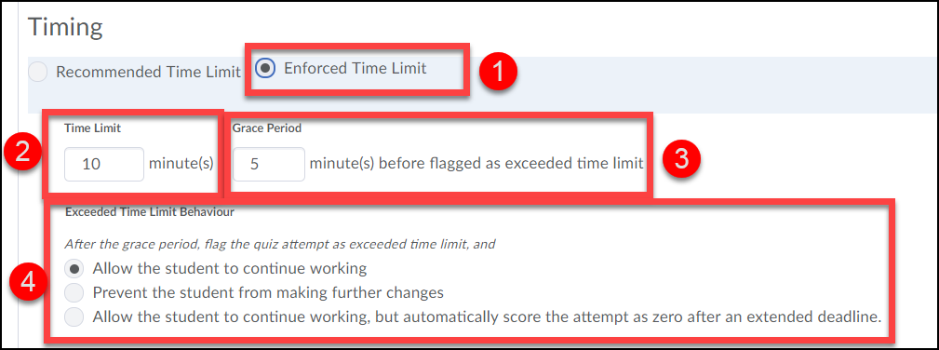

6. Select the Assessment tab.
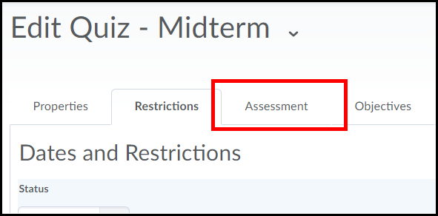
7. Select to Allow attempt to be set as graded immediately upon completion [NOT recommended if you have included a Long Answer question in the quiz due to its need to be manually graded prior to revealing entire quiz score] (1). Use the Grade Item drop-down menu to select the quiz to the Grade Item in your gradebook it belongs to (2). Select the checkbox for Allow automatic export to grades [this will send students’ grade on the quiz automatically to your gradebook] (3). Select how many Attempts are allowed on the quiz [if you choose more than one attempt it is recommended to select the Overall Grade Calculation option to be pulled from the Highest Attempt] (4). Click the Submission Views tab (5).
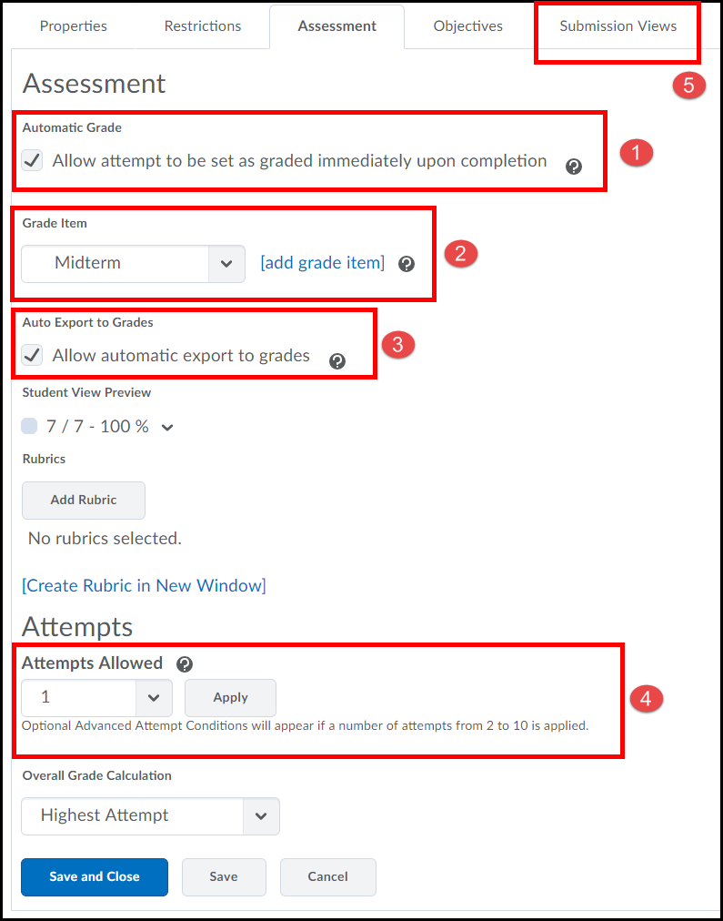
8. Click the Default View link.
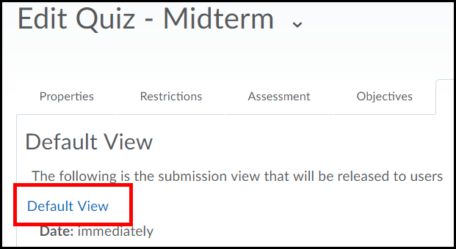
9. Enter a new submission message in the Message text block [optional] (1), select how the scored questions will be viewed by the students such as “Show all questions with user responses” and “Show question score and out of score” (2), if you want students to view their “attempt” scores upon submission select the option for “Show attempt score and over attempt score” (3), click the Save (4) button.
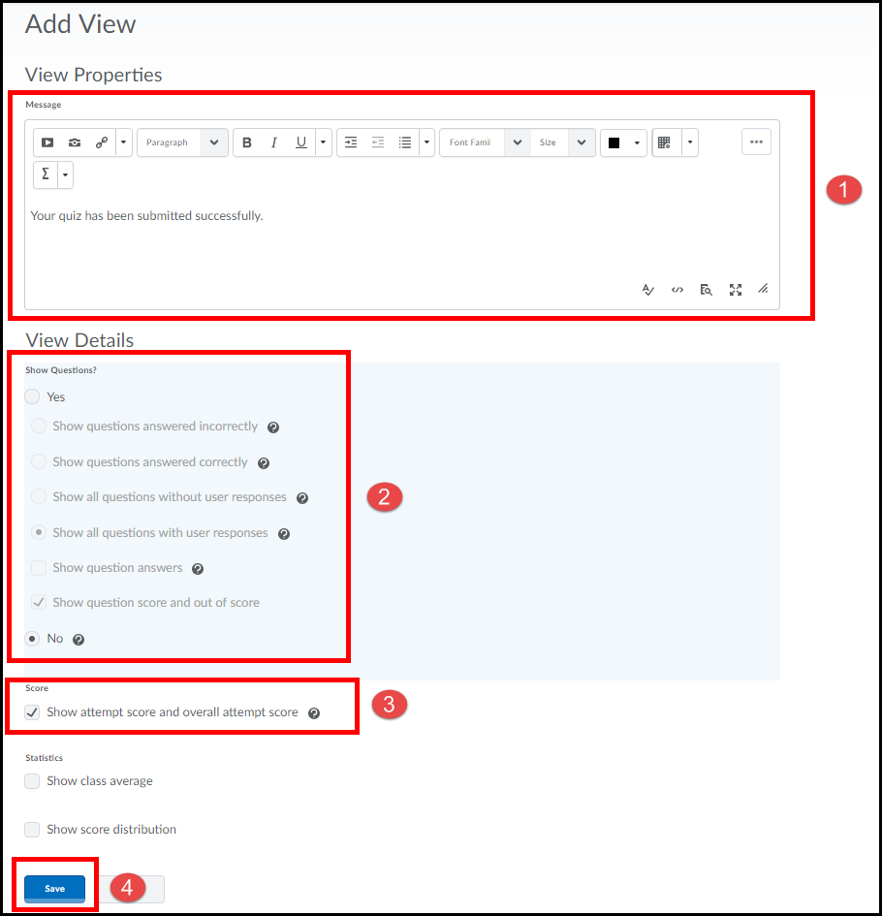
10. Then click Save and Close.
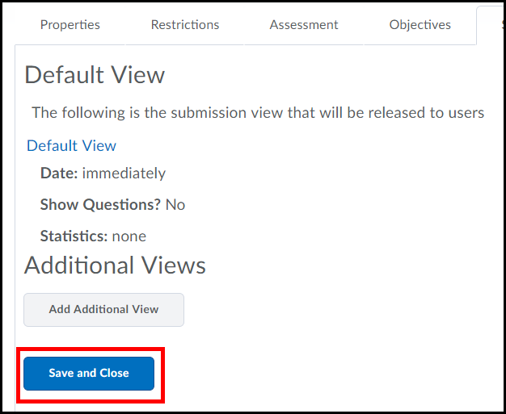
IMPORTANT: DO NOT EDIT A QUIZ after it has been released, you can adjust scoring via the Grade Tool.

Require Students to Use Respondus LockDown Browser to Take a Quiz
You can require your students to take a quiz using the Respondus LockDown Browser. However, in order to do so the quiz will need to already be created.
1. Select Quizzes from the Assessments drop-down menu on the navbar.
2. Click on the LockDown Browser tab.
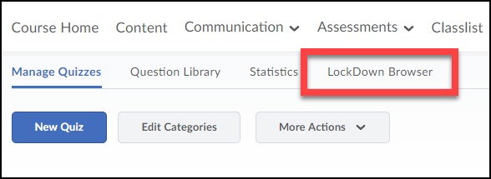

3. If the following screen appears, click the Continue to Lockdown Browser button.
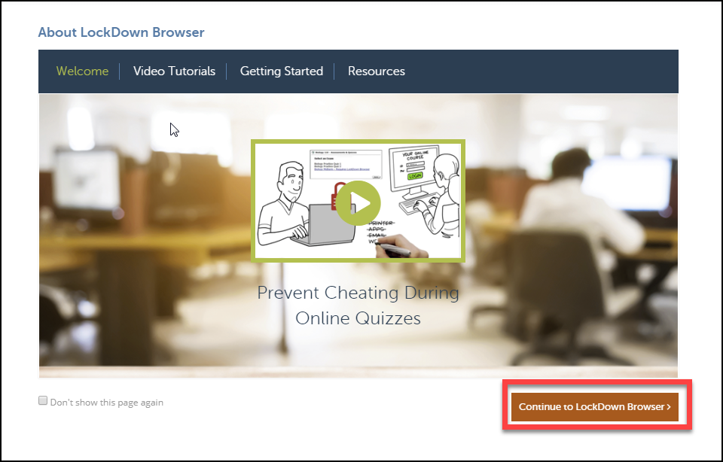

4. A list will appear with all the quizzes you have created for your course. Click on the dropdown menu next to the quiz you want to require students to use Respondus LockDown Browser for (1). Click on Modify Settings (2).
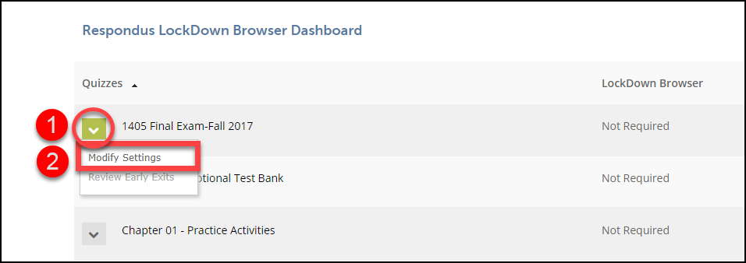
5. Choose Require Respondus LockDown Browser for this Exam.
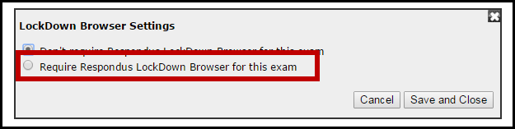

6. You can enter a password for students to enter in order to take the quiz. You can also choose to have students take the quiz using Respondus Monitor (requires students to use a webcam while taking the quiz so they can be recorded and the recording can be viewed by the instructor). Click Save and Close.
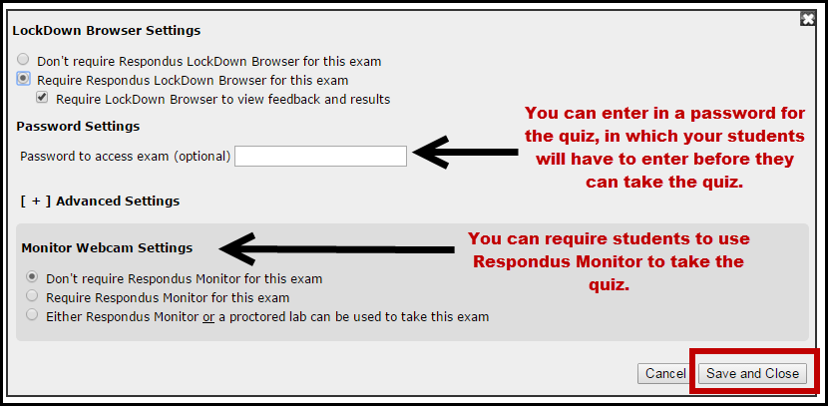

Students will now be required to take the quiz in Respondus LockDown Browser.

