In the Virtual Campus you have the ability to exempt specific students from having to complete a topic/activity found in the Content area of the course.

Exempting a student from an activity in the content area means they are not required to complete it and their grade for the activity will automatically be dropped.

NOTE: The activity you exempt a student from must be associated with an item in your gradebook.

NOTE: Students will not receive a zero in the gradebook for an exempted item. Their grade for the item will be dropped and not included in their calculation for their final course grade.

- Click on Content from the navigation bar.
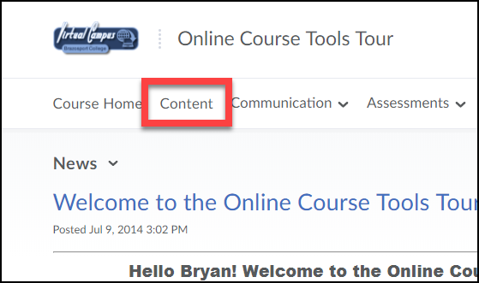

- Open the module containing the activity you want to exempt a student from.
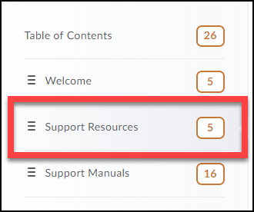

- Click the Bulk Edit button for the module.
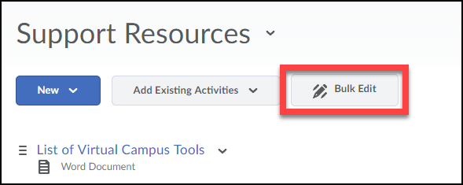

- For the content topic/activity you want to exempt a student from, click on its date of availability (Or Add dates and restrictions… if no date of availability is selected).
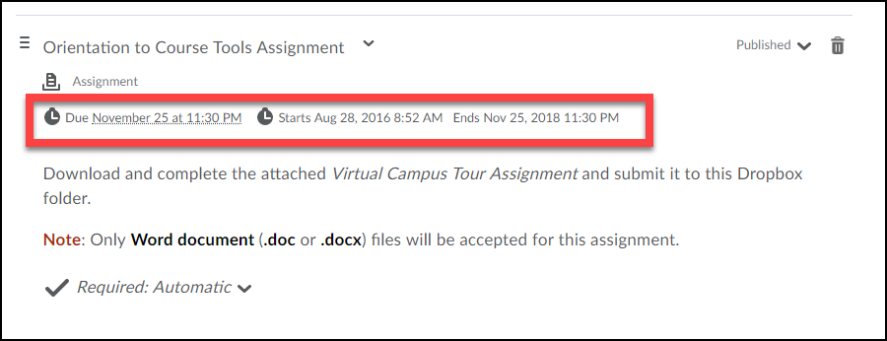

- Click on the Manage Exemptions button.
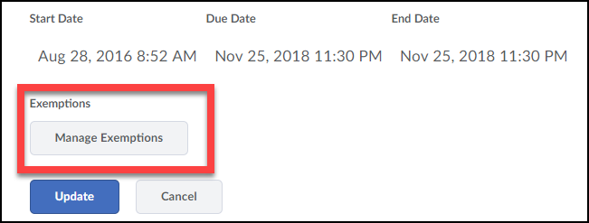

- Select the student(s) you want to exempt from the item/activity (1). Then click the Exempt button (2).
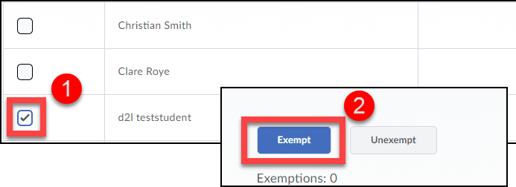

- When done click the X in the top right-corner to close the Mange Exemptions page.
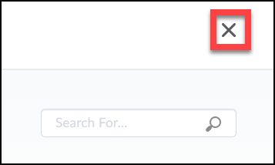

- Click the Update button to save your changes.
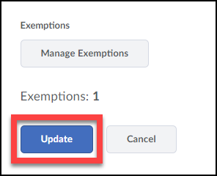

- You will now notice that the content topic displays the number of students given exemptions.
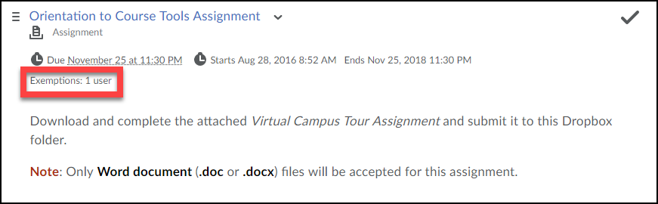

- In the gradebook for those students exempt from the content activity, you will see the word “Exempt” instead of a grade show up for them.

NOTE: The grade will not be included in the calculation for the student’s final course grade.

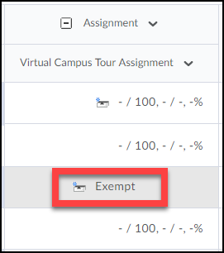

Un-exempting Students from a Content Topic

Once you have exempted a student from a topic/activity in the Content area of the course, you have the ability to remove the exemption from them. This means they will now be required to complete the activity.

- Click on Content from the navigation bar.

- Open the module containing the activity you want to exempt a student from.

- Click the Bulk Edit button for the module.

- For the content topic/activity you want to exempt a student from, click on its date of availability (Or Add dates and restrictions… if no date of availability is selected).

- Click on the Manage Exemptions button.

- Select the student(s) you want to Unexempt from the item/activity (1). Then click the Unexempt button (2).

- When done click the X in the top right-corner to close the Mange Exemptions page.

- Click the Update button to save your changes.

