You have the ability to create random question pool for quizzes. When creating question pools it will randomly pull from the specified number of questions you select from the question library.

- When creating a new quiz, click the Add/Edit Quizzes button.
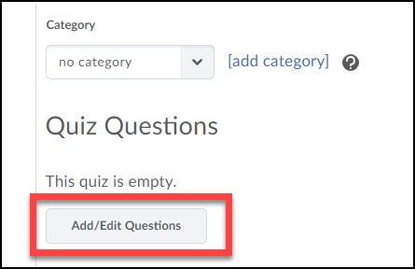

- Click on the New button (1) and select Question Pool (2).
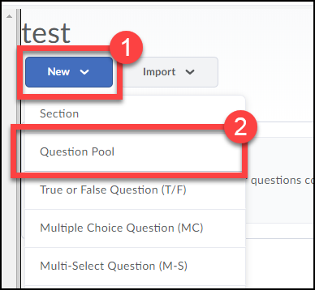

- Click the Browse Question Library button. 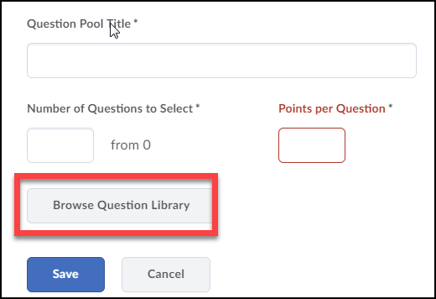

- To import all the questions from a folder you created in your question library, select the section from the list (1). Click the Add button when done (2).
NOTE: To import specific questions from a section, expand it (click on) and select the questions you want to import.
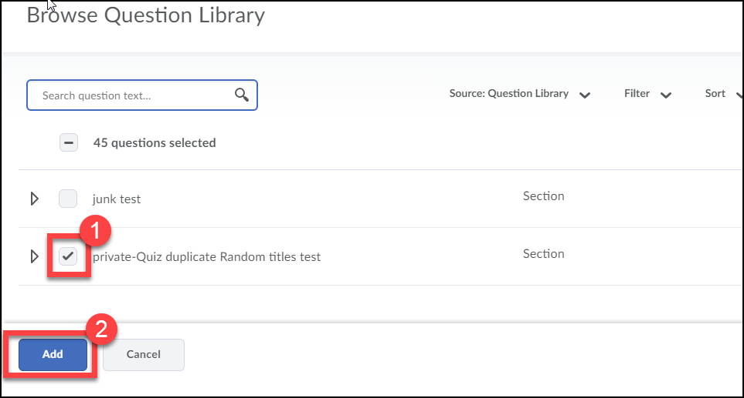
- Enter a title for the question pool (1), the number of questions from the pool to randomly give each student (2), enter the number of points each question is worth (3).
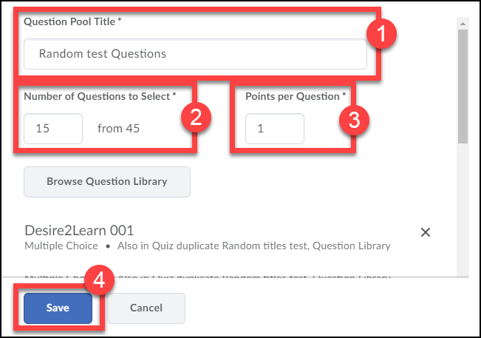

- The random question pool will be created. You can create additional question pools for the quiz if necessary. When finished creating the question pool(s) you can finish setting up the quiz (for instructions on creating a quiz view the Creating Quizzes manual).
