This process allows the student to be able to view their overall running grade average.

- Log into D2L, and then go into your course.

- Using the course navigation menu, click the Assessments tab, then Grades.
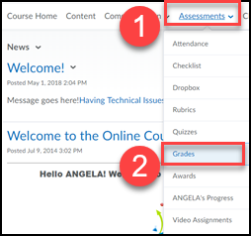

- Click on Settings on the right (looks like a gear icon)

- Click on the Calculation Options tab
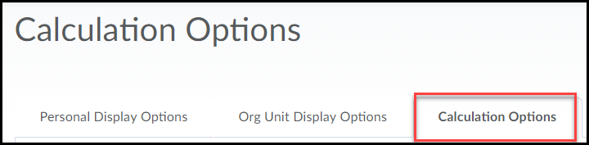

- Scroll down to Final Grade Released (1) and click the Calculated Final Grade (2).
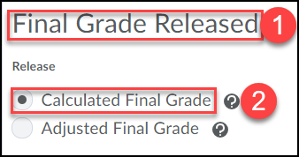

- Check the box for Automatically release final grade.
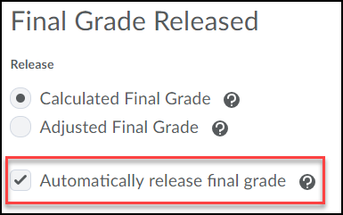

- Scroll down to Grade Calculations and check Drop ungraded items (1). Check the box under Auto Update to Automatically keep final grades updated (2).
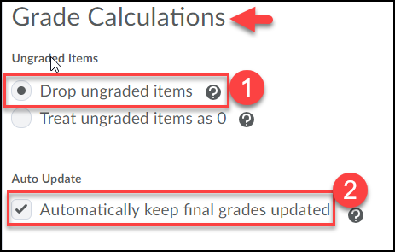

- Click Save.
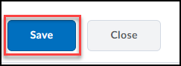

- Confirm your change by clicking Yes.
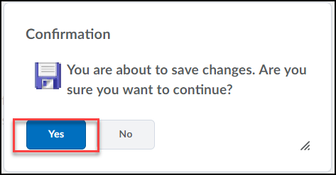

- Click Close.
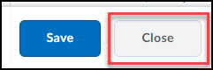

- Click the Enter Grades tab.
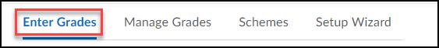

- Click the dropdown under Final Calculated Grade, located directly under the Final Grades Column.
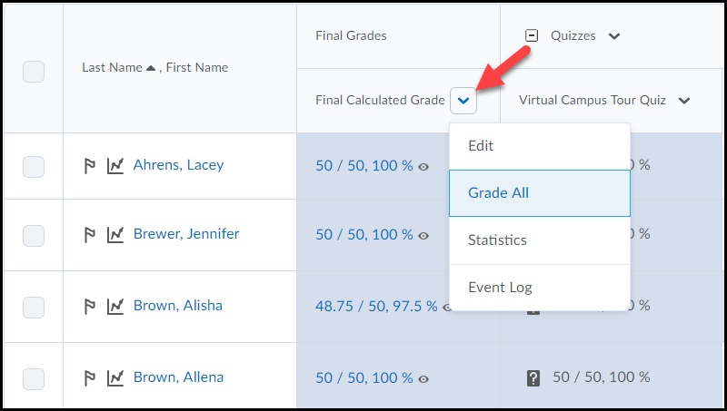
- Choose Grade All.
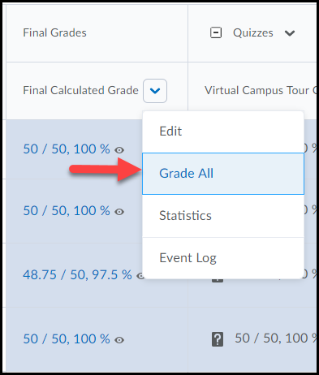

- Checkmark the box to select all students.
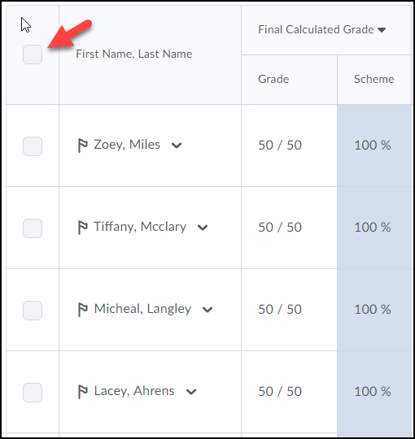

- To release the Final Grade, click Release/Unrelease located above the table.
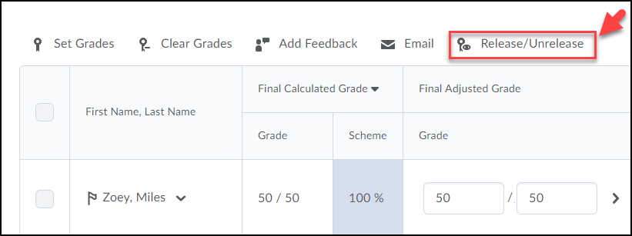

- Select Save and Close button.
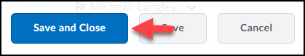

- Click Yes on the Confirmation box.
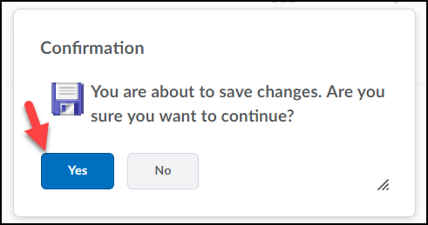

You will also now see the “eye” is opened up, meaning students now have the ability to see their running average.
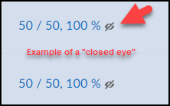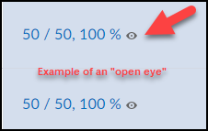
(Eye Closed) (Eye Opened)

