The Content tool is the primary area where students will access your course materials. It is used for containing modules and topics that you have created or will create for your course (e.g. lessons, handouts, PowerPoints, videos, etc…).

Getting Started
To begin, you will need to access the content section by clicking Content on the navigation bar.
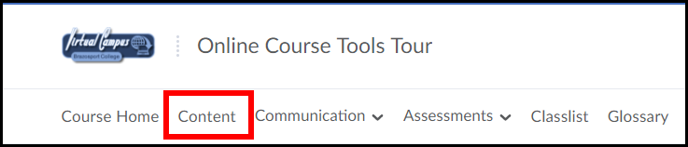

Modules
Modules are used to categorize and organize your content, similar to folders or headings. For example, a course may have modules based on weeks, units or chapters. You MUST create at least one module in order to post course content.
The Table of Contents is used to add modules to the content area (1). To the right of that is the module preview pane which is used to add topics and items to a selected module (2).
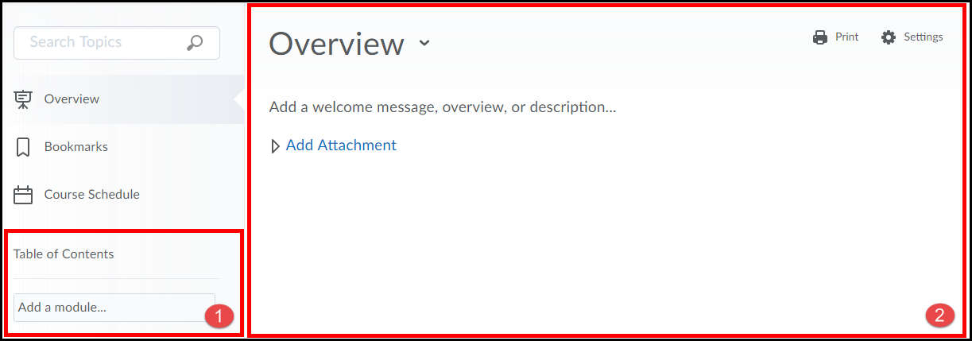
NOTE: The Welcome to your course message appears in courses that have no content in them.

Adding a Module
- On the left side of the page (under the Table of Contents section) enter a Title for the module in the Add a module… field. When finished hit the Enter button on your keyboard.
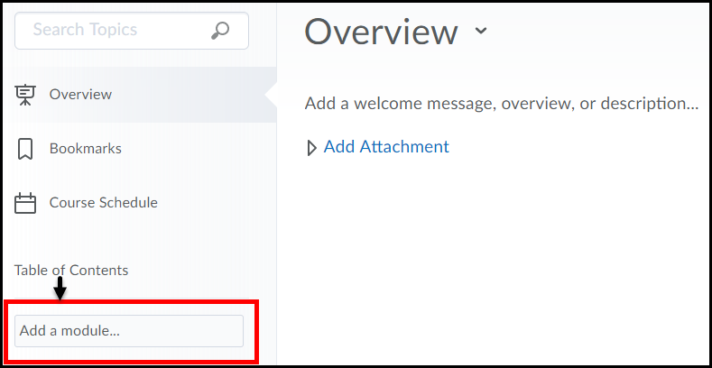

- The module is now created.
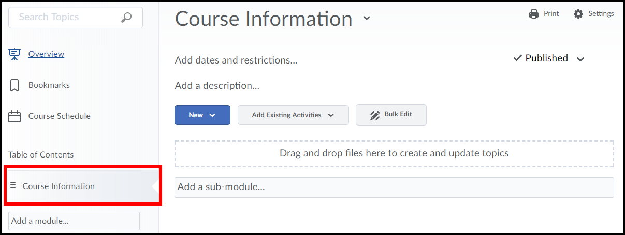
NOTE: Once a module is created and clicked on, it becomes viewable in the “module preview pane” on the right-side of the page.

Topics
Topics are links to individual files you add to the course. We will take a look at 2 ways in which you can add Topics to a Module: New Document and Upload Files.
Adding a Topic
The module preview pane will allow you to add topics to the module.
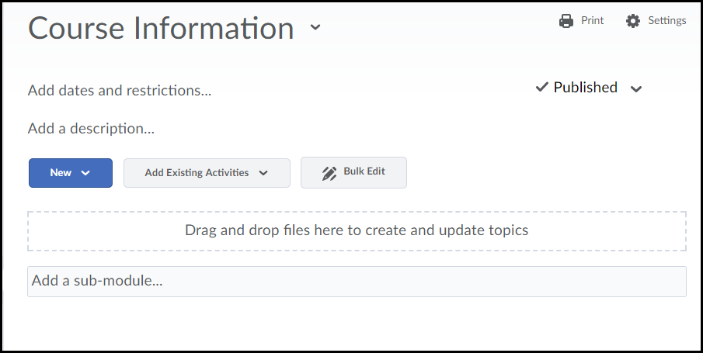

Creating a New Document
This option allows you to create a web-based content document directly in Desire2Learn (D2L) using the HTML Editor.
- Click on the New drop-down menu (1) and select Create a File (2).
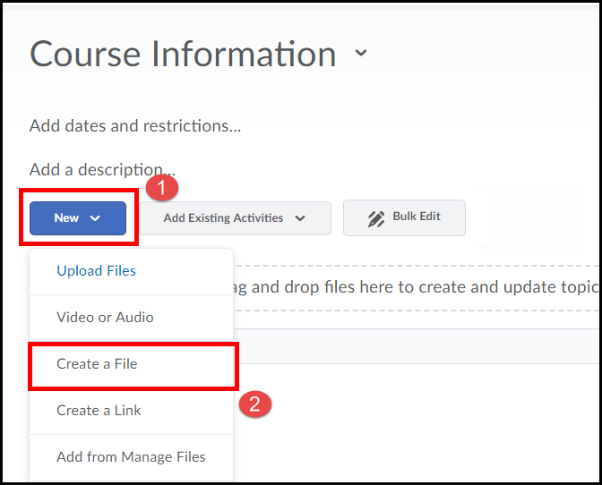

- Enter a topic Title (1) (example: Introduction).
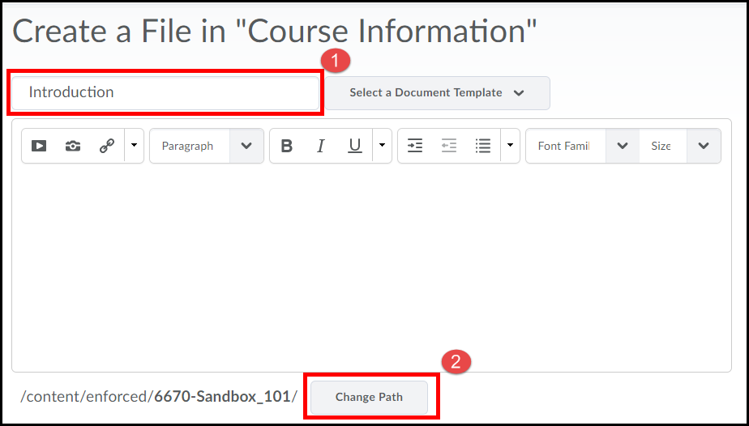
NOTE: For organizational purposes, the Change Path button allows you to either create a folder to save the file in the Manage Files area of your course or to save the file in an existing folder.

- Enter text (1) in the “content” area of the HTML Editor; use the formatting and spell check tools as needed and click the Publish button when finished (2) or select Save as Draft if you would like to come back later and finish it.
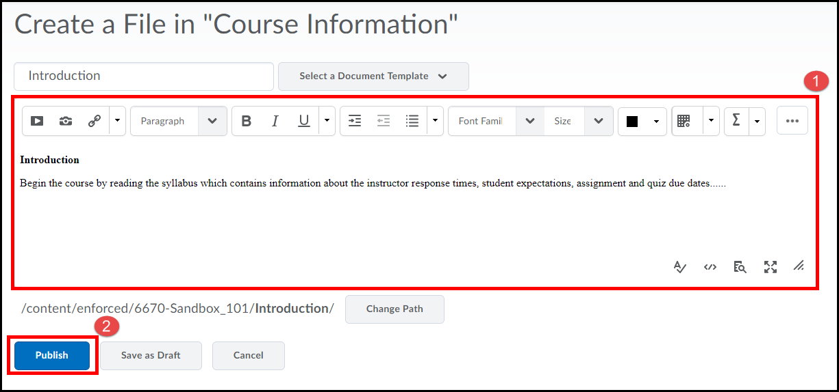

- The new document will open and be viewable to you.
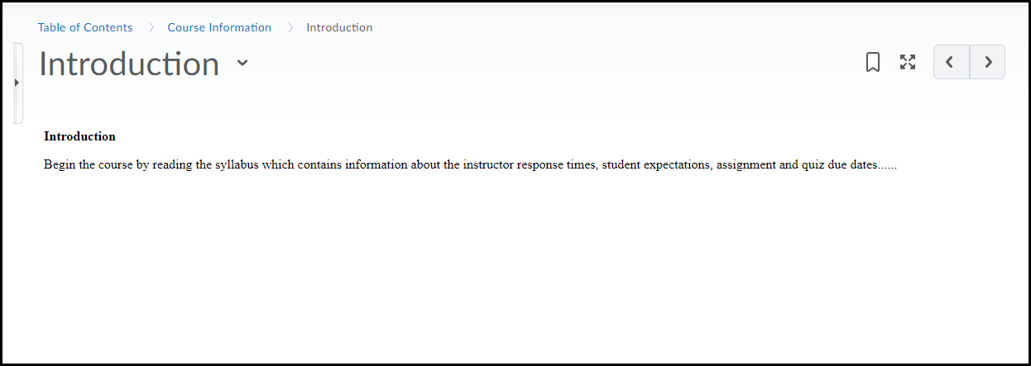

- Click on the Table of Contents link at the top of the page to return to the content area.
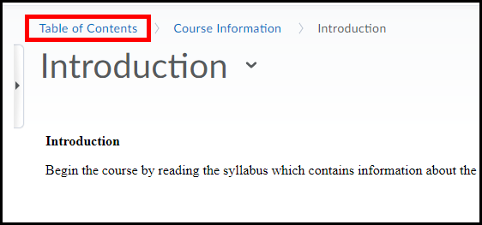

- The New File you created will now be displayed as a topic in the content section. Students will click on the file title to view the document.
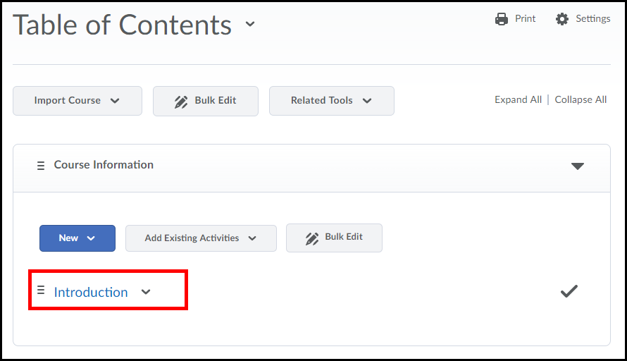

Create a Topic from an Uploaded file
This option allows you to upload files from your computer directly to the content section of D2L.
- Click on the New drop-down menu and select Upload Files.
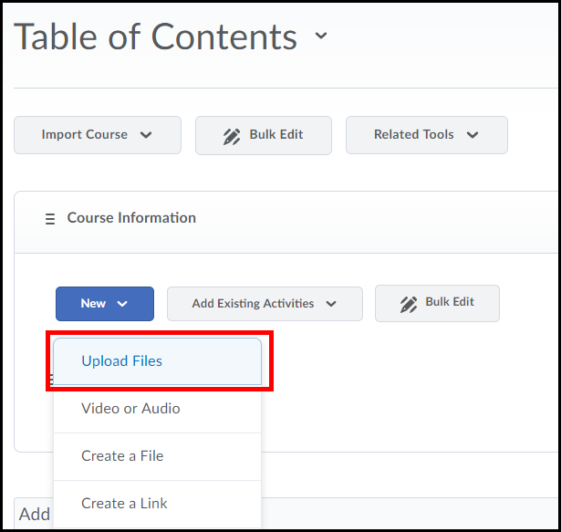

- Click on My Computer.

- Select the Upload button.
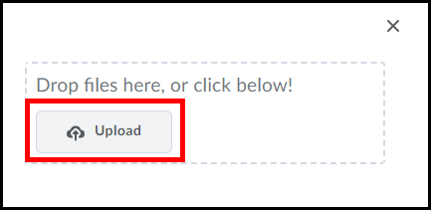

- Locate the file on your computer, click on it once to select (if you have multiple files to upload hold down the CTRL key on your keyboard and select the files you want to upload )(1). When finished click the Open button (2).
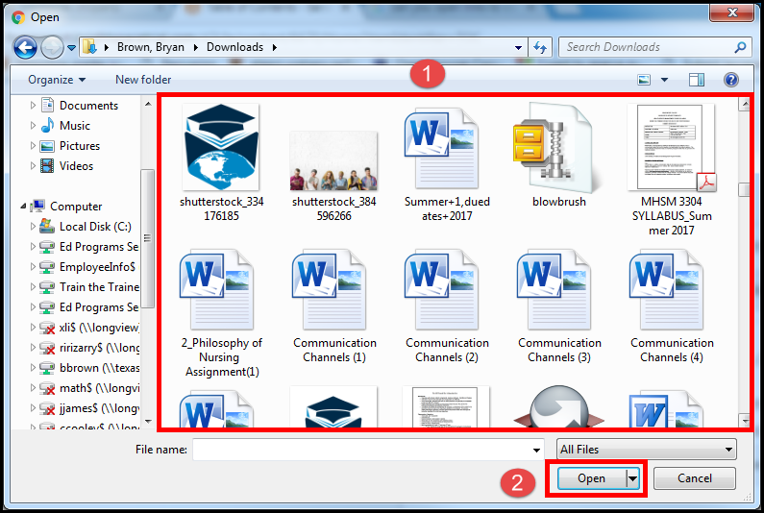

NOTE: You can also upload files by dragging and dropping them from your computer into the outlined drag and drop area.
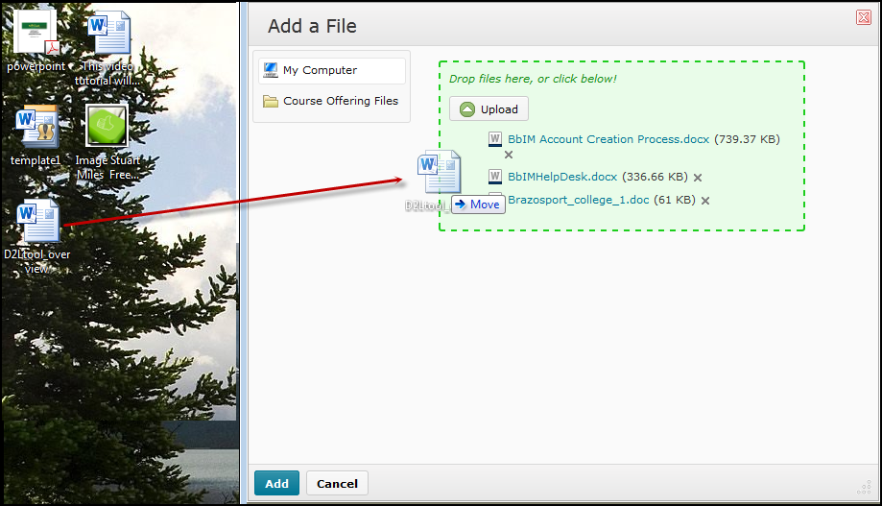

- Click the Add button when you are finished.
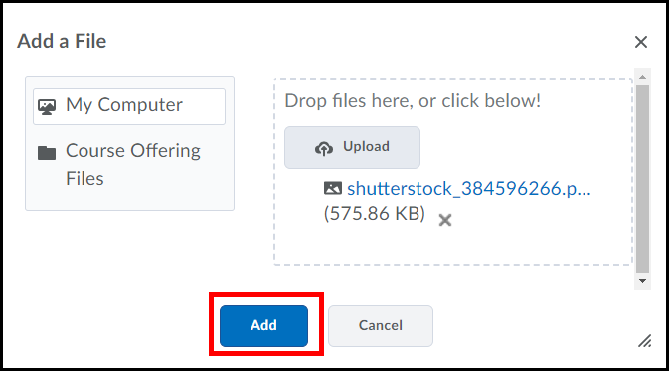

- The Uploaded File(s) will now be displayed as a topic(s) in the content section.
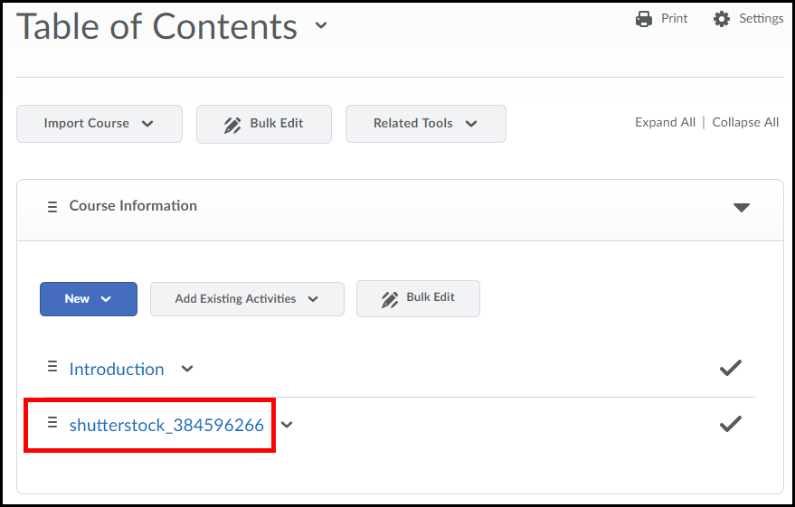

Viewing a Content Topic
- Click on the Title of the content topic to view.
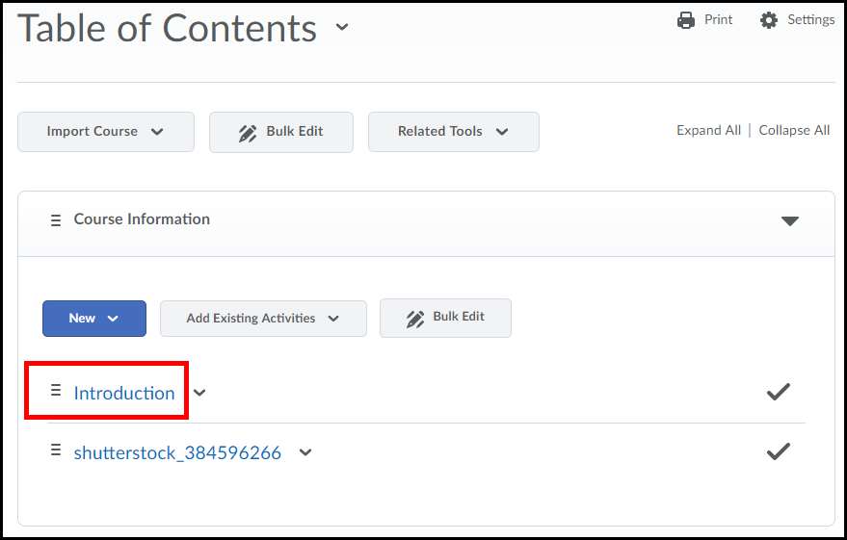

- The file will load into the window.

- To navigate back to the table of contents click on the left side panel (1) and click the table of contents link (2).
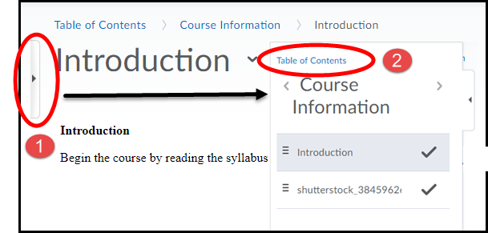
NOTE:
You can also use the side panel to navigate to other modules and topic in the content area.

Reordering Topics
If necessary you have the ability to reorder the way topics appear in the content section.
- To reorder a topic click and on the 3 vertical lines to the left of the topic’s name and hold down your mouse.
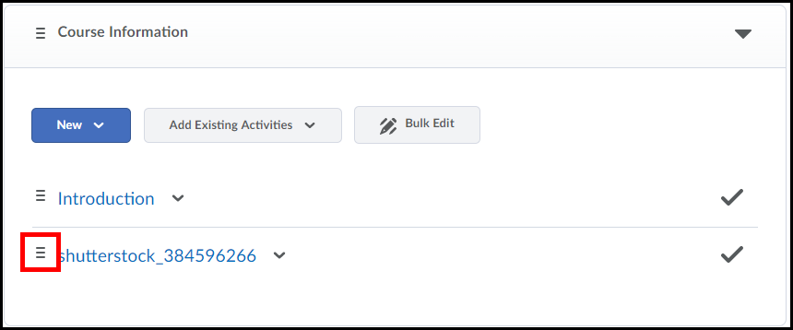

- Move the topic up or down in the order you want it to go and release the mouse.
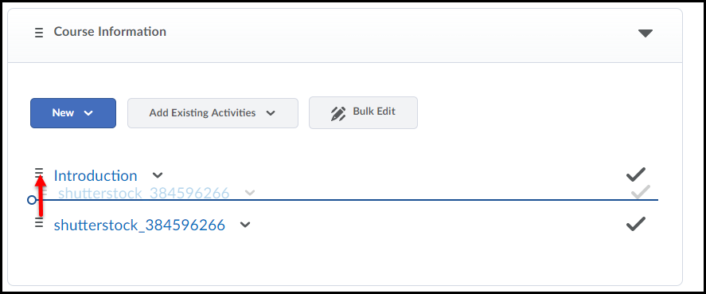
NOTE:
The blue line indicates the position the topic will be placed in when you release your mouse.

- The topic is now reordered in the content section of the module.
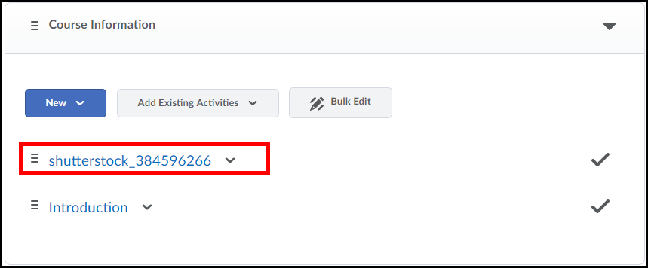

Repeat this process (with each topic) in till they are reordered the way you desire.

Content Tracking
D2L allows you to track whether users have completed/viewed topics in the content section of your course. It assists student with keeping track of their completion of course material.

Individual Topic Tracking

- To set tracking for a topic, click once on a module listed under the Table of Contents.
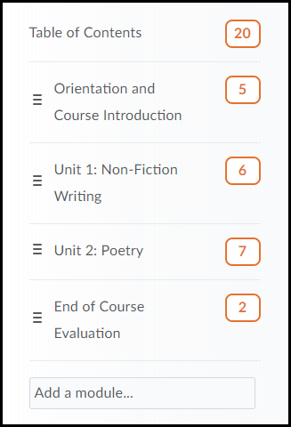
NOTE:
The number indicates there are 6 topic items in this module.

- Click on the topic’s title.
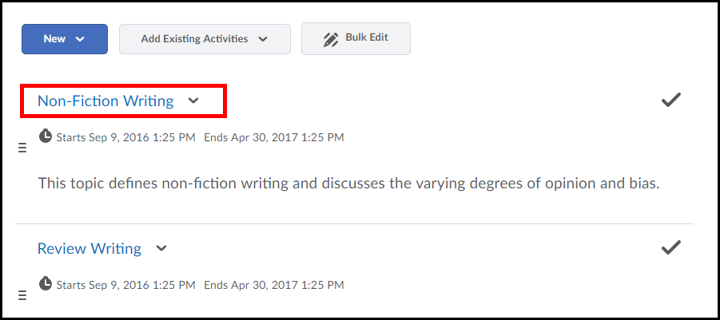

3. Scroll down the page to the Activity Details section and click on the Tracking drop-down menu.
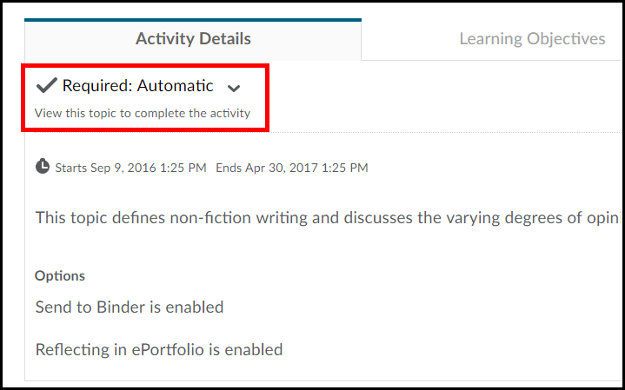

Tracking Options
You have three tracking options to choose from; Automatic, Manual and No Tracking. By default when a topic is added tracking is set to automatic.
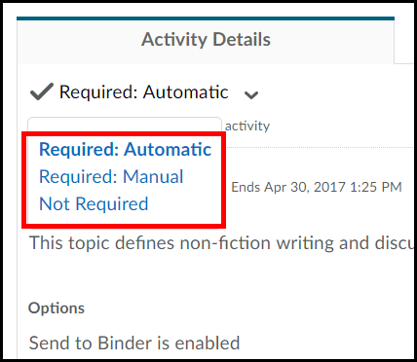

Automatic Tracking
Automatic tracking records any topic a student visits as completed. It will also mark topics a student has not visited as incomplete.
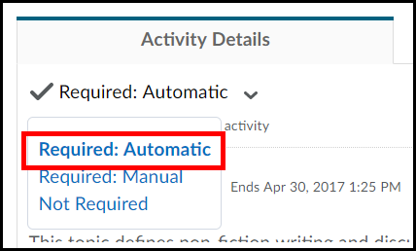

Manual Tracking
With manual tracking students will need to check off the topics they have read .
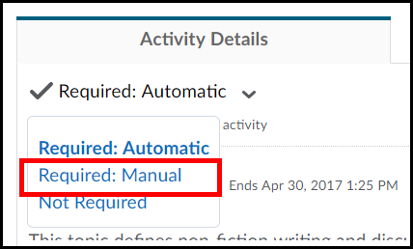

Not Required
Not Required means D2L will not track the topic when students visit it .
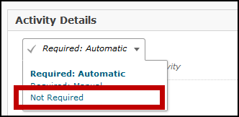
Completion Summary
The Completion Summary shows each user's progress for a specific topic in table format. The Completion Summary is located within a topic, below its content.
- Click the topic you want to view completion tracking results for.

- Scroll to the bottom of the page and click on the Completion Summary tab.
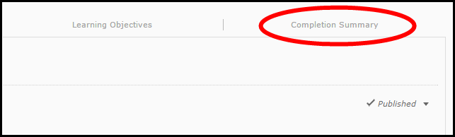

- The completion summary for the topic will be displayed in table format.
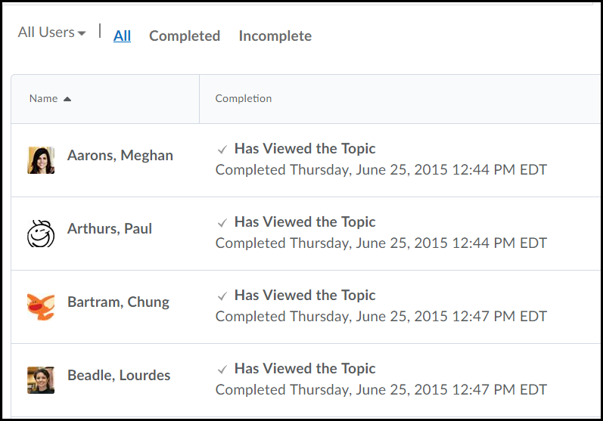

Edit a Created File Topic
You have the ability to edit any web-based document you created using the HTML editor in D2L. Web-based documents would be those that were created in D2L using the Create a File topic option (refer to page 3) or an uploaded HTML file.
Important: Microsoft Word files cannot be edited in this manner.
- Click on the title of the created file topic you would like to edit.

- Scroll to the bottom of the page and click the Edit HTML button.
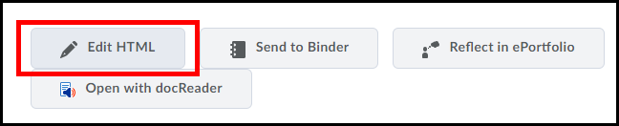

- Make all necessary changes and click the Update button when finished.
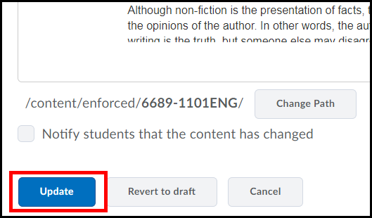

Draft or Publish a Module
You have the ability to select whether a module (along with all it topics) is either draft (hidden) or set to published (visible).

Draft a Module
When you create a module you can set it to Draft. When you set a module to Draft mode your students will not be able to access the topics within the module.
NOTE: Students can still see the module and its topics, however they cannot access them.
- Click on the module from the Table of Contents.
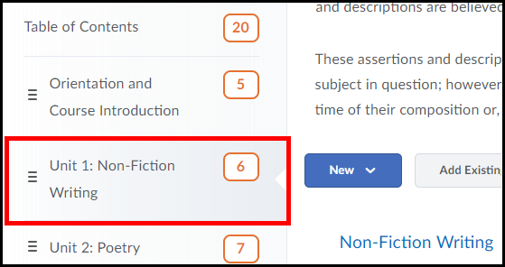

- From the preview pane (on the far right) click on the Published drop-down menu (1) and select Draft (2).
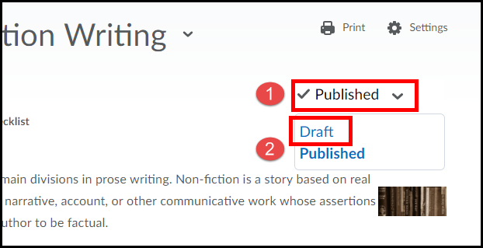

3. The module is now set as a Draft and students will not be able to access the topics within it.
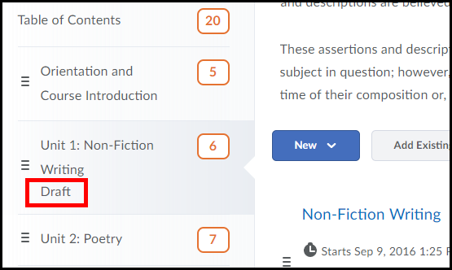

Publish a Module
When you set a module that is in Draft mode to Published your students will be able to access the topics within it.
1. Click on the module from the Table of Contents.

2. From the preview pane (on the far right) click on the Draft drop-down menu (1) and select Published (2).
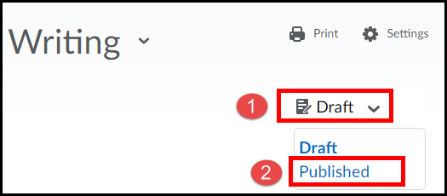

3. The module is now set as to Published and students will be able to access the topics within it.
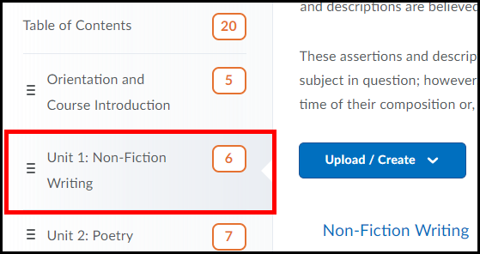

(A Module)
Allows you to upload files, create a document, and add course content to the module.
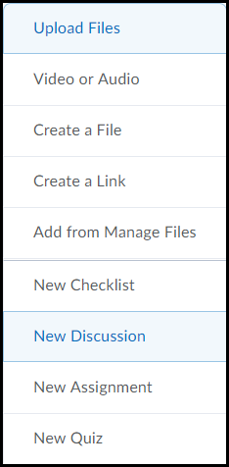
Shows the number of topics in a module.

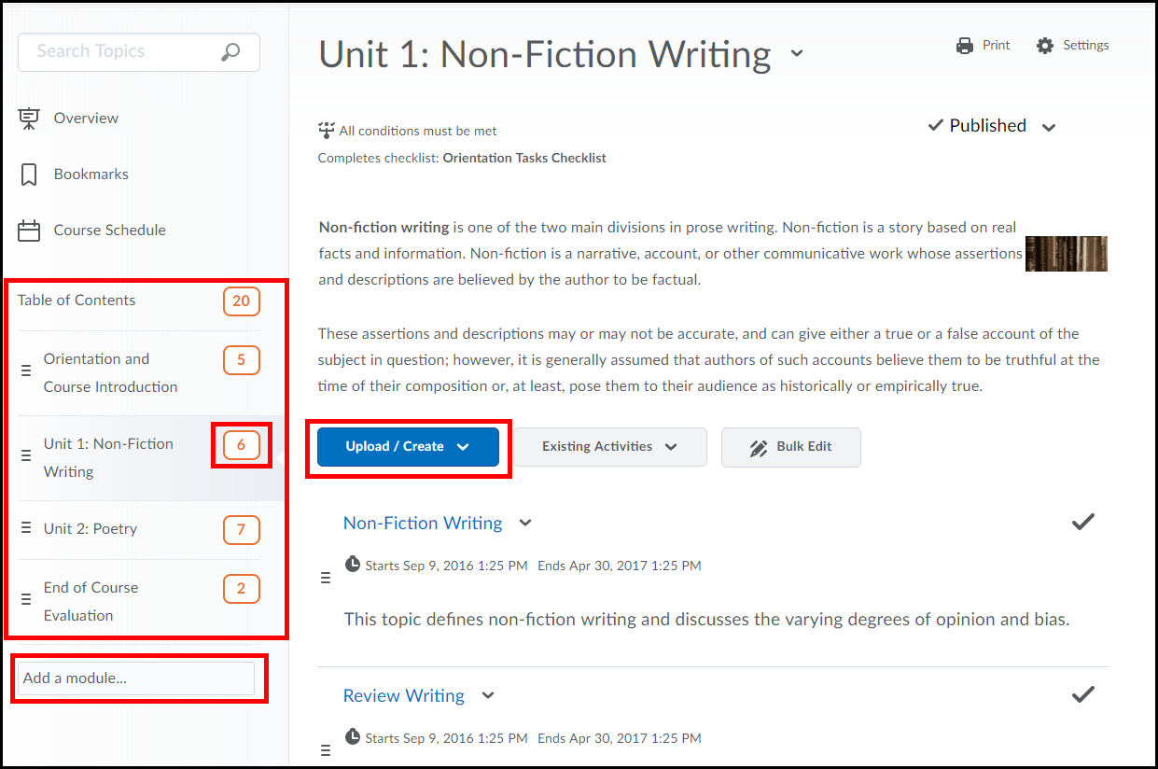
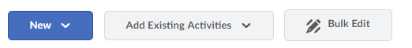
Click on a topic to view it.
Allows you to edit, delete, and download a topic. 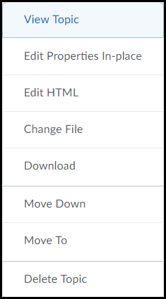

Allows you to browse content modules and access their topics.

Allows you to delete and bulk edit topic.

Where you enter a name to create a module.

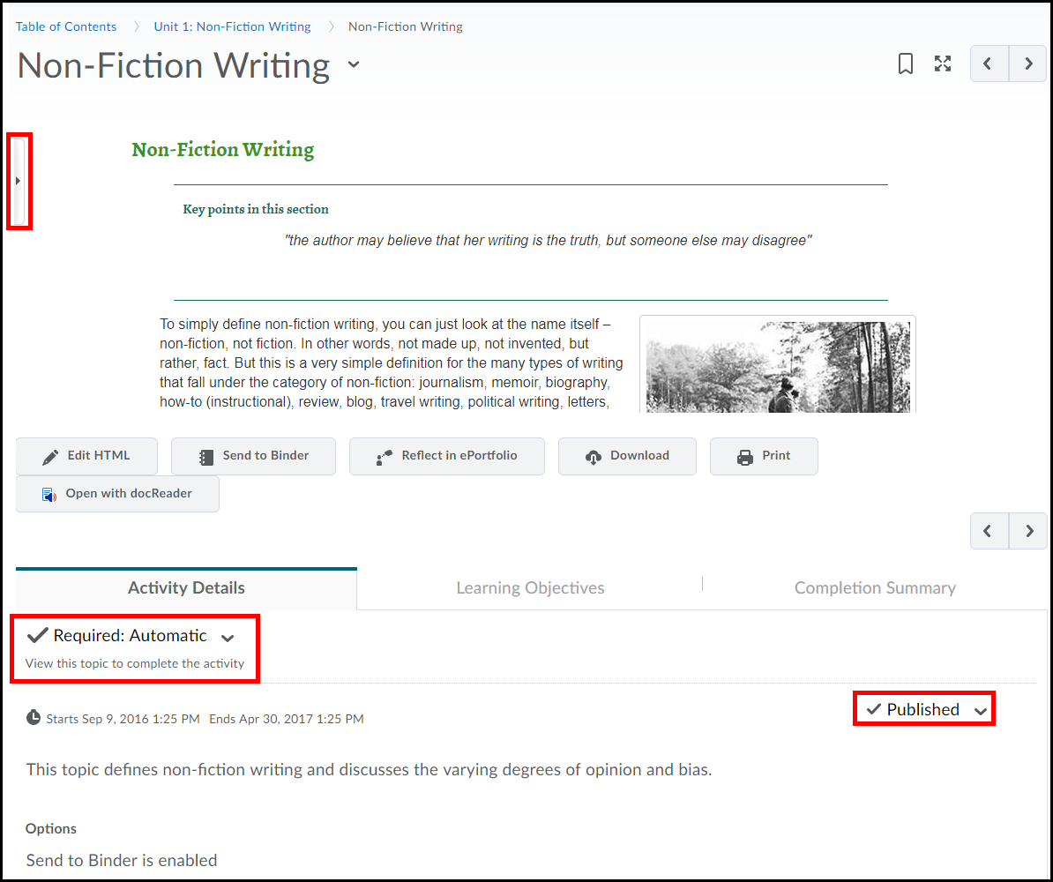
Allows you to print the topic.
Allows you to edit the topic.
Allows you to select a tracking method for when a student completes the topic.
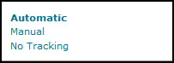

Allows you to select whether to Publish or save topic as a Draft.
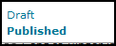

Allows you to download the content of the topic to your computer.
The Side Panel allows you to navigate between topics, modules, and lets you return back to the table of contents.
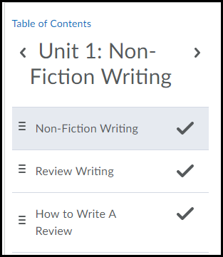
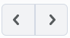 Allows you to move to the previous and next topic in the module.
Allows you to view the topic in a new window.
(A Topic)

