The Discussions tool is a collaborative area where students can post, read, and reply to messages on a variety of topics.

Add a Forum and a Topic

1. Click Discussions from the Communication drop-down menu on the Course navigation bar.
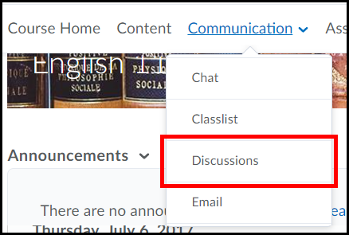

2. Click the New Forum link from the New drop-down selection menu.
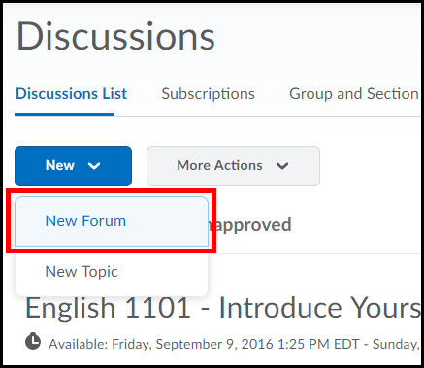
Click New Topic if you have already created a forum and need to add a topic to it.

3. Enter a Title for the discussion forum (1) and click the Save and Add Topic button (2).
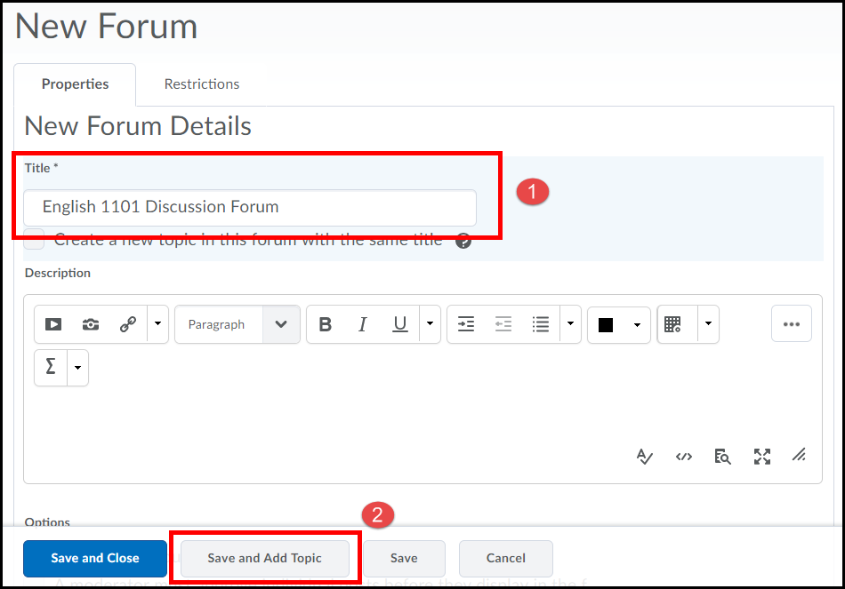

4. Enter a topic Title (1) and Description (2). Use the description area to direct students as to what needs to be done in this topic area.
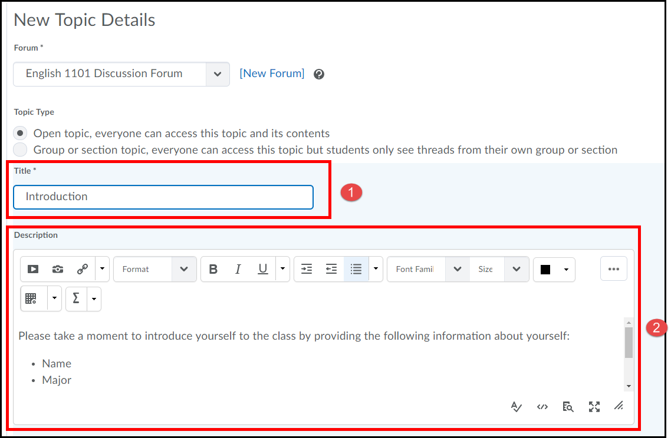
5. Under Options you can select to "allow anonymous message" (best for a feedback forum), "A moderator must approve individual posts before they display in the topic " (best used for forums dealing with sensitive subject matter), and/or "Users must start a thread before they can read and reply to other threads" (best for getting students to post unbiased or original thoughts).
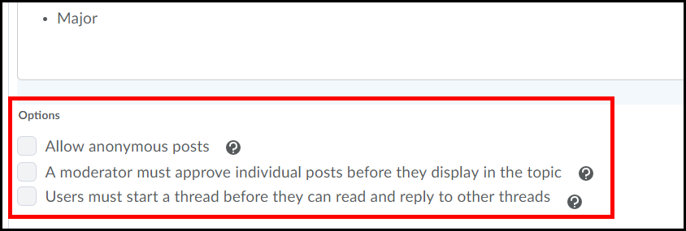

6. Under Availability (click Show topic visibility options) you can choose to leave the "Topic always visible" (best option), "Hide this topic" or make "Topic visible for a specific date range". If you choose a date range you can also select the checkbox to "Display in Calendar".
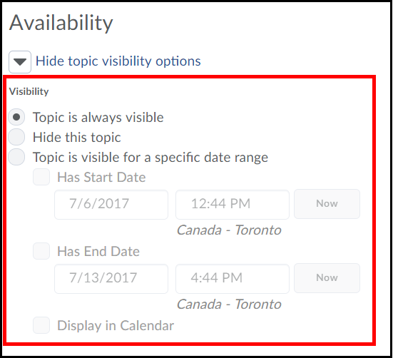

7. Under Locking Options (click Show locking options) you can choose to leave the topic "Unlocked", "Lock topic" (best for when you want students to view messages but not post), or "Unlock topic for a specific date range" (best used for when you want topics to automatically lock on a certain date/time). If you choose a date range you can also select the checkbox to "Display in Calendar".
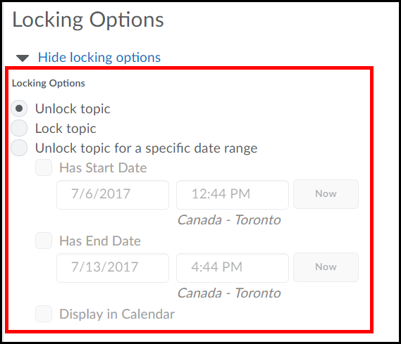
Assessment
You can evaluate users' individual postings and automatically calculate the score, or you can assign a topic score to each user.
1. To set up an assessment, scroll up and click the Assessment tab.
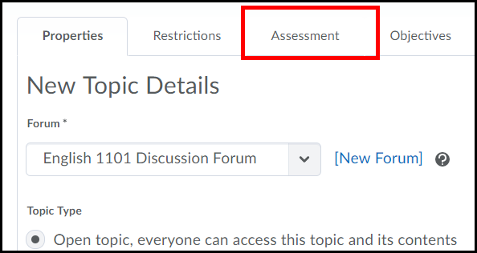

2. Select the Grade Item the discussion topic is associated with in your gradebook (click the New Grade Item link to create one if one doesn’t already exist) (1). Enter a Score Out of (or how many points the activity is worth) (2).
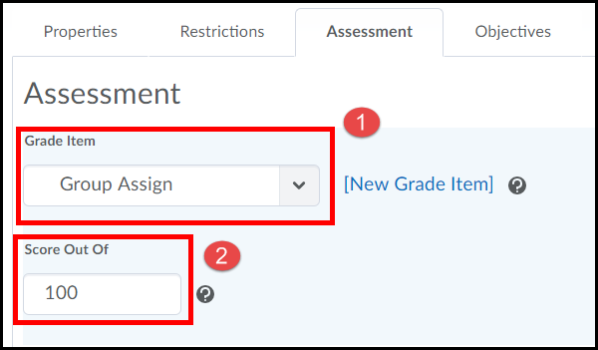

3. Decide if you want to assess individual message posting or automatically have D2L automatically calculate topic scores. If you choose the automatic method you must check the checkbox for Assess each message and automatically calculate the topic sore AND select how you want the calculation done using the Select a calculation method pull down menu.
*The calculation method allows you to score multiple postings by a student to a topic area and take the either the average, maximum, minimum, highest on multiple posts lowest score or sum of post scores on multiple postings.
Once done click the Save and then Close buttons.
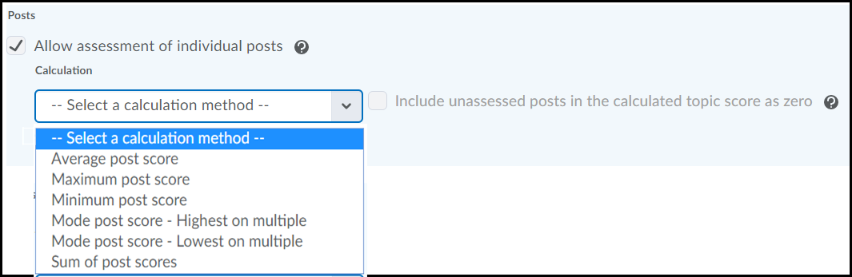

Post a Discussion message
1. Click a Topic title listed under a Forum.
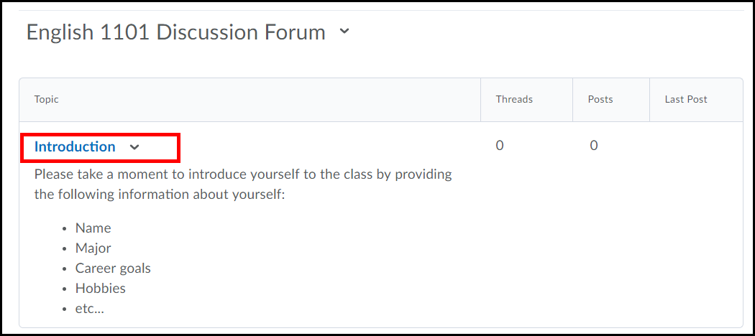

2. Click the Start a New Thread button.
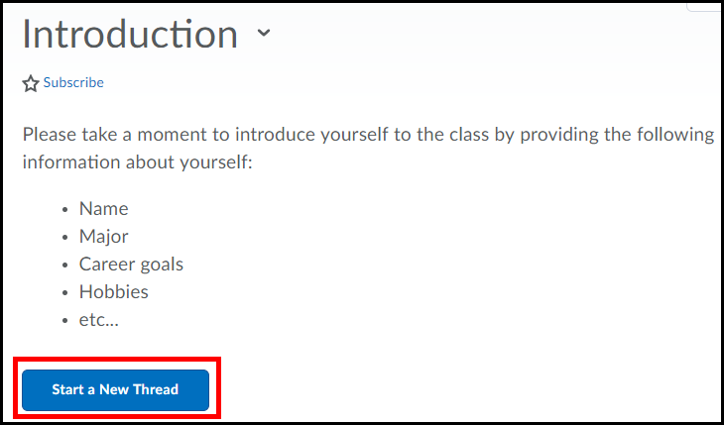

3. Enter a title in the Enter a Subject text field (1), type your message in the Message area (2)and click Post (don't forget to do a spell check)(3).
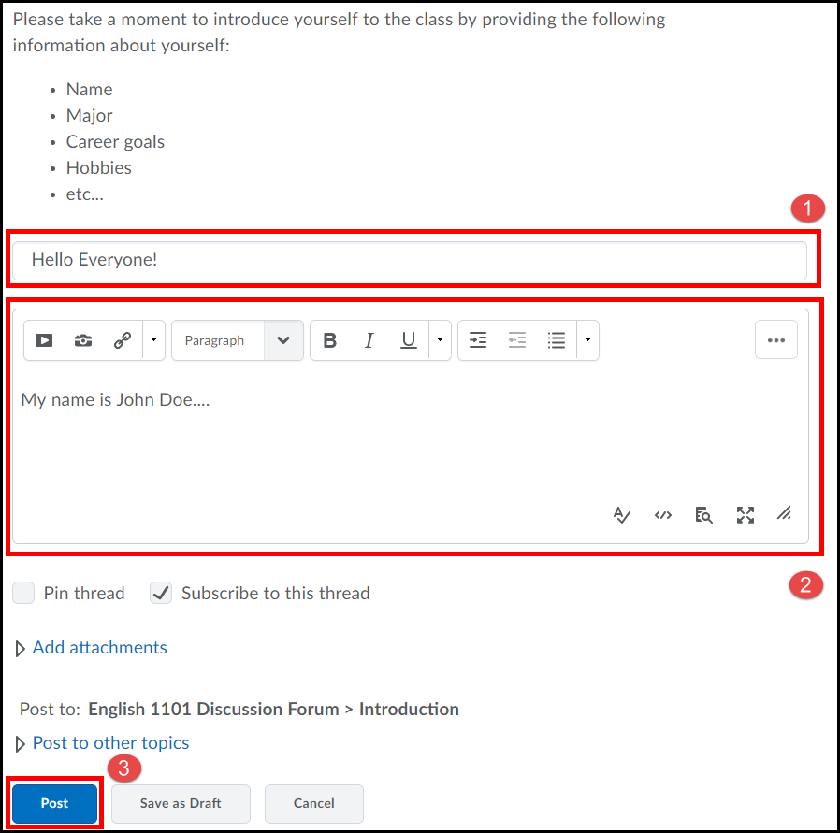

Edit a Discussion Forum
- Click on the pull down menu located to the right of the Forum’s title and click Edit Forum. Edit the forum and click the Save and Close button when done.
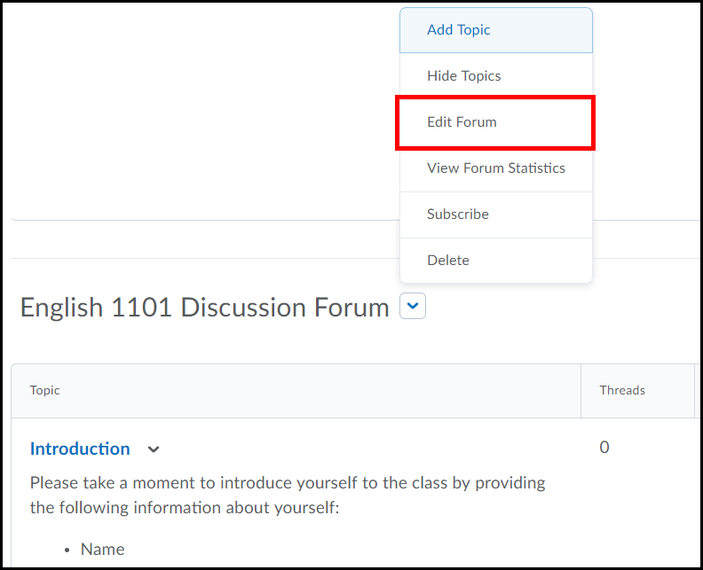

Edit a Discussion Topic
- Click on the pull down menu located to the right of the Topic’s title and click Edit Topic. Edit the topic and click the Save and Close button when done.
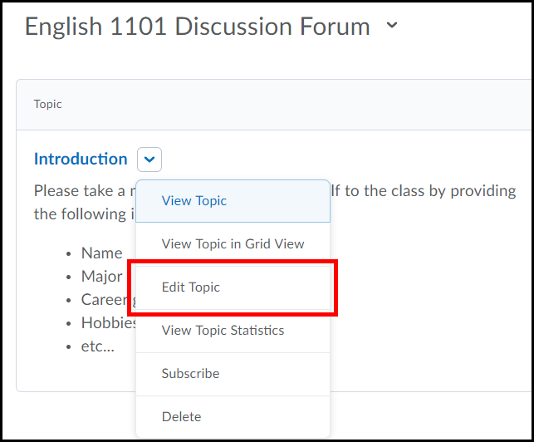
Assessing Posting
Assessing Discussion Posts through the Gradebook
The easiest way to assess and grade postings to discussion topics is directly through the grade book.
1. Click on Assessments from the course navigation bar and select Grades.
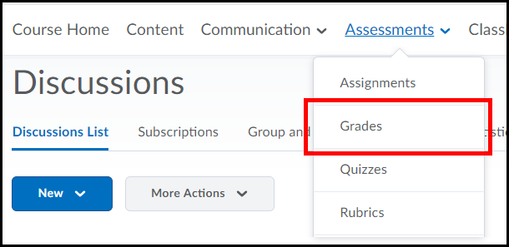
2. If a student makes a post to a specific discussion topic the discussion’s icon will appear for that student under that grade item column. Click on the discussion icon.
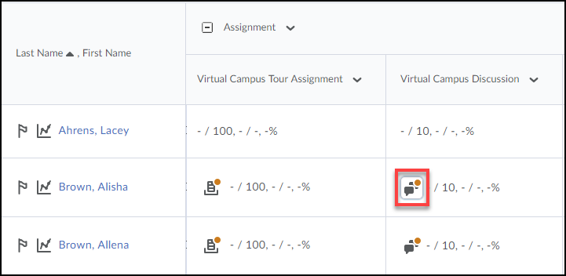
The Discussion icon will only show up if the discussion topic is associated with a grade item.

3. A new window will pop up and all the post the student has made will appear at the bottom of it.
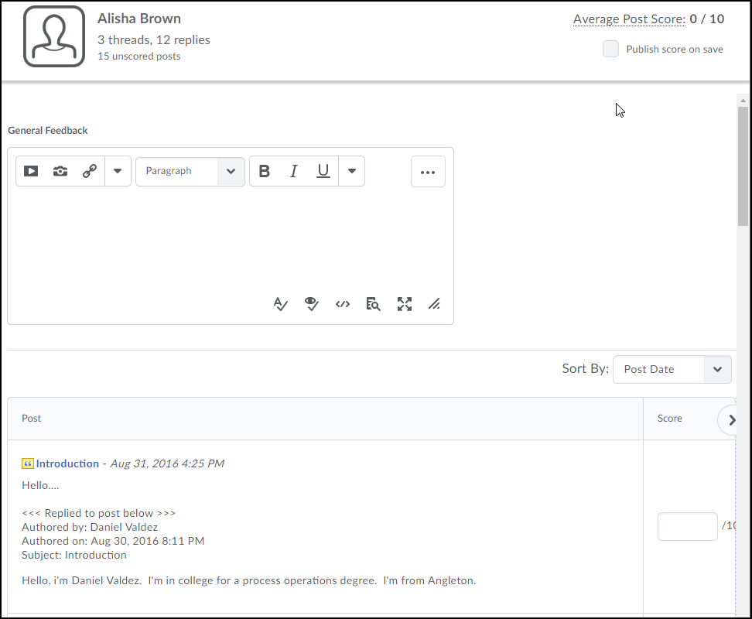

2. You can click on the quotation icon next to any of the student’s posting to be taken directly to the original discussion post. This will allow you to see more information about why the user posted that reply, or what learners replied to their post.
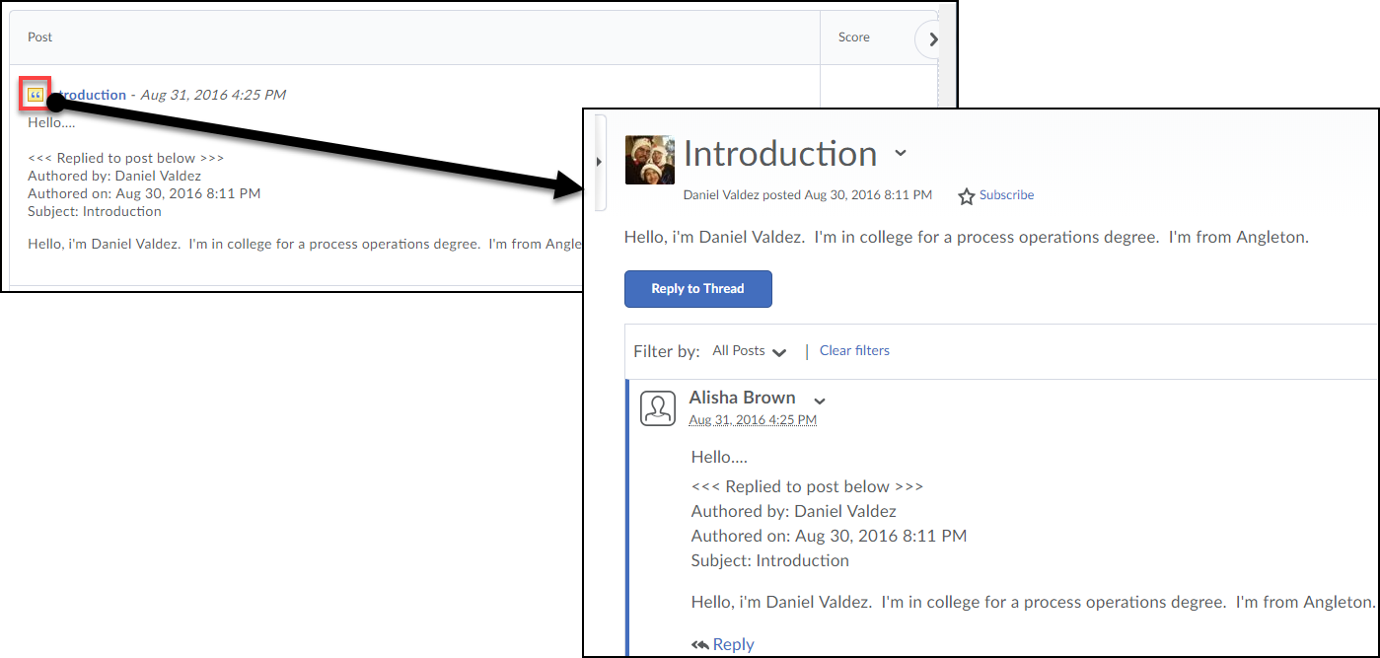
3. Enter a score for the student for the discussion topic (1). You can also leave feedback if desired (2). When finished, check the Published option to publish the grade to the grade book (3). Click the Save and Close button (4).
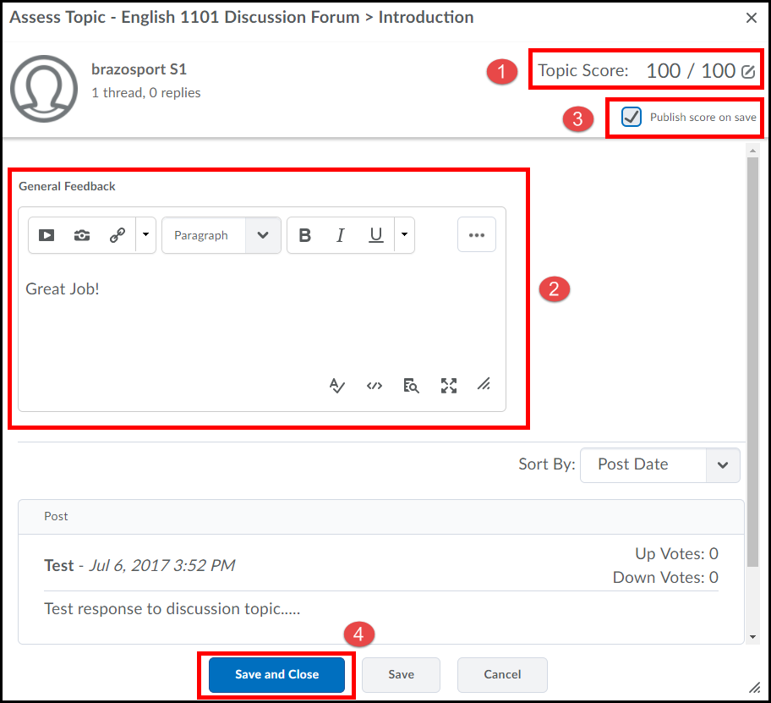

4. The grade is now displayed in the grade book for the student.
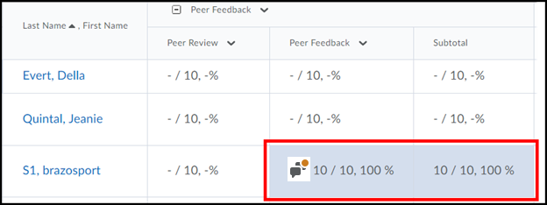

Assessing Discussion Posts from within Discussion Topics
- Click on the discussion topic in which you want to grade students’ postings for.

- Click on a student’s discussion topic to read it.
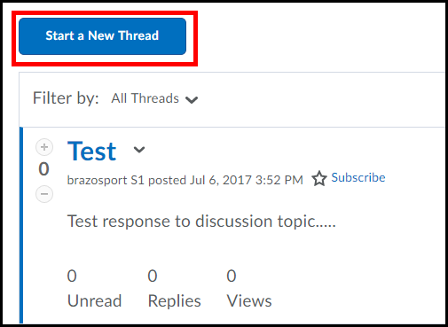

- Once you are ready to give the student a grade for the topic click the dropdown menu next to their name (1) and select Assess Student (2).
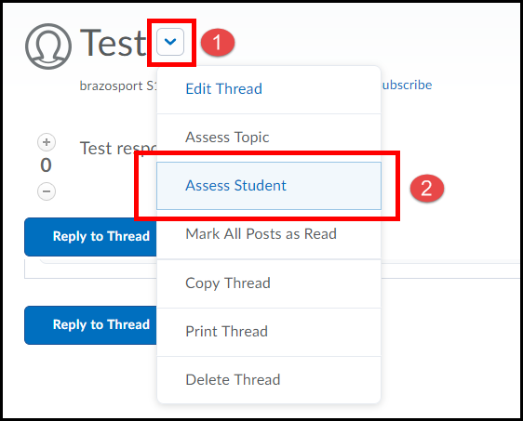
- A new window will pop up and all the post the student has made will appear at the bottom of it. Enter a score for the student for the discussion topic (1). You can also leave feedback if desired (2). When finished, check the Published option to publish the grade to the grade book (3). Click the Save and Close button (4).

The grade you give the student should now be reflected in your gradebook for the course.
Change View Settings

If you prefer, you can change the default discussion view to a Grid Style. In the Grid Style view, message threads are listed on top and read on the bottom.

- To change the view settings, click on the drop-down menu in the top right corner of the page next to your name (1) and select Account Settings (2).
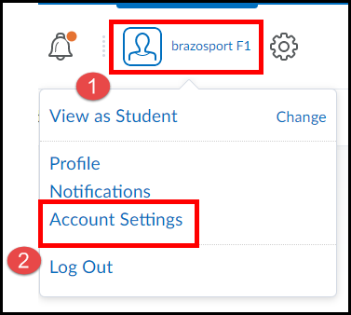

- Click on the Discussions tab.
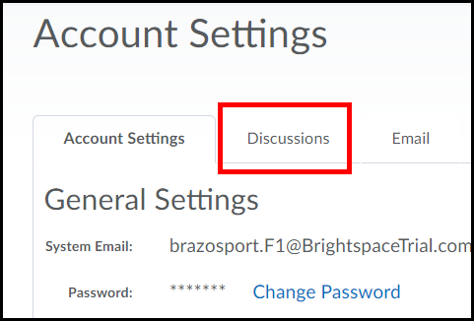

- Select the Grid View option under Default View (1) and click Save and Close (2).
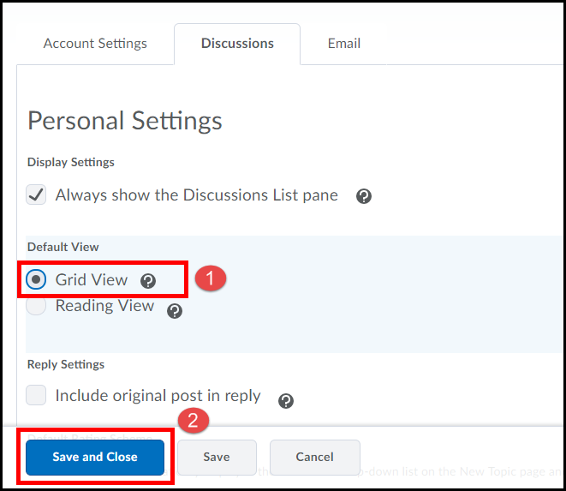

- Your discussions will now be viewable in Grid view.
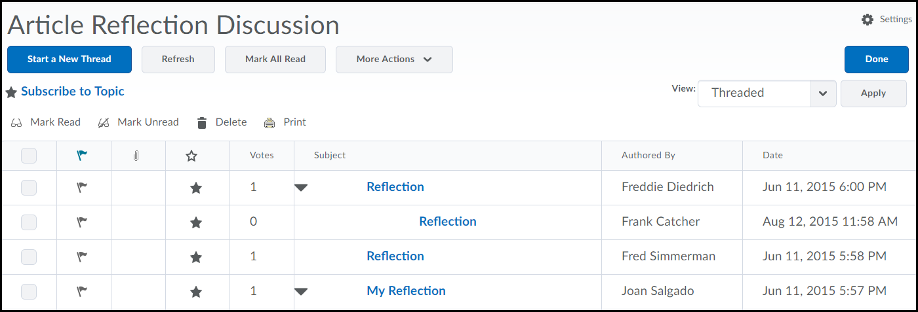

View a Discussion Topic in Grid View

If you prefer, you can view a discussion thread in Grid View. In the Grid view style, message threads are listed on top and read on the bottom.

- To change a discussions view, click on the drop-down menu next to the discussion topic’s title (1) and select View Topic in Grid View (2).
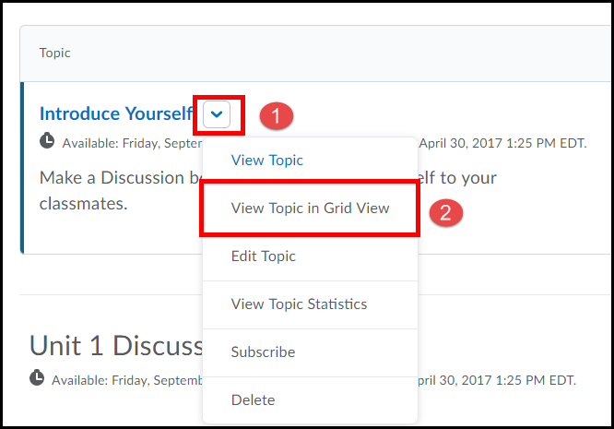

- The discussion topic is now viewable in Grid view.
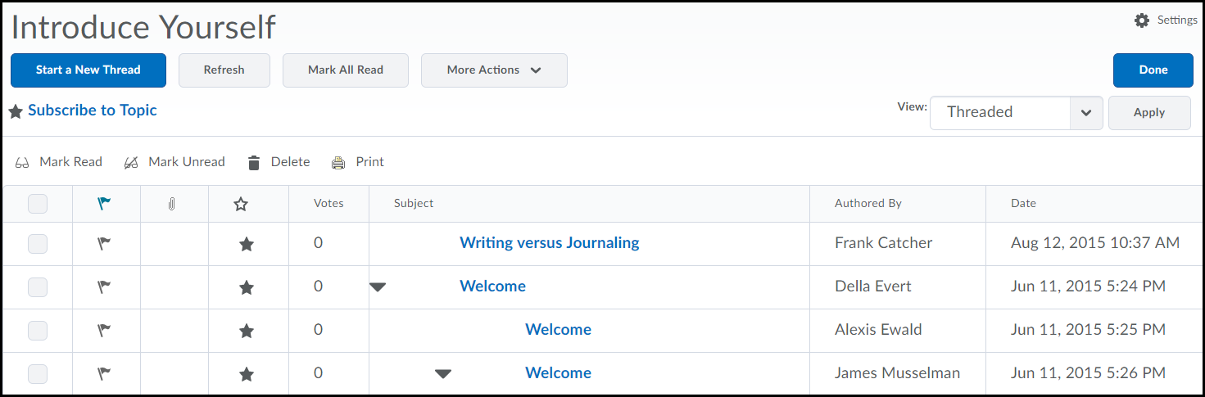

Restoring a Deleted Discussion
You have the ability to restore any deleted discussion back to the discussions area of your course.
- From within the Discussions area you will click on the More Actions button (1) and select Restore (2).
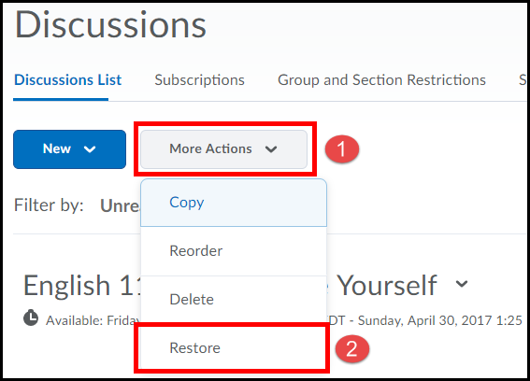

- A list of every discussion you have deleted will appear. From here click the Restore button of the discussion you would like to restore.
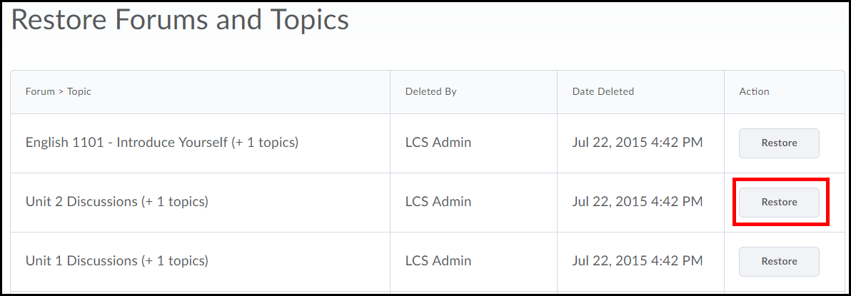

- Click the Restore button.
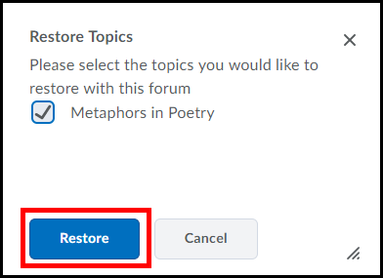

- When you return to the discussions area the Discussion will now be placed there.
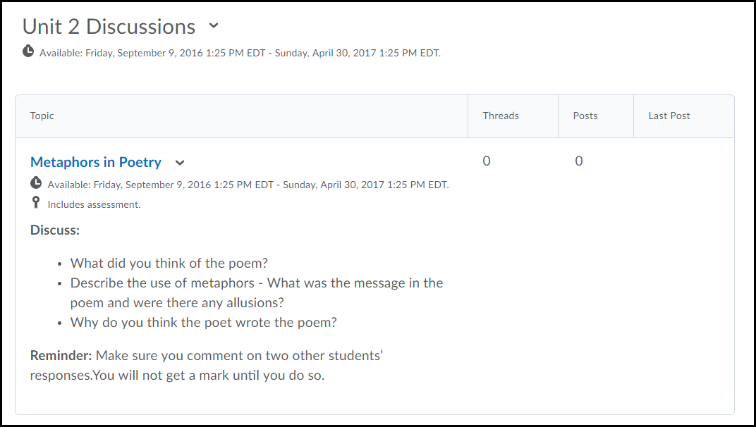

Printing all Discussion Thread in a Discussion Topic
- Click on the drop-down menu next to the discussion topics title (1) and select View Topic in Grid View (2).

- Check all discussion threads listed (1) and click the Print button (2).
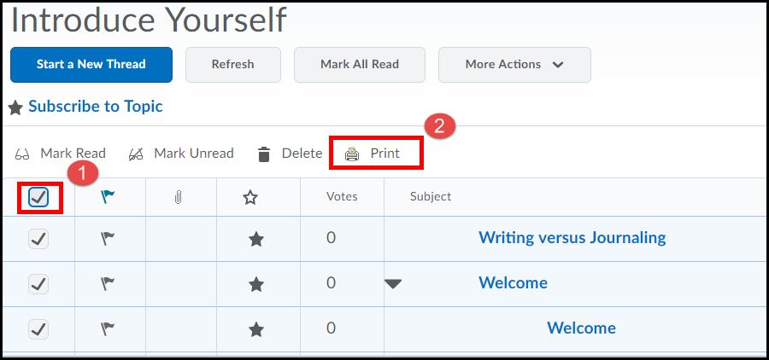

You will now be able to print all the threads in the discussion topic.

Transferring Overall Topic Score from Rubric to Topic Score
If you grade a discussion topic using an attached rubric from the Assess Topic page you can transfer the overall grade from the rubric to the discussions topic’s Topic Score.

1. Click on the dropdown menu next to the discussion topic you want to grade (1) and select Assess Topic (2).

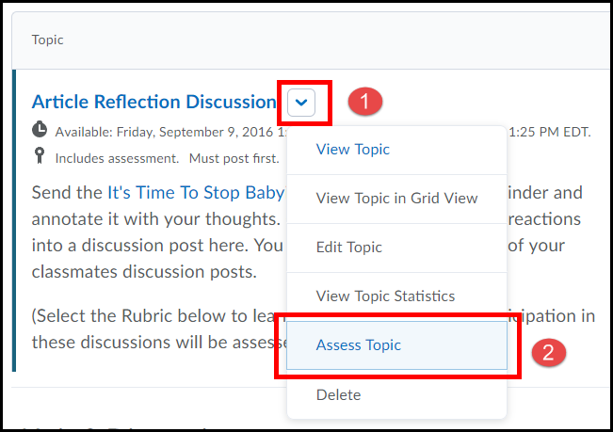

2. To grade a student’s posting using an attached rubric click on the Topic Score link beneath their name.

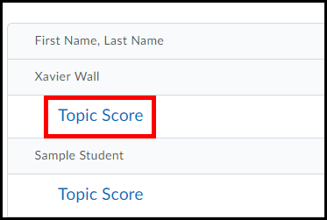

3. Grade the students’ discussion posting using the rubric (1), then select the Publish score on save option in the top right corner of the page(2) then click the Save and Close button when done (3).

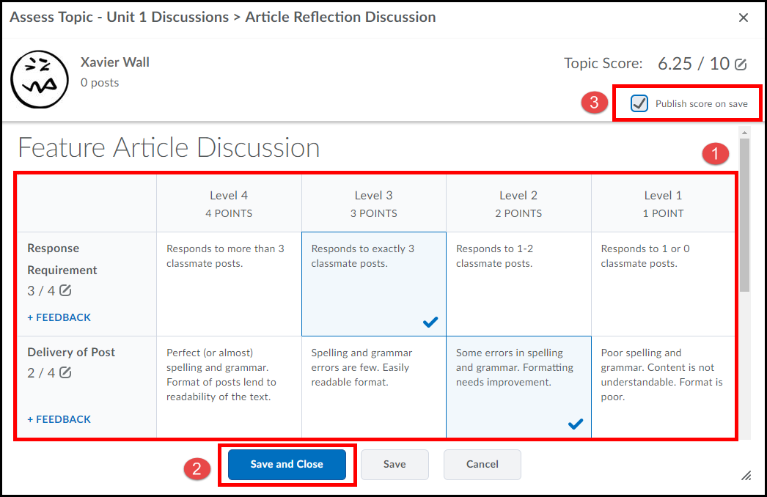

6. The student’s grade will now be published to the Gradebook in the course. Repeat steps 1-3 for each student posting you need to grade using the rubric.

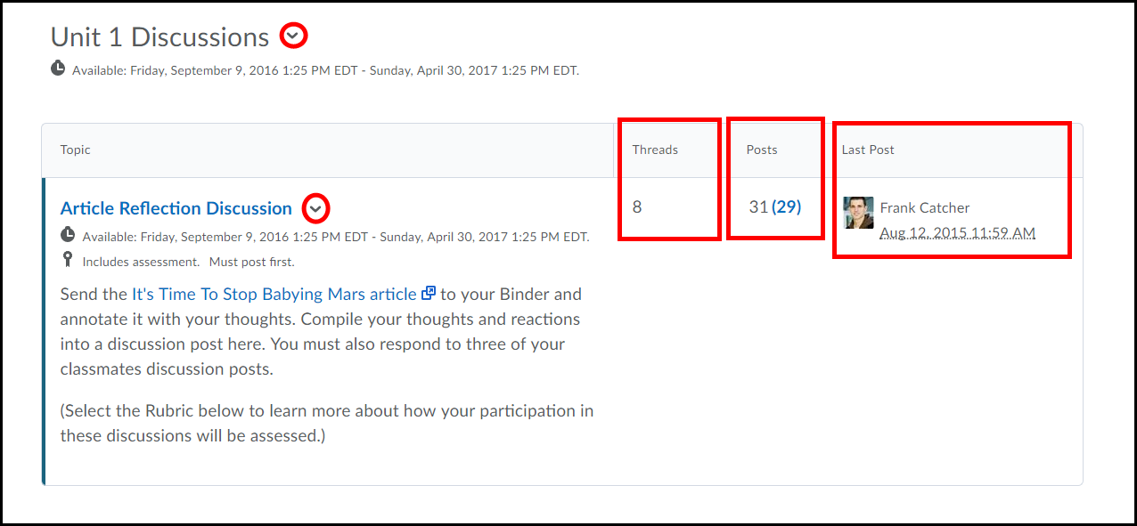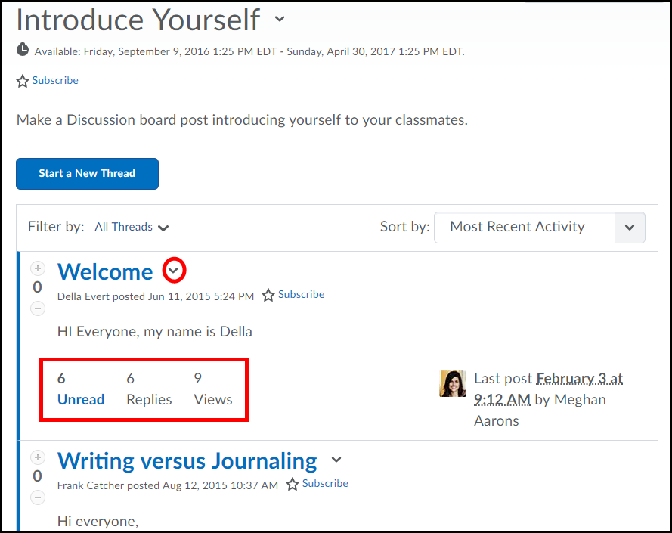
Allows you to add a new topic, Edit, Subscribe and Delete a forum.
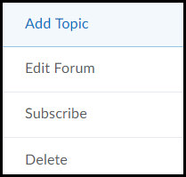

Discussion Forum

Displays the number of Threads and replies posted. Number in blue indicates the number of unread threads and replies for the topic.

Displays the number of Threads posted to the topic.

Displays the last person to post a thread to the discussion topic, including the date and time.
Allows you to View in Grid view, Edit, Assess, Subscribe to and Delete a topic.
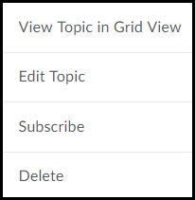
Indicates the topic is an assessment.
Discussion Topic

Discussions Area
Displays the last person to post a reply to the discussion topic, including the date and time.
Allows you to sort the way posted messages are viewed.
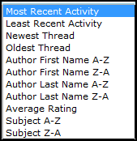

Displays the number of unread replies, replies, and views to the posted thread.
Allows you to Edit, Flag, Assess and Delete a posted message.
Discussions Topic
Allows you to create a message for the topic.

Allows you to filter messages either by unread or flagged.
Indicates you have subscribed to the topic.
Allows you to edit, delete, and asses a topic.
