Dropbox
The Dropbox tool is used for student to submit assignments to.

Add a Dropbox Folder
1. Click on the Dropbox link from the Assessments drop-down menu on the course navigation bar.
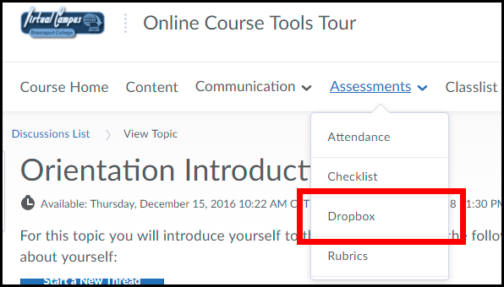
2. Click the New Folder button.
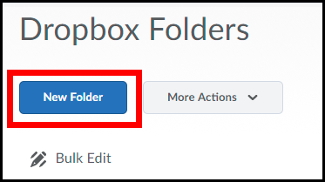

3. Enter a Title such as “Assignment 1” (1). Enter custom Instructions for students to complete the assignment (2).

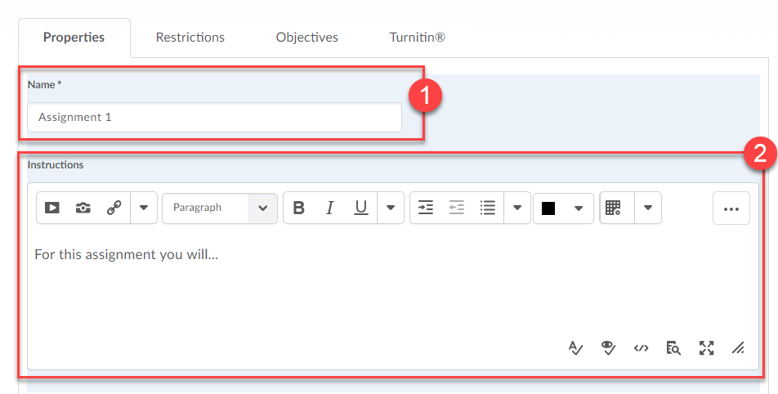

4. Select the Submission Type (1).
- File submission (default): Assignment is to be uploaded directly to the Dropbox as a file.
- Text submission: Assignment is to be submitted as a text submission instead of uploading a file. Students will use the HTML editor in the Virtual Campus to type up their assignment and submit it.
- On paper submission: Assignment is submitted directly to instructor in class, but evaluation and feedback will be completed via the Dropbox.
- Observed in person: Assignment/presentation will be observed in person, but evaluation and feedback will be completed via the Dropbox.
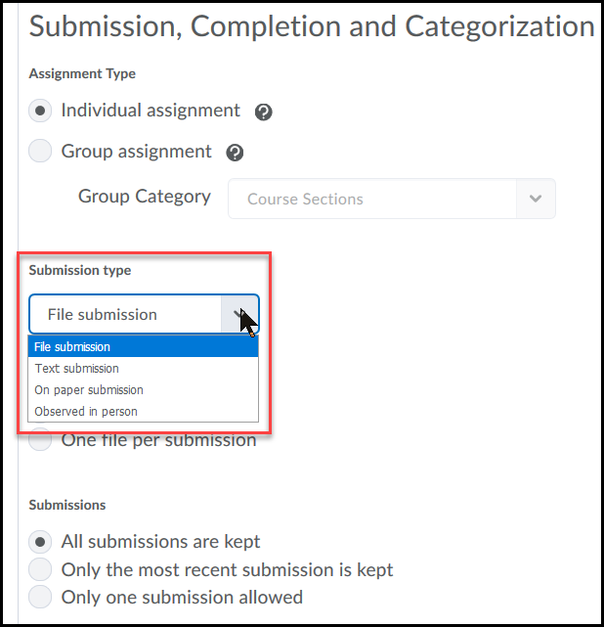

NOTE: On Paper and Observed in Person assignment types can also be created directly from Content.

5. Based on the Submission Type chosen above you will need to choose the submission options:
- If File submission is selected, select the Files allowed per submission for students (1), and then choose which Submissions are kept (2).
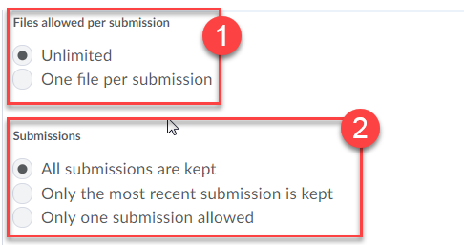
- If Text submission is selected, choose which Submissions are kept.
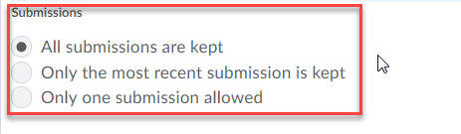

- If On paper submission or Observed in person is selected, choose when the assignment is Marked as completed.
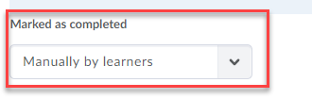
NOTE: You can enter an email address to receive a notification whenever a new file or text submission is submitted.
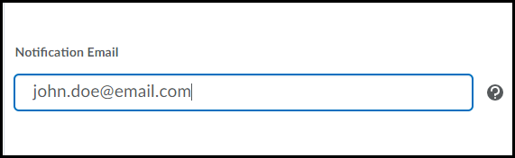
6. Enter the Score Out of (what the assignment is worth) (1) and select the Grade Item the Dropbox assignment is associated with in the gradebook (2).

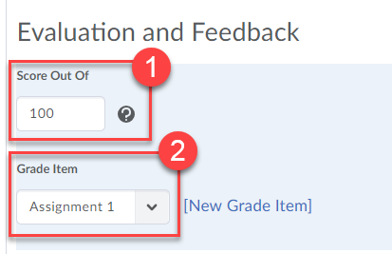

7. Scroll back up to the top of the page and click on the Restrictions tab.
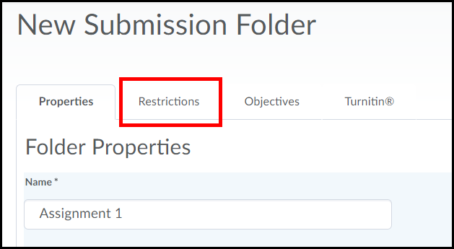

8. Click the checkboxes for Has Start Date, Has Due Date and Has End Date to select their desired date and times. You can select Hidden from users to hide the dropbox from students in till you are ready for them to access it.
IMPORTANT: You MUST select a start date for a dropbox in order for the Turnitin plagiarism checker to run without issues.
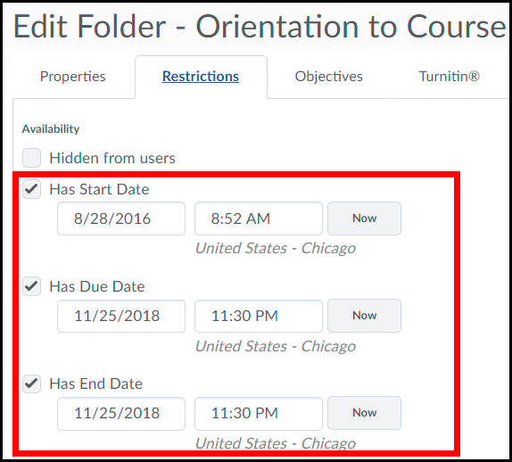
Select Hidden from users to hide the dropbox folder from your students in till you are ready for them to access it.
Enabling Turnitin
1. If you need to check submissions for plagiarism, click on the Turnitin tab.
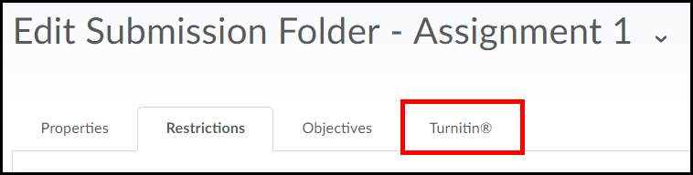

2. Check the Enable GradeMark for this folder option (1), Check the Enable Originality Check for this folder option (2). You can check the Allow learners to see Turnitin similarity scores in their dropbox folder to let students see the percentage of plagiarism found in their submissions (3). Click the More Options in Turnitn button (4).
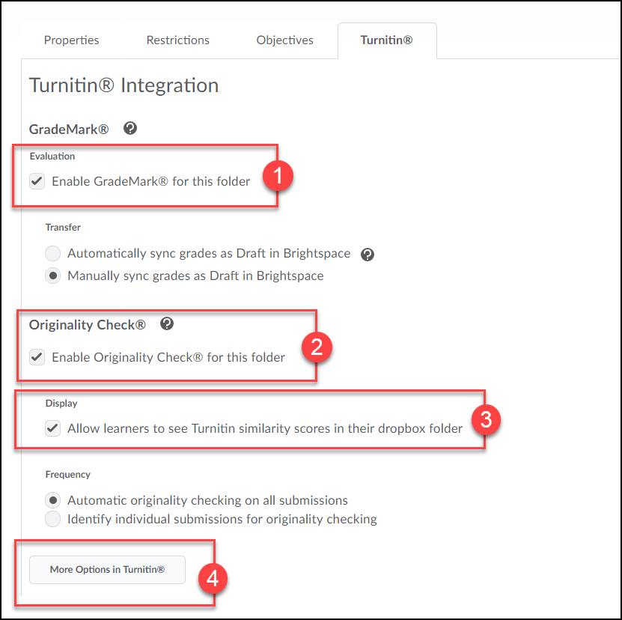

3. Click I agree if you receive the Turnitin User Agreement. Make sure Allow submission of any type is selected (1), and click the Options Settings link to apply additional settings (2).
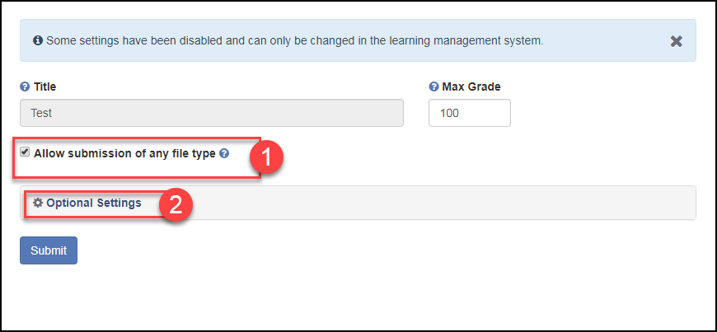
F.Y.I.: Turnitin supports the following file formats:

- Microsoft Word™ (DOC and DOCX)
- Corel WordPerfect®
- HTML
- Adobe PostScript®
- Plain text (TXT)
- Rich Text Format (RTF)
- Portable Document Format (PDF)
- Microsoft PowerPoint (PPT, PPTX, and PPS)
- Hangul (HWP)

4. From the Similarity Report drop-down menu select Generate reports immediately (students can resubmit until due date): After 3 resubmissions, reports generate after 24 hours (1). Select Save these settings for future use so that all the settings you selected will be applied to any future dropboxes you create for the course (2). Then click the Submit button (3).
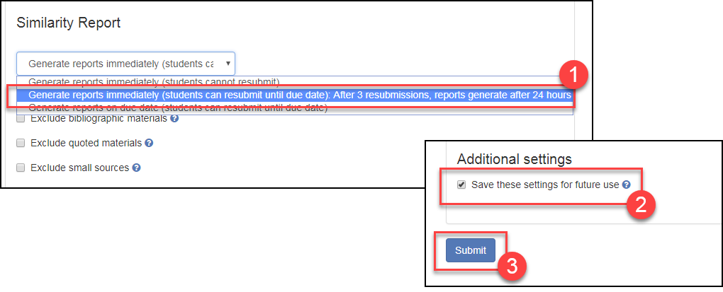

5. Click the Save and Close button when done.
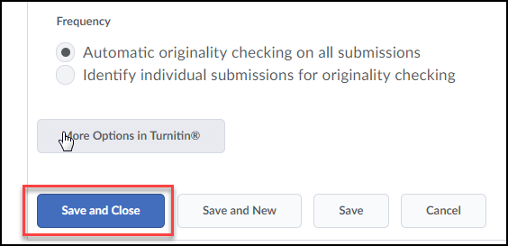

Edit a Dropbox Folder
1. Click on the drop-down menu located on the right of a Dropbox’s title and select Edit Submissions Folder.
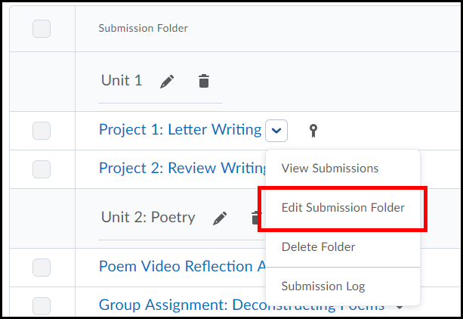
2. Edit the dropbox folder and click the Save and Close button when done.
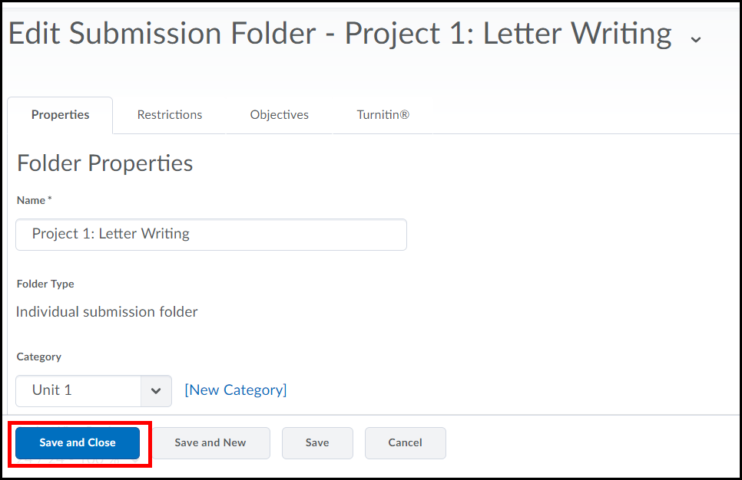
3. If no learner submissions have been made to an assignment, the assignment type and submission type can be changed. This allows for existing assignments to be modified without the need to create a new assignment.

Evaluating and Grading a Dropbox Submission
1. Once a student has submitted an item return to the Dropbox area in the course and click on the title of the dropbox folder, after viewing what needs to be completed.
Completed is how many students have submitted an assignment. Evaluated indicates total number of submissions that have been reviewed. Feedback Published indicates that feedback has already been given. Due Date indicates the due date for the assignment.
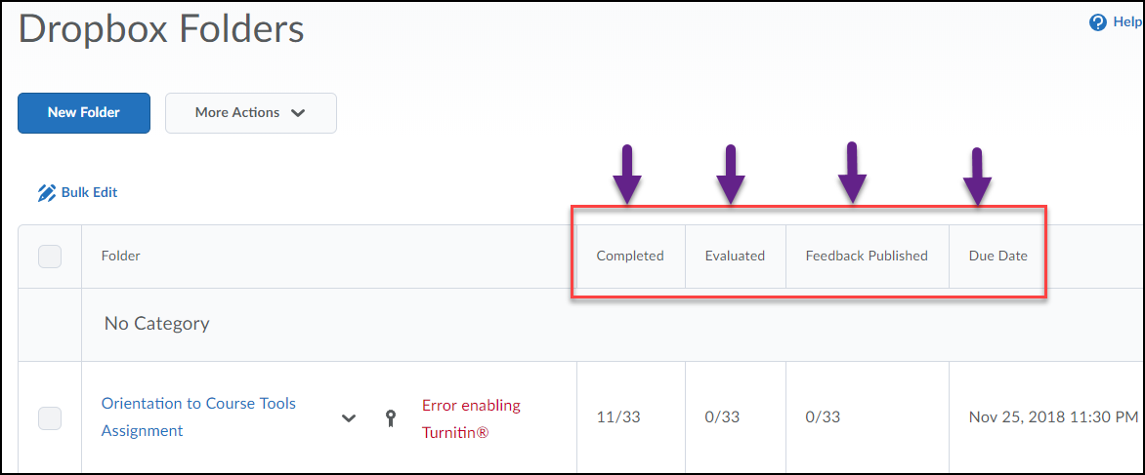
Click on the assignment you wish to review.
2. Scroll to the bottom of the page, click on the student's name to open the file and read it, or click Evaluate on the right. NOTE: You can select the checkboxes next to multiple student submissions and click the "Download" link (best if you want to access all submissions at one time). Once the file is downloaded, unzip file (double click on file name) to access each individual submission.
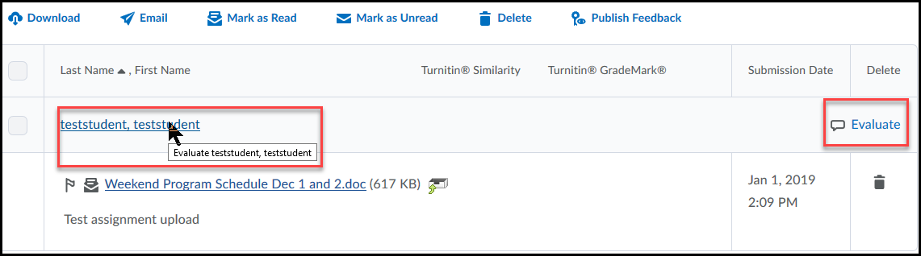
NOTE: Click on the submission file name to download it to your computer.
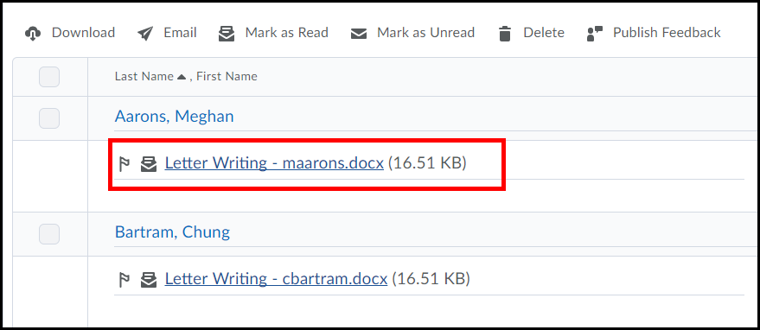
NOTE: Emails can still be sent to students from the Submissions page by selecting the check box beside a learner’s name, and clicking Email.
3. If the assignment is Turnitin enabled, there will be a link on the left to submit file to Turnitin.
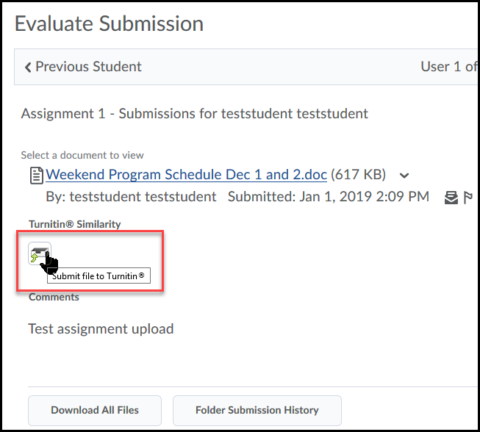
4. On the right of the screen enter a Score (1) as well as any Feedback you would like to provide (2) and choose to Publish or Save Draft to complete later (3).
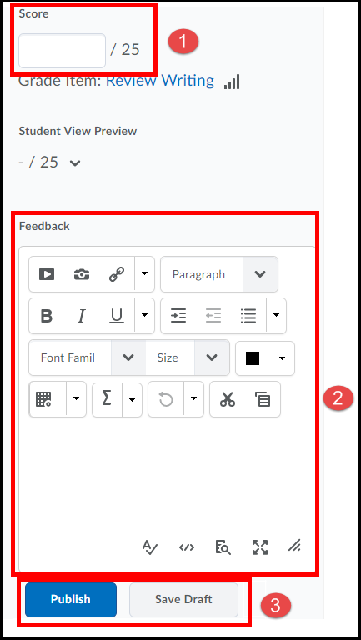
NOTE: To continue grading and publish later choose Save Draft, then click Next Student.

To publish feedback to selected students or all students at one time
1. For each student enter Score and Feedback and select to Save Draft, DO NOT click the Publish button (this will actually publish the feedback) instead click on the link for "Back to Submissions" located in the upper right corner of the screen.
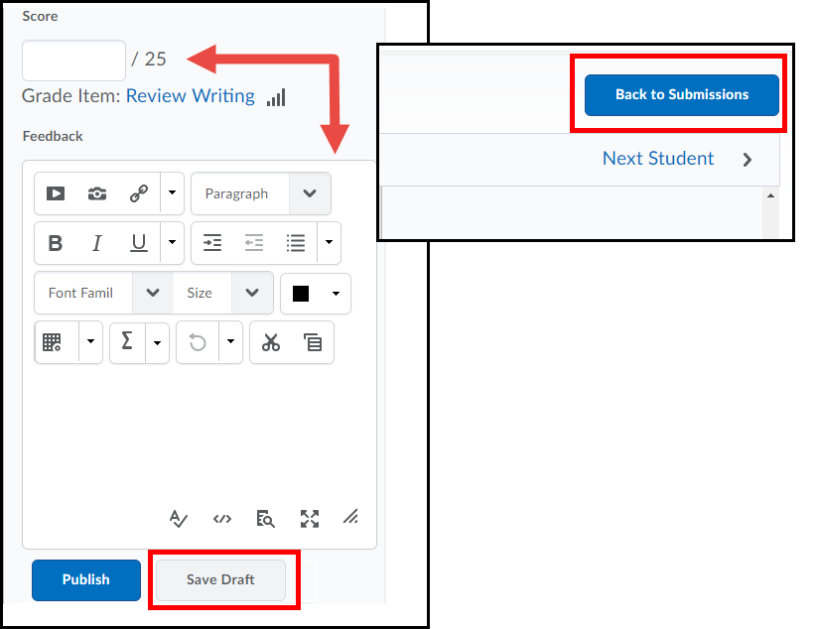

2. After the grade and feedback has been saved as a Draft for the last student, return to the submission area for the dropbox folder. Check the boxes next to every student you would like to release the score for OR click the checkbox at the top of the table to select all students.
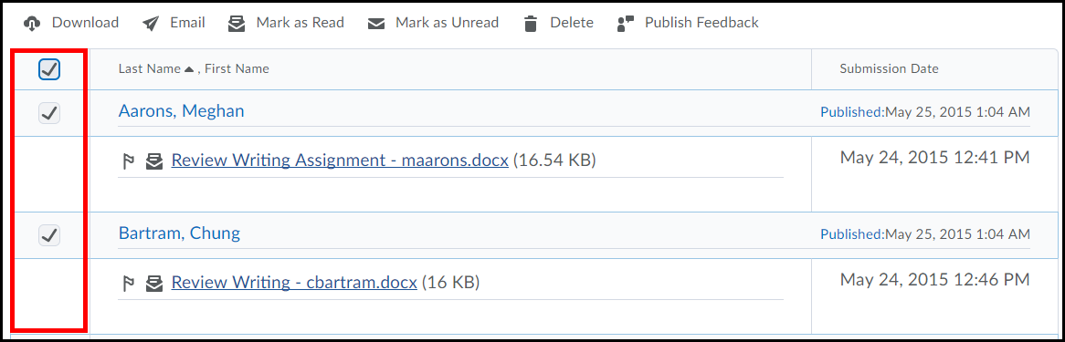

3. Once done with selections, click the Publish Feedback link to release feedback.
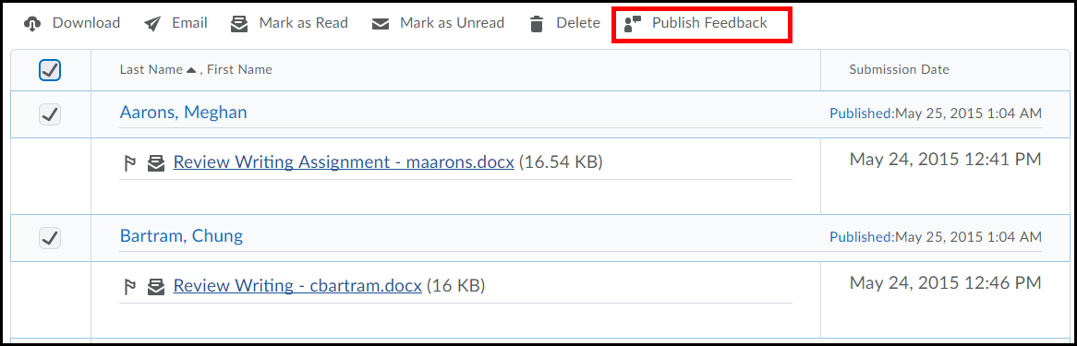

Download Multiple Submissions
You have the ability to download multiple student submissions from a Assignments to your computer and provide feedback offline
- Check the boxes of the students’ whose Assignments submissions you want to download.

- Click the Download icon to download the files to your computer.
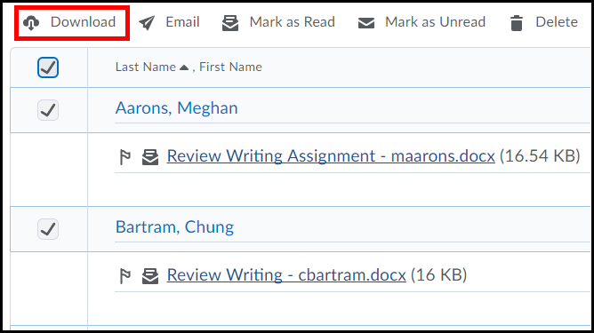

- Click the download link from the prompt window to download the submissions (note the link is the name of the submissions file folder).
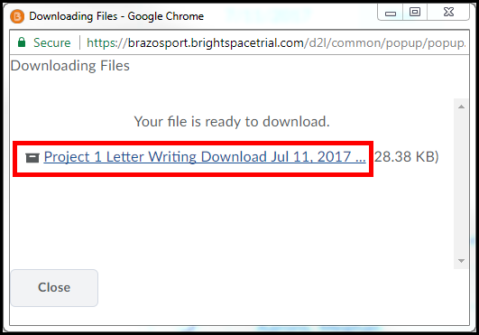

- Select Save File (1) and click the OK button (2).
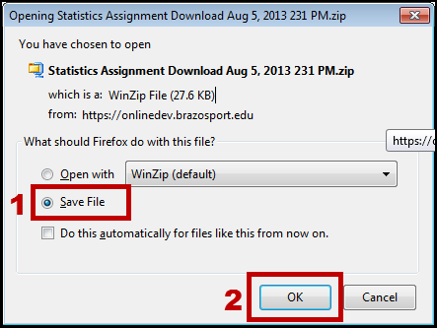
- Locate the file on your computer (if using windows it may be located in your downloads folder) and double click to open it.
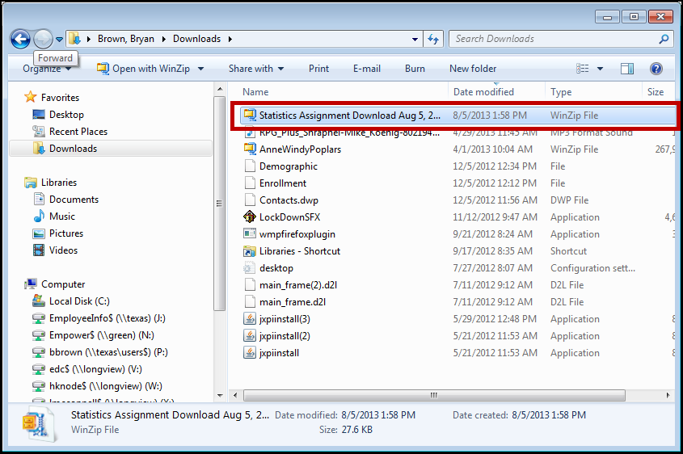

- The files are now accessible on your computer for you to evaluate, double click to open each.

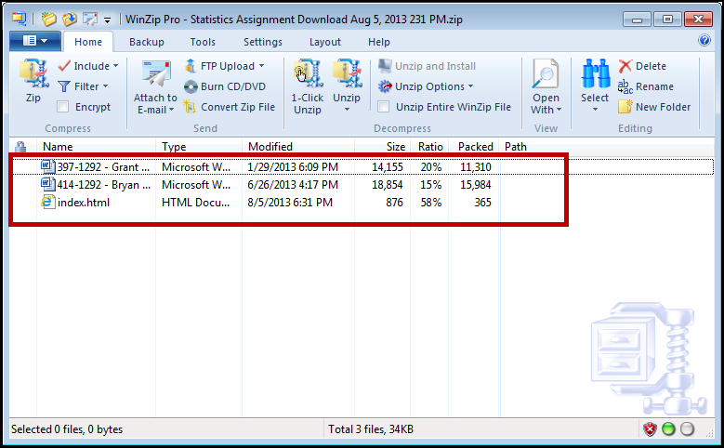

NOTE: Do not change the name of any of the submission files when you save them to your computer. The file names are unique to D2L and are used to replace the files with the correct students’ evaluation/feedback when uploaded back into the Assignments.

Uploading Evaluated Submissions back into D2L
Once you have evaluated Dropbox submissions you will need to upload them to back to D2L. D2L will automatically place the evaluated files with the corresponding students in which they belong to.
- Click the Add Feedback Files button.
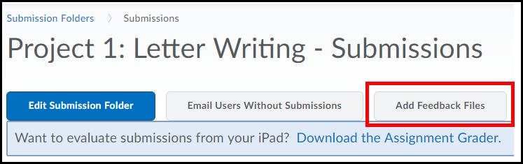

- Click the upload button.
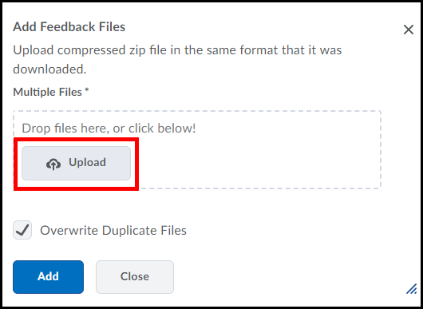

- Hold down the CTRL key on your keyboard and select all the files you want to upload (1). When finished click the Open button (2).
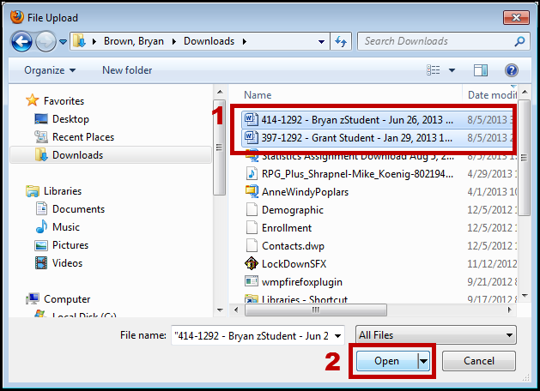

NOTE: You can also upload files by dragging and dropping them from your computer into the outlined drag and drop area (must have Internet Explorer 10 or higher).
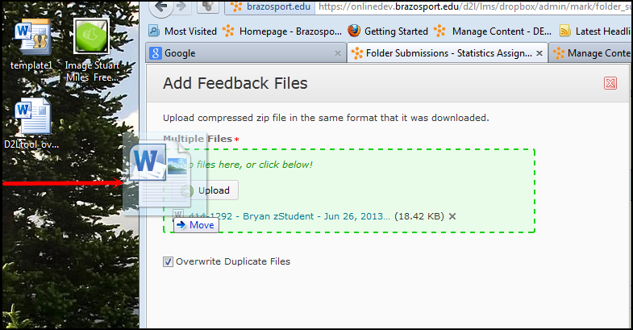

- Click the Add button when finished.
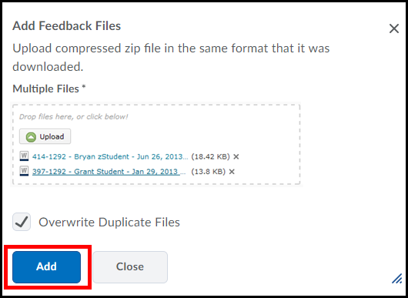

- When you click on a student’s submission you should now see to your completed evaluation.
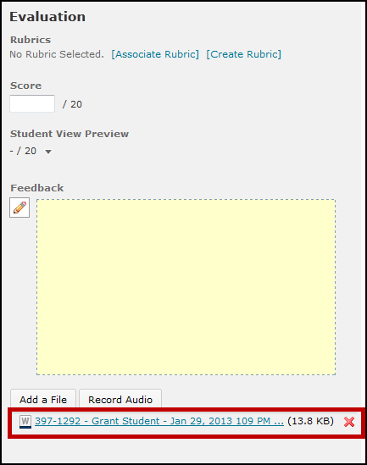

Restoring a Deleted Dropbox
You have the ability to restore any deleted Dropbox back to the dropbox area of your course.
- From within the Assignments area you will click on the More Actions button (1) and select Event Log (2).
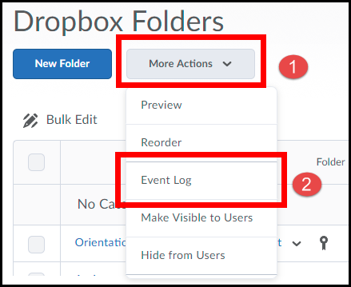

- A list of every Dropbox you have deleted will appear. From here click the Restore button of the Dropbox you would like to restore.
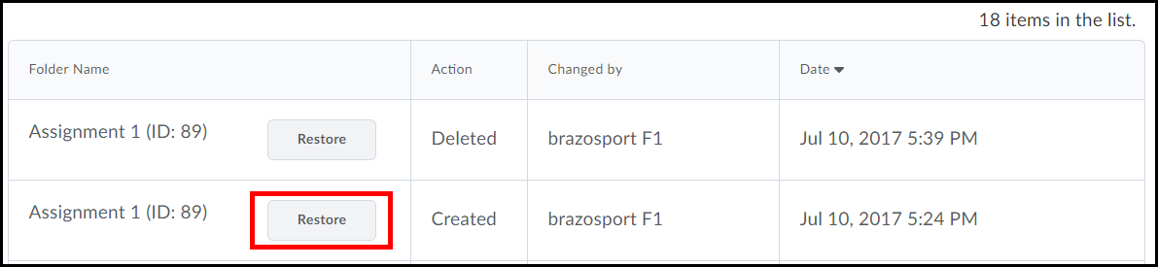

- When you return to the Dropbox area the specific Dropbox folder will now be restored there.
