Rubrics created in D2L can be used to guide grading and to communicate to students what is expected on an assignment. This manual will show you how to create a rubric for a D2L assignment, quiz, or discussion.
- Select Assessments (1) from the navigation bar and click on Rubrics (2).
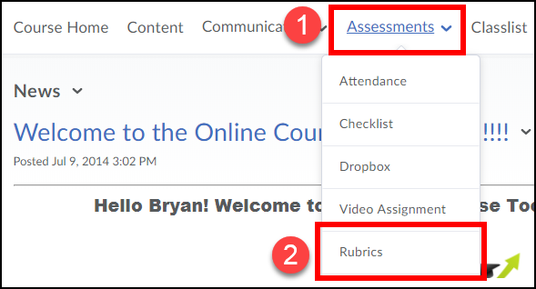
- Press the New Rubric button.
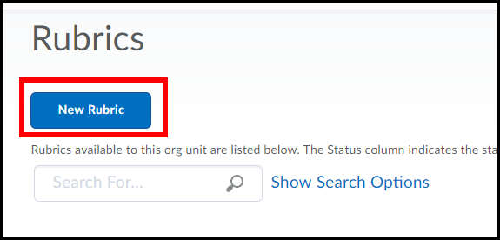

- Enter a Name (1) and a Description (2) for the rubric.
[NOTE: Leave Rubric Status set to Draft for now.]
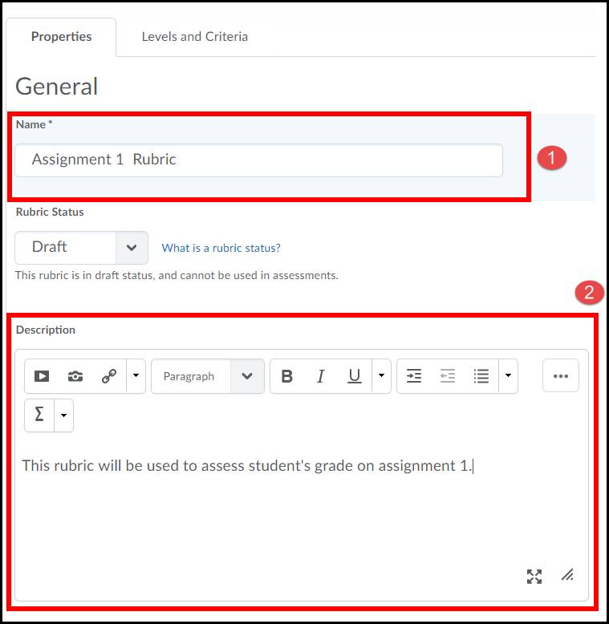

- Select the type of rubric you would like to create.
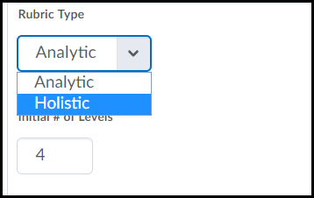

There are two types of rubrics in D2L: Holistic and Analytic. Holistic rubrics are single-criteria rubrics used to evaluate students' overall performance based on predefined achievement levels. Analytic rubrics may contain multiple levels of achievement and assessment criteria to evaluate students based on different criteria using a single rubric.

Creating a Holistic Rubric
- Select Holistic from the Rubric Type dropdown list.
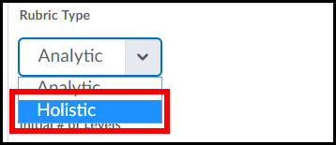

- Select the Initial Number of Levels that you want to include in your rubric; four (4) is the default.
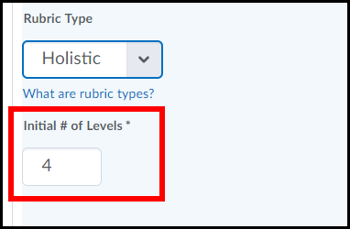

- Select a Scoring Method: Percentages (default) or Text Only.
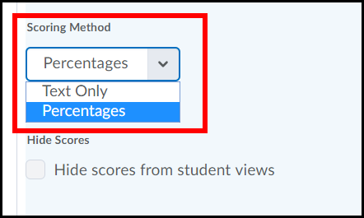

- Under the Advanced Availability menu, ensure that the Competencies options are checked so this rubric can be linked to other tools in this course.
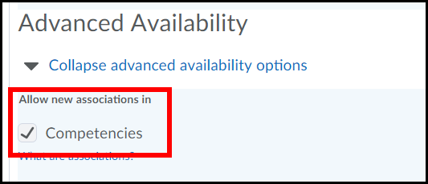

- Click on the Levels and Criteria tab.
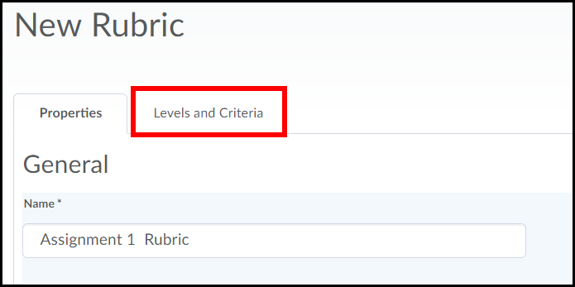

- Press the Edit Levels link.
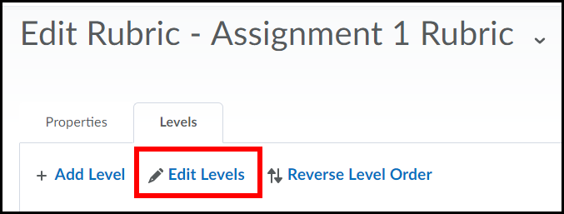

- In the Level Name column, enter a title for each level; this will overwrite the default text that appears in each level.
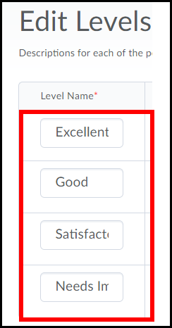

- If you chose to use percentages as your scoring method, enter a start range for each level. Your lowest achievement level range should start at 0%, the start range of your second, third, fourth, etc... achievement level will then be the next highest percentage achievable.
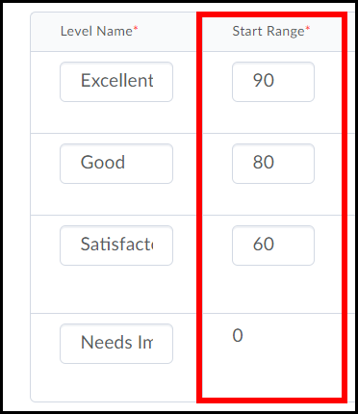

- Enter a Description for each level to explain what is expected of a student to receive a score in that category.
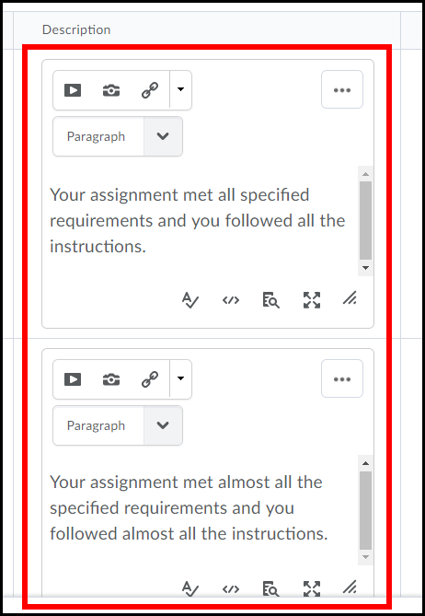

- You can enter Feedback which will appear to each student scoring within that level (this step is optional).
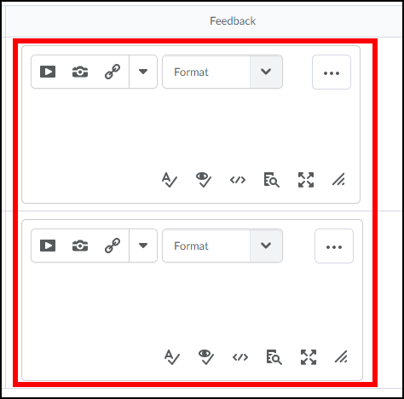

- Press the Save button.
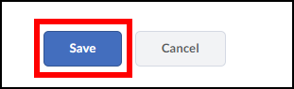

- Return to the Properties tab.
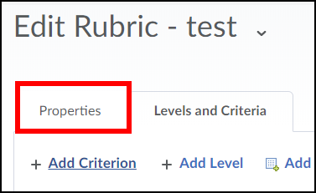

- Change the rubric's status to Published when it is complete (1) and press the Save button (2).
NOTE: You cannot associate a rubric with other tools in your D2L course unless its status is set to Published.
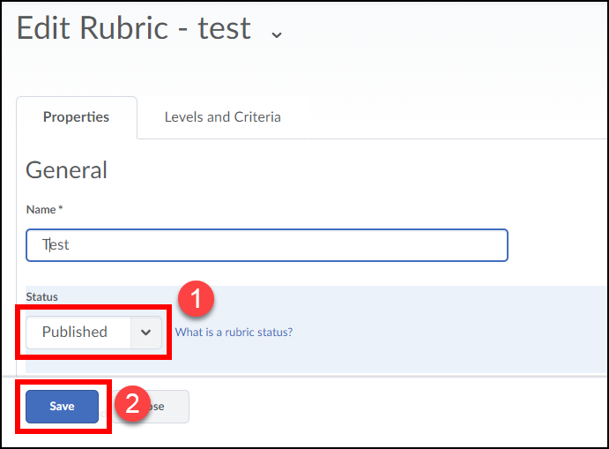

Congratulations!!!! You have now created a Holistic rubric.

Creating an Analytic Rubric
- Select Analytic from the Rubric Type dropdown list.
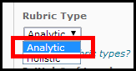

- Select the Initial Number of Levels (achievement levels are displayed in columns) (1) and Initial Number of Criteria (evaluation criteria are displayed in rows) (2) that you want to include in your rubric.
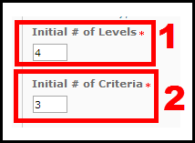
- Select a Scoring Method: Points (default), Custom Points, or Text only. This manual will create a rubric using points.
Points: allows you to include points to assess performance. For example, three performance levels for a rubric could be Poor (0 points), Good (75 points), and Excellent (125 points).

Custom Points: allows you the ability to assign different values to different criteria in your rubric, giving more "weight" to one or more criterion than to others. This is the recommended scoring method and the one used in this manual.

Text only: allows rubric performance levels to be expressed using only text. For example, three performance levels for a rubric could be Poor, Good, and Excellent.
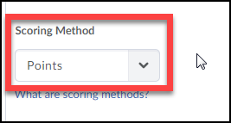

- Select the Rubric Visibility. Rubric is always visible to learners (default): rubric will always be visible to students; Rubric is hidden until feedback published: rubric will only be visible to students once the assignment it is attached to has been graded; Rubric is never visible: rubric will not be visible to students.
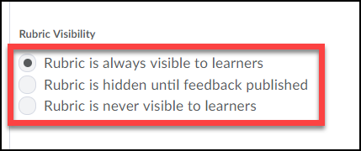

- Under the Advanced Availability menu, ensure that the Competencies options are checked so this rubric can be linked to other tools in this course.
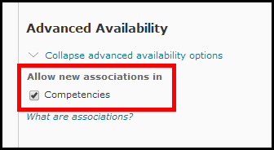
- Click on the Levels and Criteria tab.
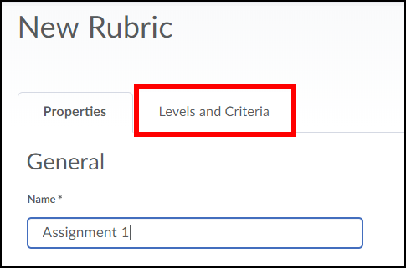

- Click on the Criteria dropdown menu (1) and choose Edit Criterion Group from the drop-down menu (2).
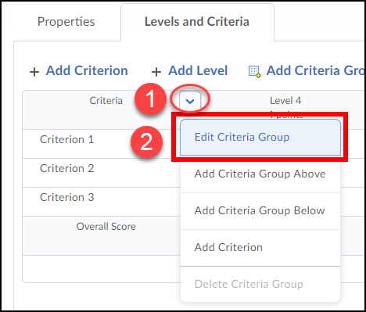

- Enter a name for each level (1). Enter a name for each criteria listed (2) and click the Save button (3).
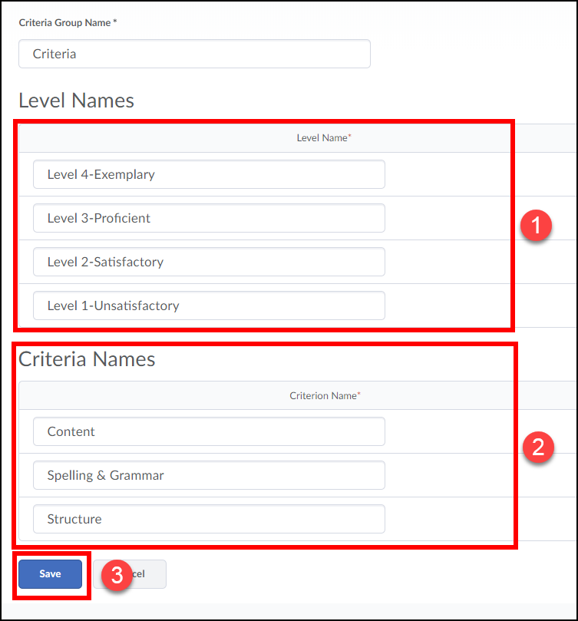

- Click the drop-down menu next to a level of the rubric (1) and select Edit Level (2).
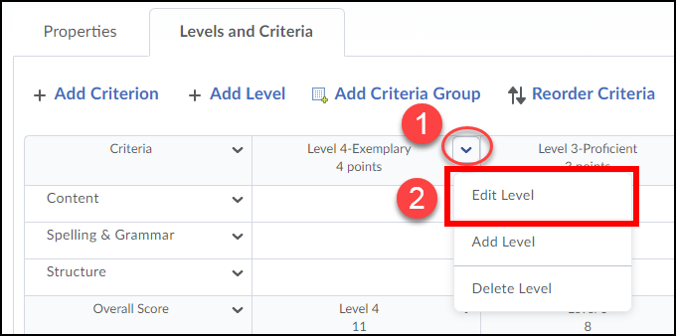

- Enter the Score (points) (1) a student can receive for each criteria met in the level. Enter a description (2) for each criteria in the level. The description explains what is expected of a student to receive the points for that category.
Note: It is recommended that you make the points for the highest level of your rubric 10 points each.
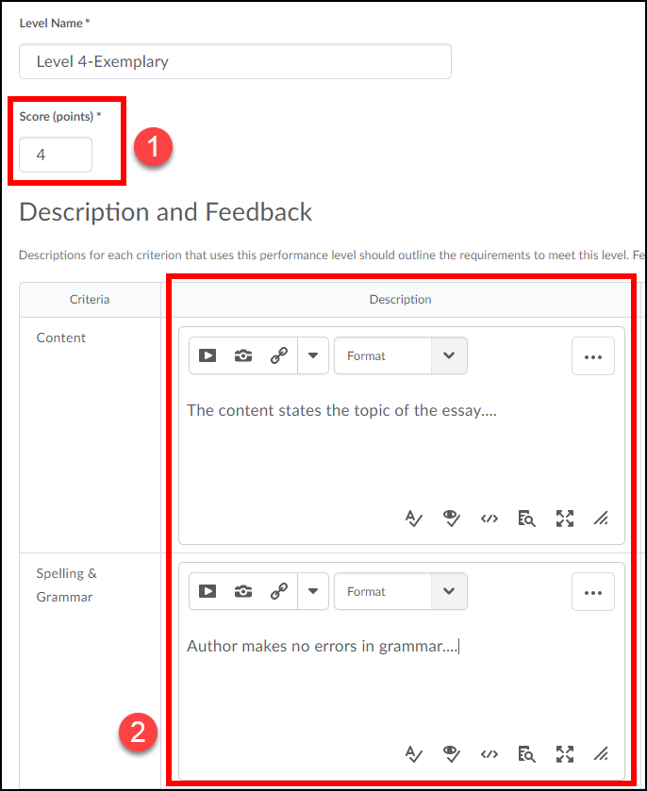

- Enter standard Feedback text which will appear to each student scoring within that level (this step is optional).
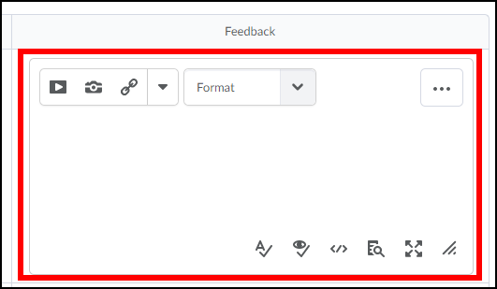
- Click the Save button when finished.

- Repeat steps 9-12 for each criterion level of your rubric.

- Click Add level to create an incomplete level to add to the rubric.
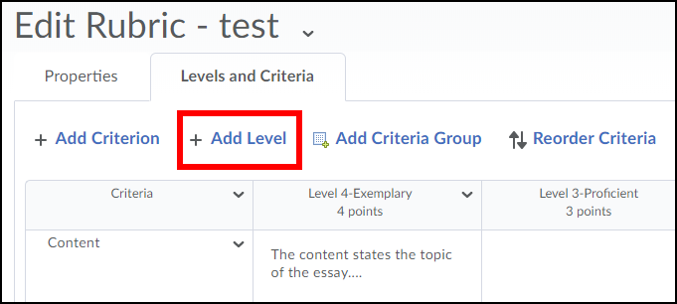

- Enter a name for the level, such as Incomplete (1). Enter 0 for the Score (points) for each criteria met in the level (2). If desired you can enter a Description and Feedback for each criteria in the level (3). Click Save when done (4).
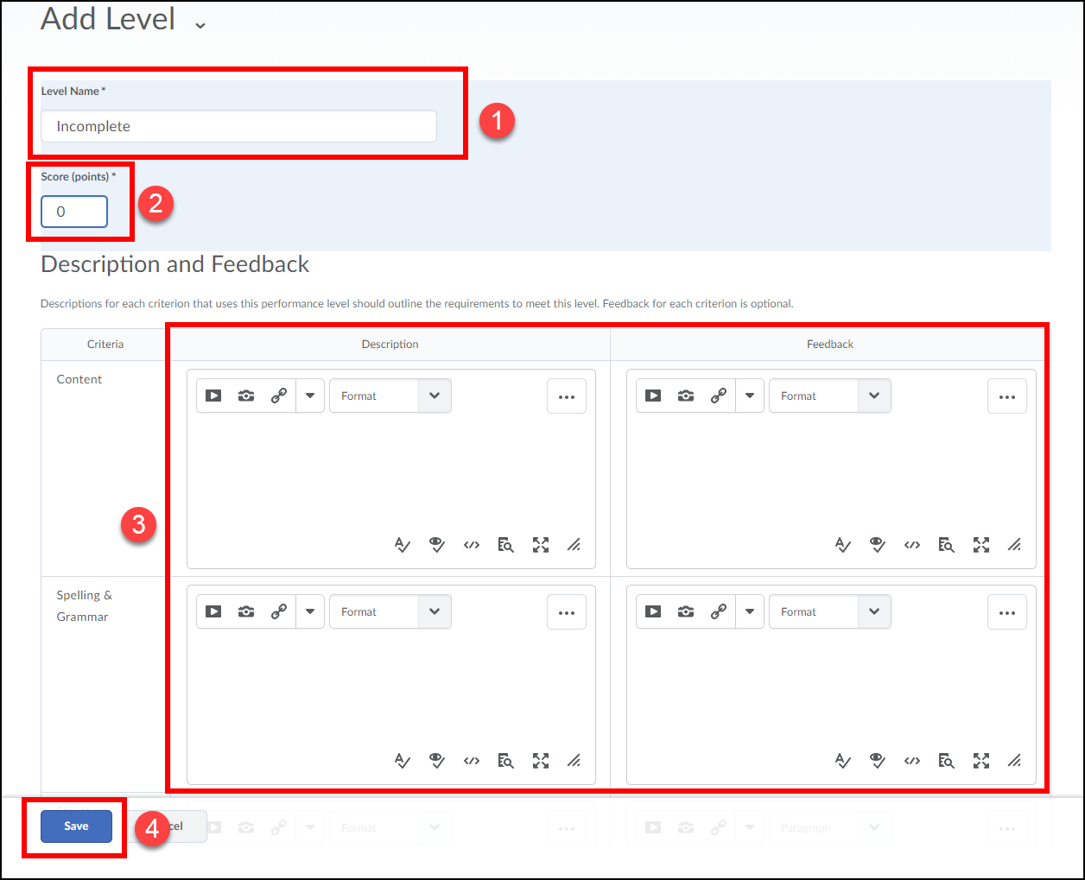
Adjusting the Score Ranges of Rubric Levels
You may find it necessary to adjust the score ranges of the levels of your rubric. The score range for a level on the rubric reflects the range in which a student’s score must fall under in order for that student to meet the performance specified by that level of the rubric.
Note: the score range of Level 1 cannot be adjusted. It is automatically set to 0 by the system.
- To adjust the score range of a level click on the dropdown menu in the last cell of that level (1) and select Edit Level (2).
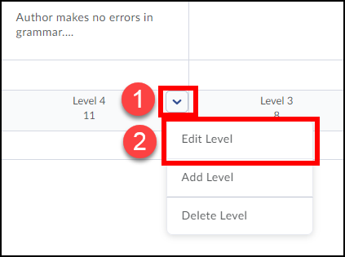

- Enter a Start Range for the level (1). The start range is the lowest possible points a student can get for that level. Click the Save button when done (2).
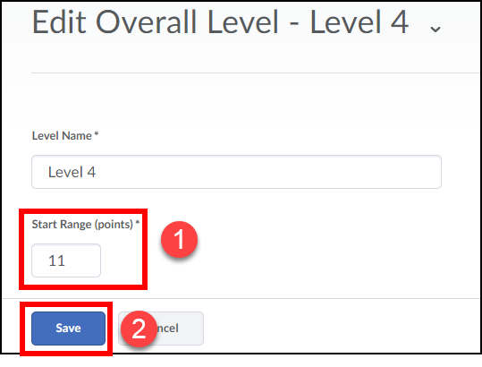
- Repeat steps 1-2 for each additional level of your rubric.

- Return to the Properties tab.

- Change the rubric's status to Published (1). When done press Save (2).
Congratulations!!!! You have now created an Analytic rubric.

Linking Rubrics to Course Activities
You can link rubrics you create to Dropbox, discussion, and quizzes in your D2L course.
Link to a Dropbox:
- From the Properties tab (appears whenever you edit or create a Dropbox) of a Dropbox click the Add Rubric button.
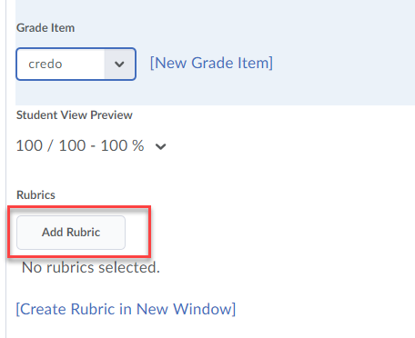

- Select the rubric you would like to link to the Dropbox (1) and click the Add Selected button (2).
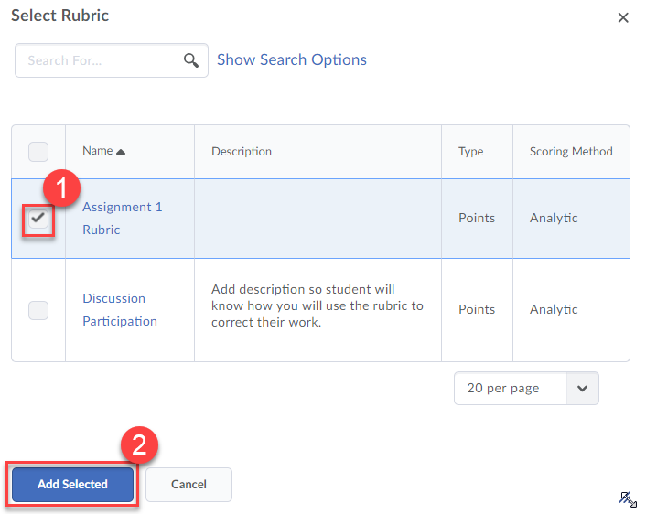
- Make sure the rubric appears under the rubrics section of the Dropbox’s properties tab. Click the Save and Close button.
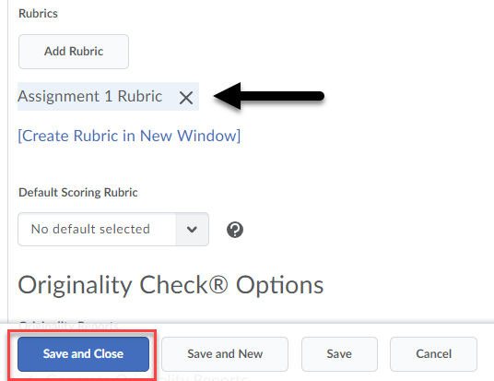
The rubric is now linked to your Dropbox!

Link to a Discussion Topic:
- From the Assessment tab (appears whenever you edit or create a discussion topic) of a discussion topic click the Add Rubric button.
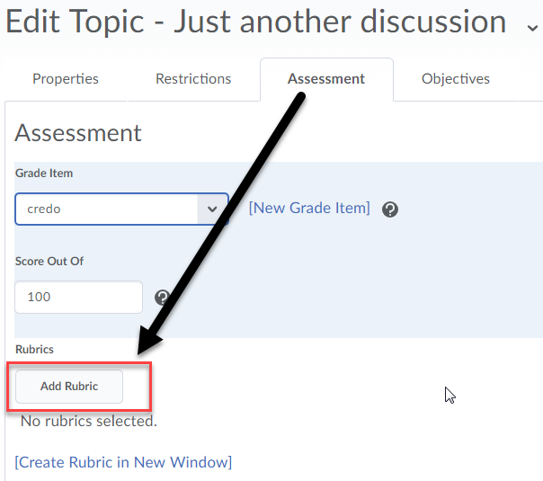

- Select the rubric you would like to link to the discussion topic (1) and click the Add Selected button (2).

- Make sure the rubric appears under the rubrics section of the discussion topic’s properties tab. And click the Save and Close button.
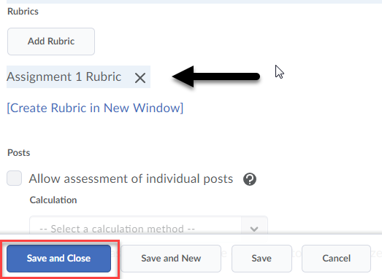
The rubric is now linked to your discussion topic!

How will Students View Rubrics?
Dropboxes:
Students can see the rubric when they access the Dropbox before submitting a document (if you have made the rubric visible to them).
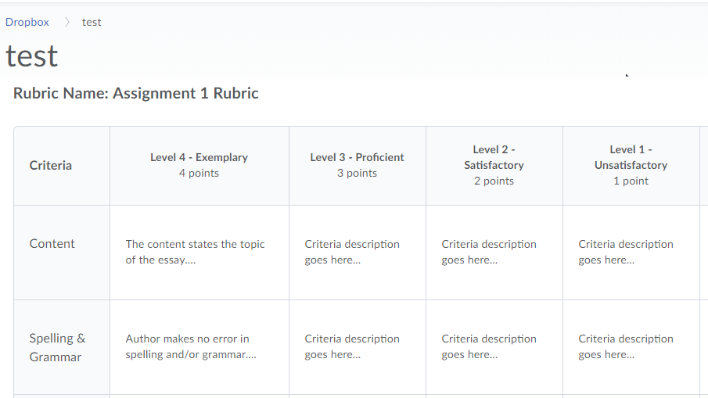
Once their submission is assessed, students will see a View Feedback link in the Dropbox for the assignment. Clicking on the link will allow students to view their graded rubric feedback.
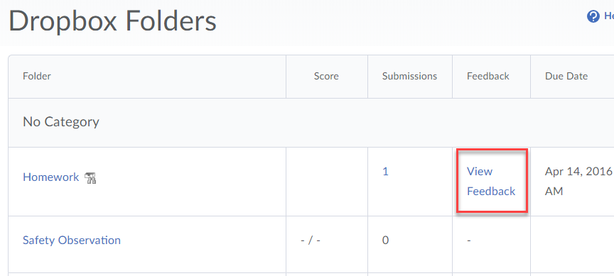

Students can view their graded rubric feedback for a Dropbox assignment via their gradebook by clicking the View Graded Rubric link for it.
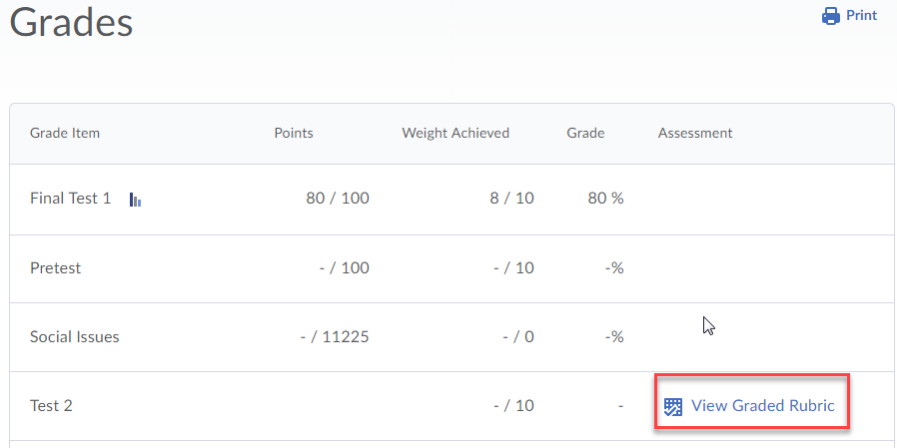
Discussions:
If a rubric is linked to a discussion topic students can see it when they click on the rubric link found when clicking on the discussion topic or starting a new thread in it.
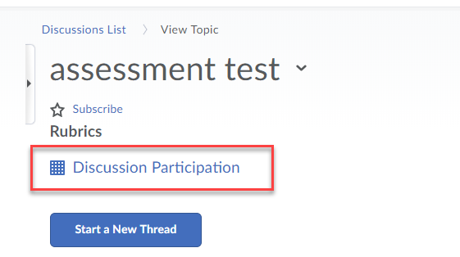
Students can view their graded rubric feedback for a discussion via their gradebook by clicking the View Graded Rubric link for it.

