Adding Video Note
Video Note enables you to create short video recording from a webcam and insert in any area that uses the HTML Editor in D2L, such as Content, Discussions, Dropbox, Dropbox Feedback, etc.
Use cases for Video Note:
- Create a new topic in Content area
- Add a video description to a Module or a topic in the Content area
- Create a video News item on the course Homepage
- Provide video instructions when creating a Dropbox item
- Provide video feedback on students’ Dropbox submission
- Give a video description of a new topic in Discussions or make a video post on a Discussion topic
- Give students video comments (feedback) in the Gradebook
- … and any other place where D2L HTML editor is available
1. From any tool with an HTML Editor, click on Insert Stuff.
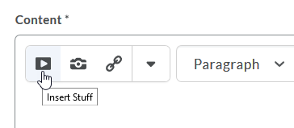
2. Click Add Video Note.
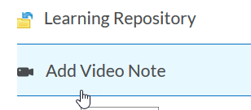

3. Make sure correct Camera and Microphone are selected and click “Allow” (note: check box for Remember this decision if you don’t plan on changing these options).
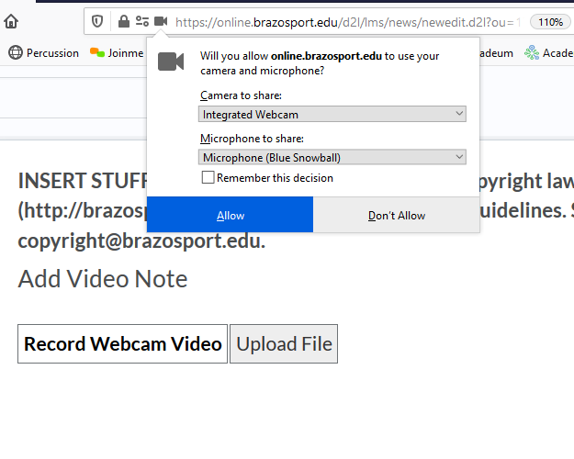
4. Select New Recording.
5. Select Stop Recording when done.
6. If you want to record again, click New Recording OR click Next.
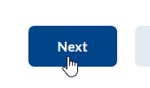
7. Enter title, optional description, select language, and optionally check auto captions (please note captions may not match your words exactly, since this is an automated service). Click Next when done.
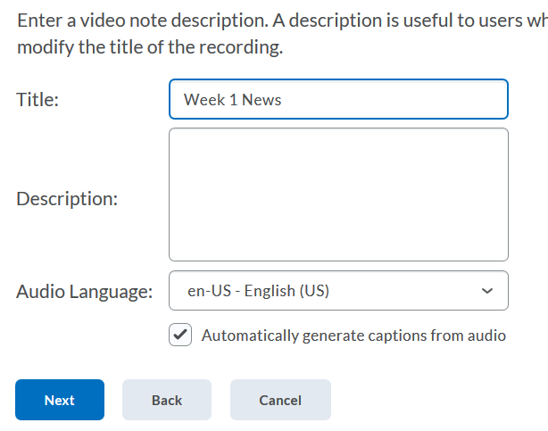
8. It does take some time to process the video, click Insert. Once video has completed processing it will be viewable. Note: the longer the video, more movement in the video, and including captions results in lengthened processing times.
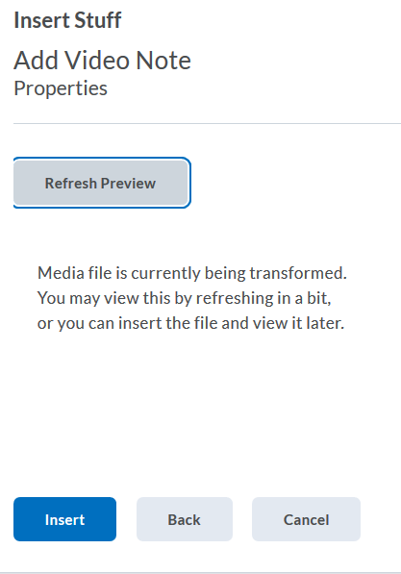

9. Once inserted, click Save or Save and Close. To view, click the Play button. To read captions, click the captions icon and select “Default”.
