**Zoom**

Zoom is a tool that allows you to facilitate virtual meetings with your students.

**What to Know Before Getting Started with Zoom:**

1. Zoom is for **live meetings/lectures** and is NOT intended for the pre-recording of lectures.

2. Zoom meetings will be purged within one semester (not at the end of each semester…example: fall zoom recordings will be deleted at the end of spring)

3. If for some reason you want to keep Zoom meeting recordings from your past semester courses (not advised since questions asked by students from past semesters can lead to confusion or no longer be applicable) you should export the recordings from D2L and upload them to MyMediasite.

**Scheduling a Meeting**

1. Click on **Communication** from the navigation bar (1) and click on **Zoom Meeting** (2).

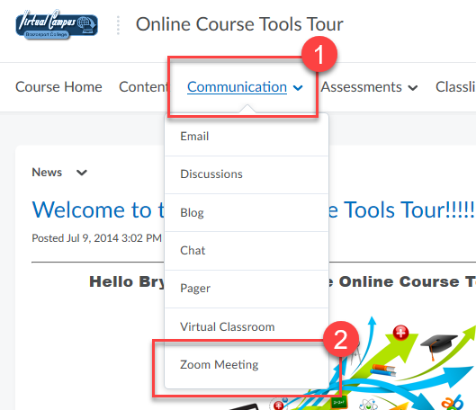

2. Click on **Schedule a new meeting**.

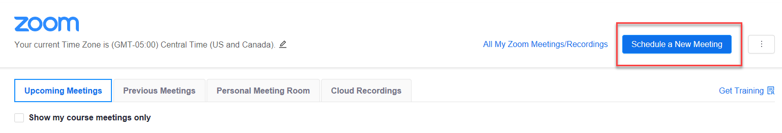

3. Enter a **topic/name** for the meeting (1), you can enter in a **description** (2). Enter in the **date and time** the meeting will take place (3) and select **how long the meeting will last** (4).

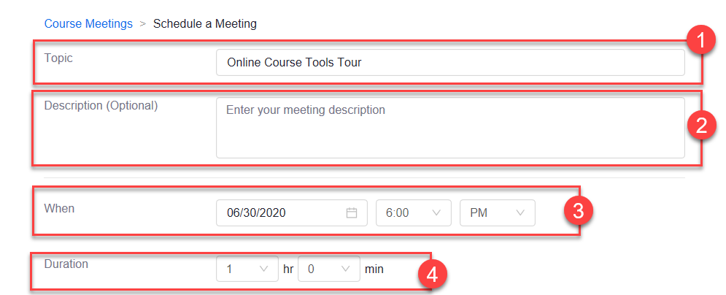

4. Select IF the meeting will be **recurring** (1). Select whether you want yourself or participants to **join with their video/webcams on or off** (2). Ensure **Both** is selected for audio so participants have the option to use either the phone or computer audio during the meeting (3). NOTE on the following **meeting options** (4):

* **Personal Meeting ID** (PMI): Do NOT select this as an option. The link is always open, allowing users to join in at any time and all the time.
* **Record the meeting automatically**: Only select option if doing a lecture/presentation. You would not want to record office hours, Aceit meetings, etc.

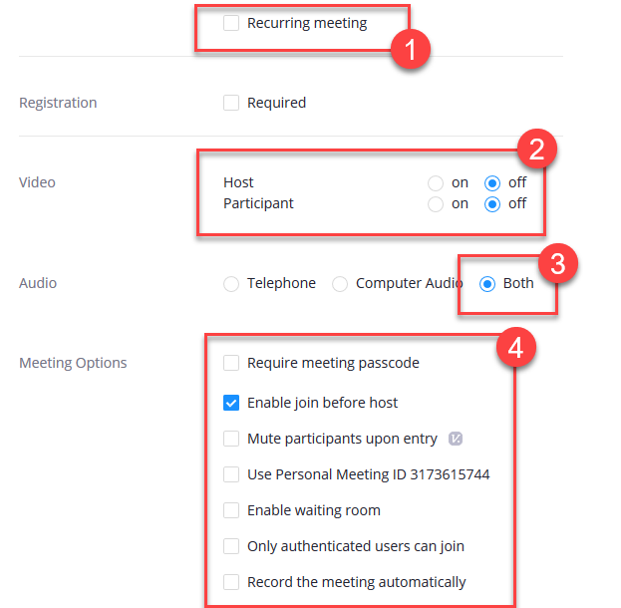

5. IF you would like additional hosts, such as guest lectures, enter their email. Click **Save** when done.

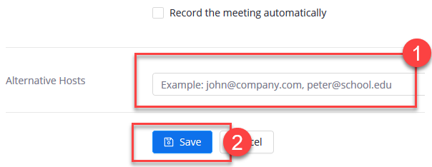

6. Scroll up and you can now **add the meeting to your Outlook calendar** (1). If needed you can copy the meeting link to email to others outside of the course. (2). NOTE: if you are sharing outside of D2L you will need to make sure you DO NOT select the option for “Only authenticated users can join”.

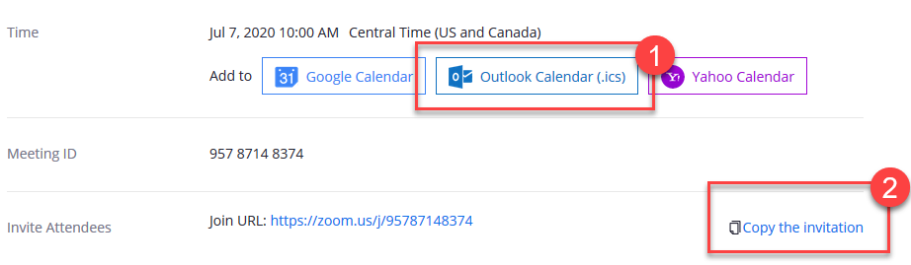

7. If needed you can **delete, edit, or start the meeting**.

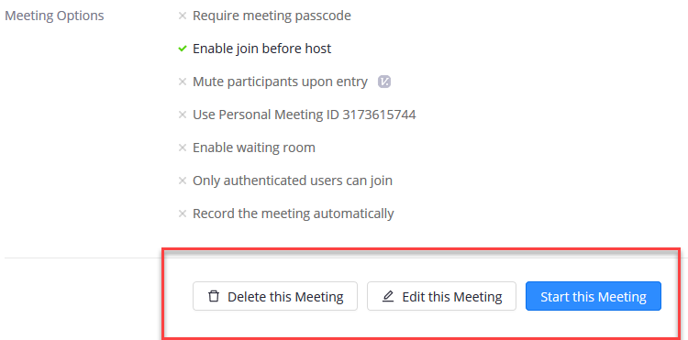

**SECURITY NOTE**: Zoom Bombing is when “an uninvited person joins a Zoom meeting and often hurls racial slurs or profanity.” There are a few security measures you can select when creating your next Zoom meeting whether in D2L or via your Zoom account which may help deter this from occurring:

1. Select to use the “Passcode” option which is set by default.

2. Select the option for “Waiting Room” so that you only admit those students you know

3. Disable “Enable join before host” so that you must be in the meeting first before students can join

4. Choose to “Mute participants upon entry” as well

5. DO NOT create “recurring” meetings which results in all of them having the same Meeting ID number. Stick with scheduling a new meeting each time. That way if someone happened to get ahold of an ID they wouldn’t be able to keep using it to pop in and out of future meetings.

6. At the start of the semester tell students to no share login or meeting access link with others.

**Starting a Scheduled Meeting**

1. Click on **Communication** from the navigation bar (1) and click on **Zoom Meeting** (2).



2. Click on **Start** for the scheduled meeting.

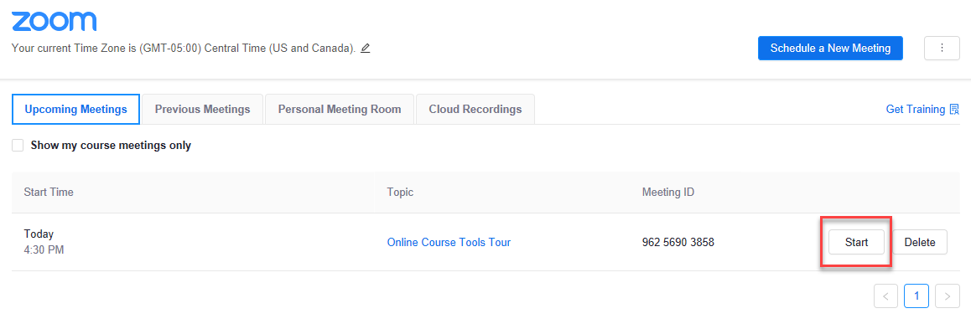

3. If you have not done so before, **download/save**the Zoom Launcher to your device and *Run it* (1). If you already have downloaded the Zoom launcher it should automatically launch for you. If it doesn’t, click the **launch meeting** link (2).

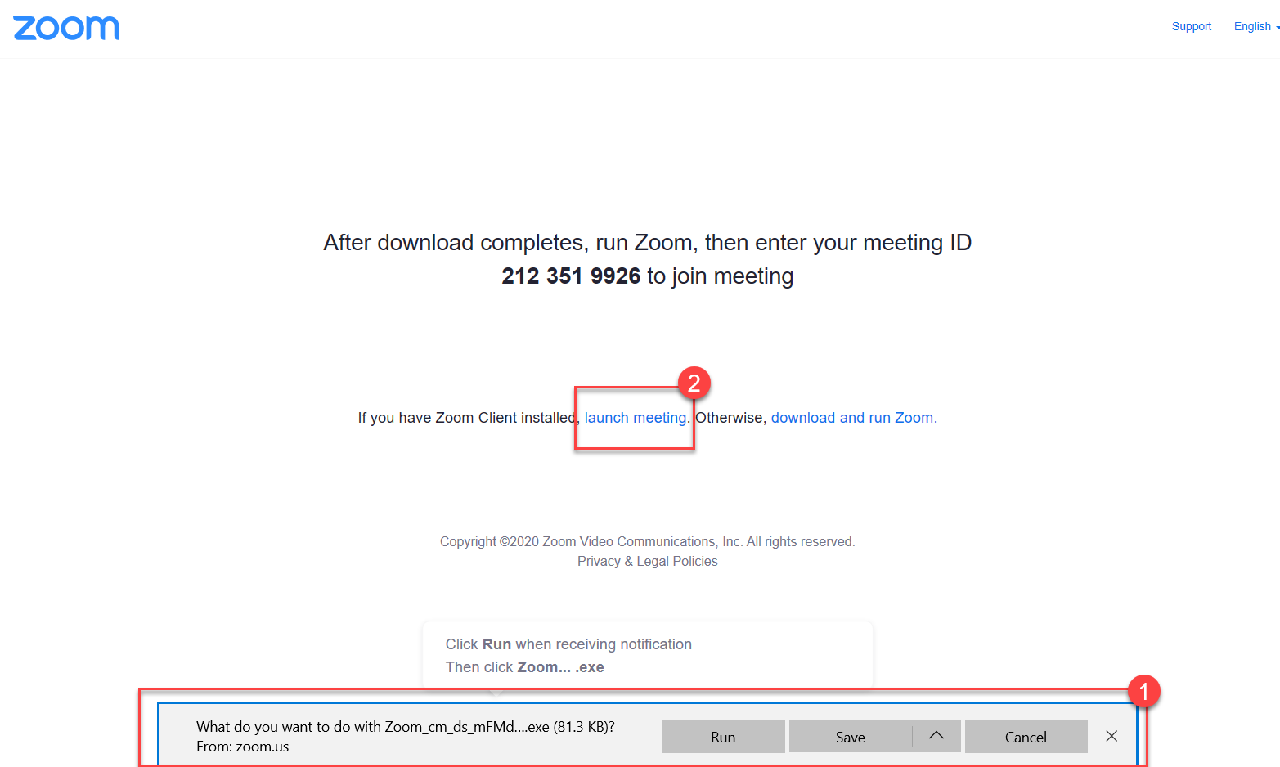

4. The Zoom meeting will open and you will need to choose whether you want to join with audio via your **Computer Audio** or you **Phone**.

*Computer Audio*: Click on **Join with Computer Audio** to connect with your computer headset/speaker.

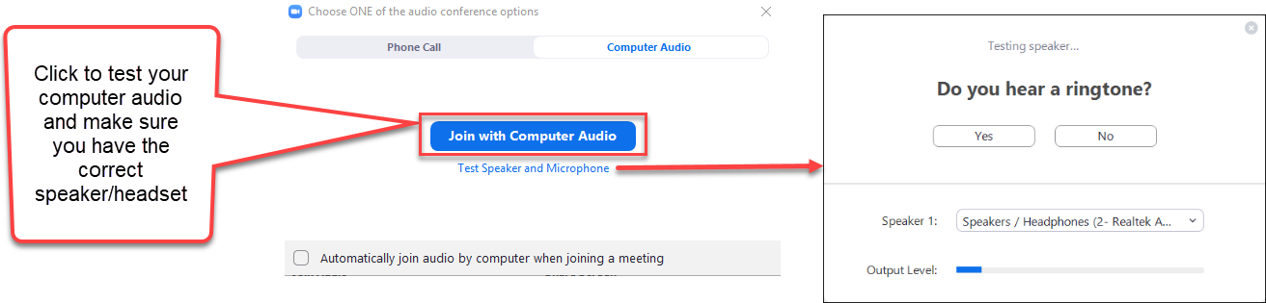

**OR**

*Phone Call*: Use the phone number info provided to call into the meeting with your phone for audio.

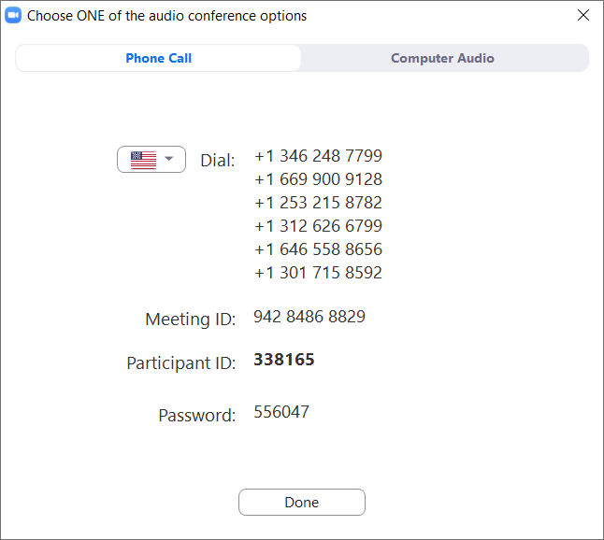

5. The **initial meeting room screen** will be displayed to you.

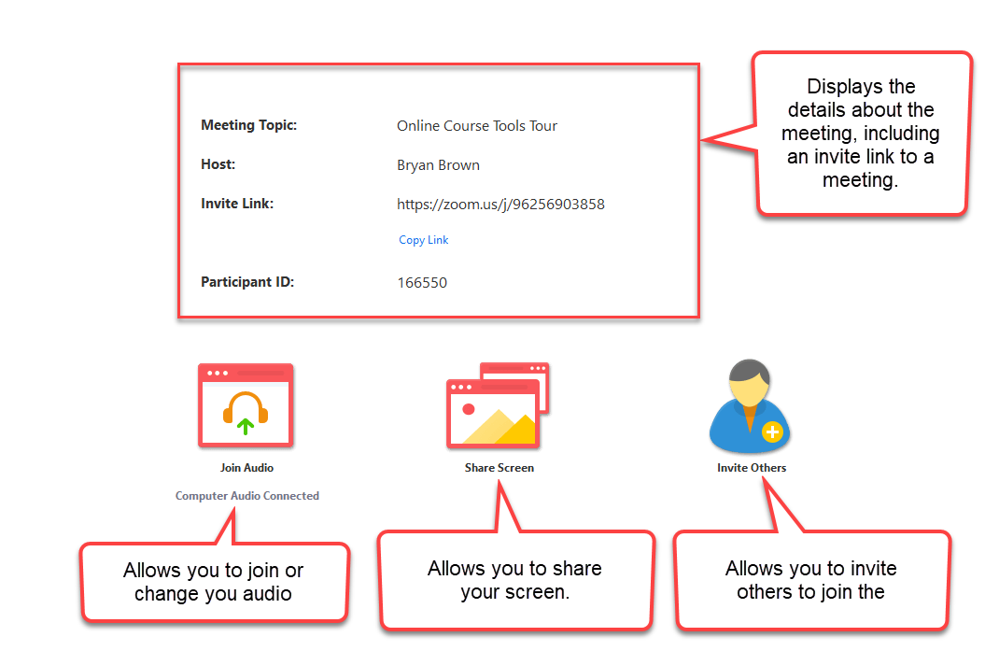

6. Hover over the meeting screen to access the **meeting menu features**.

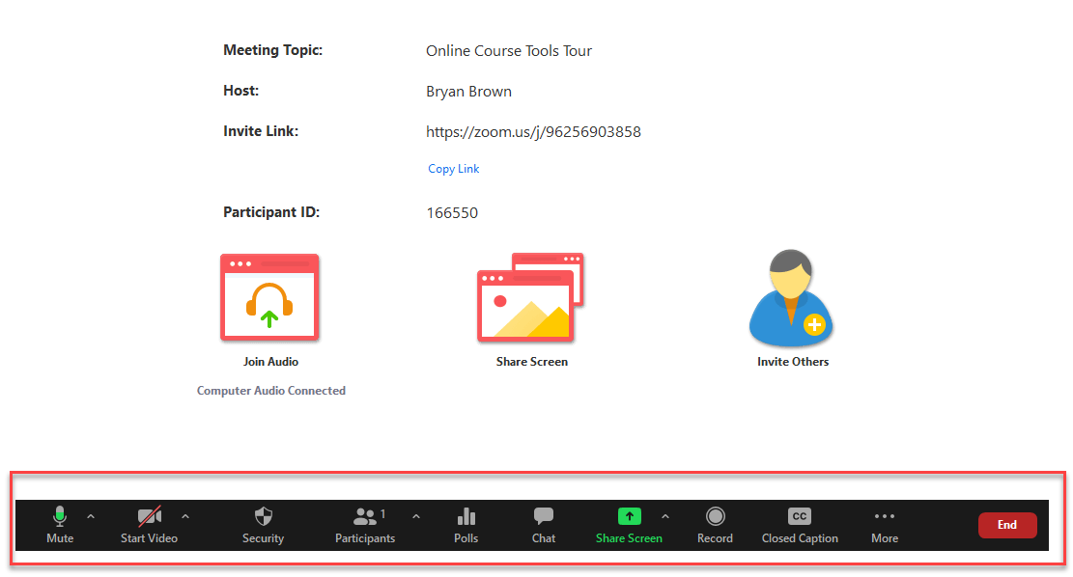

**Zoom Meeting Features**

*Mute***:**

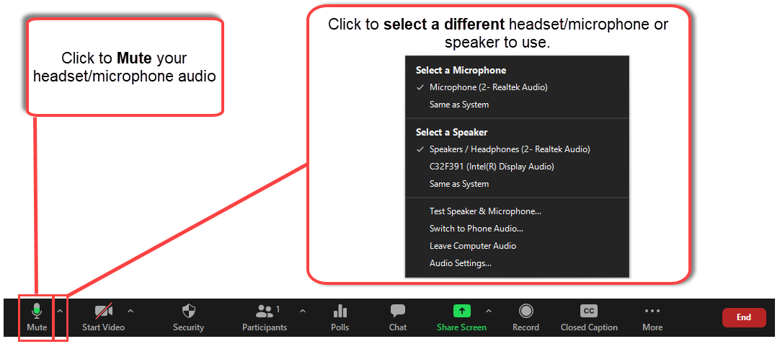

*Start Video:*

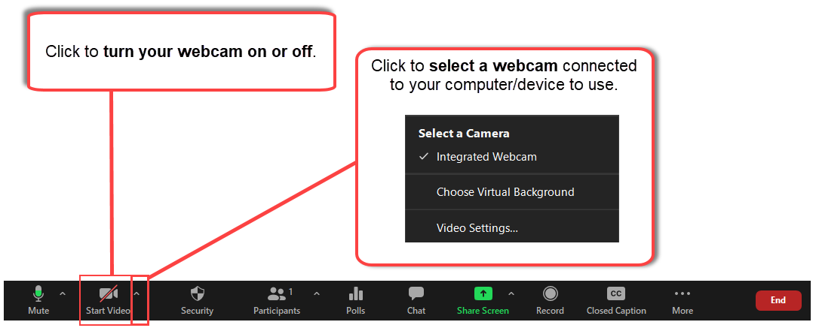

*Participants:*

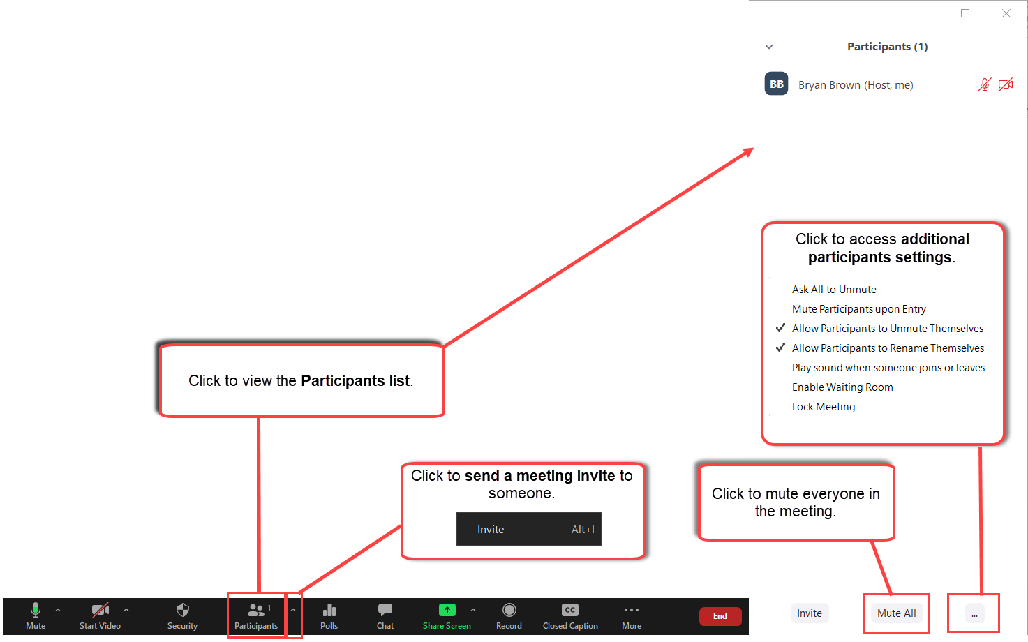

*Polls:*

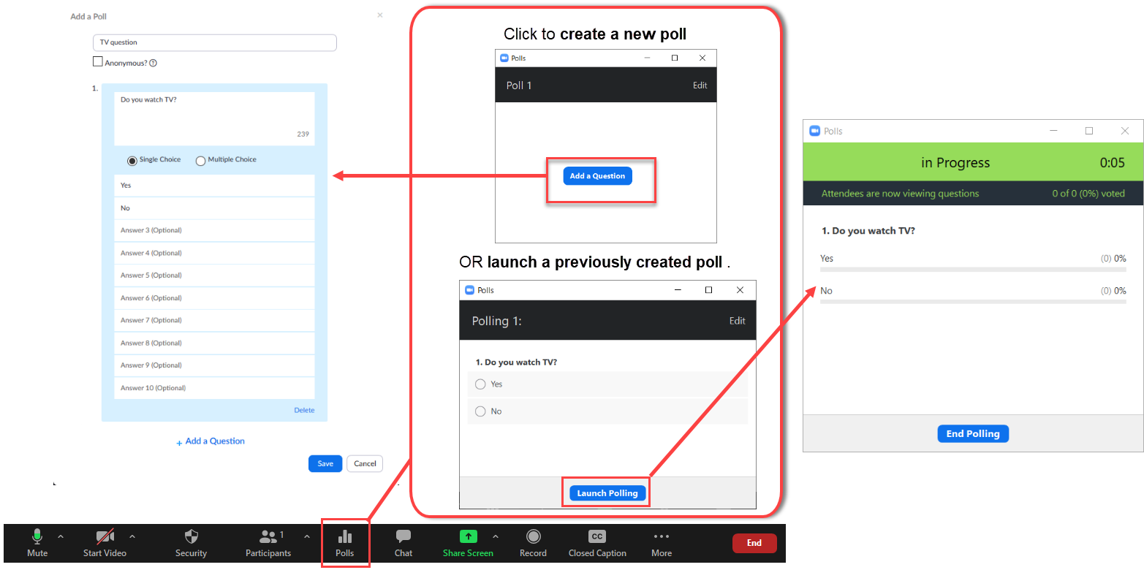

*Chat:*

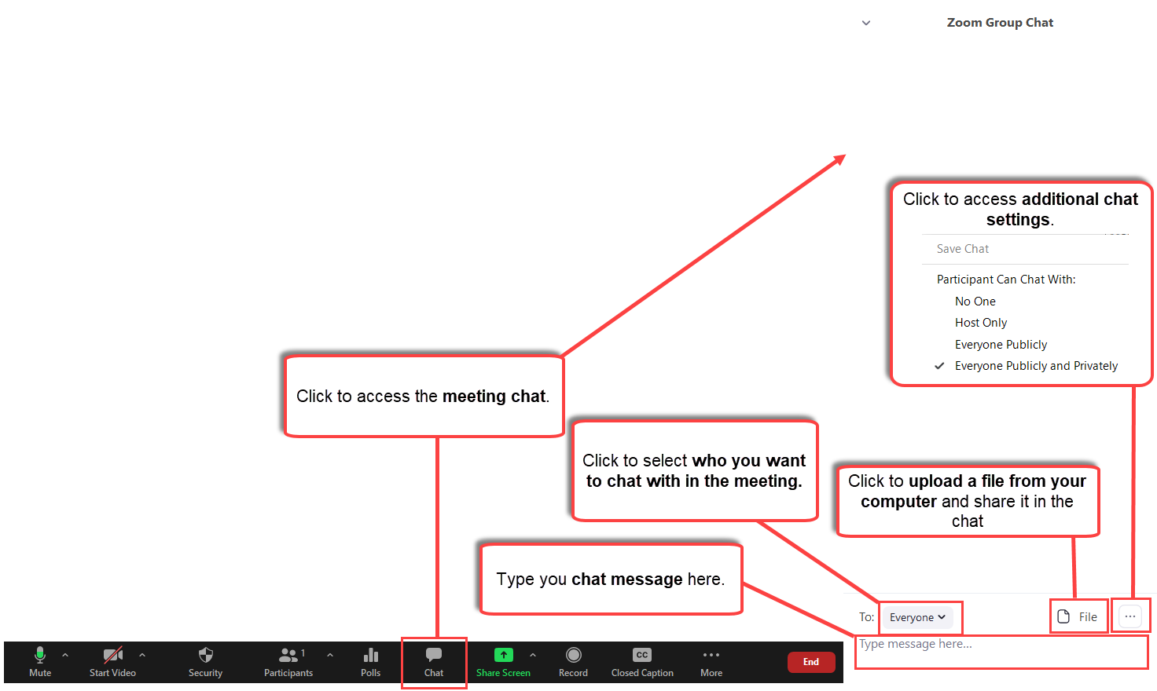

*Share Screen:*

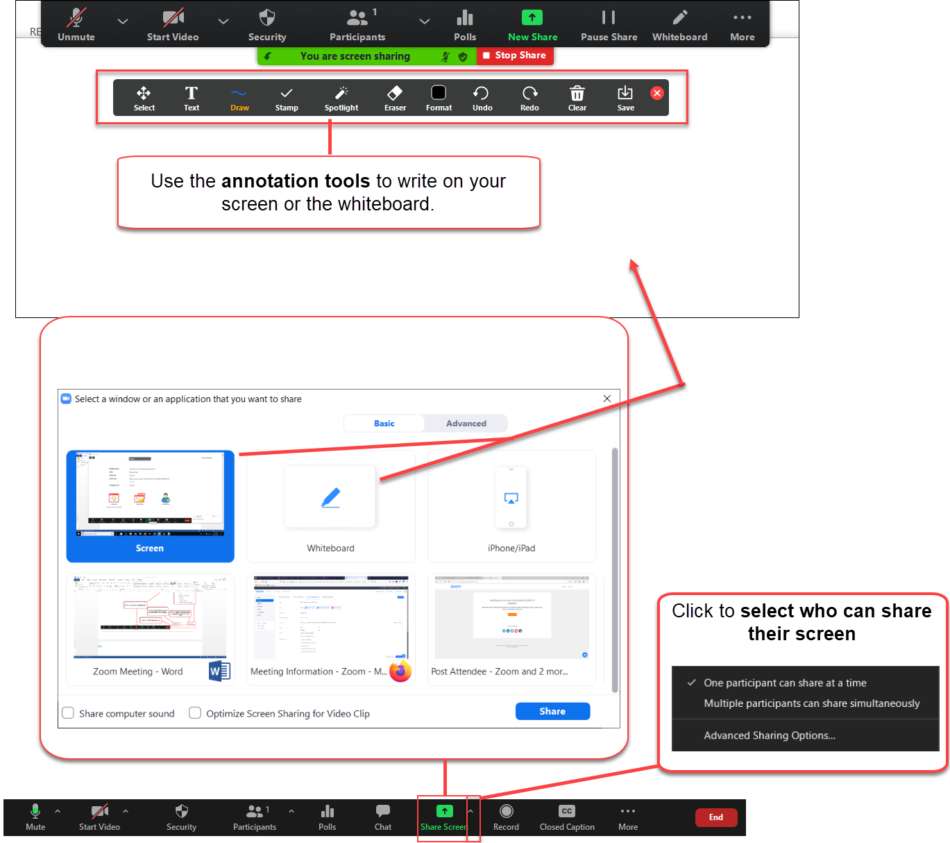

*Record:*

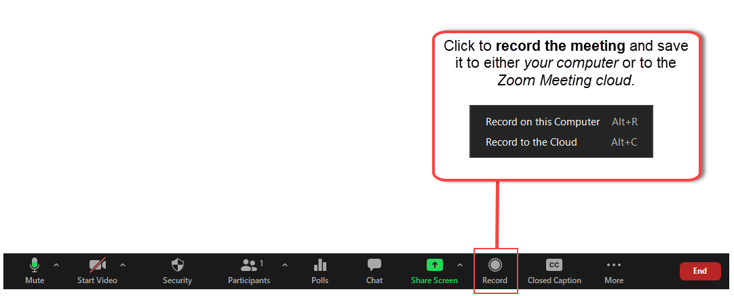

*Breakout Rooms:*

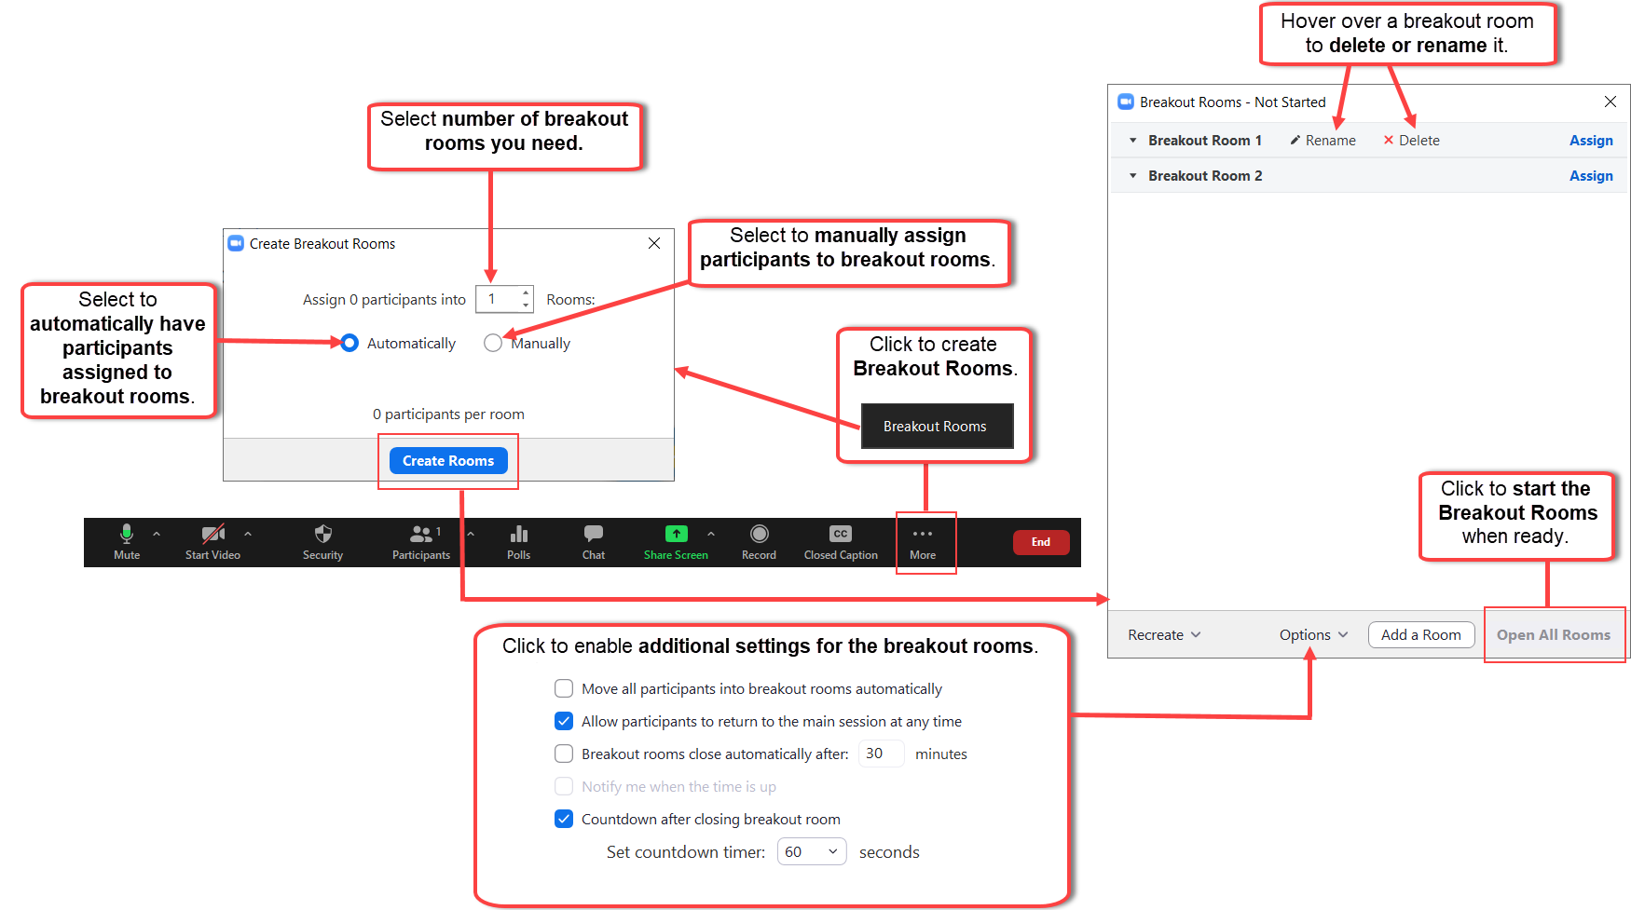

*End Meeting:*

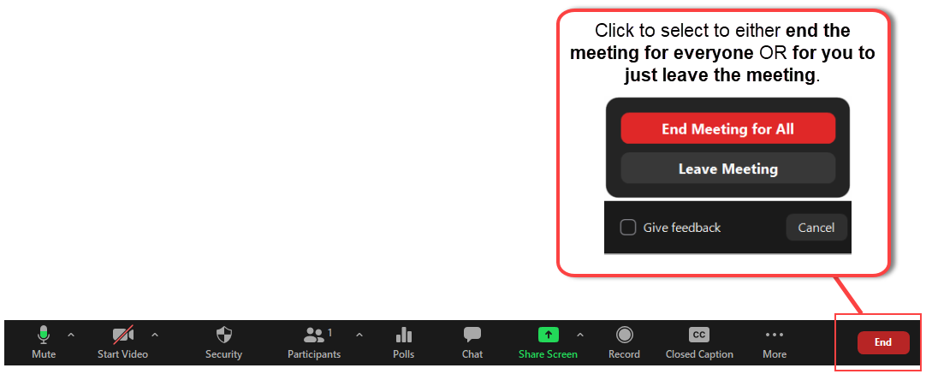

**How to Play a Video in Zoom During a Meeting**

1. Open the video you want to play on your computer. If the video is on a website (e.g., YouTube), go to the site in your browser. If the video is saved to your device (e.g., an MP4 file saved on your computer), open the video.

**2.** When you are ready to play the video, click the **Share Screen** **button** on your Zoom control panel.

**[](https://s3.amazonaws.com/cdn.freshdesk.com/data/helpdesk/attachments/production/42038715947/original/bTBizuvdLlNWrQqOtD8pjxXtnshZji7Apg.png?1581699849)**

**4.** Select the **video** from the menu of options in the "*Select a window or an application that you want to share*" box.

**[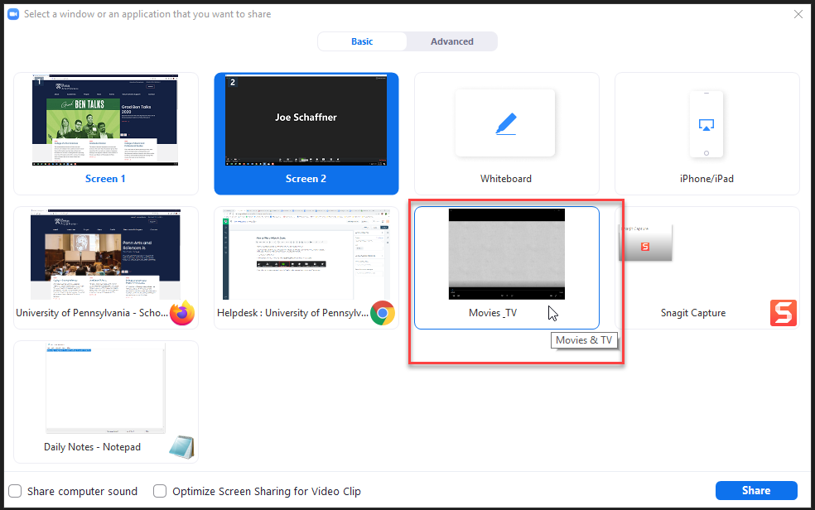](https://s3.amazonaws.com/cdn.freshdesk.com/data/helpdesk/attachments/production/42038716513/original/0-RYXN0OKqzb3osDDqwYqa_t1DIQp6wxGw.png?1581700476)**

**5.** Select the **Share computer sound** (1) and **Optimize Screen Sharing for Video Clip** setting (2). Then, click **Share** (3).



**6.** Play the video.

**7.** When the video ends, click the **Stop Share** button.

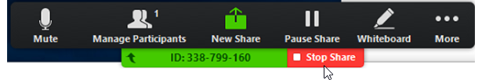

**Accessing Meetings Recorded to the Cloud**

Whenever you record a meeting to the Cloud, you can access the recording for it once it has processed and publish it for your students.

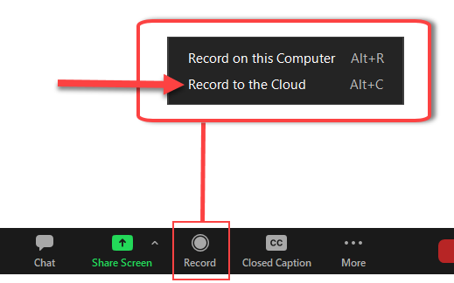

1. Click on **Communication** from the navigation bar (1) and click on **Zoom Meeting** (2).



2. Click on **Cloud Recordings** for the scheduled meeting.

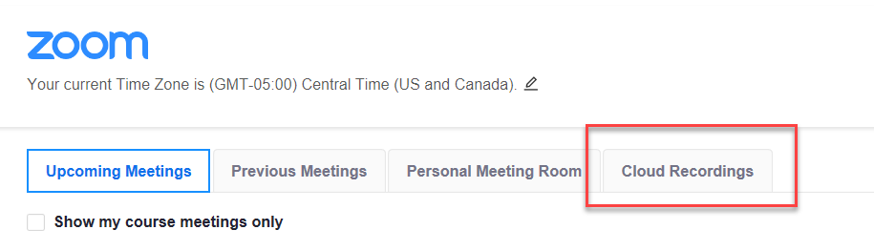

3. Your recorded meetings will be listed here and you can **publish** it so your students can access and view it.

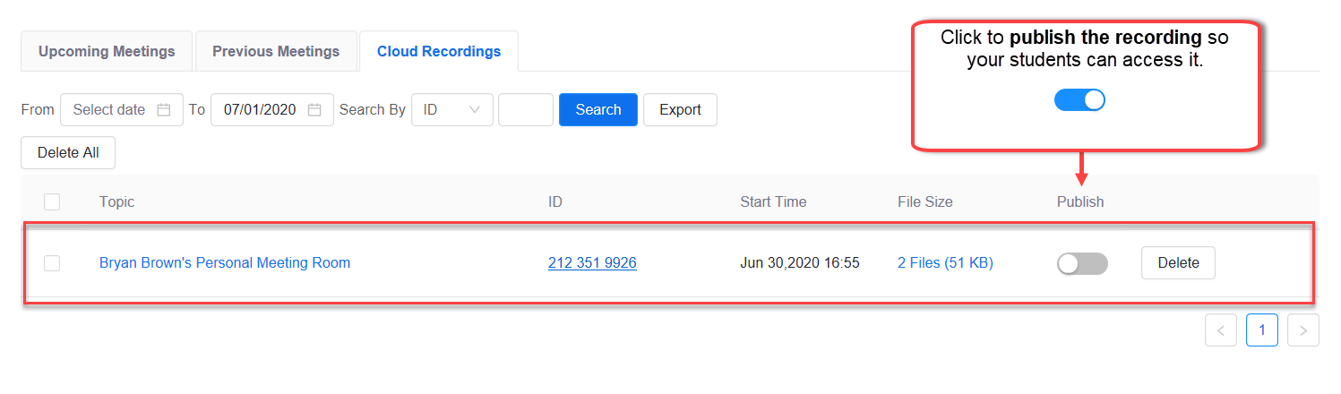

**Start a Personal Zoom Meeting**

When needed you can start an impromptu meeting using your personal Zoom Meeting room without having to schedule a regular meeting.

1. Click on **Communication** from the navigation bar (1) and click on **Zoom Meeting** (2).



2. Click on **Personal Meeting Room** for the scheduled meeting.

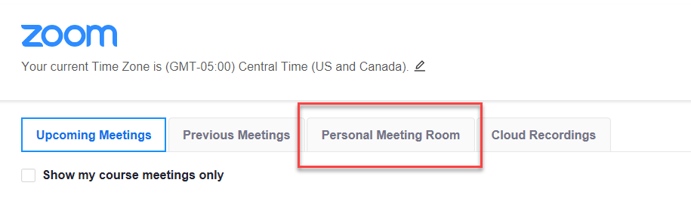

3. **Copy the meeting invite** and share it to whoever you want to attend the meeting.

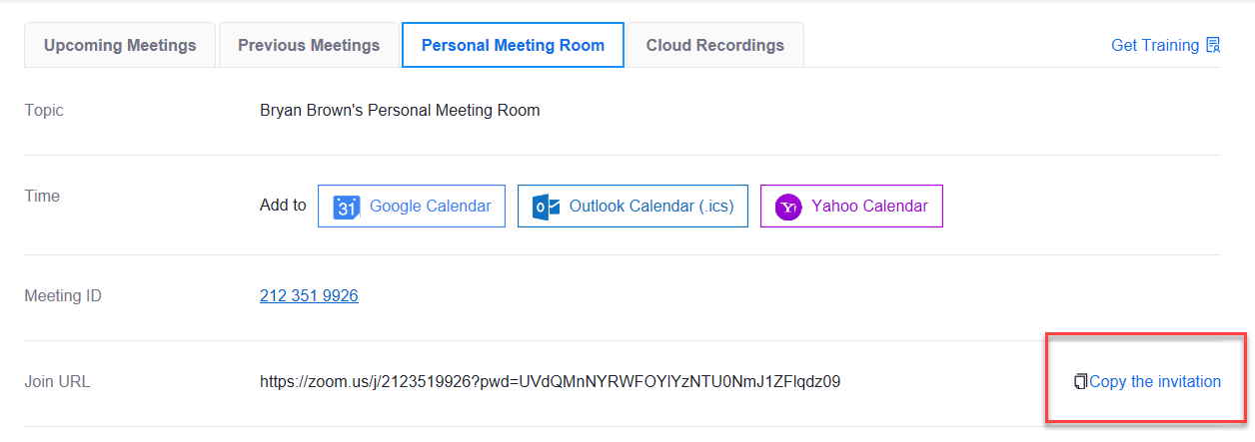

4. Scroll down and **start the meeting** whenever you are ready.

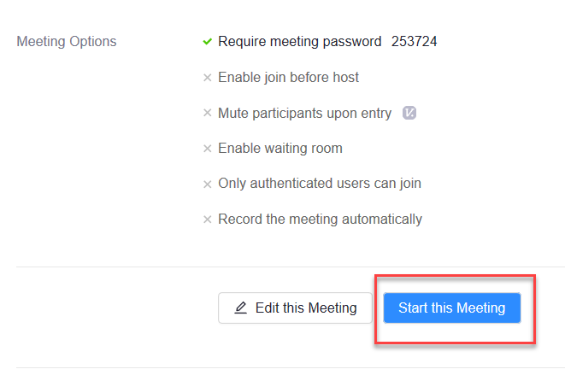

**Viewing the Attendance from a Meeting:**

1. Sign into Zoom via a browser (<https://zoom.us>)

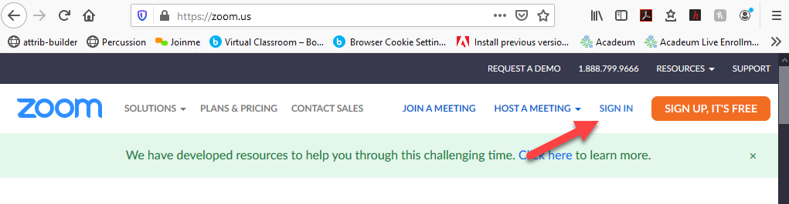

2. Click on **Account Management**.

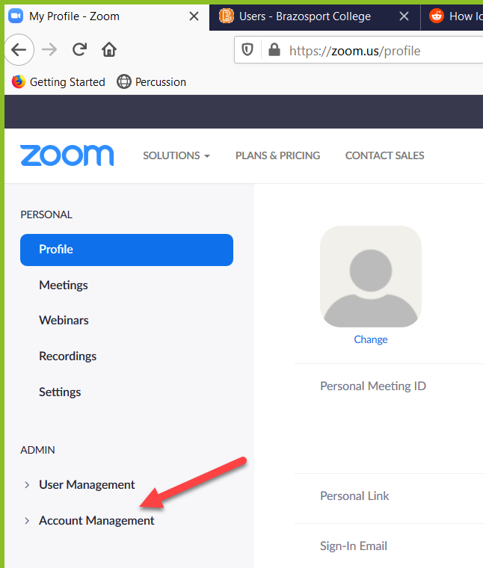

3. Select **Reports**.

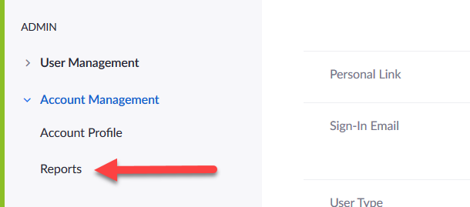

4. Click on **Usage**.

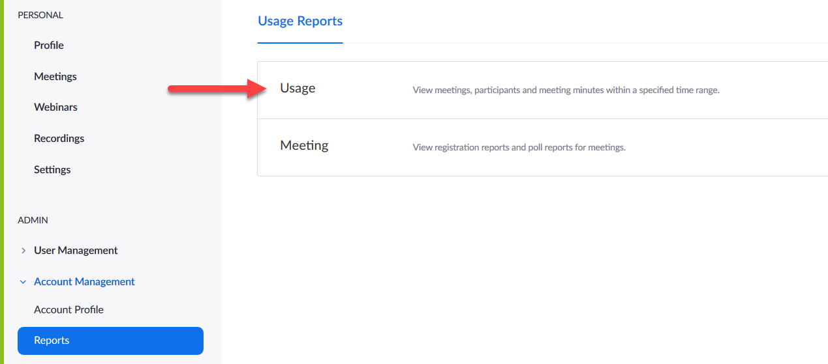

5. Use the **From:** and **To:** area to enter a date range for the meeting or meetings you would like to pull attendance information from and click on the **Search button**.

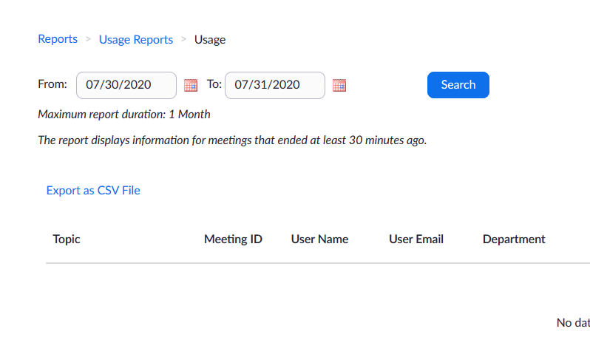

6. Click on the **numbered link** under the “Participants” header to view attendee list.

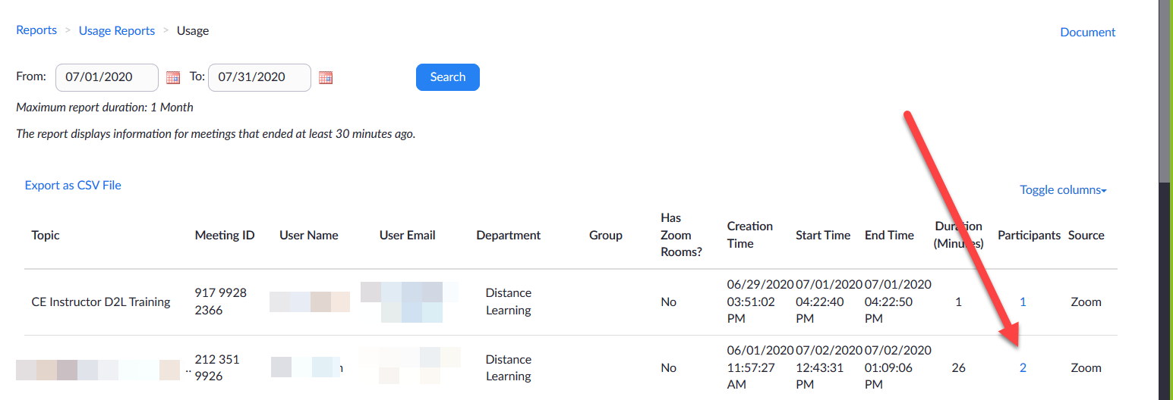

**Whiteboard Feature**

**Prerequisites for using Zoom Whiteboard**

* + Zoom desktop client
    - Windows: 5.10.3 or higher
    - macOS: 5.10.3 or higher
    - Linux: 5.10.3 or higher
  + Zoom mobile app*
    - Android: 5.10.3 or higher
    - iOS: 5.10.3 or higher

Follow the steps below to upgrade if necessary.

1) Open the Desktop client and **click** your profile picture (1). **Click** Check for Updates (2).

2. When the Update Available window pops up **click** Install.

3. Once the update has completed, the Whiteboard icon will now be available on the desktop client.

**To use the Whiteboard in a meeting**

1. Start a new Zoom meeting as normal.

2. Click the Whiteboards option on the navigation bar.



3. **Click** New Whiteboard (1) if you want to create a new one during the meeting. **Click** the name of the whiteboard you have created prior to the meeting (2) if you created one on the Zoom website and wish to share it. **Click** your option to allow participants to be able to edit (3). **Click** Open and Collaborate when done (4).

4. Use the Toolbar to **edit** the whiteboard.

5. **Click** the three dots in the top right corner for options to Export to either a PNG or a PDF document.

6. **Click** Share to share by email.

**NOTES:**

Your whiteboard is auto-saved to the cloud, and any changes you make to the whiteboard during a meeting will sync automatically to your account on the Zoom website.

**How to create a whiteboard from the Zoom desktop client while not in a meeting:**

1. Sign into the Zoom desktop client.
2. Click the **Whiteboards** button  at the top right (1). Click **New ** to create a new whiteboard (2).

How to create a whiteboard from the Zoom web portal:

1. Sign in to the [**Zoom web portal**](https://zoom.us/wb#/).
2. Click **Whiteboards.**

1. Click **+ New** at the top right to create a new whiteboard. 

Resources

* [Zoom Tutorial & Videos by Zoom Help Center](https://support.zoom.us/hc/en-us/articles/206618765-Zoom-Video-Tutorials)

**Best Practices for Securing Your Zoom Meetings**

Whenever you schedule a Zoom meeting it is important that you follow the necessary security measures to ensure your meetings are secure, which includes the following:

* Lock your Zoom Meeting
* Control screen sharing
* Enable the Waiting Room
* Lock down the chat
* Remove a participant
* Enable security options when scheduling a class

To view step by step directions on how to incorporate the abovementioned security measures, click on the following link: [Best Practices for Securing Your Virtual Classroom](https://blog.zoom.us/best-practices-for-securing-your-virtual-classroom/)

Also, when it comes to Zoom, avoid clicking on links sent to you via email which contain subject lines such as **Missed Zoom Meeting**, **Zoom Account**, **Meeting canceled- could we do a zoom call**.