How to Export & Delete D2L Zoom Meetings
If you recorded a Zoom meeting during the semester and want to keep it (archive) you will need to do the following at the end of each semester:
- download recording
- upload into MyMediasite
- delete recording
1. Log into D2L using BC credentials at https://online.brazosport.edu.
2. Enter your course, go to Communications and click Zoom Meeting.
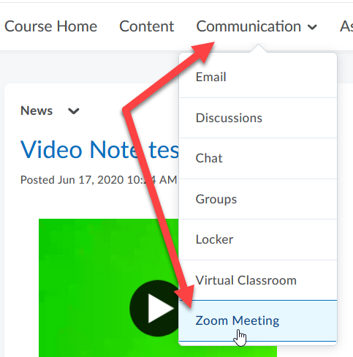
3. Click on Cloud Recordings tab.
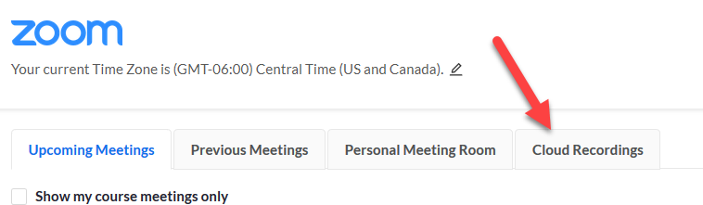
4. Click on title of recording.
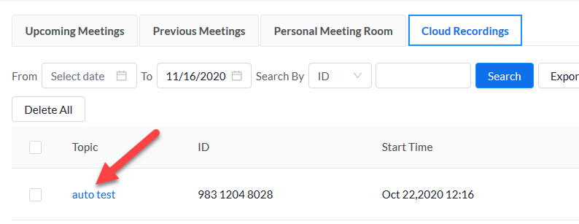
5. Click the eyeball icon under the “Recording” image
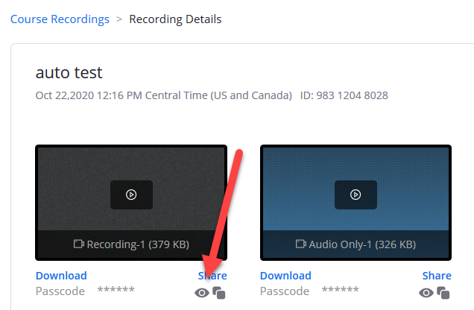
6. Write down OR use mouse to highlight code, then right+click and select to copy.
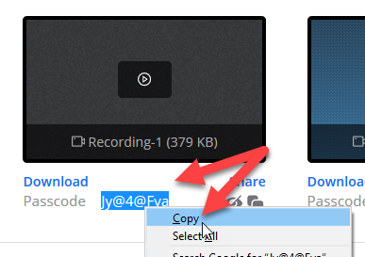
7. Click the Download link.
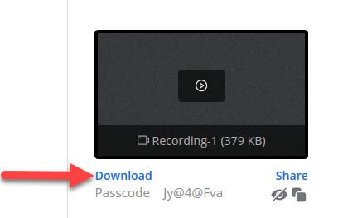

8. Type or paste Passcode in text block and click Access Recording button.
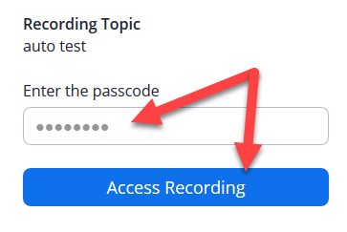
9. Click the Download link.
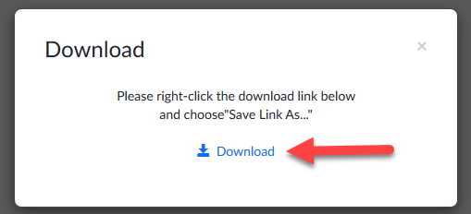
10. Click OK to save file to computer (by default it will save to your Downloads folder).
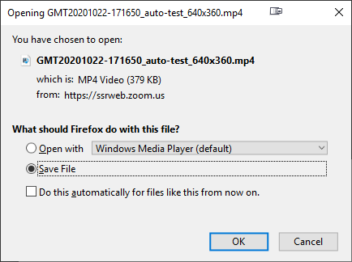
11. Once downloaded it can now be added to your MyMediasite. Please follow instructions on how to: Create a MyMediasite account, add video and embed.
Confirm the download by going to Downloads folder or any location you chose to download to and make sure you see the video icon or title. To make sure it plays, double click on title and it should open in Windows Media Player or default player on your machine.
12. Once video has been downloaded, delete the recording from the cloud by clicking on the Course Recording link to return to the Zoom Meeting list. Please note, once you delete you cannot retrieve it, so verify the video has been properly downloaded to your computer.
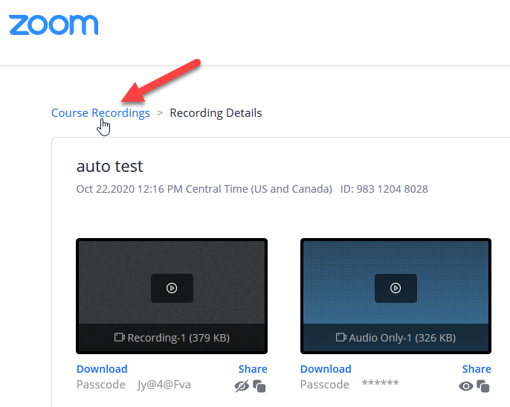
13. Click the Delete button.
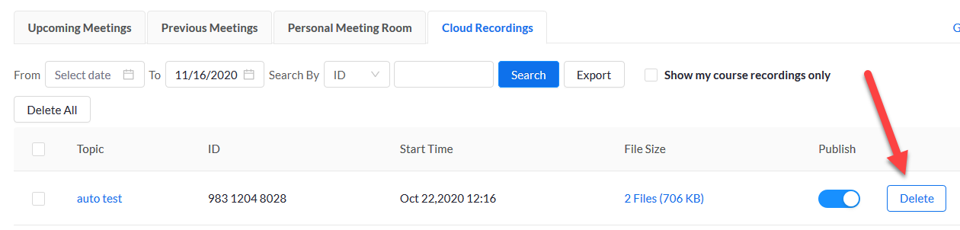
14. Click the Yes button.
