Adding Respondus LockDown Browser/Monitor to a Quiz
You can require your students to take a quiz using the Respondus LockDown Browser and/or Monitor. The LockDown Browser can be used alone to secure opening of apps and browser windows during taking of the exam. Yet, adding the Monitor option will bolster testing security with the addition of video recording during test taking. Either option though requires that a quiz be created first, once done the Lockdown Browser and Monitor can be added.
1. Once a test is added, within the Quizzes area click on the LockDown Browser tab.
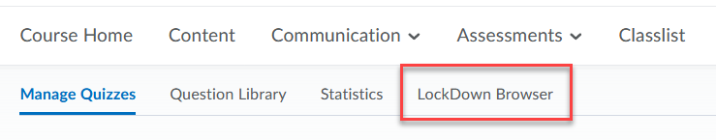
2. Scroll down to a quiz and click on the down arrow next to the quiz title and click Settings.
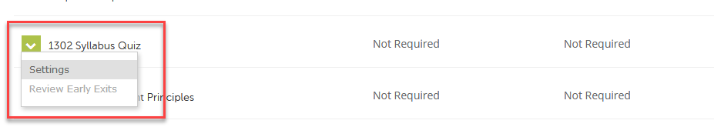
3. Check the radio button for “Require Respondus LockDown Browser for this exam”.
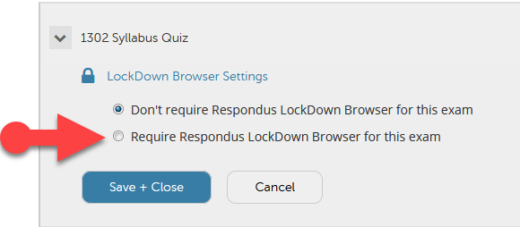

4. Additional settings are now available. Deselecting the option for the Browser to view feedback is easier for students, one less block for them to see their results.
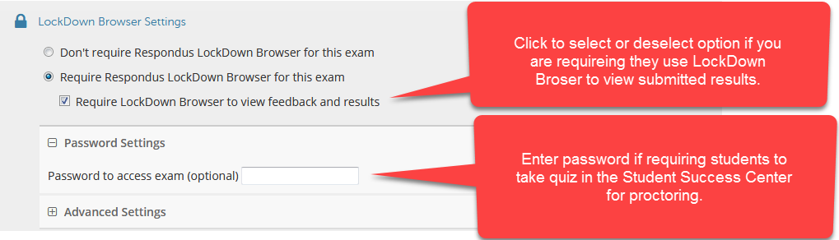
5. Click on the + sign for Advanced Settings and check desired options to add to quiz settings, making sure to include “Allow students to use LockDown Browser for Chromebook (beta)”.
A “beta” release of a new Chromebook extension for LockDown Browser is currently available for exams. The LockDown Browser and Monitor is used for optional online proctoring of D2L exams/quizzes. Chromebook users have not been able to utilize LockDown Browser in the past, due to Google licensing and management requirements. Since this is a “beta” release there are limitations and known issues (described below), so we should still be flexible to those students who may run into technical issues.
With that said instructors will need to enable the use of the Chromebook on a per exam basis. Once enabled students will be able to download and launch Respondus during the “Start” quiz process as they have done in the past. IMPORTANT: Advise students pop-ups MUST be enabled in Chrome otherwise they may get stuck on the "Start Quiz" page (how to enable pop-ups in Chrome)
Limitations and/or known issues with LockDown Browser for Chromebook (beta):
- Quiz passwords (specified via the "optional password" field in the LockDown Browser Dashboard) aren’t currently supported
- The “Early Exit” feature in LockDown Browser isn’t currently supported
- LockDown Browser’s Calculator and Spreadsheet features aren’t currently supported
- The extended keyboard functions (for adding symbols and special characters) isn’t currently available
- LockDown Browser’s “Help Center” is currently unavailable
- "Allow access to specific external web domains" option is currently not supported

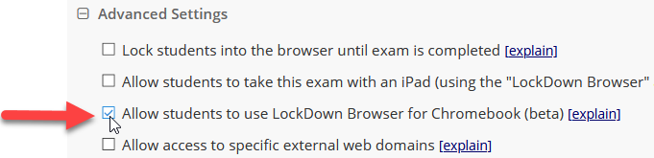
6. If you want to add the Monitor option (ability to record student as they take the test), click the option for either “Require Respondus Monitor for this exam” or for “Either Respondus Monitor or a proctor lab can be used to take this exam”.
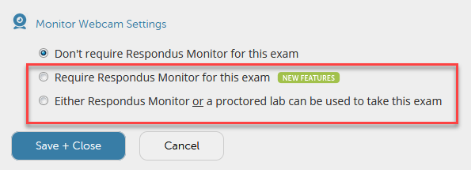
If selecting “Either Respondus Monitor or a proctored lab can be used to take this exam” you MUST enter a password in the “Password to access exam (optional)” text area shown in Step 4 and make sure to send this to Learning Services. NOTE: the “optional” changes to “required” once this selection is chosen.
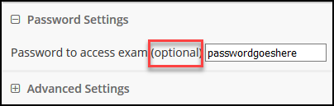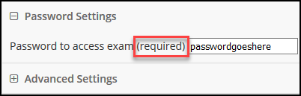

7. If selecting the Monitor for the first time you will be prompted with the following, just click Continue to Respondus Monitor.
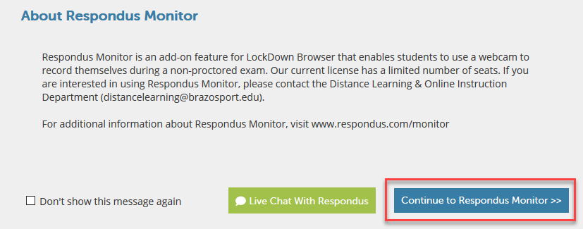

8. Once done additional options become available associated with the Monitor. By default these are selected for you, click those options to deselect if you do not want to use them. Typically folks deselect EITHER the “Student photo” or “Show ID” option, both options aren’t needed.
It is highly recommended to keep “Guidelines + Tips” selected. You should also keep the “Facial Detection Check” selected if you are requiring an Environment Check.
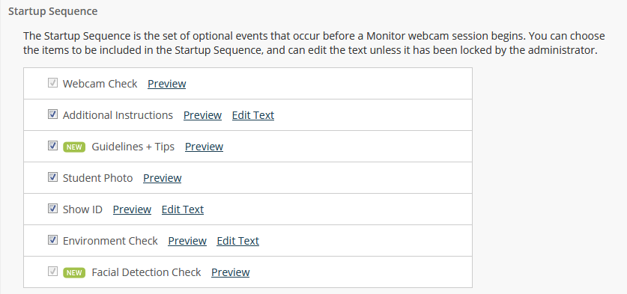
9. Scroll down to the Facial Detection Options for the Monitor. Leave these at the default and change nothing. Settings will help students stay in camera during recording.
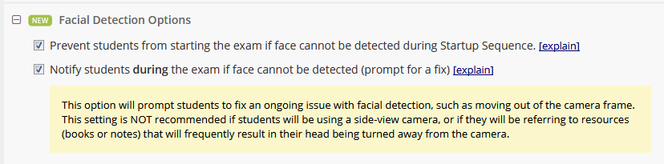
10. Leave below Advanced Settings as they are and click on Save + Close button. If it will not allow you to Save it could be a setting is missing, scroll up to confirm no “red text” is indicating you need to make adjustments.
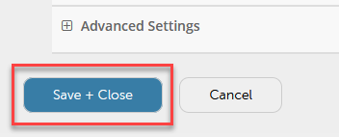

To Edit Settings
1. If you need to change these settings return back to Assessments, click on the LockDown Browser tab, click on down arrow next to quiz title and select Settings.
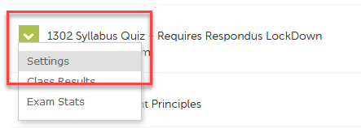
2. Alter settings are needed and save and close.
View Monitor Recordings and Data
If Monitor was set to be used, to view student recordings and data gathered during testing return to Assessments, click on LockDown Browser tab, click on the down arrow next to the quiz title and select “Class Results”.
Keep in mind the purpose of recording is not that you need to review all of them or spend hours investigating each clip. The recordings and telling students you are utilizing the Monitor in assessments is to be a deterrent and if you suspect cheating then investigate deeper by viewing videos.
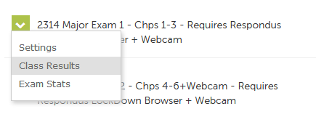
3. There is a lot of information here, view “How is priority determined” for detailed descriptions of this area. To look at video thumbnails and review a recording click on the + sign next to a student’s name.
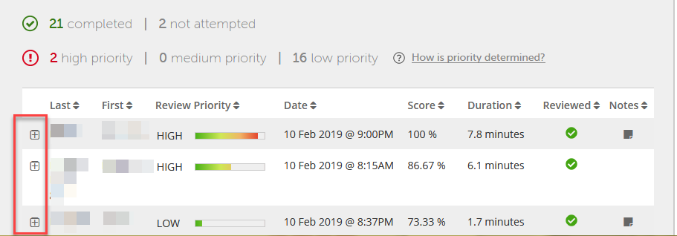
4. Details about the student is presented.
