The Attendance tool allows you to create registers that help track attendance for your course. You can create multiple registers for a single course. The attendance tool is not connected to the grade book. Attendance grades must be manually entered into the grade book in order for the score to be factored into the student's final grade.

Create a Registry
An attendance registry is a collection of attendance sessions used to collect attendance information. For example, if you plan to take class attendance, you will need to create one attendance register with a session for each class meeting.
- Click the New Register button.
- Enter a Name and a (optional) description. Make your register's name something intuitive, as this text will be the hyperlink the student clicks to view his/her attendance information.
- Select an Attendance Scheme from the drop down menu.
  - By default, D2L's attendance scheme is Present = 100% and Absent = 0%.
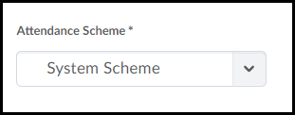

- Enter a Cause for Concern (optional)
  - The Cause for Concern is an automatically calculated percentage, and depending on the number entered in this field, D2L will flag students who are falling below the cause for concern percentage.
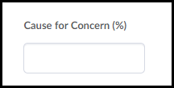
Example of flag:
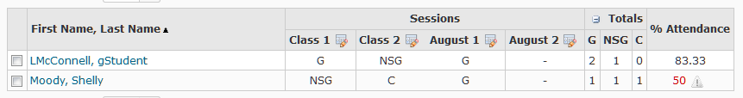
- Check the Visibility option if you would like students to be able to view the register.
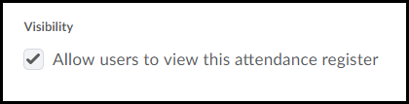
- In the Users option, select which students to track in the register. By default, D2L will track all class participants.
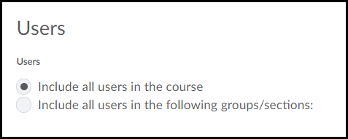
- Enter a name for each session. For example, if you are creating a daily attendance register, you may name your sessions with the dates of the class meetings.
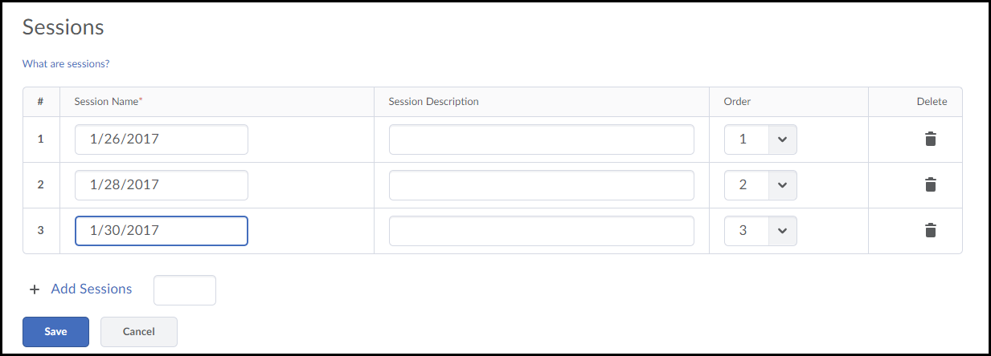
- Enter Session descriptions (optional)
- Use the Order drop down menus to reorder your sessions if you choose.
- Click the trashcan icon to delete a session.
- If your register requires more than three sessions, enter the number of additional sessions needed in the Add Sessions text box and then click the Add Sessions button. D2L will then add additional rows to the Sessions table.
- Click Save to save your register.

Taking Attendance
Taking attendance in D2L cannot be automated. An instructor must select an attendance value for each student for each session.
- From the Attendance Registers List page, click the name of the Attendance Register to enter attendance information.
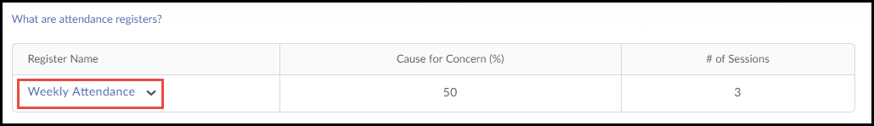
- Click the Enter Attendance Data icon for a particular session.
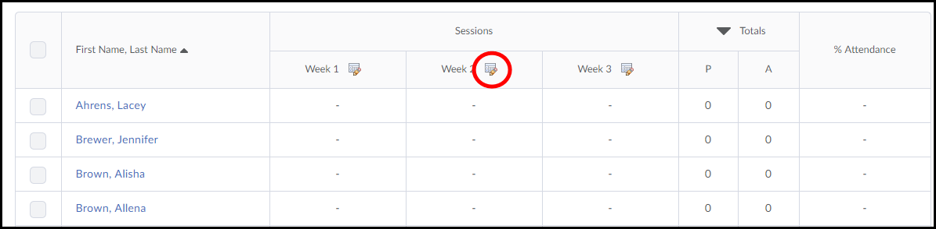
- There are two workflow options for entering session attendance:
  - Manual - Select an Attendance Status for each student on the class list.
    - Select a value from the Attendance Status drop-down menu for each student.
    - Click Save to save your register.
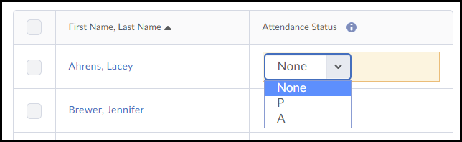

  - Set Status in Bulk - Update all students' status and then make changes where necessary.
    - Check the Select All checkbox and then click the Set Status button.
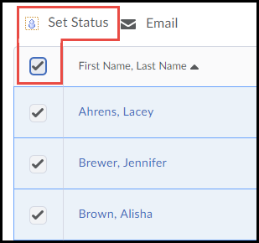
    - Select a Status and then click Save. This status will update all students' Attendance Status on your class list.
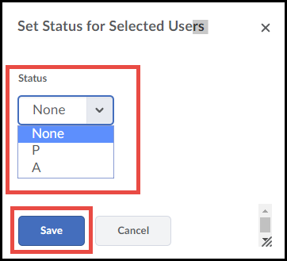
    - Identify the students requiring a different status. Select the alternate status for those students.
    - Click Save to save your register.

Student View of Attendance
