Copy Course from Semester to Semester

- Log into Desire2Learn (https://online.brazosport.edu).
- Access your new course shell (the course in which you would like to copy content into).
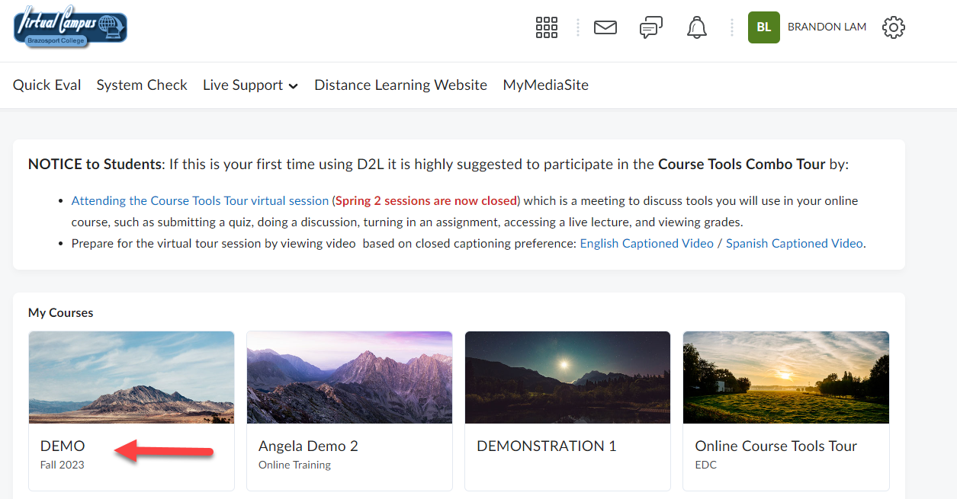

- On the Course Home page, scroll down to the Site Resources section and select Import/Export/Copy Components.
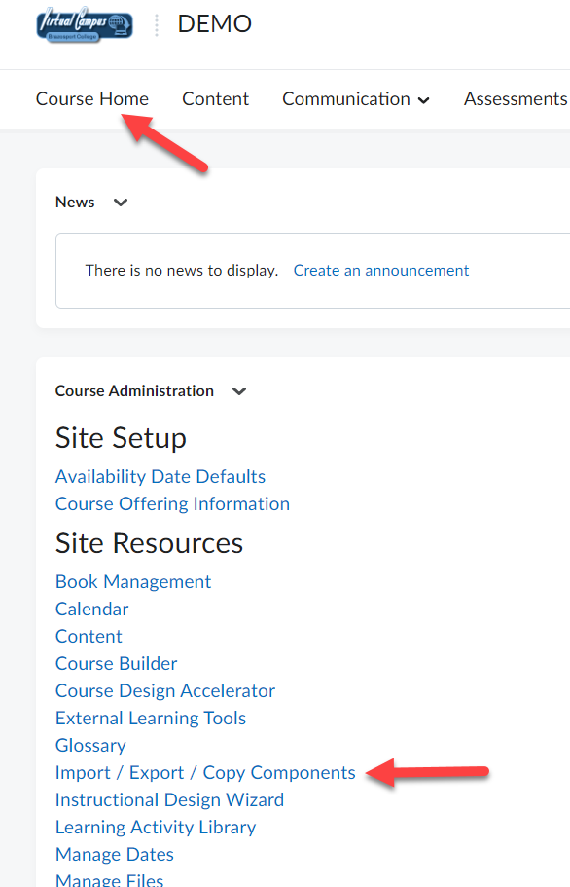
- Verify Copy Components from Another Org Unit is selected (1), ensure Include protected resources is checked (2), and then click Search for offering (3).
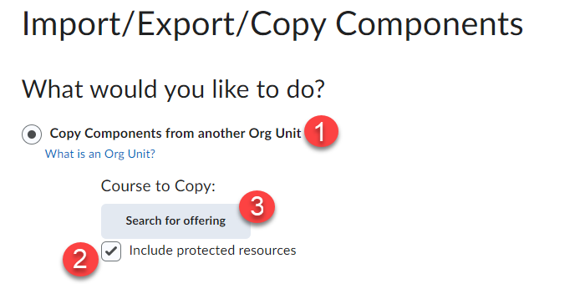

- From the new window that appears click on the Search icon (1), and then from the list of courses that appears select the course containing the content you would like to copy (2) and click Add Selected (3).
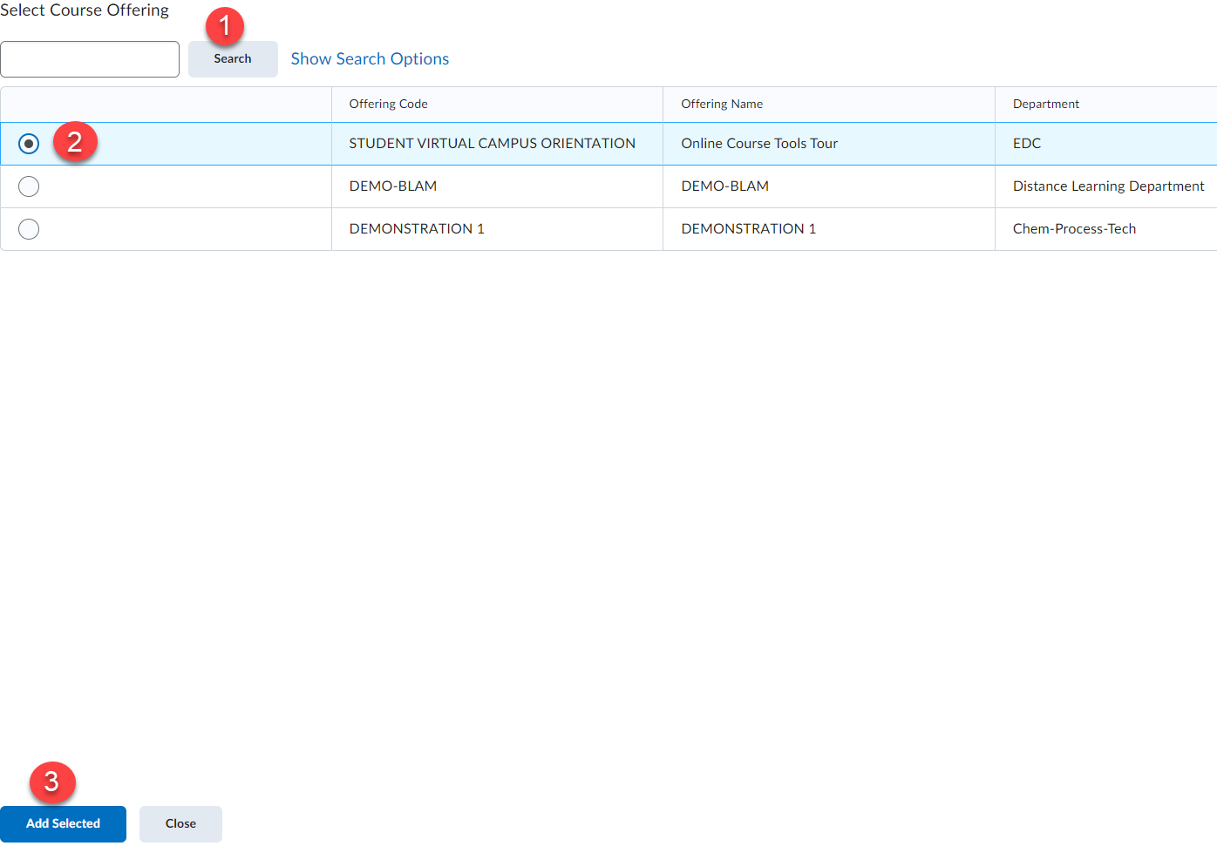

- Click the Copy all Components button to copy the entire course.
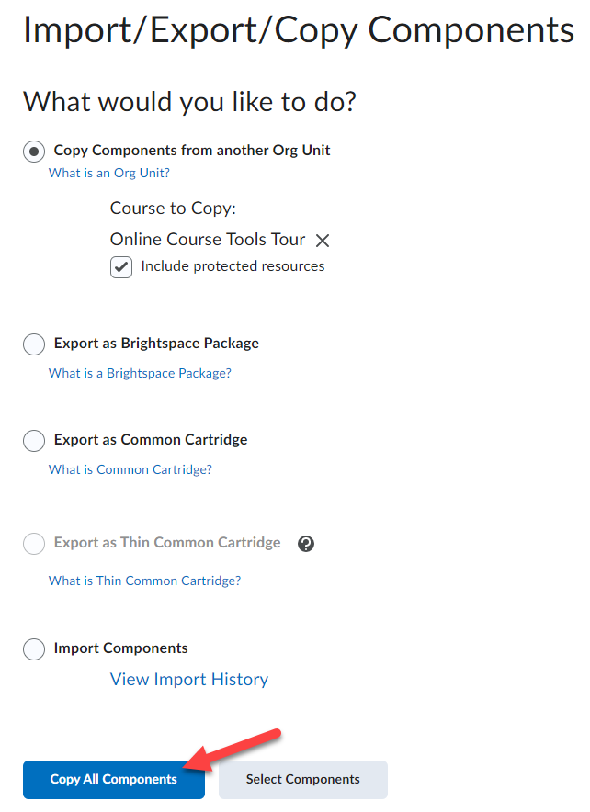

- The course will begin to process.
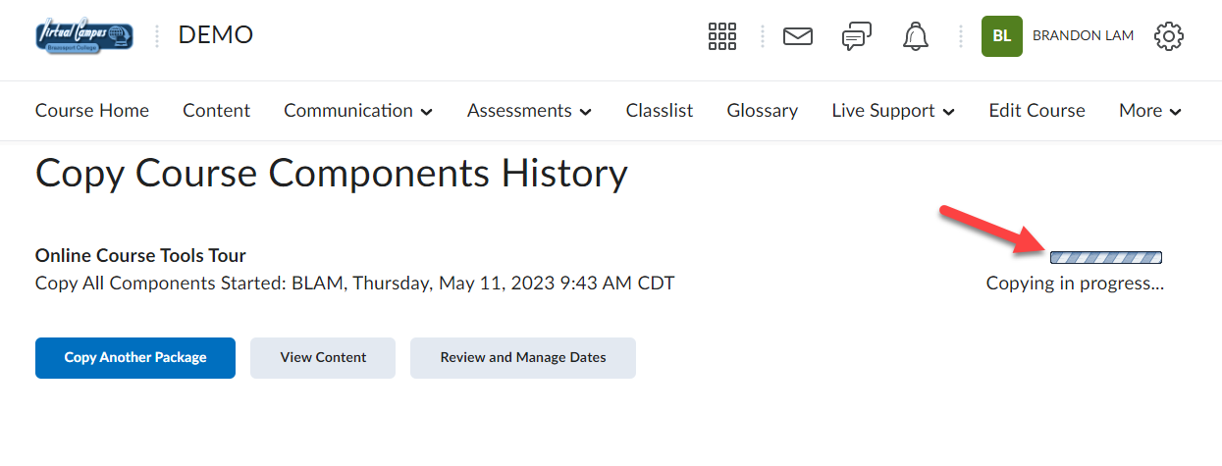

- Depending on the size of materials being copied, it may take a few seconds. Once the course is successfully copied, you can click the Review and Manage Dates button to offset old dates to dates relative to the new semester (1). Or you can click the View Content button to view the copied course content (2).
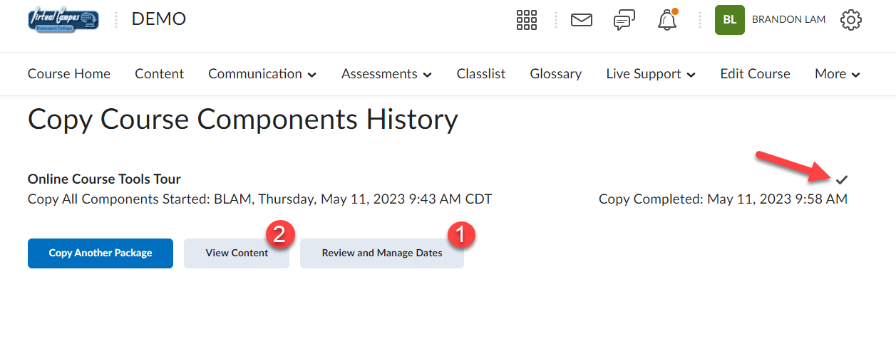

You can now update materials as desired.

IMPORTANT:
Course Copy Info regarding Quizzes Requiring Respondus Lockdown Browser:
- Whenever you copy a course that has quizzes/exams that require Respondus LockDown Browser or Monitor you MUST access the LockDown Browser tab in the copied course.
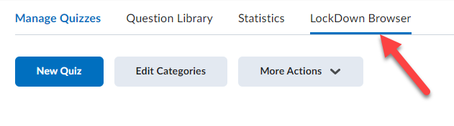

- This will update the settings for all the quizzes and ensure Lockdown Browser and Respondus are enabled for them.
NOTE: If this process is not completed students will have issues when they attempt to take these types of quizzes.
