You can create random question pool for quizzes. When creating question pools it will randomly pull from the specified number of questions you select from the question library.
Creating Question Pools for Quizzes

- When creating a new quiz, click Create New button.
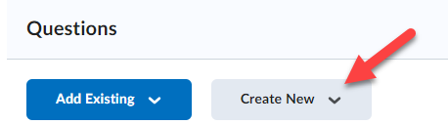

- Select Question Pool.
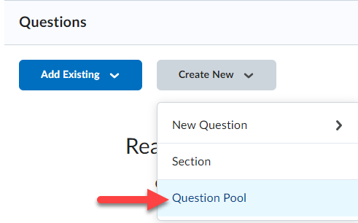

- Click the Browse Question Library button.
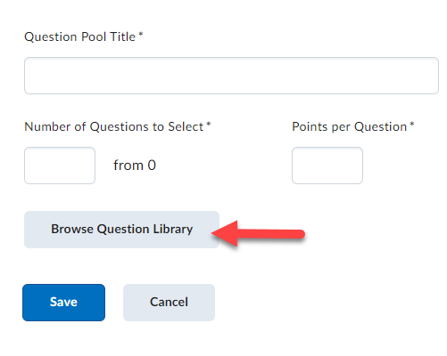

- To import ALL questions from a section created in your question library, select the section from the list (1) and click Import when done (2).
NOTE: To import specific questions from a section, expand the section and select specific questions for import.
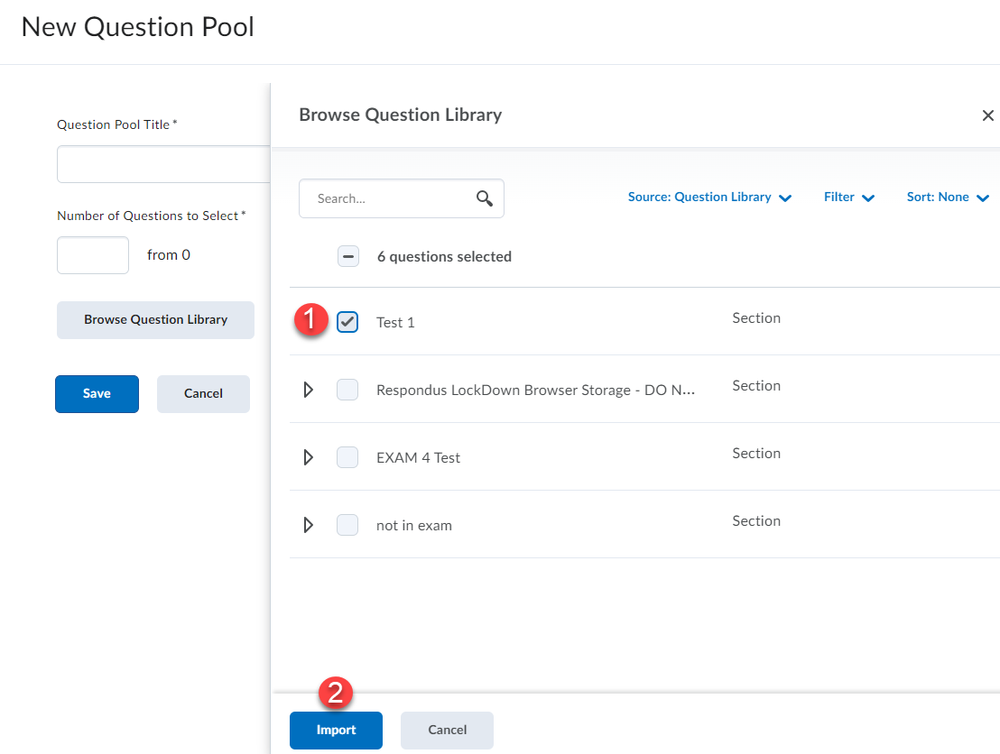

- Enter a title for the question pool (1), number of questions to pull from the pool to randomly give each student (2) and enter the number of points for each question (3). Click Save when done (4).
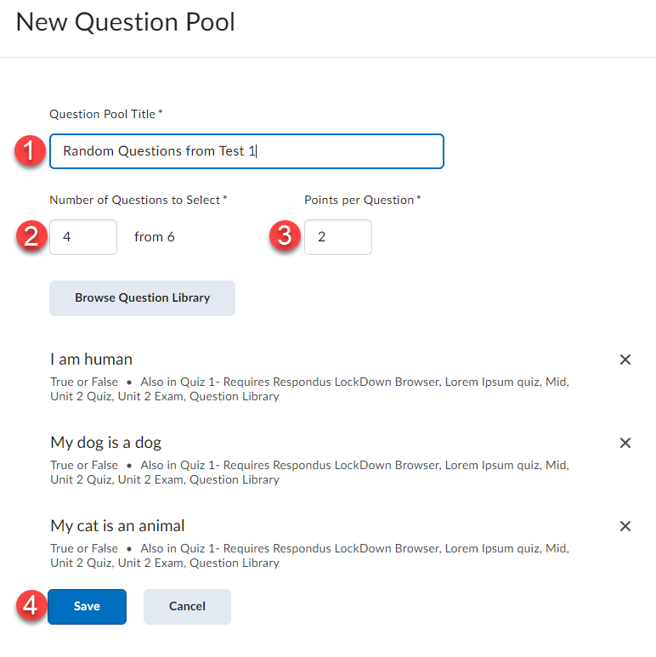

- The random question pool will be created. You can create additional question pools for the quiz if necessary. When finished creating the question pool(s) you can finish setting up the quiz (for instructions on creating a quiz view the Creating Quizzes manual).

