The HTML Editor, in BrightSpace, allows you to create files on the fly without having to create and upload them from another program (i.e., Microsoft Word). It allows you to insert images, media, and create hyperlinks to course tools such as a quiz and more. The editor is part of most tools in the courses such as Announcements (news), Discussions, Quizzes, Dropbox, Feedback boxes, etc.
Using the BrightSpace HTML Editor

- Click on the News pull down menu and select New Announcement to access the HTML editor.
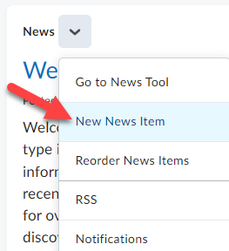

- The HTML Editor is located near the center of the page.
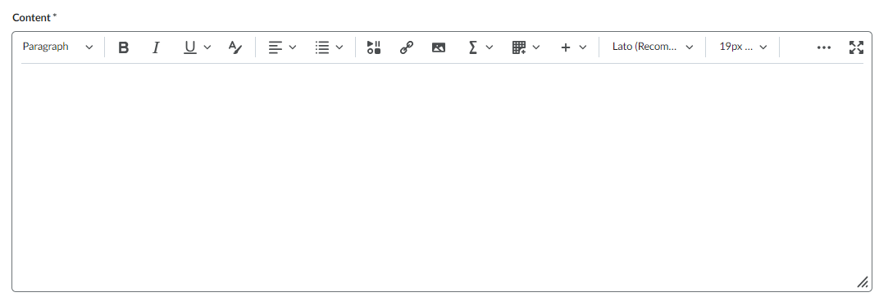

- When using the Editor if you click the button with the three dots it expands/collapses the editing menu.
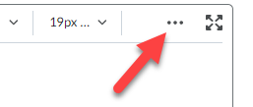

- In the text area, click and begin typing text, using formatting features (Bold, Italics, colors, etc which are readily available in the menu (much like in Microsoft Word).
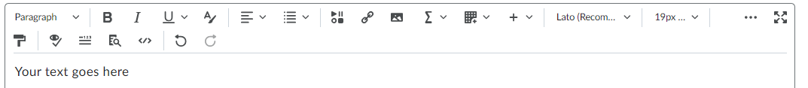

Inserting an Image
Just as in Microsoft Word you can insert images.
- To insert an image, position the cursor in the desired location you would like it to appear.
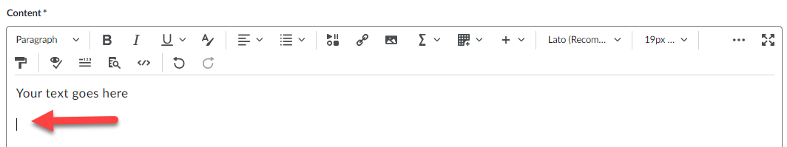

- Click the Insert image icon on the toolbar.
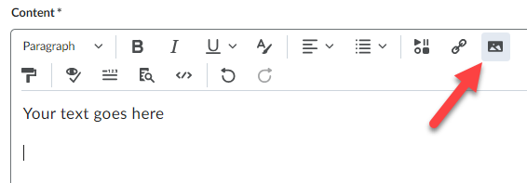

- Click the My Computer option.
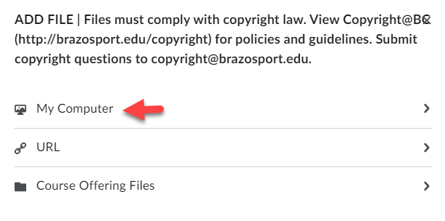

- Drag and drop an image file from your computer into the Upload box and click the Add button.
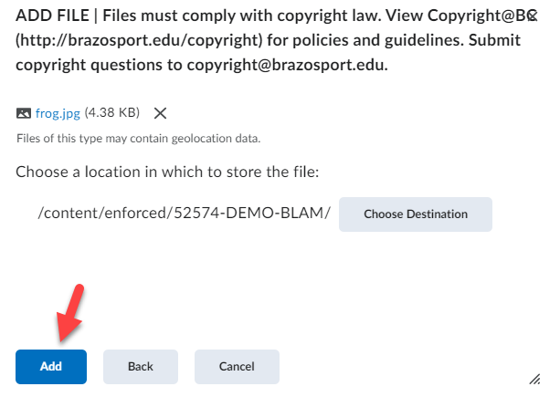

- Enter a short description of the image (i.e., pic, image, or map) (1) and click OK (2).
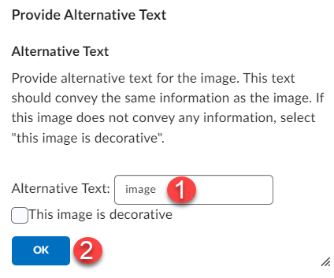

- The image will now be inserted into the HTML editor.
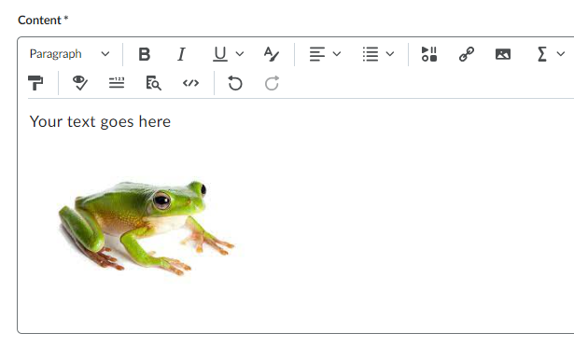

- You can re-size the image by clicking on it and use the pop-up options at the top. You can also quickly resize image by clicking on the squares around the image and use the mouse to drag in or out to the size you would like.
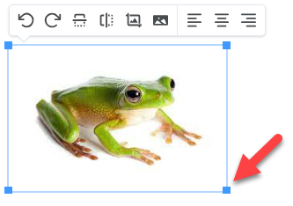

Insert Stuff
The Insert Stuff feature in the HTML Editor allows you to link files, embed videos from MyMediasite as well as YouTube, and much more.

Inserting a Link to a File
You can insert links to Microsoft Office files such as Word, PowerPoint, or Excel, plus PDF’S and many others. To create a link, you must have your file already created and saved on your computer.
Keep in mind that when linking to files, other than those that are web-based, users will need to have those programs installed to open them. For example, if linking to a PowerPoint file, users must have Microsoft PowerPoint installed.

- In the HTML editor, position the cursor at the position you want students to click on to view the file and click the Insert Stuff icon in the menu bar.
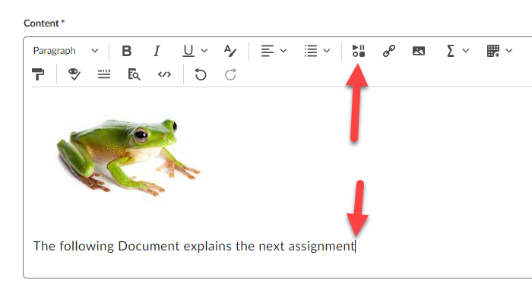

- Click on the My Computer option.
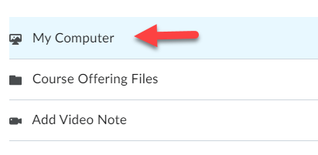

- Click the “Browse” button (1), located file on computer and click it to select (2), click the “Open” button (3), and select Upload (4).
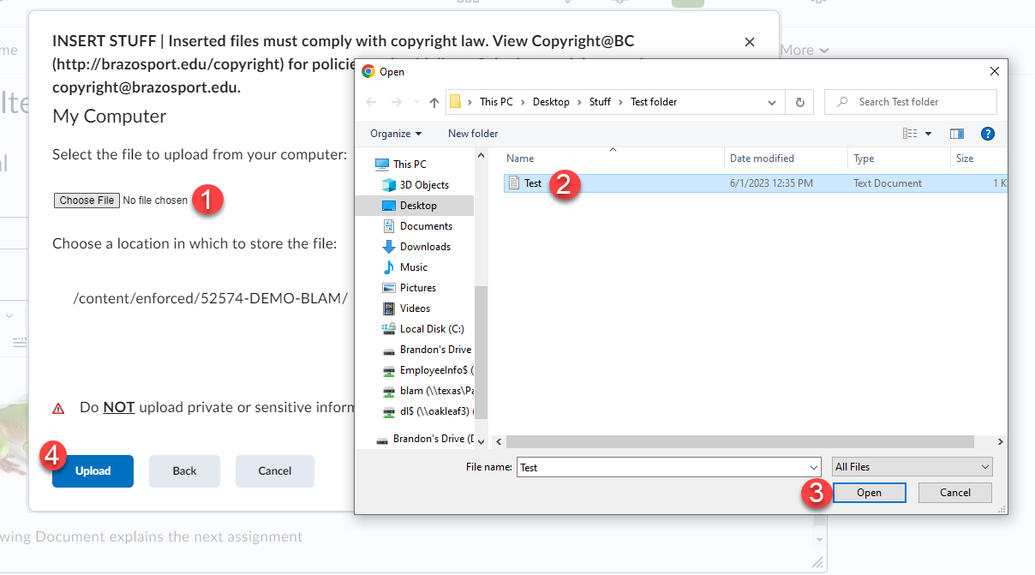
- Enter the text you want displayed for the link (text is what the user will click on to open the file) and click the Insert button.
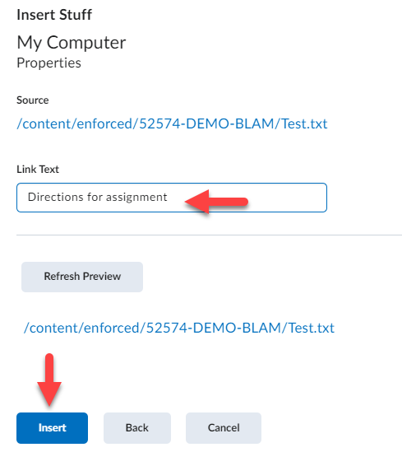

- A link to the file is now inserted and is indicated by the text turning blue.
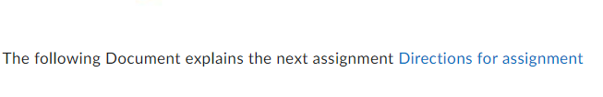
NOTE: A copy of the file is stored in the Managed Files section of D2L.

Inserting YouTube Videos
You can search and embed YouTube videos directly through D2L via the HTML editor as well.
- In the HTML editor, position the cursor where you want to insert a YouTube video and click the Insert Stuff icon.
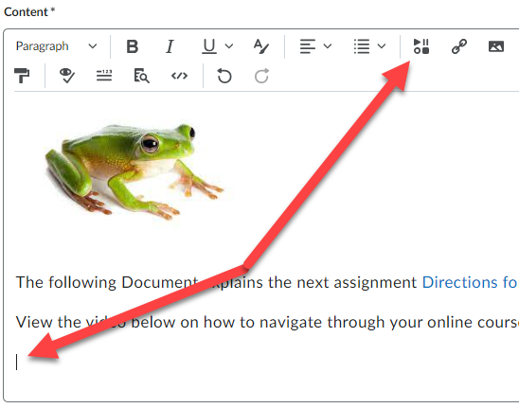

- Scroll down the listings and click on the YouTube.
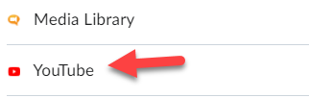

- Enter a description for a desired video in the search box and click Search.
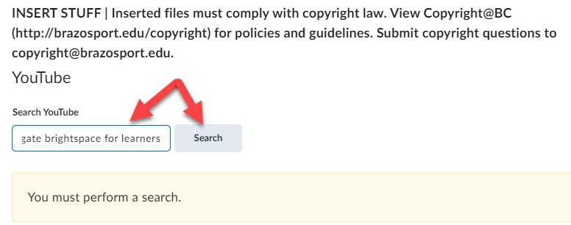

- Once video is located click on it once to select it and click the Next button.
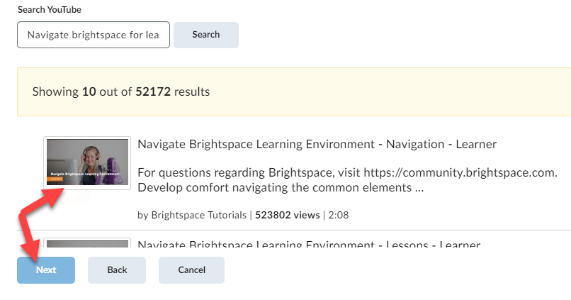

- A preview of the video will appear. Click the Insert button to add it.
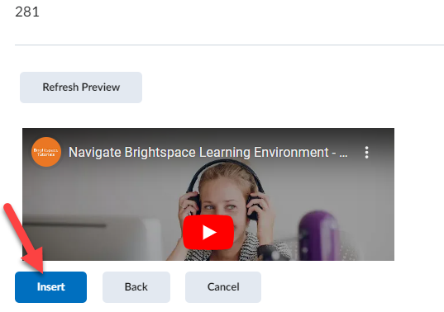

- The YouTube video is now inserted.
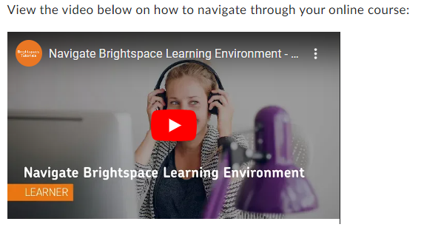

This same process is used for inserting course videos you have placed in your MyMediasite, instead of clicking on YouTube, you would select Mediasite and search for your Presentation to embed into the course. View the Create a MyMediasite account, add video and embed info online course document for more information.
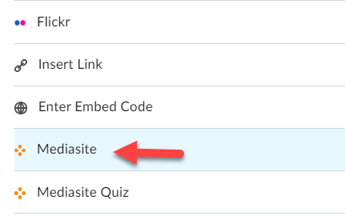

Inserting Links
There are two types of Quicklinks (hyperlinks) that can be inserted into the Editor. This manual will show you how to insert a quicklink to a website and a D2L course component such as a Discussion topic, Dropbox or Quiz item using the HTML editor.
Inserting Quicklinks to Websites
Insert links to websites as additional resources for the course or for an activity.
- Locate the website you would like to add to the course, copy the URL by highlighting the web address, then right-click mouse and selecting Copy.
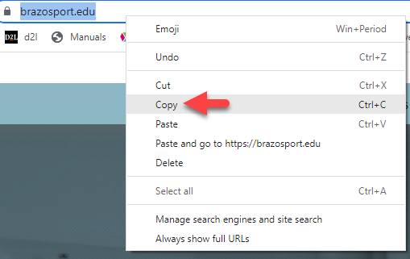

- In the HTML editor enter text you want students to click on which would take them to the website, then highlight the words (with your mouse) you want to turn into a link.
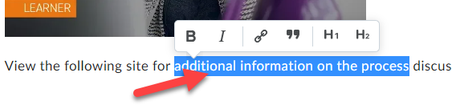

- Using the pop down menu click on the chain icon.
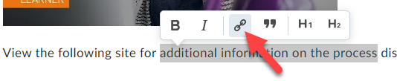

- With the mouse right-click and paste the URL into the text block, then click create.
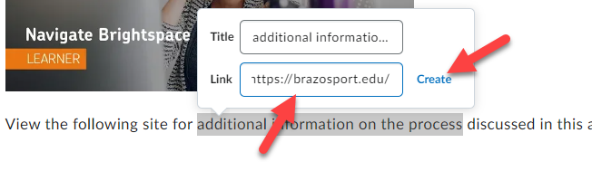

- The text is now a link to that website.
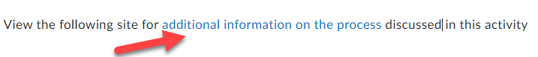

Inserting Quicklinks to D2L Components
You can create links to course items as well, such as: discussions, content, announcements, which helps guide students and provides quicker access.

1. In the HTML editor enter text you want students to click on which will take them to an area in a course (for example a discussion item) and highlight the text with your mouse and click on the Quicklink icon in the HTML editor’s navigation bar.
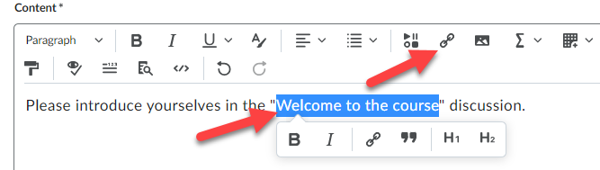

2. Scroll down, and in this case, click on Discussions.
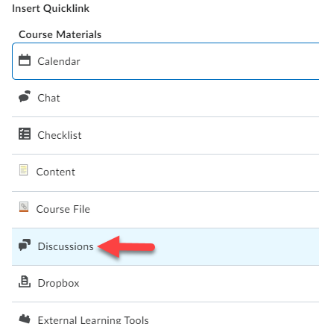

3. Select the correct discussion forum and then the discussion item.
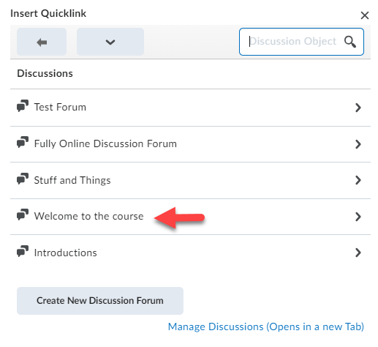

4. The text is now a link that takes students directly to the discussion item.
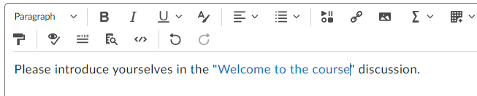
Using the BrightSpace HTML Editor
D2L has updated the HTML Editor with the goal to create an editor that felt like the original, but more modern! It works the same as always, yet now has great new features. View below for specific enhancements and additions.
Additional Enhancements
• More and different formatting options.
• An improved color picker with WCAG compliance checking.
• A full set of emojis and special symbols
• The move of footer options like 'preview' ' source' 'accessibility checking' and 'expand' to the main toolbar.
• Updates to our font size menu
• Removal of Spellchecker
• Removal of Cut/Copy buttons (which no longer worked on most browsers anymore in any case)
• A refreshed Accessibility checker
Additions to the Editor
• New Advanced Tables that includes sorting options.
• Contextual menus for editing text, links, and images (image editing is not available in all areas)
• Word Count including character and selection word count
• Advanced Source Code Editor that includes code suggestions and colour coding for tags.
• Lato font
• @mentions support in Discussions
• An 'Other Insert Options' menu for overflow items to improve responsiveness.
• Limited text pattern support: * * for italics, ** ** for bold, ## for H2, ### for H3, etc until

