Intelligent Agents monitors a course to find activity that matches criteria you set and then sends an email to the user (student). You can run multiple Agents at any one time. The criteria that the agents can search for are:
Working with Intelligent Agent Tool
- login activity (refers to logging into D2L)
- course activity (refers to login to a specific course)
- release conditions in D2L (refers to a criteria based on a tool)

This manual provides directions on how to set an Agent to notify any student who has not logged into a course over a specified period of time. Set an Agent to run during the first 2 weeks of the course, so you would know which students have yet to log into your course by either the first or second week of class.

- Access the Intelligent Agent tool by selecting Edit Course.
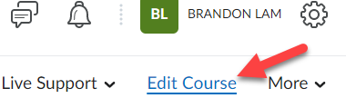

- Click on Intelligent Agents from the list of options.
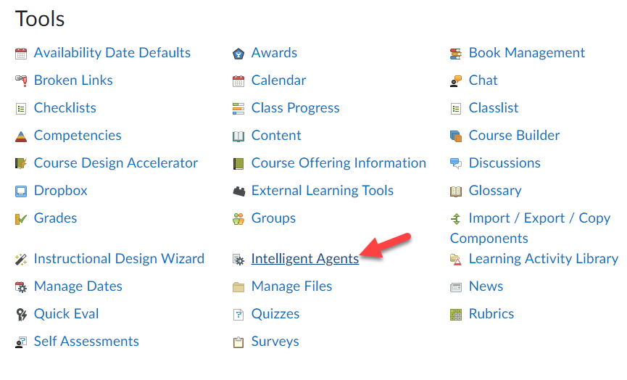

- Click the New Agent button.
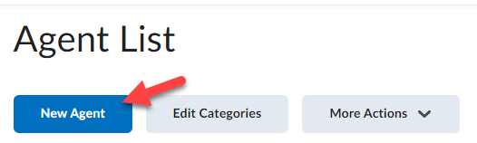

- Type in an Agent Name (1) and Description (2). The description will help you manage your Agent list later on. For example: Agent Name: Login with Description: Alert me when a student has not accessed the course for 1 week.
Check the Status checkbox so Agent is enabled (3).
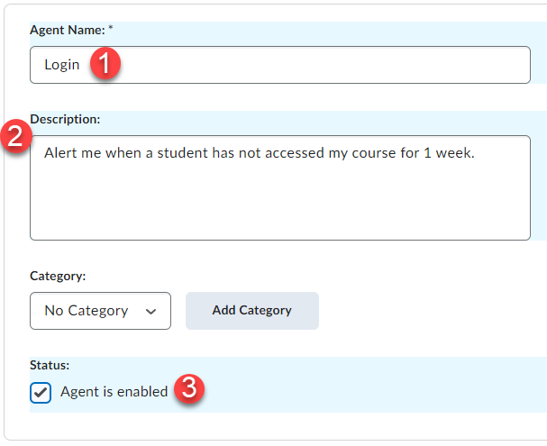

- Under Role in Classlist, select User with specific roles (1) and select Student (2). Under Take Action on Activity, select the checkbox for Course Activity (3) and click the radio button for User has not accessed course for at least ____ days [type in how many days you would like, I chose 7 in this example] (4).
NOTE: If you need to attach a release condition to an agent skip 3 & 4 for step 5 from above and instead, click Create under the Release Conditions section and select the condition(s) for the agent.
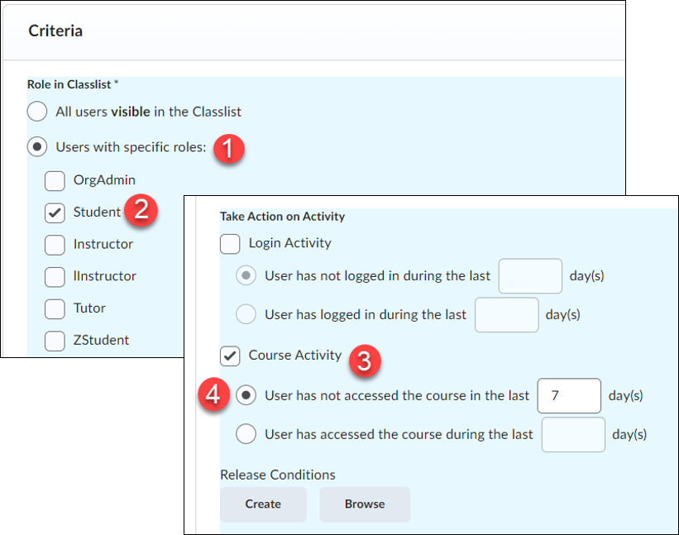

6a. Under Agent Action, select the radio button for Take action only the first time the agent’s criteria are satisfied for a user (you could also choose the second option for each time, but for this example I am only looking for those who have not logged in during the first week of class).
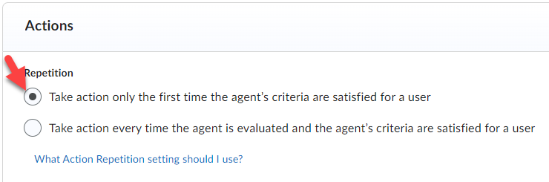

6b. Click the check box to send an email.
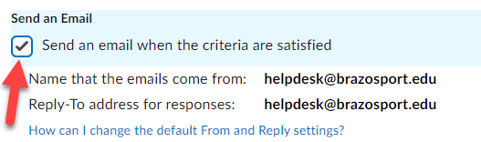

- In the To: header type the following exactly as indicated here, including the: {InitiatingUser}
This will send an email to all students who have not accessed your course for 7 days.
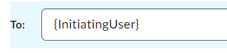

- Type in an Email Subject header, such as Attendance Report for ENGL101.
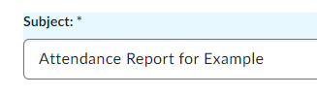

- Type your message. If you want to have the user first and last name included in the message you must enter the following exactly as indicated here, separated by a single space and including the braces:
{InitiatingUserFirstName} {InitiatingUserLastName}
For example: Hello {InitiatingUserFirstName} {InitiatingUserLastName}, rest of message goes here.
Click the Save and Close button when done.
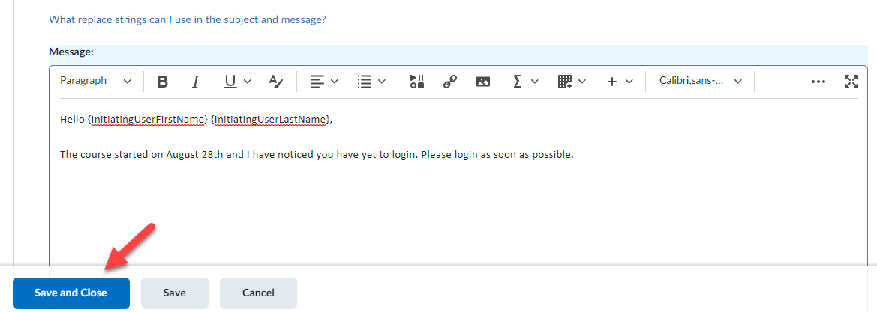

- The new intelligent agent will appear in the Agent List.
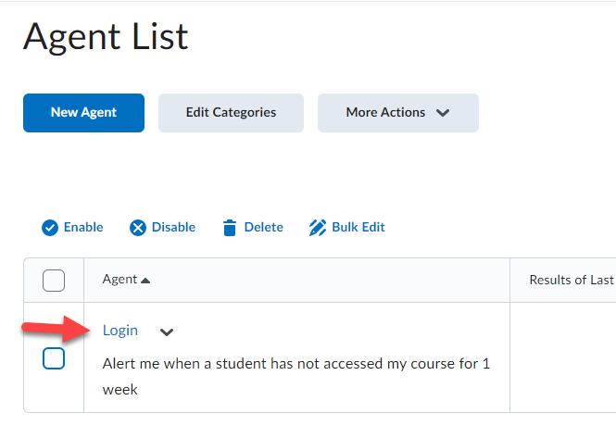
- Once an Intelligent Agent has ran, you can see a list of all the student who received an email for the agent (because they met the criteria for it) by clicking the … users identified link in the Results of Last Run column.
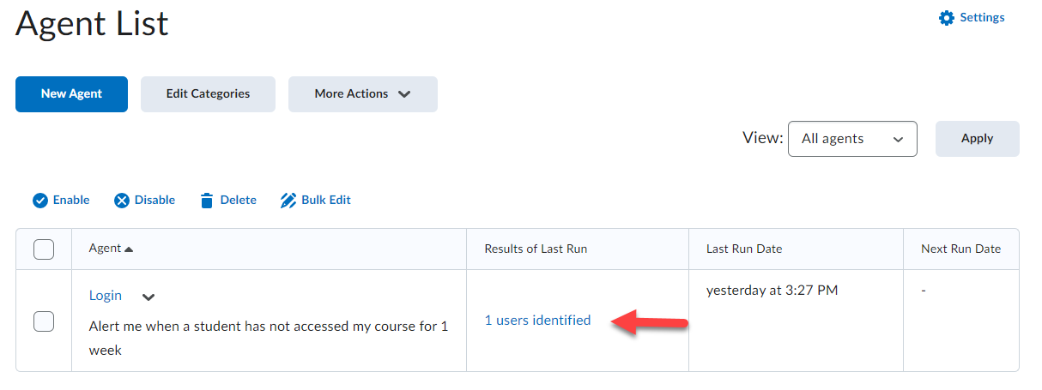

- You can create a "reply-to" email address so that students can reply to any email sent by an Intelligent Agent. To do so, from the Intelligent Agent click Settings (1), select Set custom values for this course (2), enter an email address in the Reply-To address for responses field (3), you can enter you name in the Name that emails come from field [this will include your name in the email address that appears for the emails sent to your students] (4), and click Save (5).
