Creating questions in the Question Library allows you to share questions among quizzes and choose sets of questions to be added to a quiz. Creating sections of questions in the Question Library helps to organize, manage, and edit questions later.
Question Library
Creating questions in the Question Library
Creating Sections
1. Select Quizzes from the Assessments drop-down menu on the navbar.
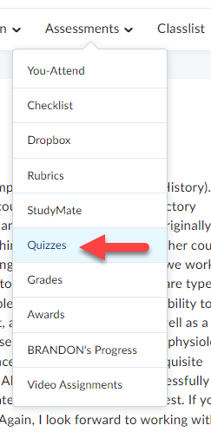

2. Enter the Question Library by selecting the Question Library link located underneath the Navbar.
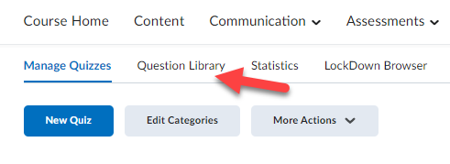

3. Click the New button.
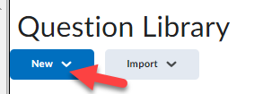

4. Select the Section link.
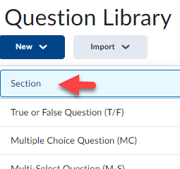

5. Enter a Section Title (1) such as “multiple-choice questions” or “unit 1 questions”. If desired, enter Section Text (2) as a description about what is contained in the section and click the Save button (3).
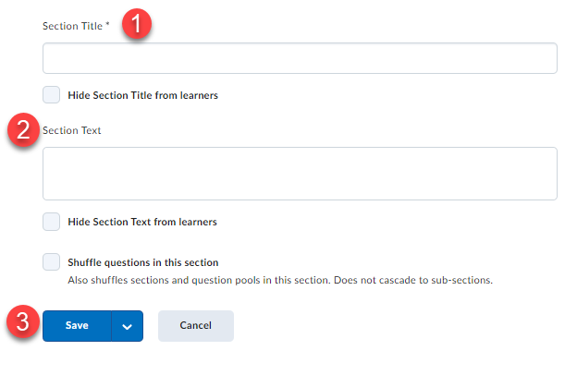

6. To add questions to the new Question Library section click on the section’s name text link.
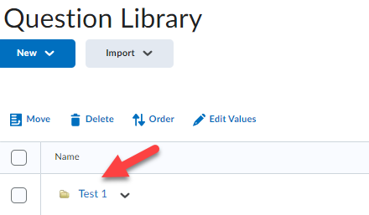

7. Use the New pull-down menu to select a question type.
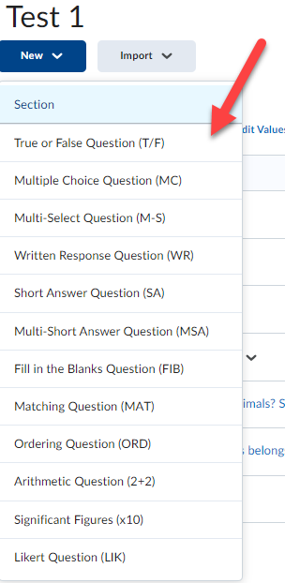

NOTE: Clicking on the Question Text or Answers choice (MC questions) fields will produce the toolbar that allows you to format text, inset links & images, and more.
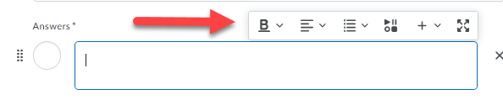

The following section describes how to create True/False, Multiple-choice, Matching, Short Answer and Written Response question types.
Question Types
True False Question Type (T/F)
1. Type a question in the Question Text (1), select the correct answer (2), enter a Points value [this can also be altered later] (3), and click the Save button (4). A preview of the question is shown in the panel on the right (5).
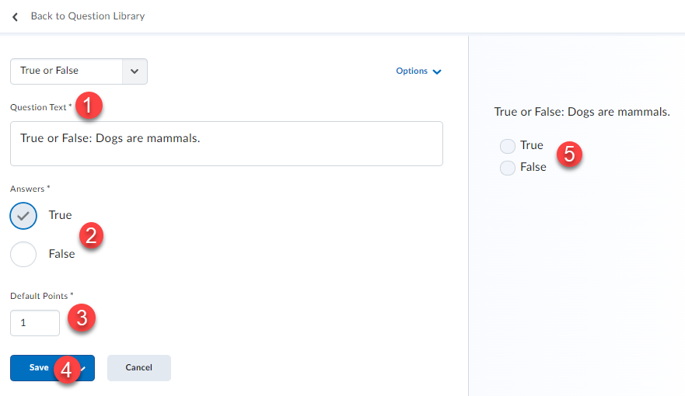

Multiple Choice Question Type (MC)
1. Type a question in the Question Text field (1); enter the answer choices for the questions [if you want to remove an answer choice, click on the X next to it]. (2), if you need additional answer choices click on the Add Answer link (3), select the option for Randomize answer order [this ensures each user taking the quiz will receive question options in a different order] (4). Then enter a Points value [this can also be altered later] (5) and click the Save button (6).
NOTE: To add feedback for each question choice, click the Options (A) link and select Add Feedback (B).
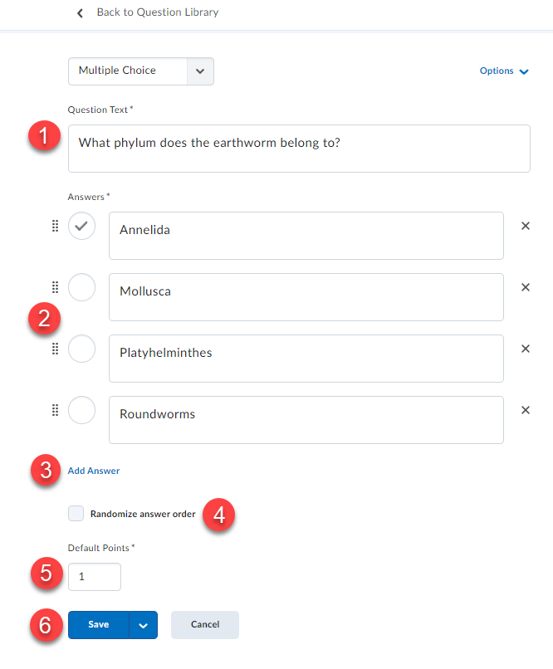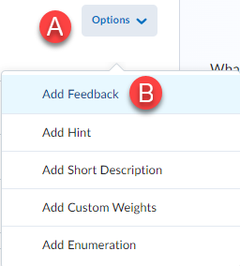

Matching Question Type (MAT)
1. Enter a question title in the Title field (1) [it is optional but does help during future editing]; enter the Points value [this can also be altered later] (2) and type a question in the Question Text field (3).
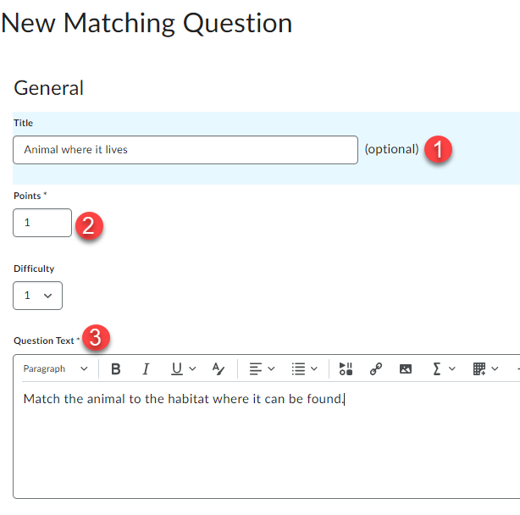

2. Select a Grading option.
• Equally weighted: User receives marks for each correct answer.
• All or nothing (this is the Default): User must have all the possible correct answers or else they receive no marks.
• Right minus wrong: The number of right answers chosen is subtracted from the number of wrong answers chosen to get an overall mark for the question.
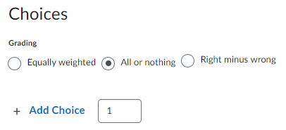

3. Enter Choices [choices show on the right of the page and should be short for better onscreen reading]. (1), if you need additional choice boxes click Add Choice [you can enter more choices than matches which helps correct responses based on elimination] (2). If you want to remove a choice, select the Trash icon (3).
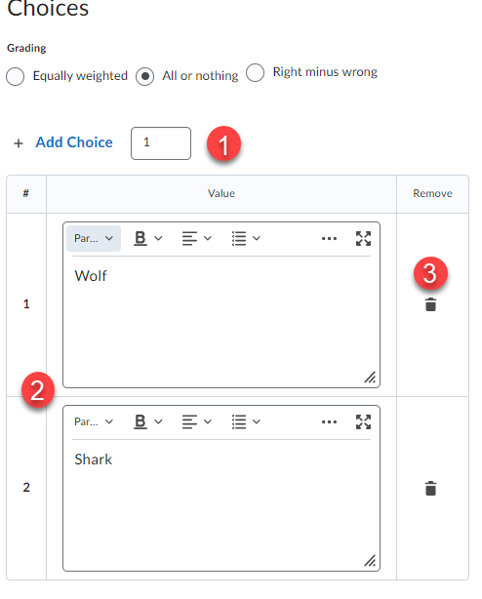

4. Enter Matches (1) [matches show on the left of the page]. Use the pull-down menu to select the correct Choice option for the Match (2). If you want to remove a match, select the Trash icon (3), type in overall question Feedback (4) [it is optional, but it is a great way to provide guidance] and click the Save button (5).
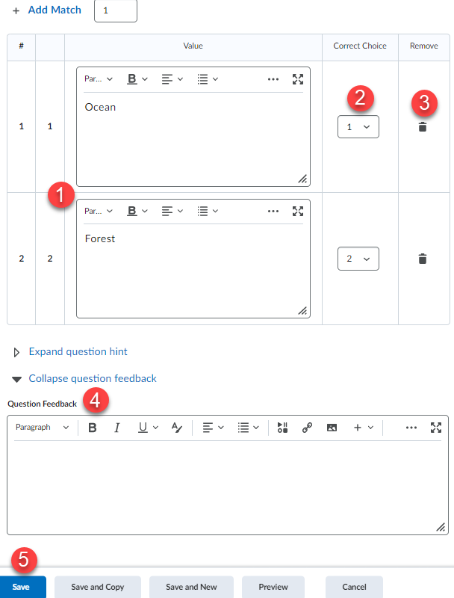

Short Answer Question Type (SA)
[Short Answer types require you to enter ALL acceptable responses for each item response in the question]
1. Type a question in the Question Text field (1). Enter your first acceptable answer in the Answer for Blank 1 text block (2), to add additional answer blanks click the Add Blank link (3). Enter the Points value for the question [this can also be altered later] (4). Click the Save button when done (5).
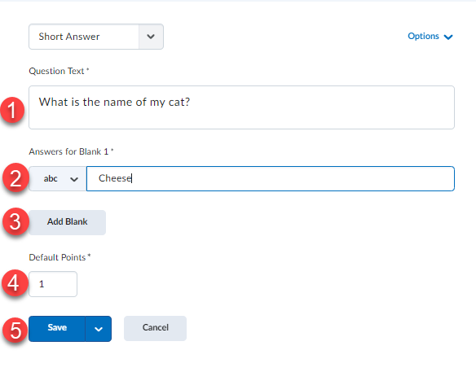

Written Response Type (Formerly Long Answer Question)
1. Type the question in the Question Text field (1) and enter the Points value [this can also be altered later] (2).
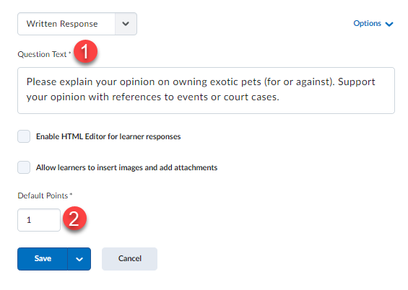

2. If you are looking for a verbose response click the Options link (1) and select Add Custom Response Box Size (2) use the Custom Response Box Size drop down menu to select a size (3).
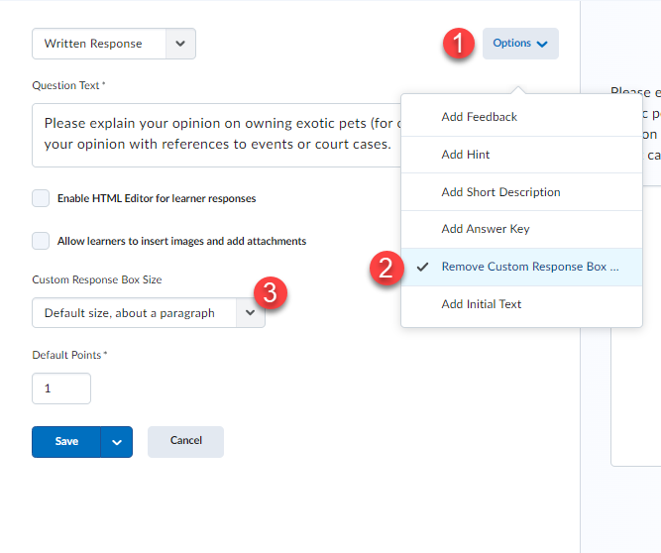

3. To add overall question Feedback [it is optional, but a great way to provide guidance] click the Options link (1) and then click Add Feedback (2) and then enter the feedback you want to provide (3).
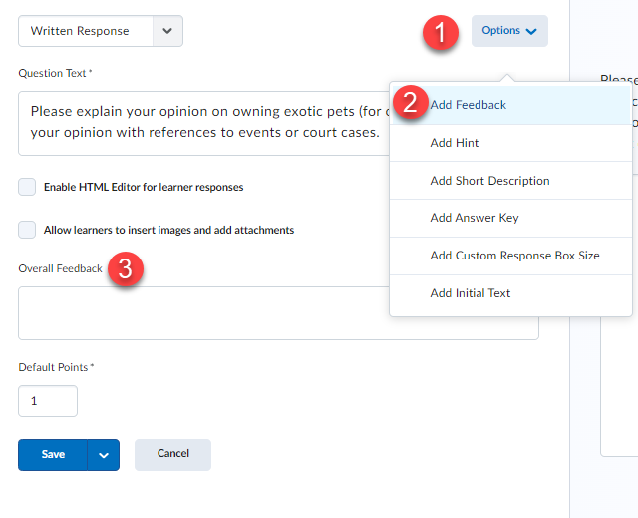
4. Add initial text to Written Response questions, to perhaps give instructions for the answer you are looking for, or directions to respond. Click Options (1), then Add Initial Text (2).
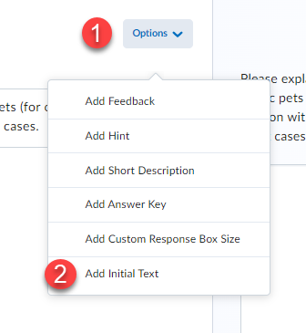

5. Type your instructions or directions (1), click Save (2).
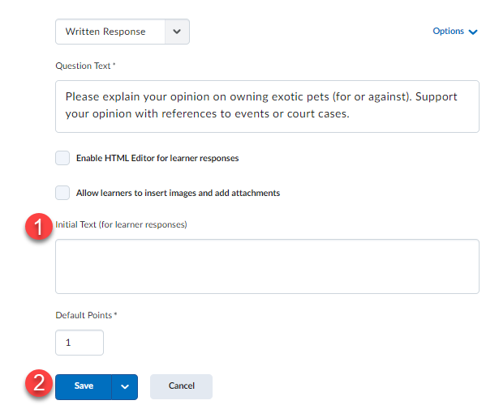

IMPORTANT: DO NOT EDIT A QUIZ after it has been released, you can adjust scoring via the Grade Tool.
Require Students to Use Respondus LockDown Browser to Take an Exam
To learn more about how to require students to use LockDown Browser for an exam view the following manual:
http://oakleaf3.brazosport.edu/bcdl/manuals/instructors/brightspace/PDF/Lockdown%20browser.pdf

