1. Log in to Virtual Campus and go to the correct course.
2. Click on the Communication tab, then on Virtual Classroom.
3. Launch the meeting you have already setup in advance. Click here for a tutorial on that.
4. With the meeting already open, double click the Image Mate4 icon on the desktop to start the document camera software (or whatever document software you have installed).
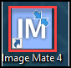
5. Click on the ELMO UVC Camera option (or whatever your document camera software uses).
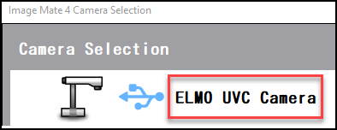
6. On the Virtual Classroom screen, click the Share your Screen option:
7. On the dropdown asking Window or Screen to share, click on ELMO UVC Camera, and then click Allow.
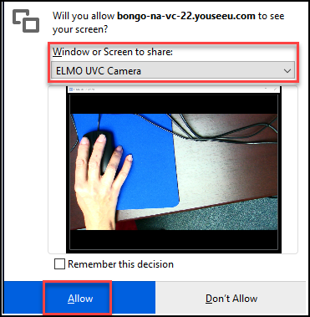
8. To view any documents you have already loaded click View Presentation, and to pause the Screenshare click Pause Screenshare.
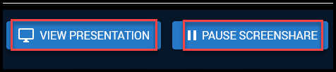
9. To go back to the document camera, click Resume Screenshare.
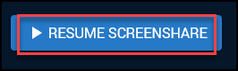
10. To stop sharing your screen click Stop Screenshare.
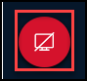
Troubleshooting steps:
If the document camera does not work, or freezes up while inside the Virtual Classroom, try these steps to resolve:
Select the document camera as the camera source instead of Screenshare. To do this, you will need to make some changes to the browser. Select from either Chrome or Firefox.
- For Chrome, in Settings > Privacy and Security > Site Settings, select Camera or Microphone. Set the default camera or microphone you want to use in the dropdown selector. You will need to reshare your webcam or audio for the correct device to be used.
- For Firefox, you select the camera and microphone when sharing. If you did not select "remember setting" during the share, just unshare your webcam or microphone and reshare using the correct webcam or microphone. If you selected the remember setting, you will need to change that by going into Preferences, and Privacy & Security. Under Permissions, select Camera or Microphone settings. This will show the websites that have requested your camera or microphone. You will need to remove the Bongo server with the wrong camera/microphone, and then go back and reshare your webcam or audio in Virtual Classroom.

