In the Virtual Campus you can exempt specific students from having to complete a topic/activity found in the Content area of the course.
Exempting Students from a Content Topic
Exempting a student from an activity in the content area means they are not required to complete it and their grade for the activity will automatically be dropped.
NOTE: The activity you exempt a student from must be associated with an item in your gradebook.
NOTE: Students will not receive a zero in the gradebook for an exempted item. Their grade for the item will be dropped and not included in their calculation for their final course grade.

- Click on Content from the navigation bar.
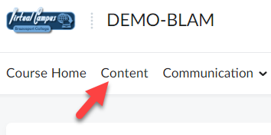

- Open the module containing the activity you want to exempt a student from.
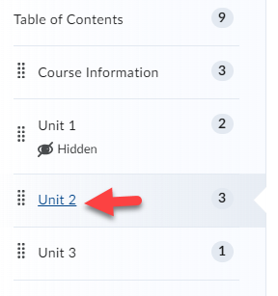

- Click the Bulk Edit button for the module.
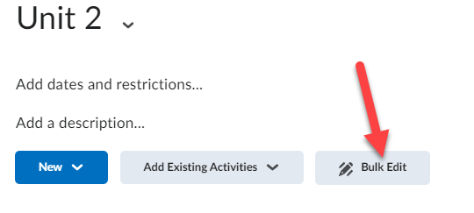

- For the content topic/activity you want to exempt a student from, click on its date of availability (Or Add dates and restrictions… if no date of availability is selected).
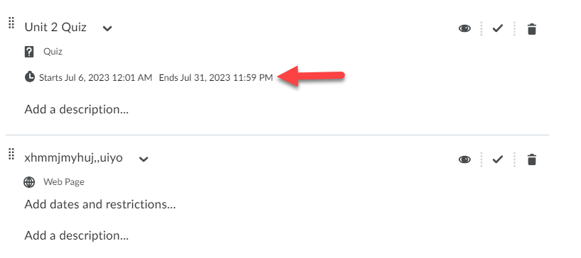

- Click on the Manage Exemptions button.
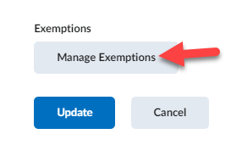

- Select the student(s) you want to exempt from the item/activity (1). Then click the Exempt button (2).
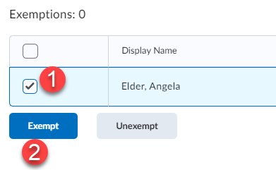

- When done click the X in the top right-corner to close the Manage Exemptions page.
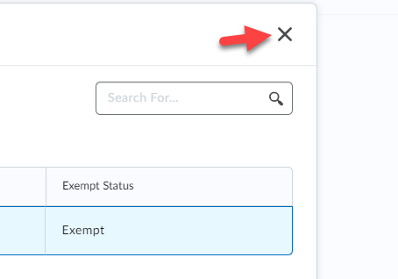

- Click the Update button to save your changes.
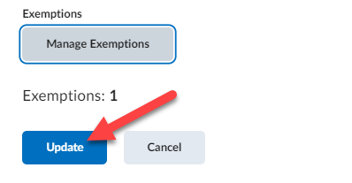

- Click the Done Editing button.
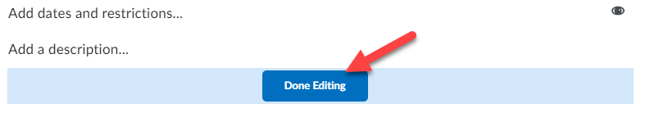

You will now notice that the content topic displays the number of students given exemptions.
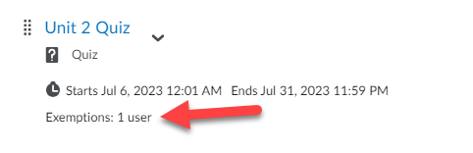

In the gradebook for those students exempt from the content activity, you will see the word “Exempt” instead of a grade show up for them.
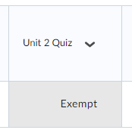
NOTE: The grade will not be included in the calculation for the student’s final course grade.

Un-exempting Students from a Content Topic
Once you have exempted a student from a topic/activity in the Content area of the course, you have the ability to remove the exemption from them. This means they will now be required to complete the activity.

- Click on Content from the navigation bar.
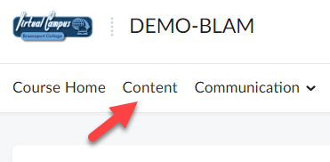

- Open the module containing the activity you want to unexempt a student from.
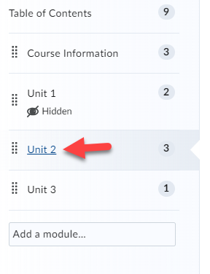

- Click the Bulk Edit button for the module.
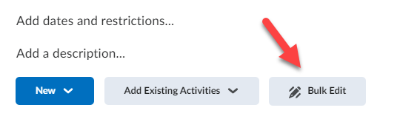

- For the content topic/activity you want to unexempt a student from, click on its date of availability (Or Add dates and restrictions… if no date of availability is selected).
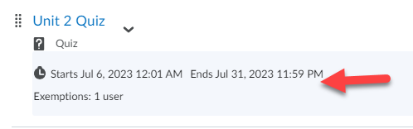

- Click on the Manage Exemptions button.
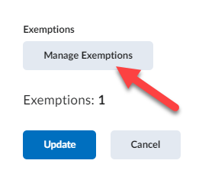

- Select the student(s) you want to Unexempt from the item/activity (1). Then click the Unexempt button (2).
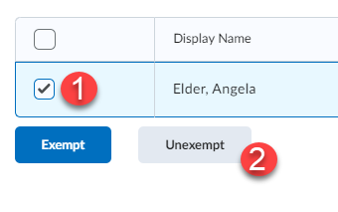

- When done click the X in the top right-corner to close the Manage Exemptions page.
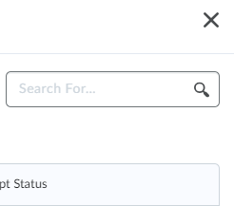

- Click the Update button to save your changes.
