If you have multiple sections in your course, create groups for each section and set restrictions to course announcements, content and tools based on those groups.
Creating Groups

Create your groups first:
- Click on Edit Course.
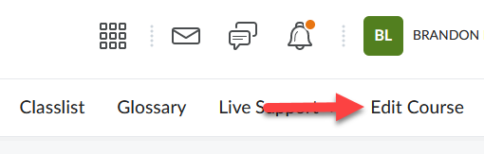

- Click Groups.
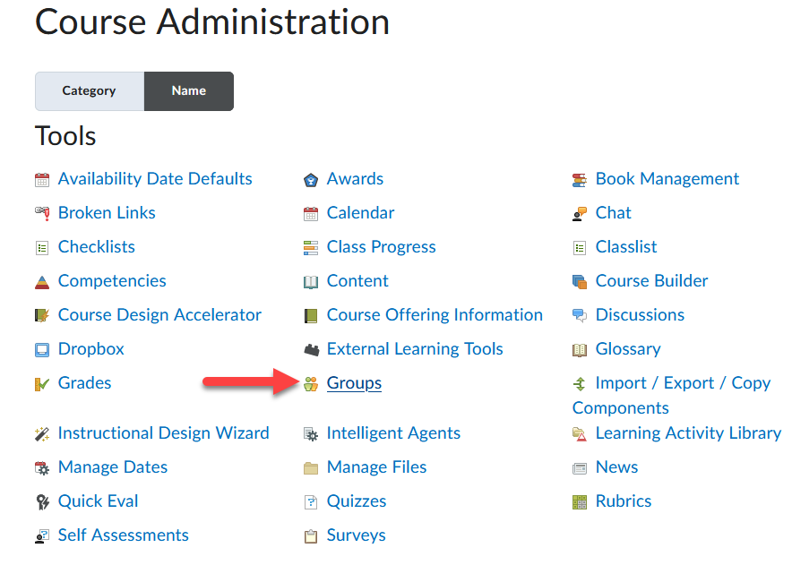

- Click New Category.
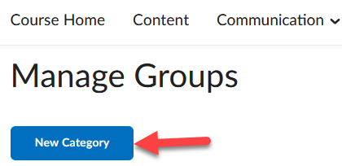

- Enter a Category Name, such as Course Sections.
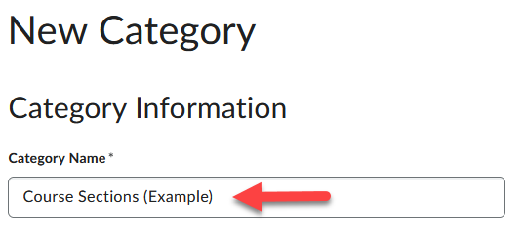

- Enter the number of groups (1) and click Save (2).
Optional: You can select to Set up Discussions and Dropbox areas for each section at this time, but it may be easier to set restrictions to groups within the tools themselves.
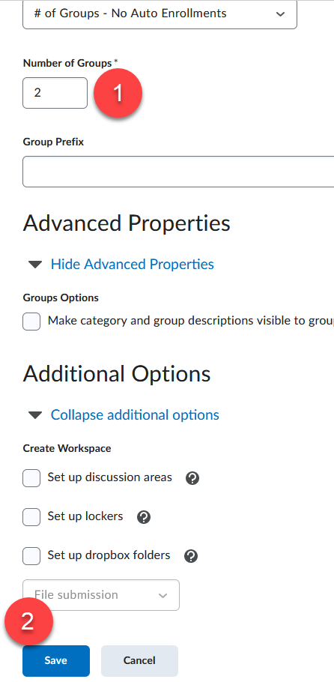
- To rename a group and enroll students to it, click on each section title (1). Enter a new name, such as Fully Online and Hybrid (2). Click Save (3).
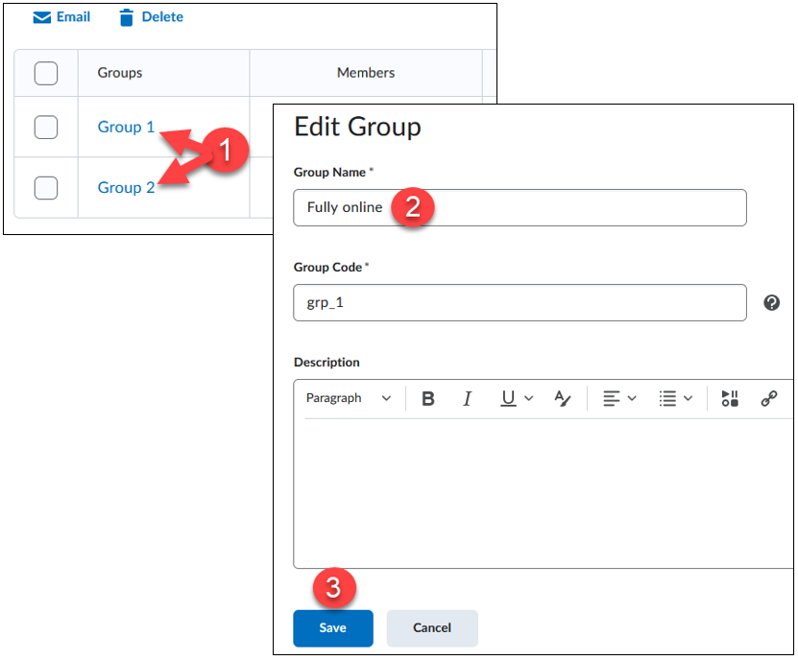

- Click the new group name.
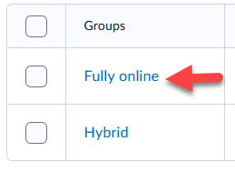

- Click the Enroll Users button (1). Select the users you want to enroll in the group (2) and click Save (3).
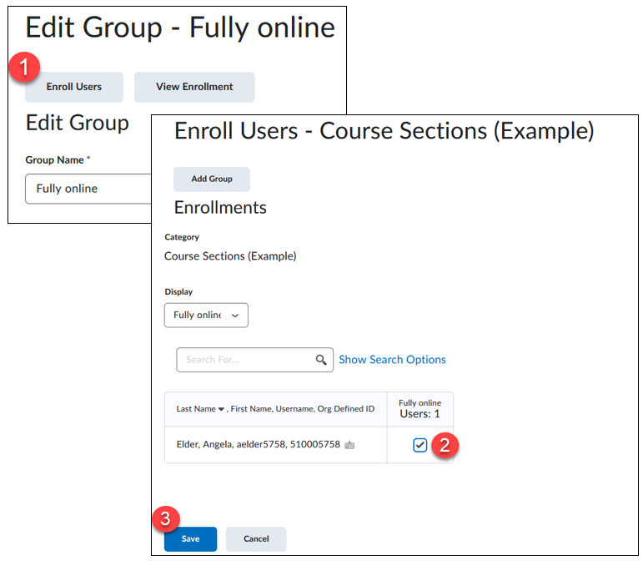

Now that we have our sections we can create or edit course Announcements and tools to restrict views based on a specific group.

Restrict Modules in the Content Tool:
In the Content tool you can create modules based on your course sections, add content to those modules and then restrict access based on your groups.

Create Content Folders:
- Go to Content in the navbar.
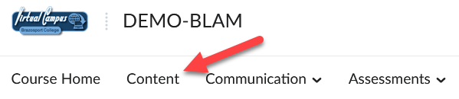

- Create a module by entering a Title for it in the Add a module field (enter a Title based on your group names such as Fully Online or Hybrid [this helps you with future Content management]).
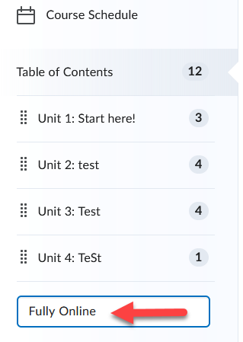

- Click on the Add dates and restrictions link that appears for the module you created before.
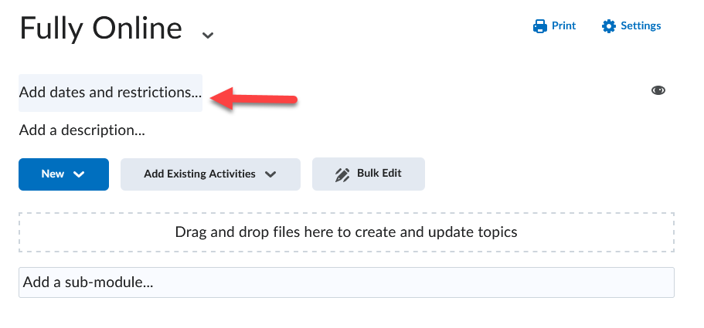
- Click on the Create button under the Release Conditions section.
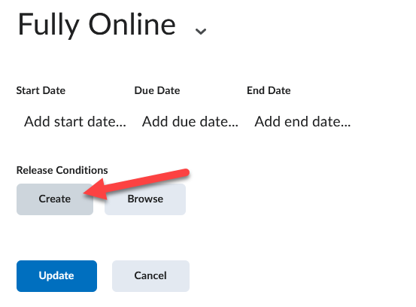

- Use the pull-down menu for Condition Type and select Group Enrollment.
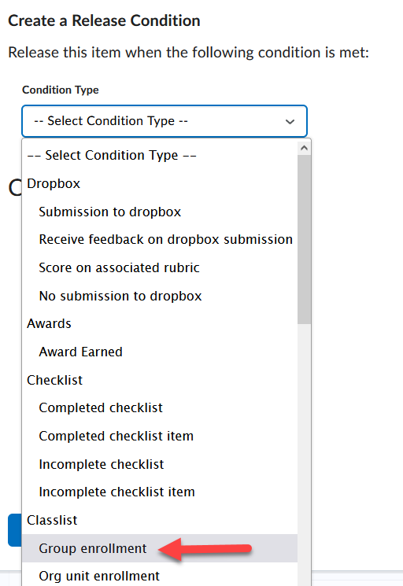

- Use the pull-down menu for Group to select which of your groups you would like to have access this particular module (1) and click Create (2).
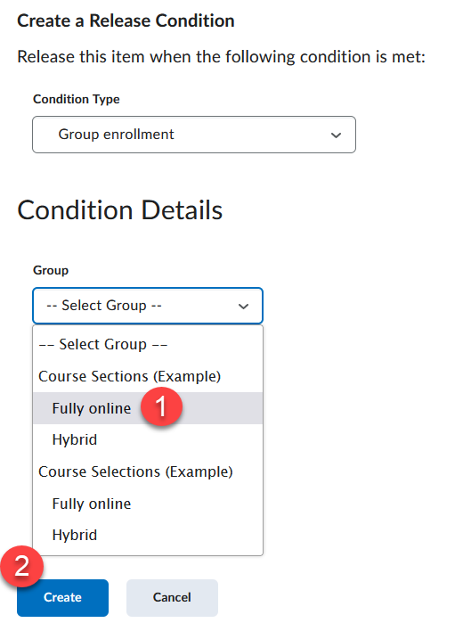

- When finished creating the folder click the Update button.
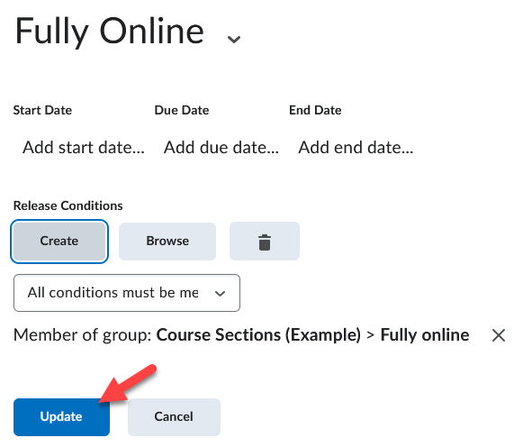

- You have now created a folder(s) that are restricted to specified groups which are indicated by the Member of group text.
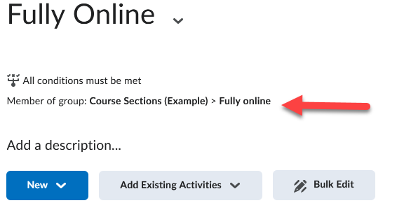

- Create any additional group modules following the same process as described above.

From this point you can now either add sub- modules or topics for each group module you created OR move existing modules/topics into the module(s).

Add a Topic to a Group Module:
- Click on the module (from under the Table of Contents section) that you would like to add a topic to.
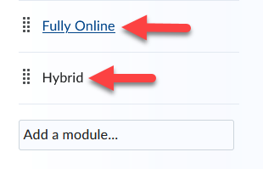

- Click the New drop-down menu and select the type of topic you want to create.
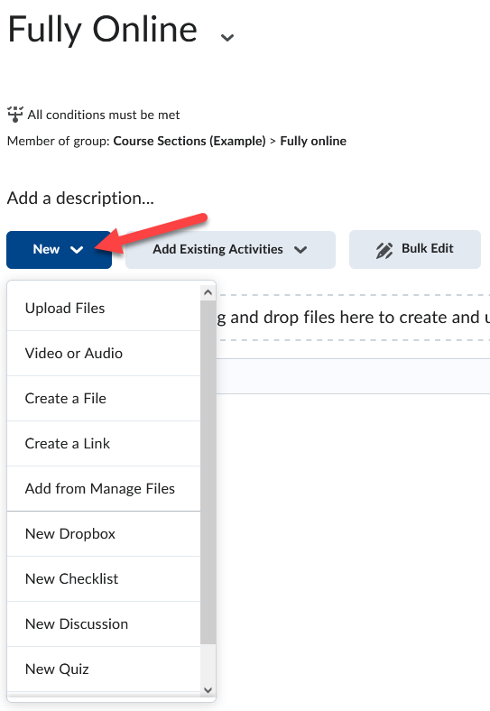

Add a Sub-module to a Group Module:
- Click on the module (from under the Table of Contents section) that you would like to add a module or topic to.

- Enter a title for it in the Add a sub-module… field.
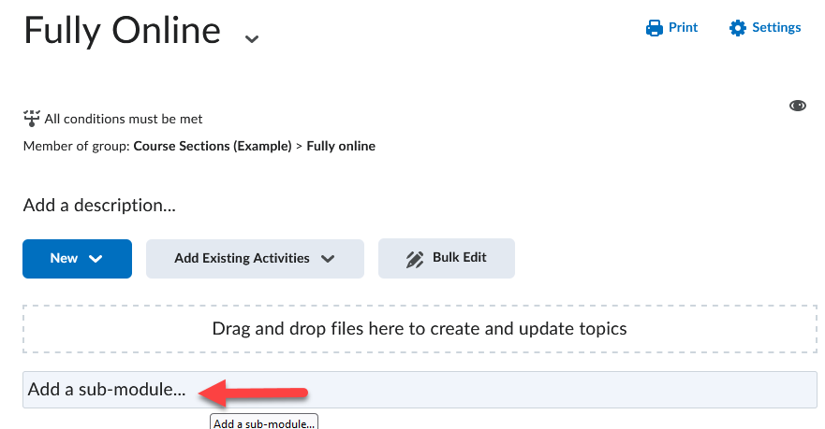
NOTE: You DO NOT need to restrict the module or topic since the folder you are adding the item into is already restricted to your specified group.

Move an existing Module or Topic to a folder:
- Click on the drop-down menu of the module or topic (1) and click the Move to option (2).
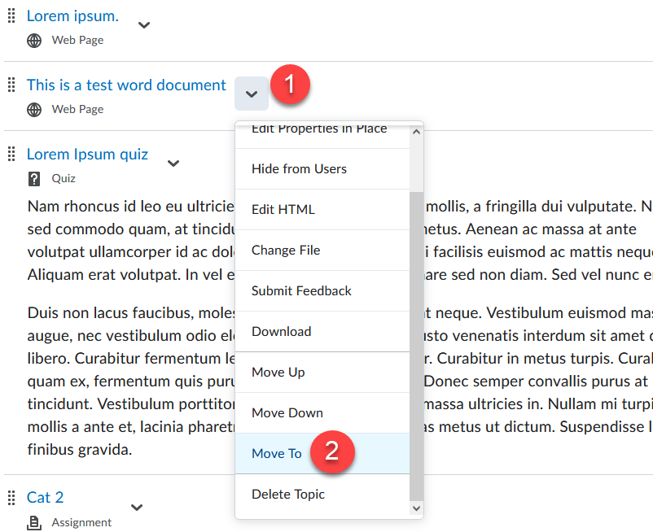

- Select which existing folder you would like to move the Module and/or Topics into (1) and click Move (2). Continue this process till all items are placed in their designated folders.
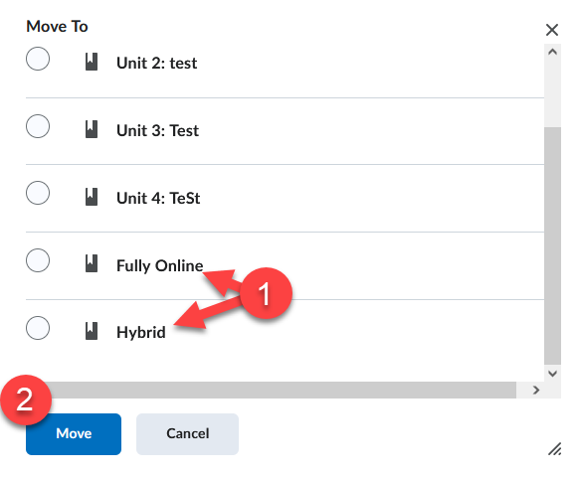

Restrict Discussions Forums and Topics based on Groups:
You can create a discussion forum and restrict access to the topics in it to a specific group.
NOTE: If you already have discussions created, Click to Edit the Forum or Topic and proceed to Step 4.

Add a Discussion Forum:
- Click Communication on the Navbar and select Discussions from the drop-down menu.
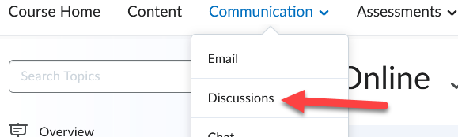

- Select New Forum from the New drop-down menu.
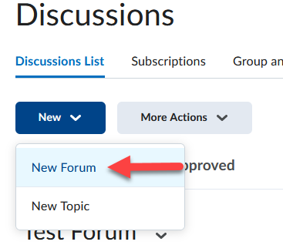

- Type in a Title, for example “Hybrid Discussions” [this helps you with future Discussion management].
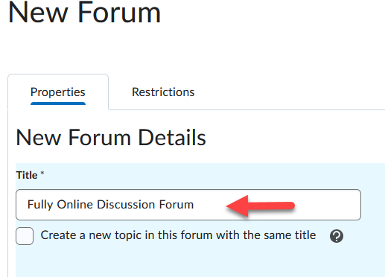

- Click on the Restrictions tab.
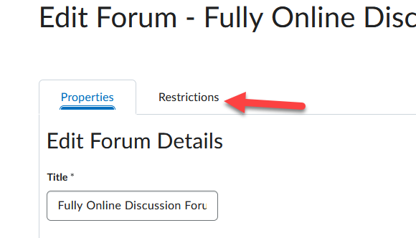

- Select the check box for Restrict this forum to the following groups (1) and click the Add Groups and Sections button (2).
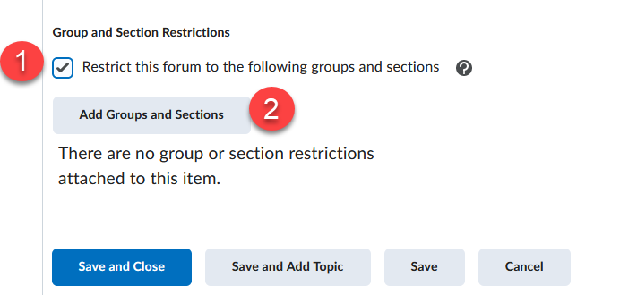

- Check the box next to the group you want to restrict the forum to (1) and click Add (2).
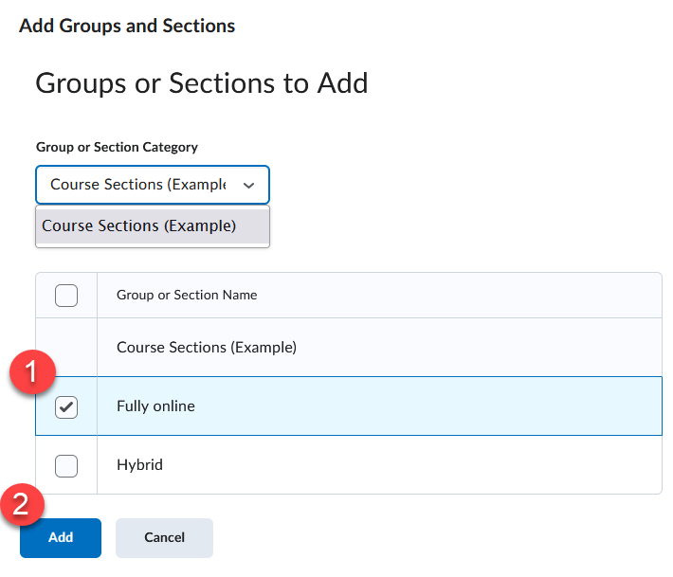

- Click Save and Close.
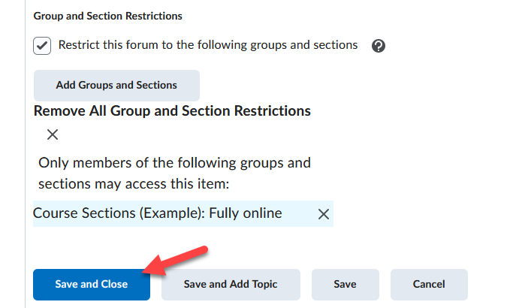

Add a Discussion Topic to restricted Forum:
- Click New Topic from the New drop-down menu.
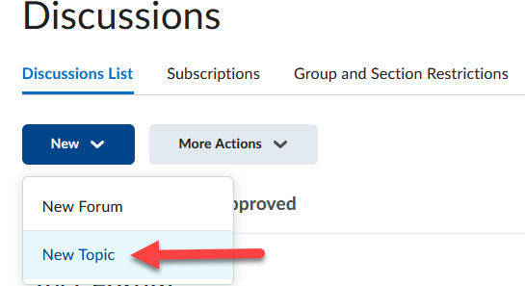

- Use the Forum pull down menu and select the restricted Forum you added earlier.
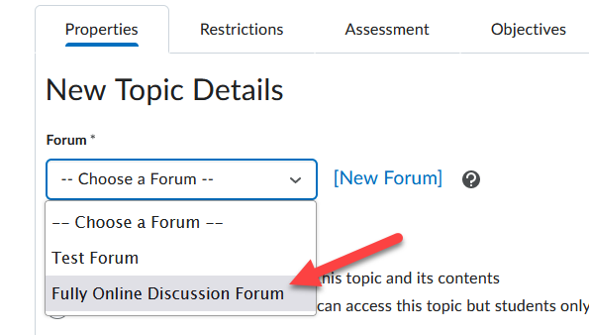

- Continue to enter Topic required information such as a Title (1), Description (2), etc., and click Save and Close (3).
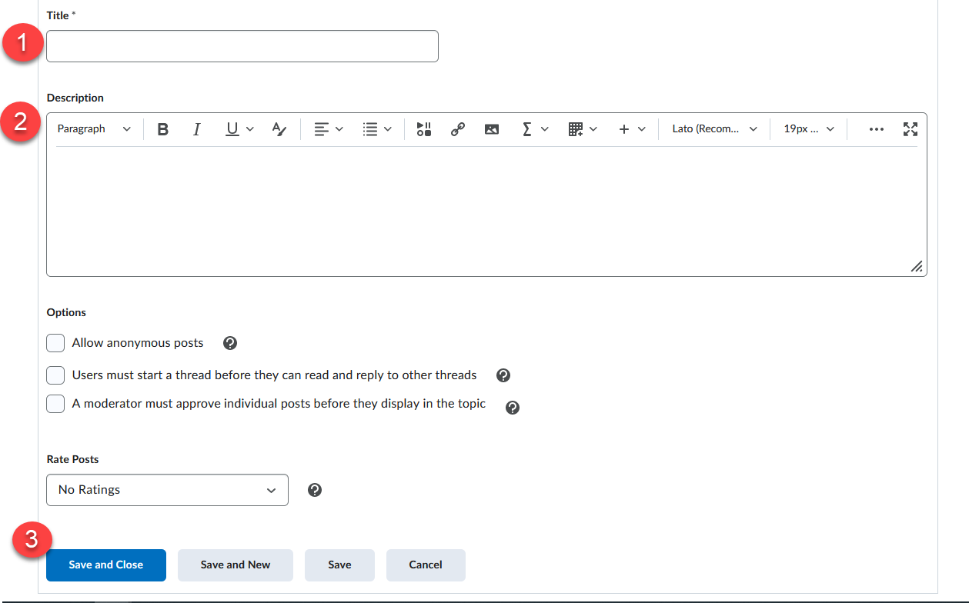

- Continue this process for each Topic.

Another option is to just restrict the Topics to groups, leaving the Forum unrestricted. For example you can have a Forum called Assignments and just add restricted Topics for each group so members only discuss course assignments within their designated group sections.

Restrict Dropbox items based on Groups:
NOTE: if you already have Dropbox items created, select to Edit the item and proceed to Step 3 and access the Restrictions tab.

Add a Dropbox Item:
- Click Dropbox from the Assessments drop-down menu on the navbar.
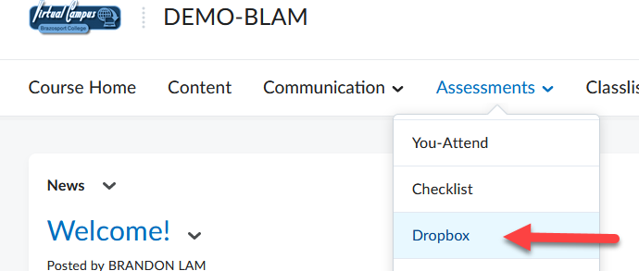

- Click New Folder button.
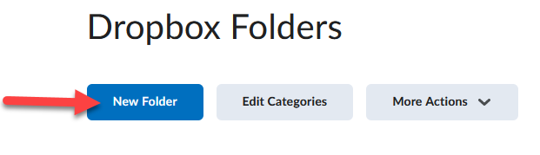

- Enter a Name, such as Assignment 1 (hybrid section) [this helps you with future Dropbox management] and make additional selections for the Dropbox item.
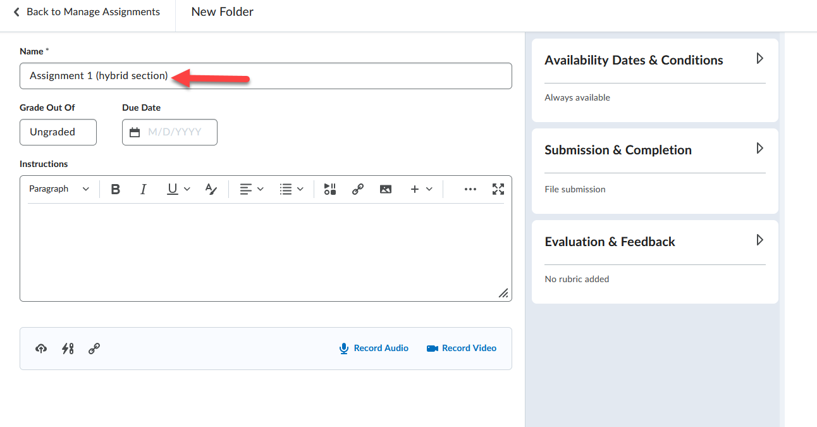
- Click the dropdown tab for Availability Dates & Conditions (1), then click the dropdown tab for Add Release Condition (2), and then click Create New (3).
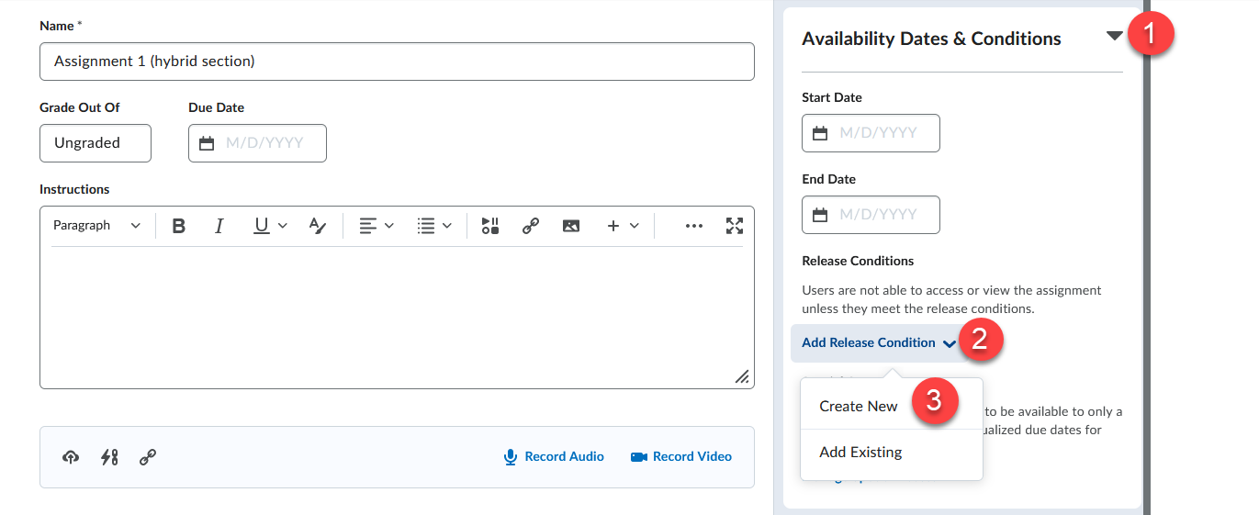

- For the Condition Type select Group Enrollment (1). For Group select which of your groups you would like to have access this particular Dropbox folder (2) and click Create (3).
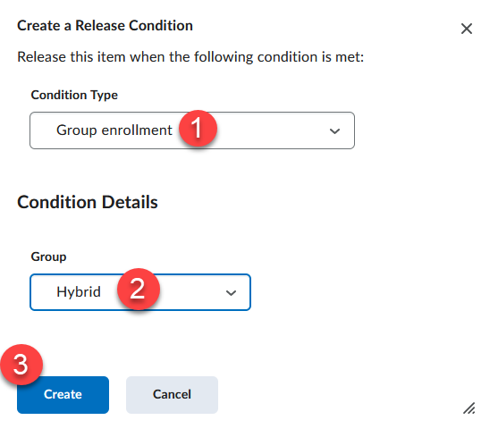

- Click Save and Close.
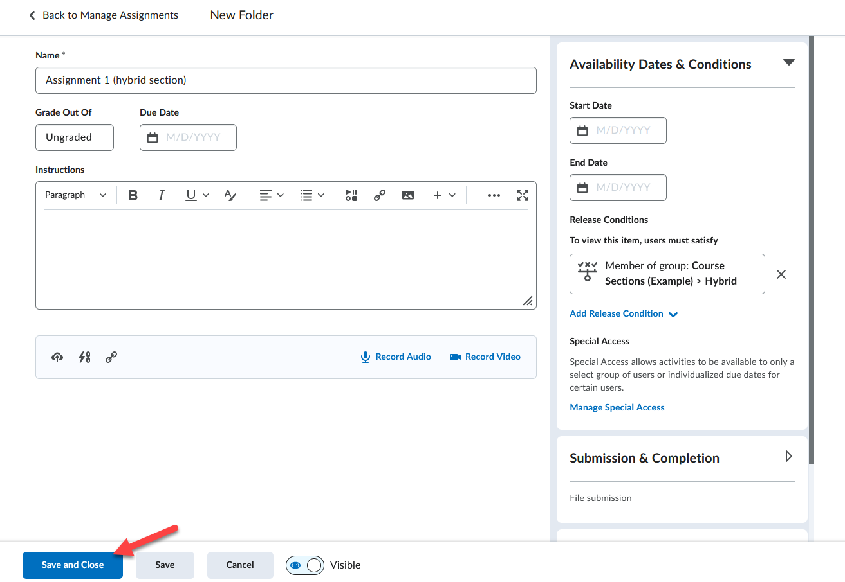
Restrict Quizzes based on Groups:
NOTE: If you already have Quizzes created click on it to Edit it and proceed to Step 3 and access the Restrictions tab.

Add a Quiz
- Select Quizzes from the Assessments drop-down menu on the navbar.
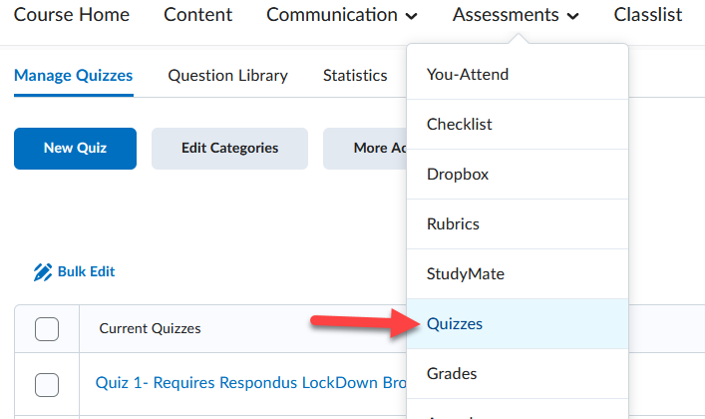
- Click the New Quiz button.
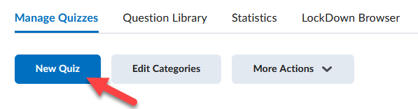

- Enter a Name, such as Quiz 1 (hybrid) and make any other desired selections.
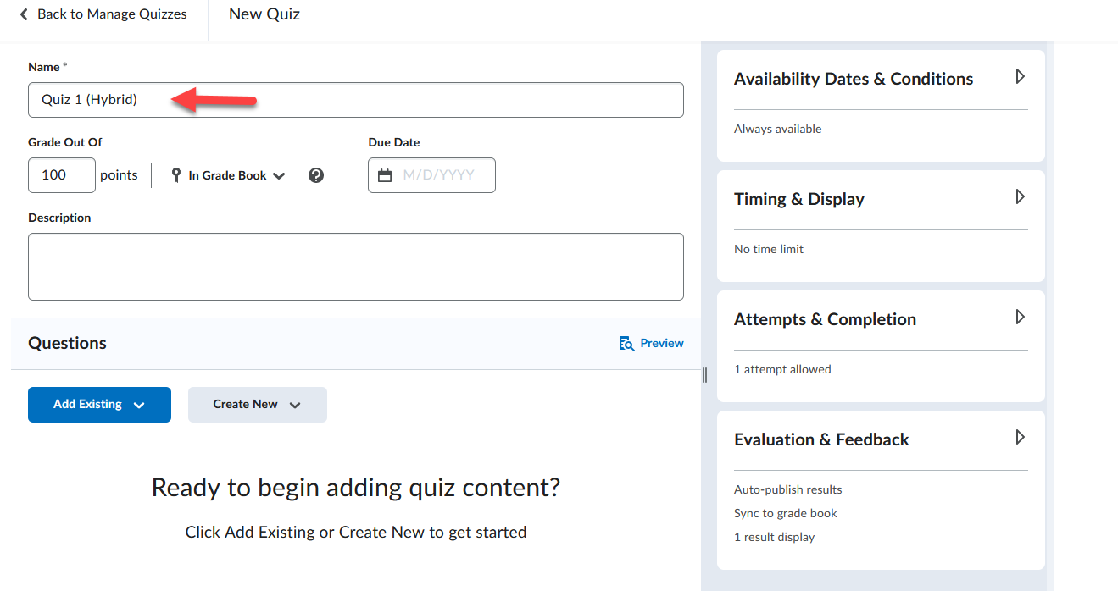

- Click the dropdown tab for Availability Dates & Conditions (1), then click the dropdown tab for Add Release Condition (2), and then click Create New (3).
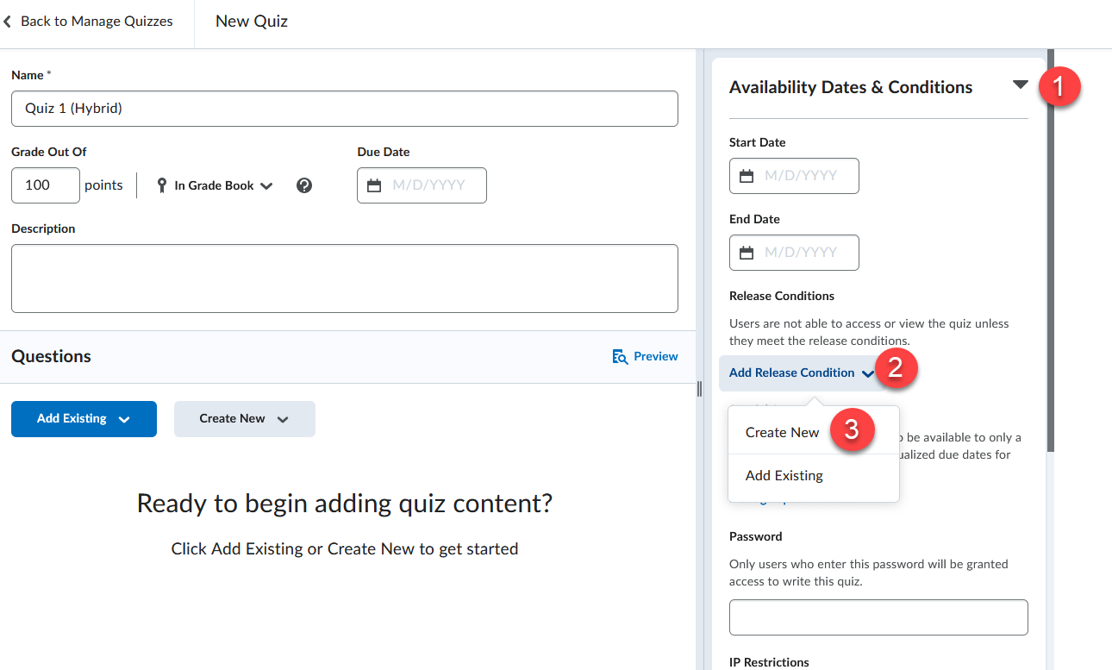

- For the Condition Type select Group Enrollment (1). For Group select which of your groups you would like to have access this particular Dropbox folder (2) and click Create (3).
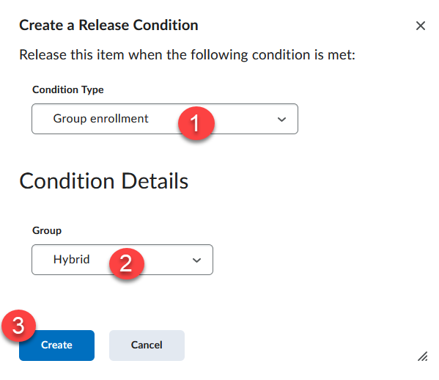

- Continue with the quiz creation process by adding questions from the question library.
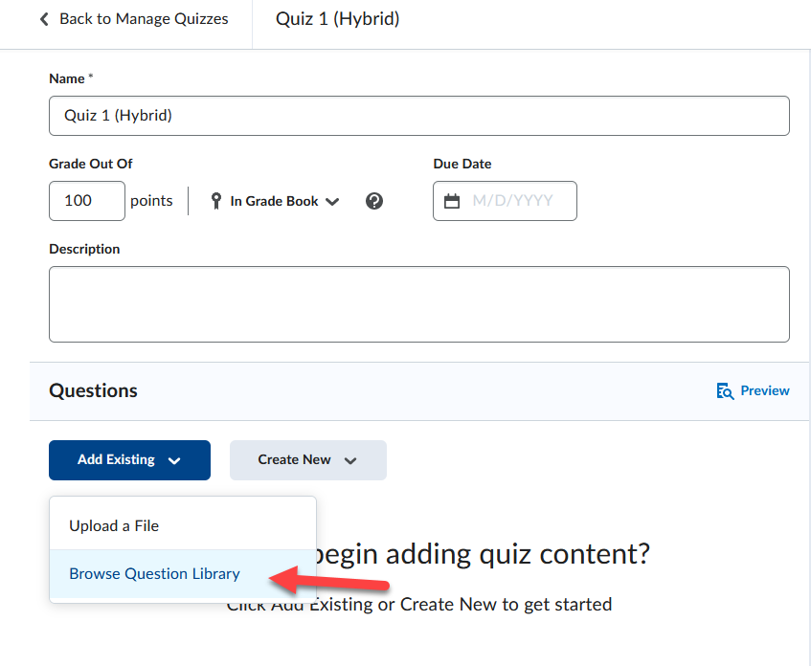

- Click Save and close at the bottom of the page.
