Rubrics created in D2L can be used to guide grading and to communicate to students what is expected on an assignment. This manual will show you how to create a rubric for a D2L assignment, quiz, or discussion.
Creating Rubrics in D2L

1. Select Assessments (1) from the navigation bar and click on Rubrics (2).
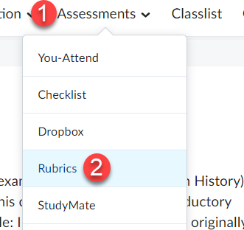

2. Press the New Rubric button.
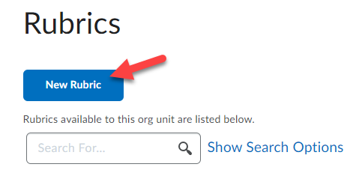

3. Enter a Name for the rubric.
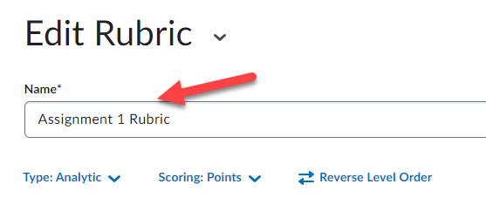

4. Select the Type of rubric you would like to create.
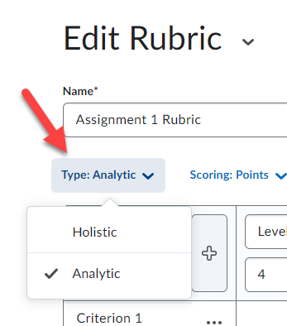

There are two types of rubrics in D2L: Holistic and Analytic. Holistic rubrics are single-criteria rubrics used to evaluate students' overall performance based on predefined achievement levels. Analytic rubrics may contain multiple levels of achievement and assessment criteria to evaluate students based on different criteria using a single rubric.

Creating a Holistic Rubric
1. Select Holistic from the rubric Type dropdown list.
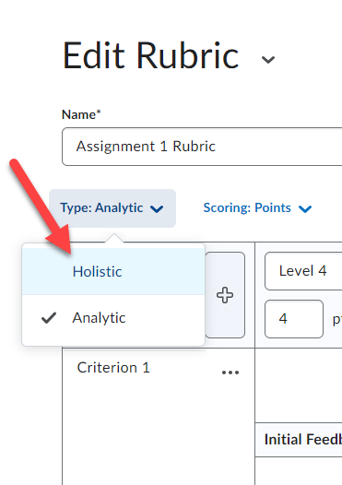

2. Click Continue on the pop-up window that appears.
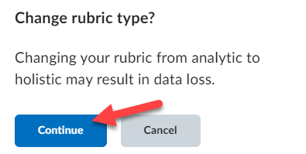

3. Select a Scoring method: Percentage (default) or No Score.
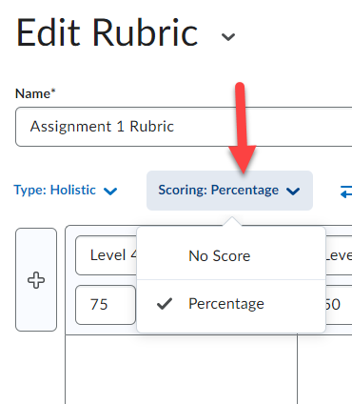

4. Enter a name for each level; this will overwrite the default text that appears in each level.
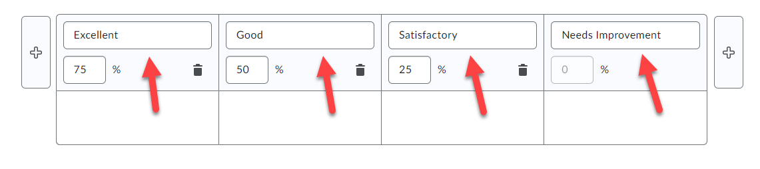

5. If you chose to use percentage as your scoring method, enter a start range for each level. Your lowest achievement level range should start at 0%, the start range of your second, third, fourth, etc... achievement level will then be the next highest percentage achievable.
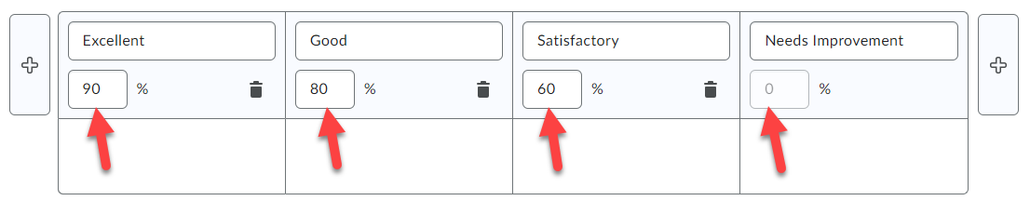

6. Enter a Description for each level to explain what is expected of a student to receive a score in that category.
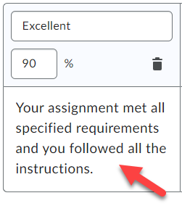

7. You can enter Feedback which will appear to each student scoring within that level (this step is optional).

8. Under Options, you can set the Rubric Visibility (1) and Score Visibility (2). Make sure that the
Competencies option is checked so the rubric can be linked to other tools in this course (3).
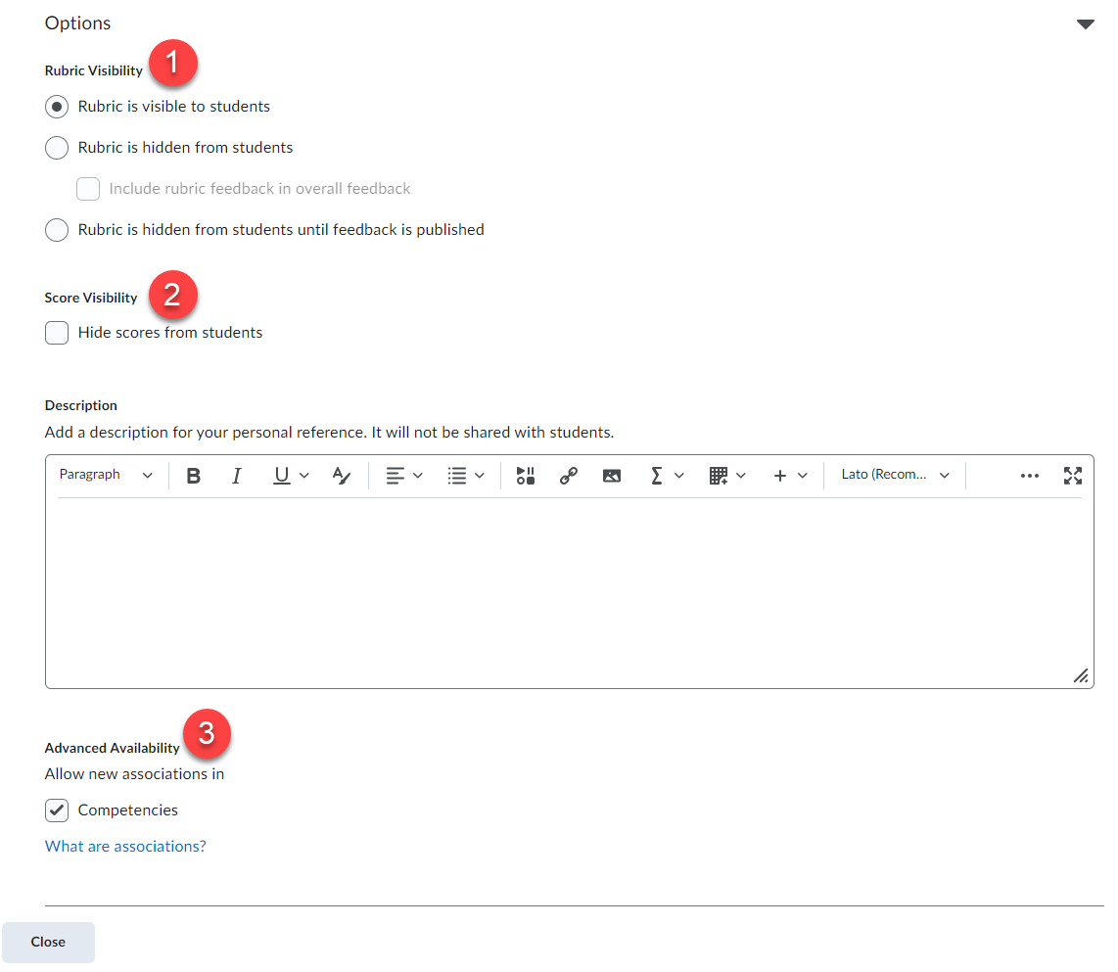

9. Scroll to the top and ensure the rubric Status is set to Published (top right corner).
NOTE: You cannot associate a rubric with other tools in your D2L course unless its status is set to Published.

10. Click the Close button.
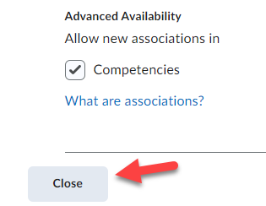
Congratulations!!!! You have now created a Holistic rubric.

Creating an Analytic Rubric
1. Make sure the rubric Type selected is Analytic.
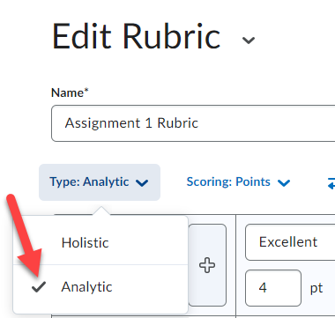

2. Select a Scoring method: Points (default), No Score, or Custom Points.
Points: allows you to include points to assess performance. For example, three performance
levels for a rubric could be Poor (0 points), Good (75 points), and Excellent (125 points).
Custom Points: allows you the ability to assign different values to different criteria in your
rubric, giving more "weight" to one or more criterion than to others. This is the recommended scoring method and the one used in this manual.
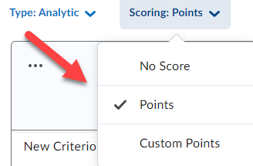

3. Enter a name for each level (1). Enter a name for each criteria listed (2).
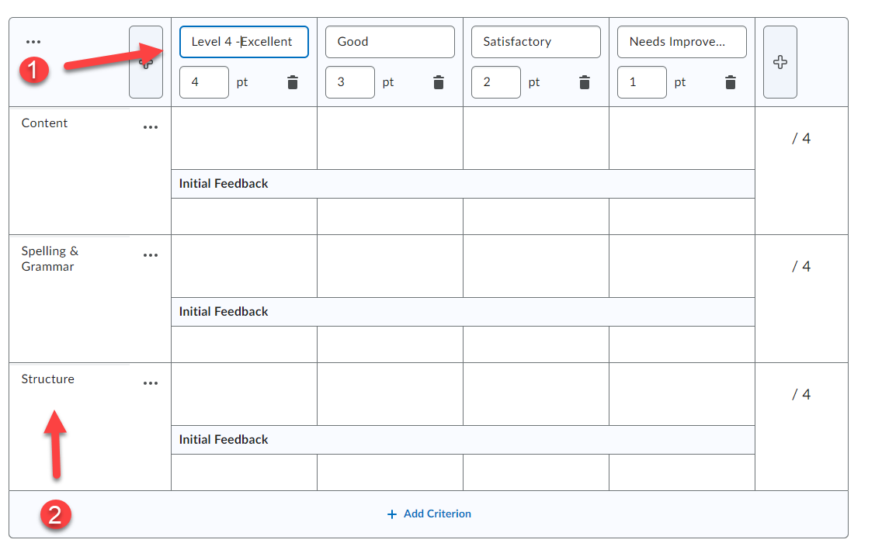

4. Enter the points a student can receive for each criterion met in each level (1). Enter a description for each criterion in the level (2). The description explains what is expected of a student to receive the points for that criterion.
Note: It is recommended that you make the points for the highest level of your rubric 10 points
each.
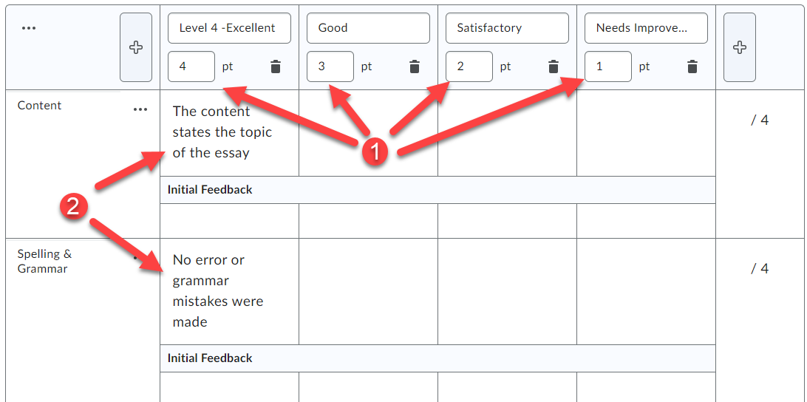

5. Enter standard Feedback text which will appear to each student scoring within that level (this
step is optional).
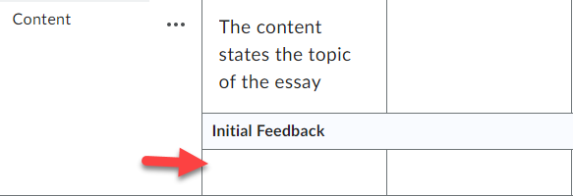

6. Add an incomplete level to the rubric.
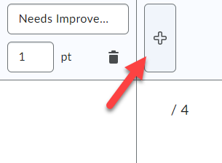

7. Enter a name for the level, such as Incomplete (1). Enter 0 for the points for the level (2). If
desired you can enter a Description (3) and Feedback (4) for each criterion in the level.
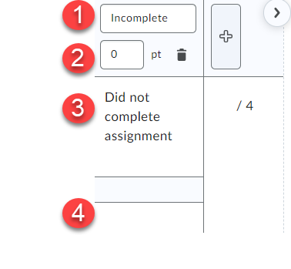

NOTE: If needed, you can add an additional criteria group to the rubric by clicking the Add
Criteria Group button.
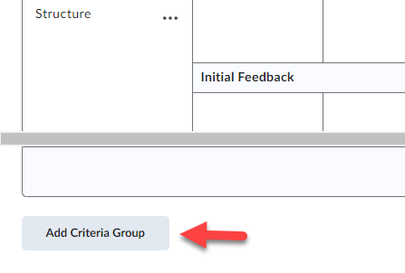
8. For the overall rubric score, enter a name for each level (1). Enter a Start Range for each level (2). The start range is the lowest possible score a student can get for that level. Then enter a description for each level of achievement (3).
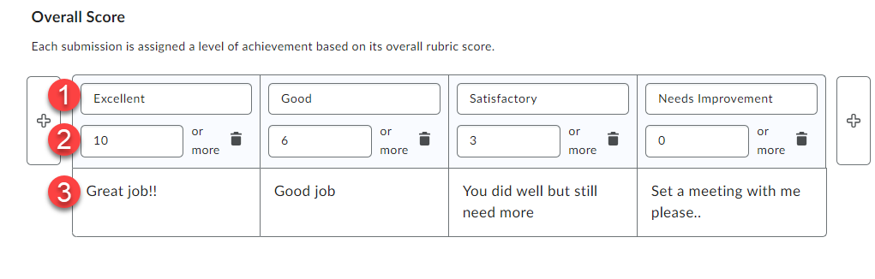

9. Under Options, you can set the Rubric Visibility (1) and Score Visibility (2). Make sure that the
Competencies option is checked so the rubric can be linked to other tools in this course (3).

10. Scroll to the top and ensure the rubric Status is set to Published (top right corner).
NOTE: You cannot associate a rubric with other tools in your D2L course unless its status is set to Published.

11. Click the Close button.

Congratulations!!!! You have now created an Analytic rubric.

Editing a Rubric
You the ability to edit a rubric that is not yet link to course activities for assessment.
1. From the Rubrics tool, click the drop-down menu next to the rubric (1) and select Edit (2).
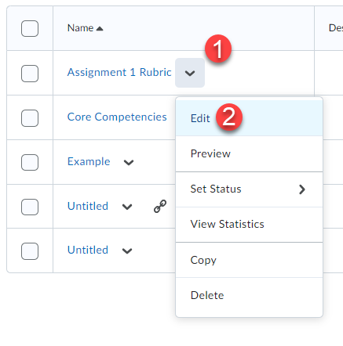

2. Edit the rubric where necessary and click the Close button when done.
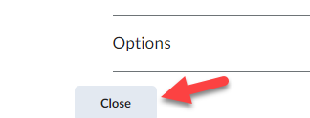

Linking Rubrics to Course Activities
You can link rubrics you create to Dropbox, discussion, and video assignments in your D2L course.

Link to a Dropbox:
1. Edit or create the Dropbox item. On the right panel click the arrow to expand the section (1) and choose Add Rubric (2). Click either Create New or Add Existing (3).
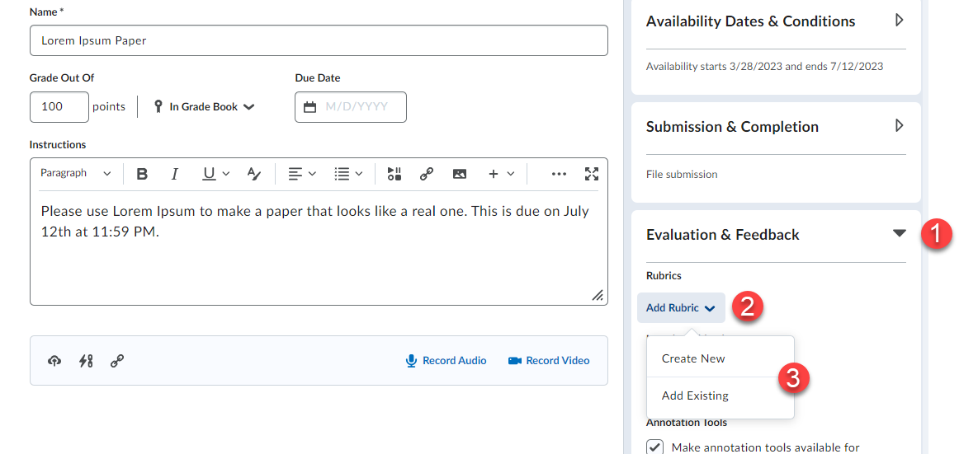

2. Select the rubric you would like to link to the Dropbox (1) and click the Add Selected button (2).
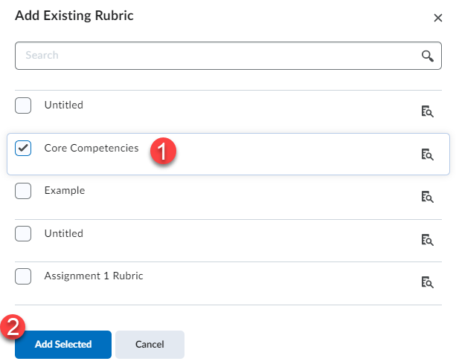

3. Make sure the rubric appears under the rubrics section. Click the Save and Close button.
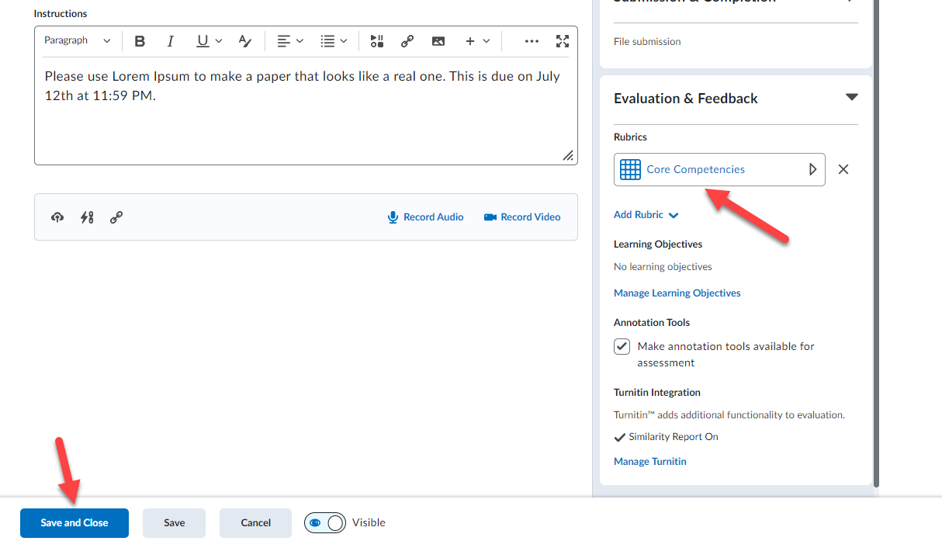

The rubric is now linked to your Dropbox!

Link to a Discussion Topic:
1. From the Assessment tab (appears whenever you edit or create a discussion topic) of a
discussion topic and click the Add Rubric button.
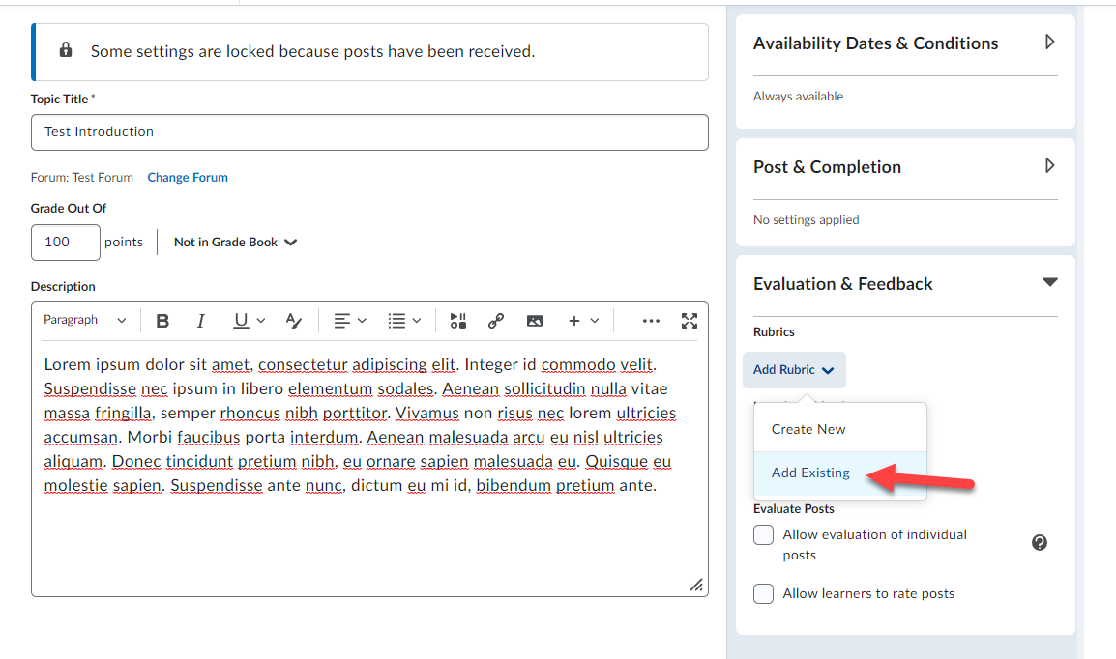

2. Select the rubric you would like to link to the discussion topic (1) and click the Add Selected
button (2).
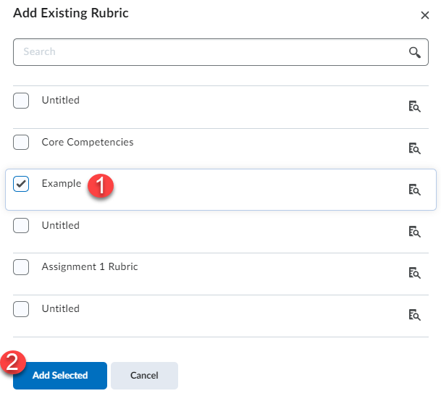

3. Make sure the rubric appears under the rubrics section of the discussion topic’s properties tab and click the Save and Close button.
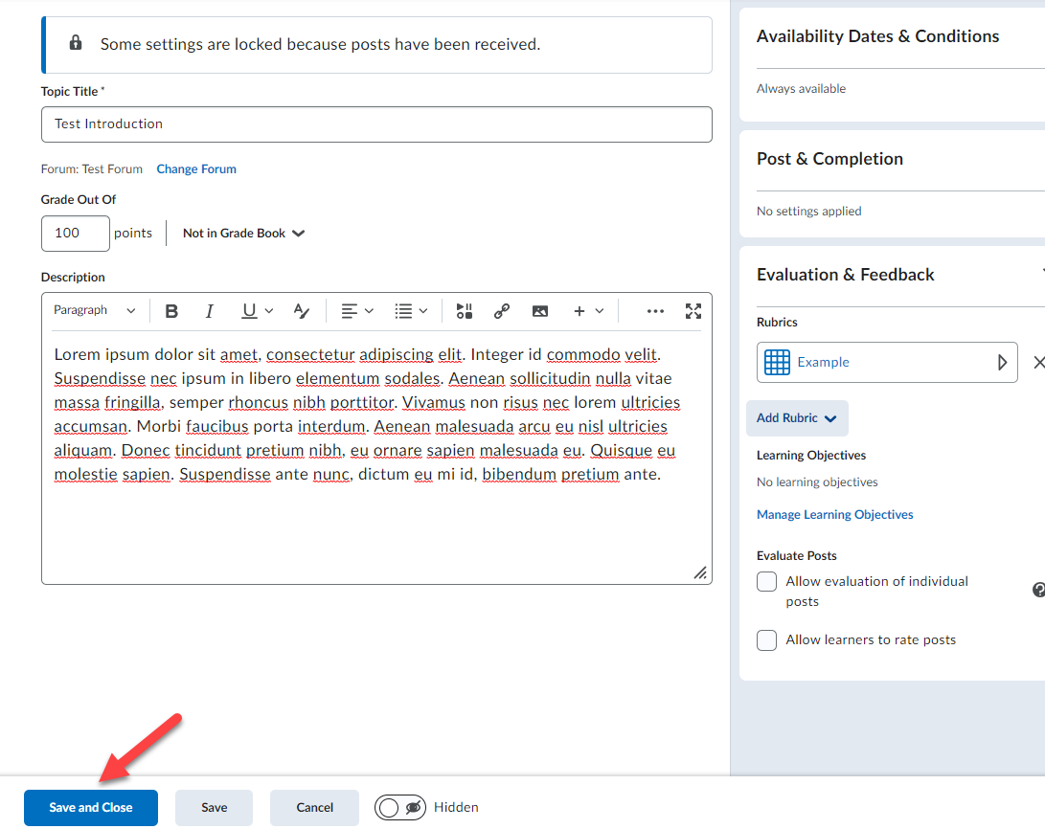

The rubric is now linked to your discussion topic!
Adding a rubric to a Virtual Classroom Assignment:
- When creating the virtual classroom assignment locate the evaluation type and change the type to rubric.
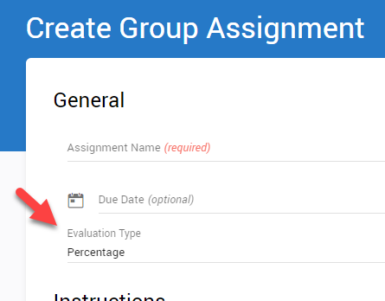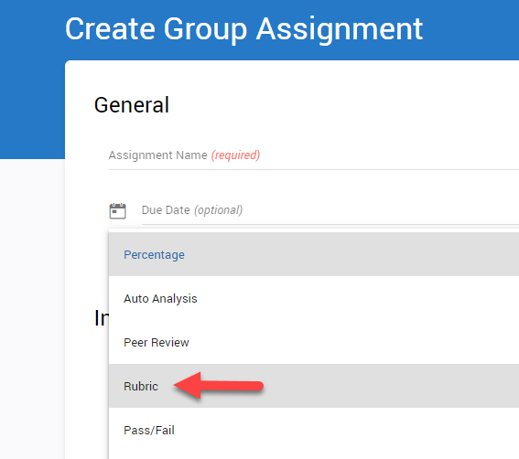

- Next select the rubric that you want to use in the section to the right of the Evaluation type section. If you do not have a rubric created or need to create a new rubric, proceed to the next step.
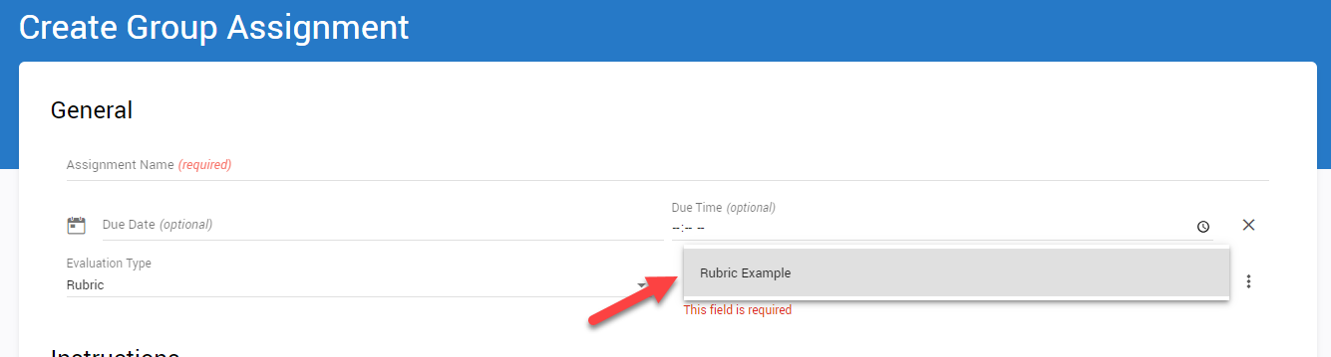

- To create a new rubric, click the 3 dots to the right of the rubric selection and click on configure rubrics.
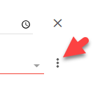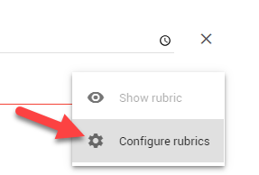

- On the bottom right of the page click on the add button to expand it and then click on the blue plus to create a new rubric.
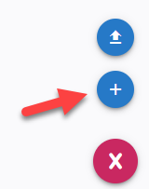

- When creating the rubric enter the rubric name (1) then enter the description for each row and column (2), enter a total point value for each column (3), enter a description for each row item (4), assign a point value for each row item (5), click the plus sign on either the row or column to add an additional section (6), or click on the trashcan icon to delete a row or column (7).
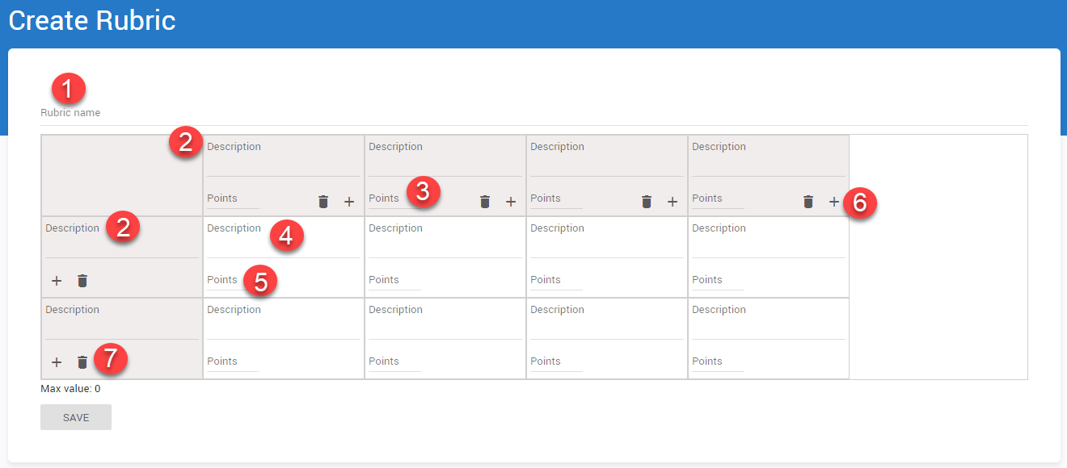

- Click save when finished creating your rubric.
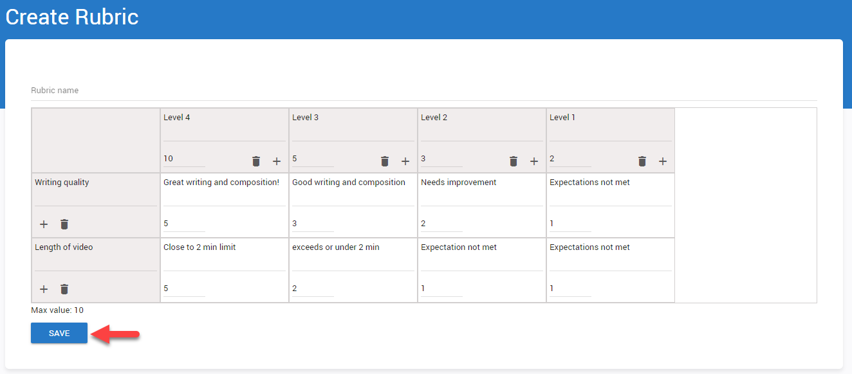

- Now you can return to your assignment by clicking configure assignment.
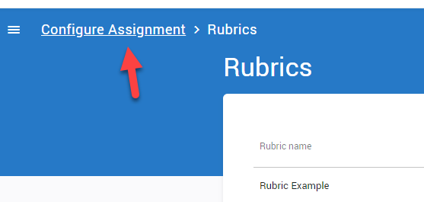

- Now select the rubric you have created by clicking the rubric field.

- Once you complete filling out the required fields, click save on the bottom of the page to publish the assignment.

Grading Dropbox Rubrics:
- Locate the dropbox folder you would like to assess.
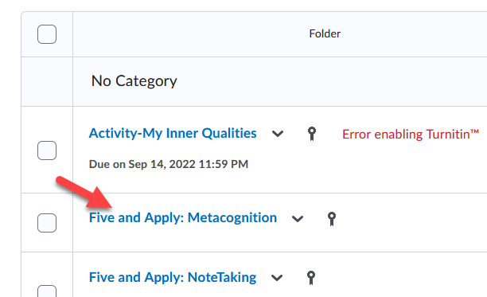

- Click on the name of the student you would like to assess.
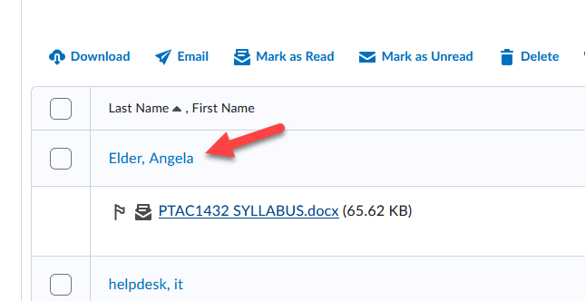

- Click on the rubric to name on the right side off the page.
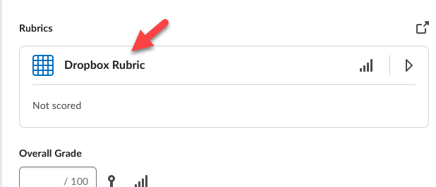

- Under the name of the discussion, you will be able to select the different tiers of the criteria that you had set.
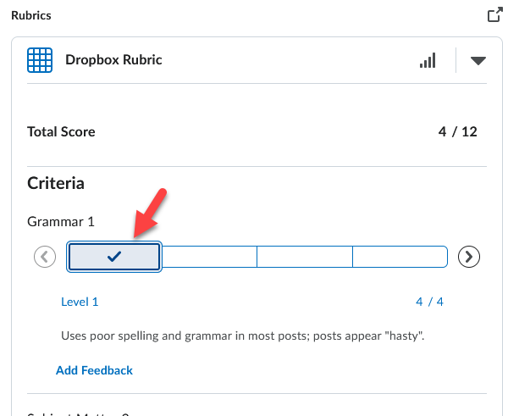

- You can enter feedback below the rubric and once finished you can publish the assessment.
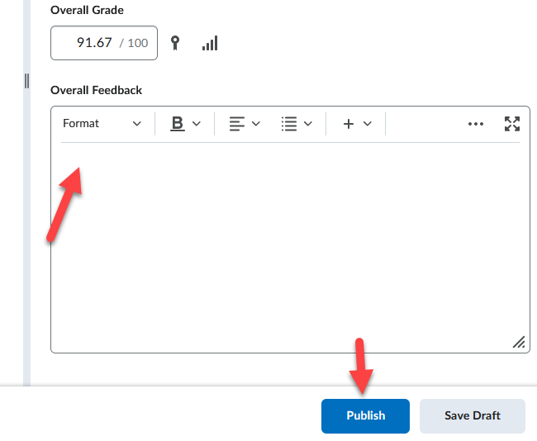
Grading Discussion Rubrics:
- Locate the discussion you would like to grade and click on the menu for the discussion to assess the topic.
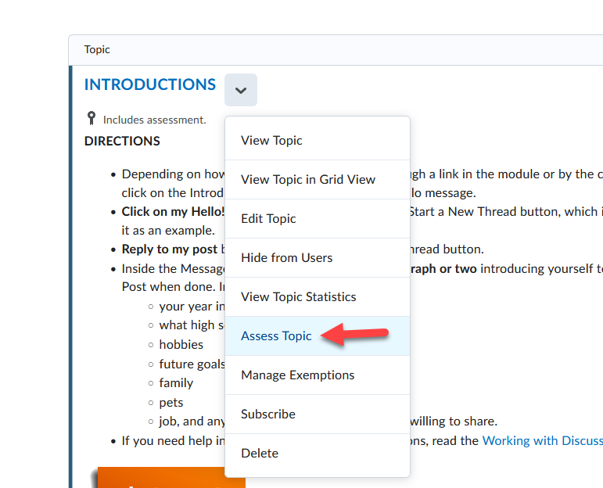

- Locate the student you would like to assess and click on the rubric you would like to use.
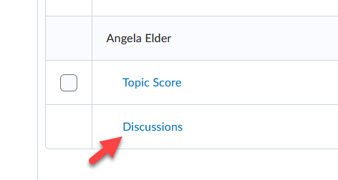

- Click on the rubric to name on the right side off the page.
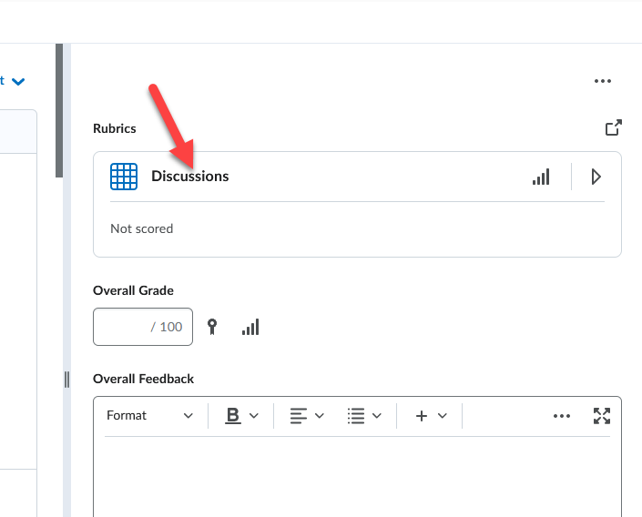

- Under the name of the discussion, you will be able to select the different tiers of the criteria that you had set.
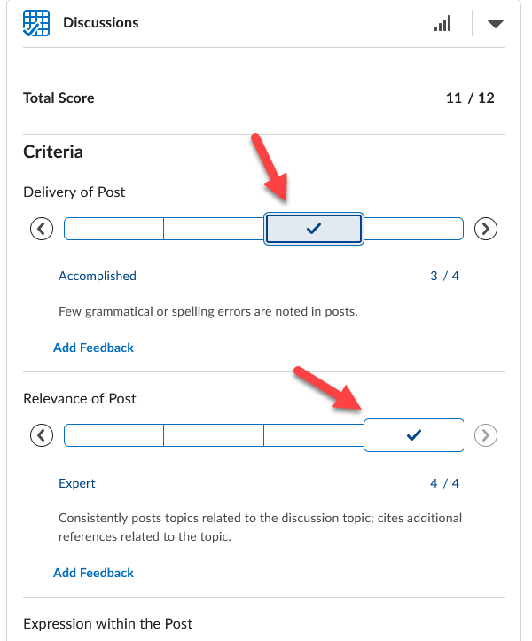

- You can enter feedback below the rubric and once finished you can publish the assessment.

Grading Virtual Assignment Submissions:
- Locate the assignment you would like to assess, click the 3 dots to the right of the assignment, and then click on overview.
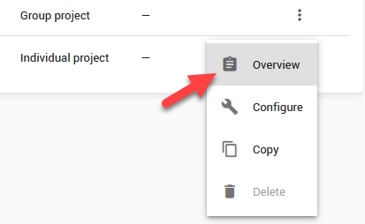

- Locate the submission that needs evaluation and click on the submission.
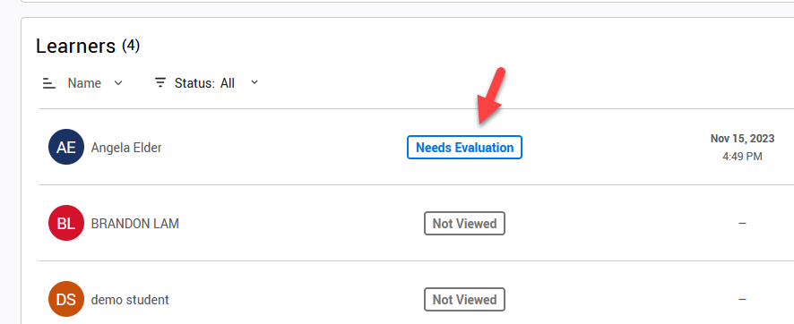
- Click on the criteria that you would like to associate with the submission. When finished click Save and Publish.
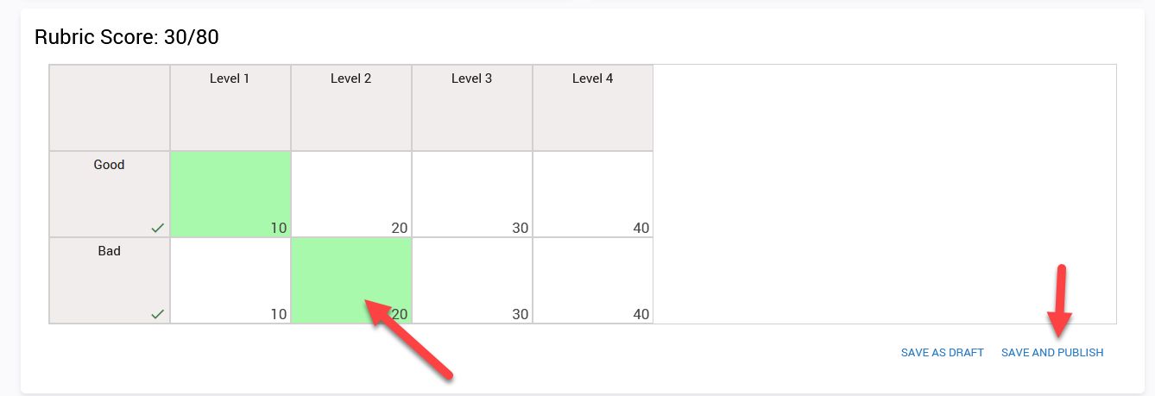

How will Students View Rubrics?
Students can go to Assessments and then click on Rubrics to see the list of rubrics in the entire
course. Individually for each assignment, they will also be visible when the assignment is clicked on.

In Dropboxes:
Students can see the rubric when they access the Dropbox before submitting a document (if you have made the rubric visible to them).
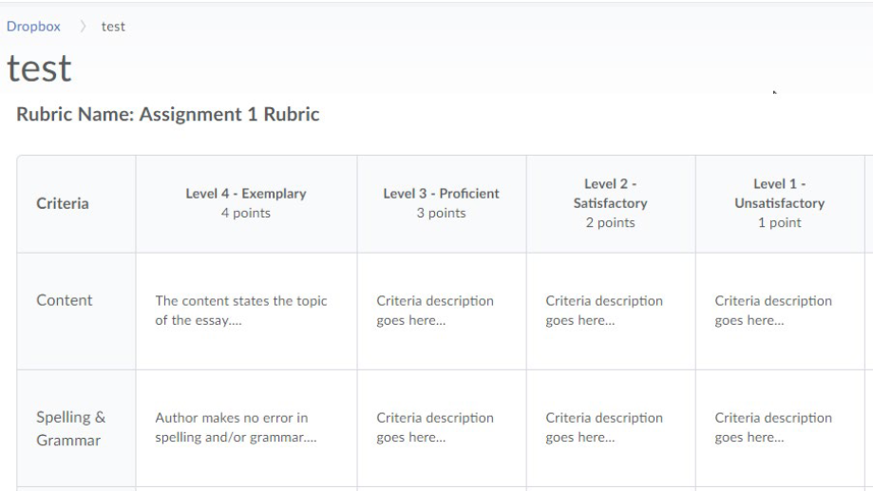

Once their submission is assessed, students will see a View Feedback link in the Dropbox for the
assignment. Clicking on the link will allow students to view their graded rubric feedback.

Students can view their graded rubric feedback for a Dropbox assignment via their gradebook by clicking the View Graded Rubric link for it.
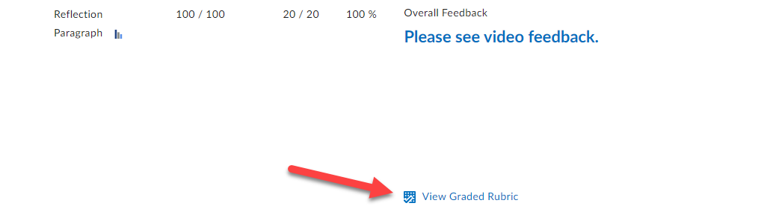

In Discussions:
If a rubric is linked to a discussion topic students can see it when they click on the rubric link found when clicking on the discussion topic or starting a new thread in it.
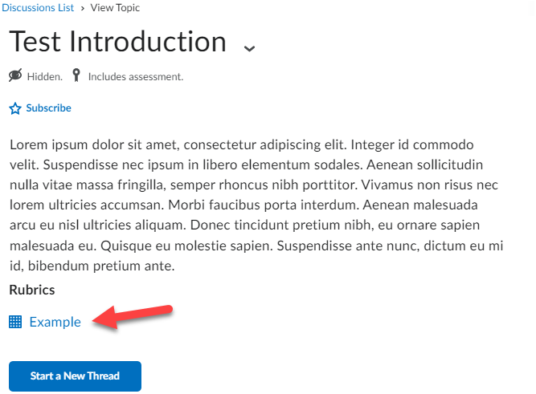

Students can view their graded rubric feedback for a discussion via their gradebook by clicking the View Graded Rubric link for it.

