Flipgrid is a video/audio discussion platform for educators and students. It can be used from any device anywhere on laptops, Surface, Chromebooks, iPads, iPhones or Android devices, as well as desktops.
As an instructor you will need to create a Flipgrid account, add discussion topics, and insert a link in your online course for student access.
CREATE A FLIPGRID ACCOUNT
1. Go to https://info.flipgrid.com/?action=signup and in the upper right corner click Sign up.
2. As an instructor you must set up your Flipgrid account with an existing Gmail or Microsoft account, and not your BC email account. Click Sign up with Google, or Sign up with Microsoft.
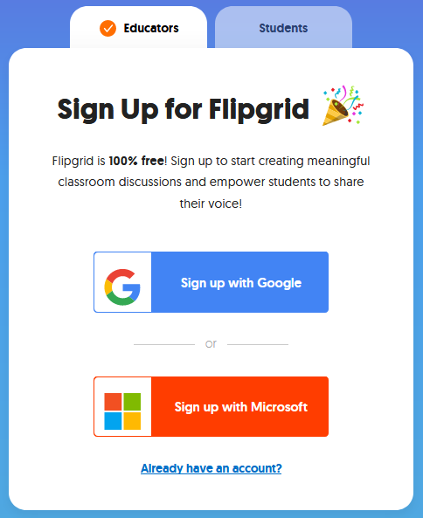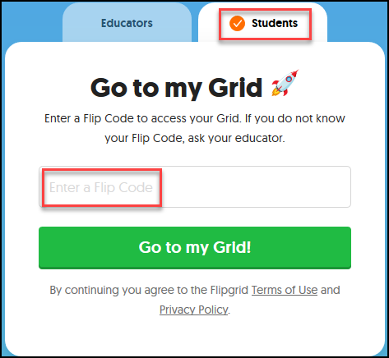
This is what a student sees. They will need to enter a Flipcode to access your Grid.
3. Fill in required information (1), check the agreement box (2), and click Let’s Go! (3) (Subject of expertise field is optional)
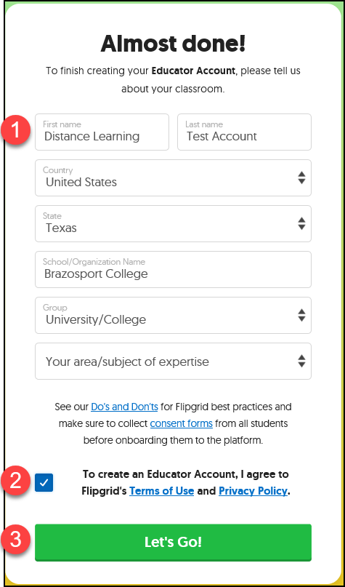
ADD GRID
1. Make sure you are logged in on the top right corner (1). Click the +New Grid button to create your first grid (2). Grids are nothing more than Discussion Forums in which multiple discussion topics can be added.
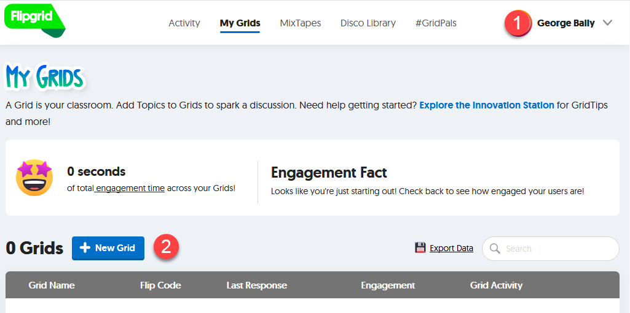
2. Click on the Grid Community Type. This is what determines how your students will access your discussions.
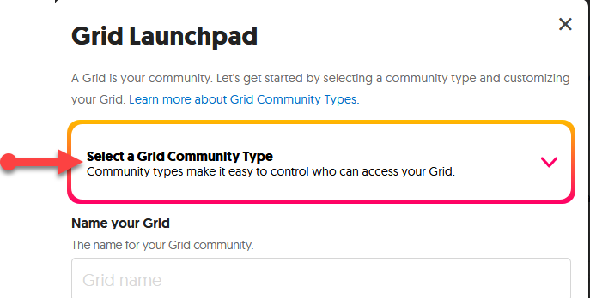

3. Select “Student ID Lists”. This is what determines how your students will access your discussions.
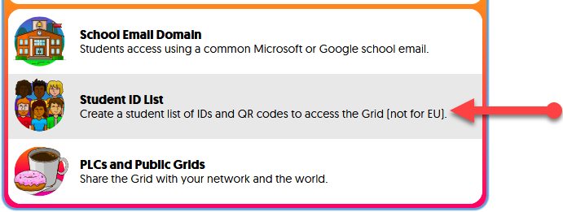

4. Enter a title for your Grid (this will be your Discussion Forum that will hold multiple discussion topics). You can have multiple Grids, one for every course if you would like.
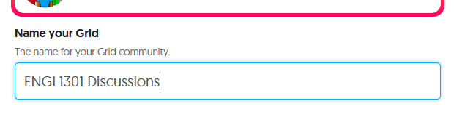

5. Create a unique Flip Code by entering a word, letters, or numbers (this is what students will click on to access your Grid). If code is already used it will show as “Unavailable”.
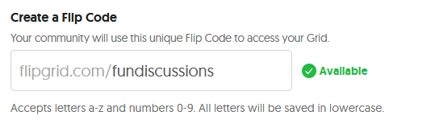

6. Optional, select from one of the categories (1) and click an image (2) to represent your Grid and then click the Next button (3).
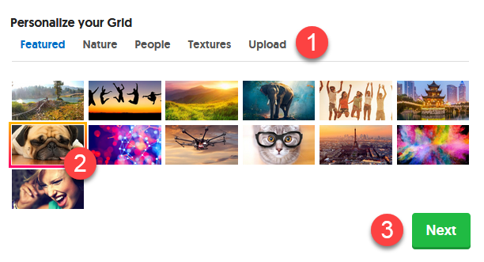

7. Enter first name, last name, and BC email address for Identifier and click the Add Student button when done. Continue this process till all students for the course have been added.
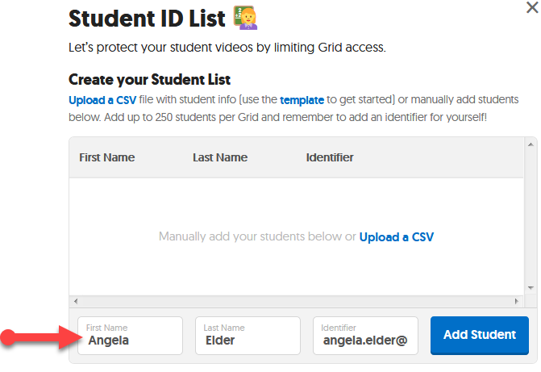
8. If an error has been made, click the X to the right of a student’s name and reenter information. Click the next button when done.
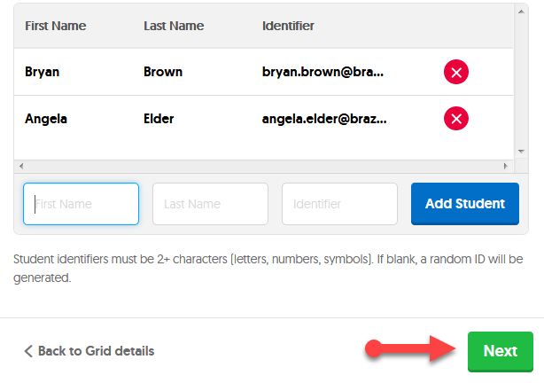

9. Click Launch my Grid.
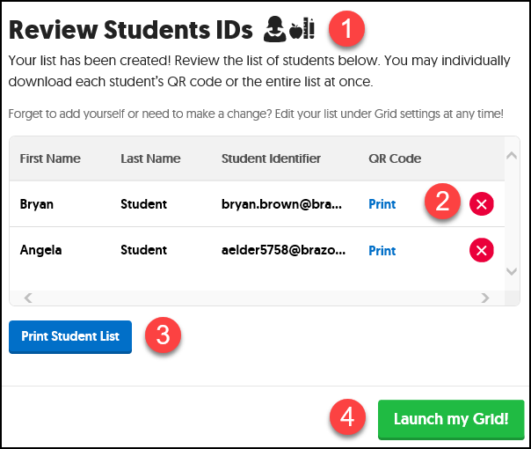

10. Click the pencil icon to access the details area for your Grid.
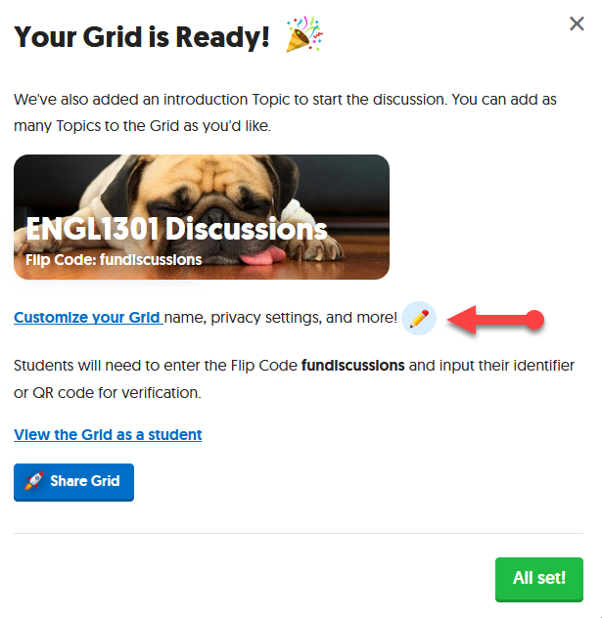
11. Scroll down to the Features section. Click the “on” option (1) to show green (by default it is grayed out or off). This will allow students to receive email notifications when new Topics have been created and new videos have been recorded.
Click the Update Grid button (2) in the lower right corner when done.
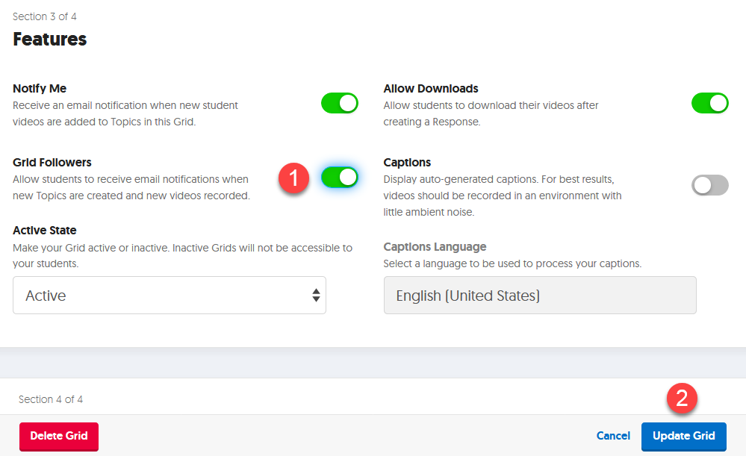

ADD TOPIC
By default Flipgrid account comes with 2 default topics (Ideas and Welcome!). Topics are similar to discussion items. One is set to Inactive, which means it is not in use, the other you can delete by clicking on the Actions button, select to delete topic and then agree to delete when prompted.
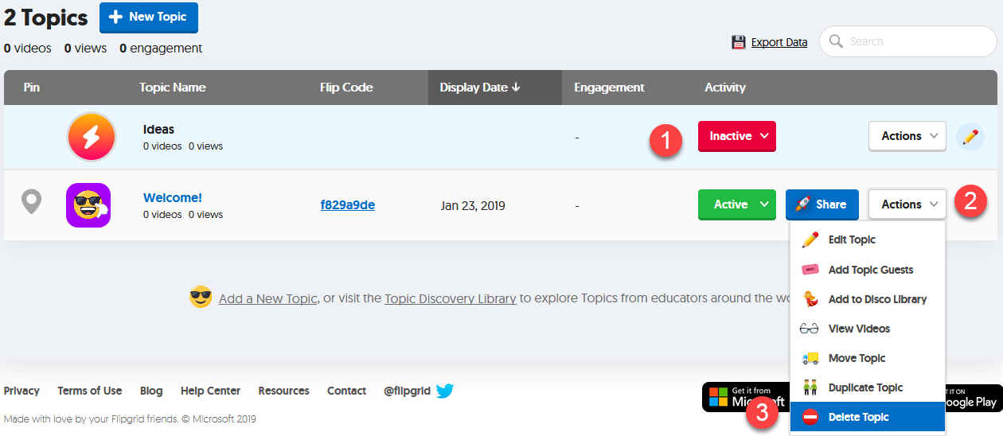

1. To add a topic click on the New Topic button.
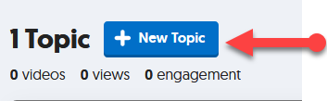

2. Enter a topic title (for example: Introductions).
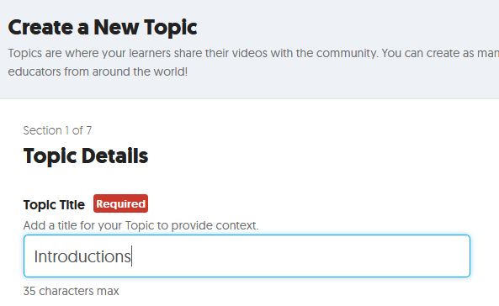

3. Click on drop-down for Video Response Time and select a recording length. You can select up to 5 minutes, students do not have to take the entire time, and the default is one minute thirty seconds.
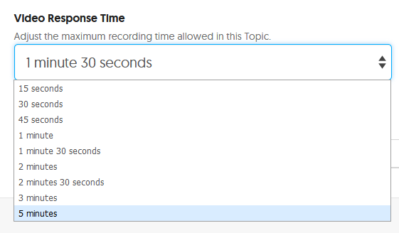
4. Use the text area under Topic Description/Question to enter directions for the discussion. Remember to add more detailed information for this activity in your online course, including a link to the student manual on how to use Flipgrid.
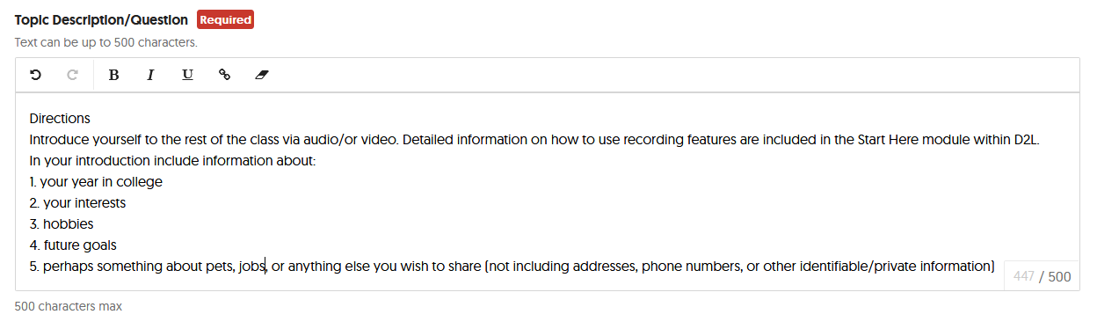

5. Scroll down the page and click on the “More Options” button. From the Topic Status section, on the right under “Launch and Freeze Dates” click (1) and select an end date (2) for this activity.
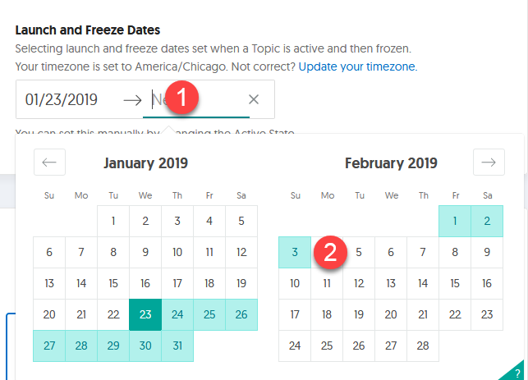

6. Click Create Topic when done.
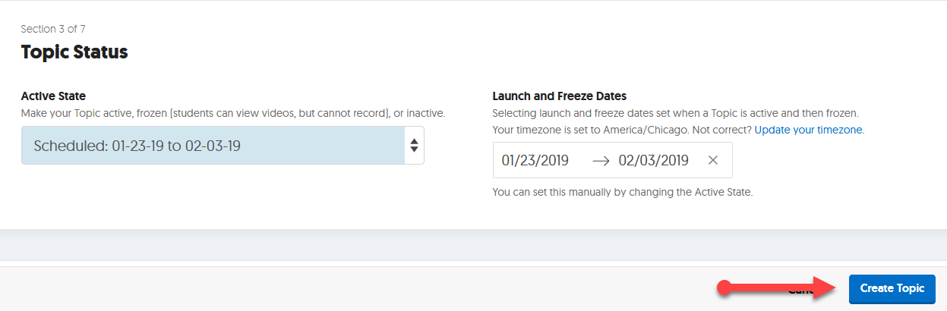
7. You are prompted with access information to both your Grid and discussion topic. The link for the Grid will provide access to all discussion topics added, while the link to the “new Topic” gives access to just that topic and nothing else.
You can retrieve these codes or links at any time. Click the “Got it” button.
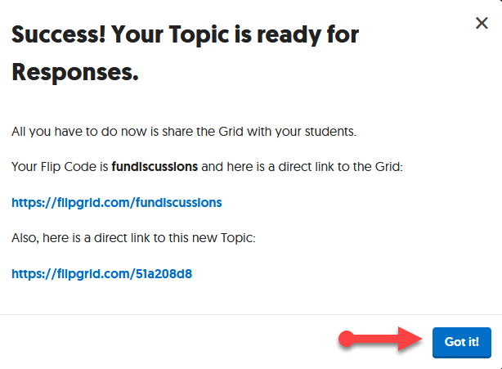

8. You are now inside the newly created Introduction topic. Once students add their audio/video intro’s they will be viewable in this area. In the upper left corner click on “ENGL1301 Discussions” to return to the Grid view.
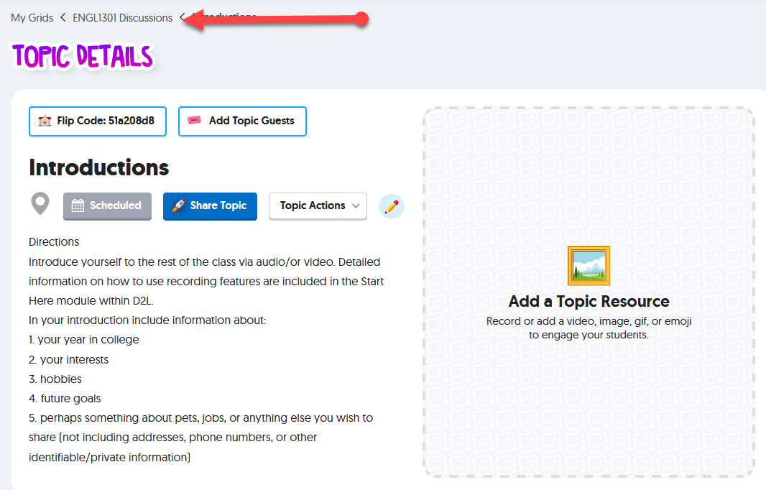
9. Your Introduction topic is now ready for student access.
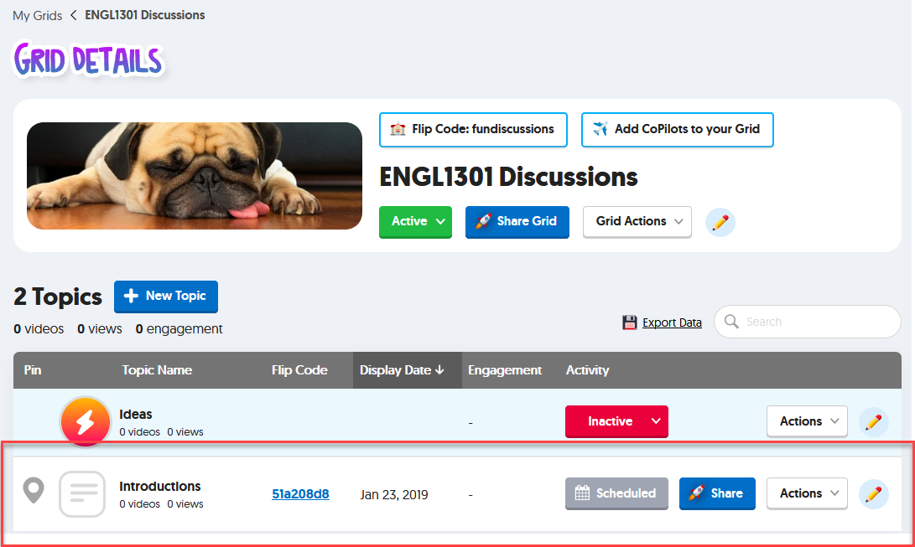

ADDING TOPIC LINK TO D2L
We now need to add a link to the topic in your online course in D2L.
1. Click on the blue “Share” button for the Introductions topic
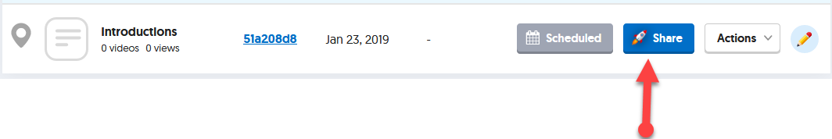

2. Click the “Copy” button (or just write down the URL).
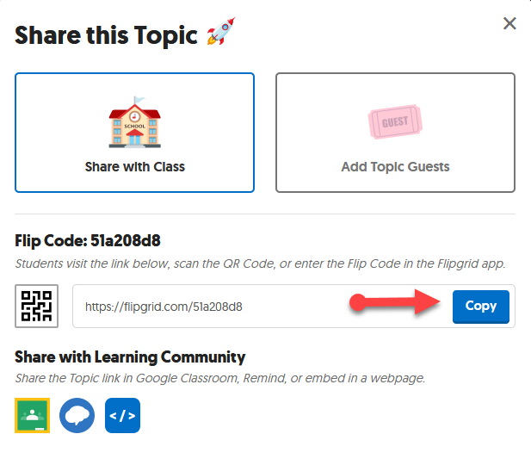

3. Log into D2L and enter a course. Once in the course go to the area in which you want students to click on the Topic link. For the purpose of this manual, it is on an HTML page in Content which includes detailed information on grading criteria and a link to the Student Flipgrid “Getting Started” video (https://vimeo.com/293033551).
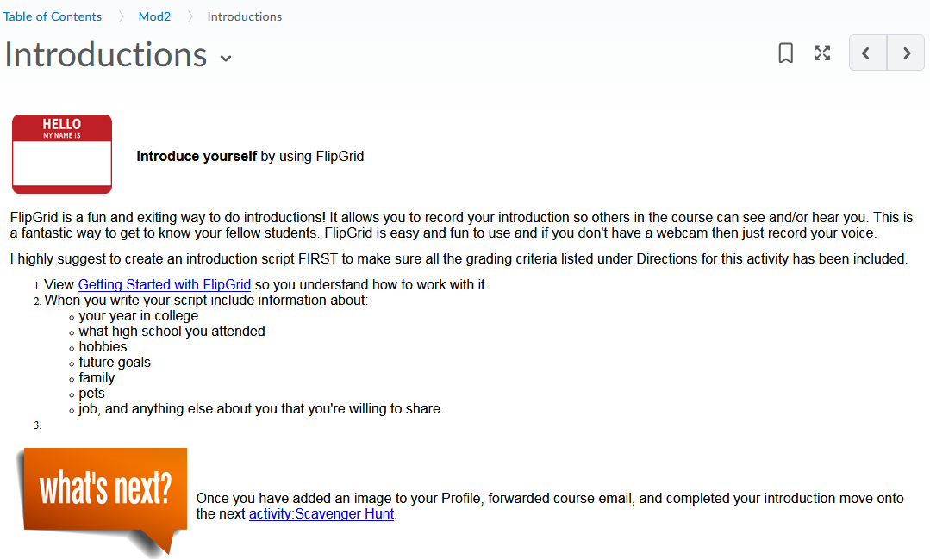
NOTE: Directions are provided for editing and adding link to an HTML file. IF you use Word documents you will need to download it, edit and paste link. Once done, upload to the course.
If you need help on creating an HTML file please contact us.
4. Click the down arrow after the page title and click on Edit HTML.
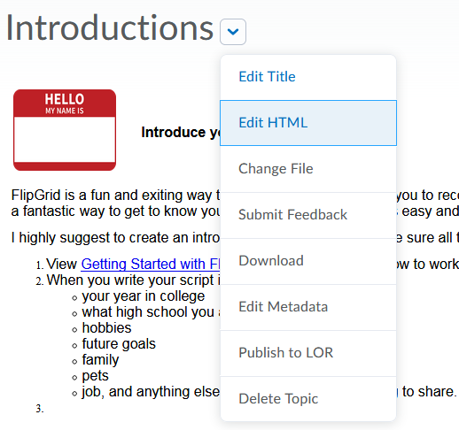

5. Click on an area on the page in which you want to add the Topic link (1) and select Insert Quicklink (2).
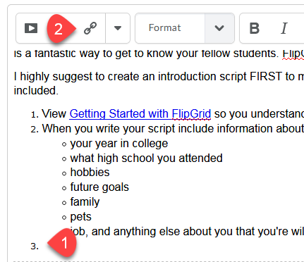
6. Scroll down and click URL.
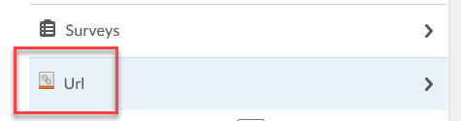
7. With mouse, right+left click (PC) in the URL text block (1) and select Paste (2).
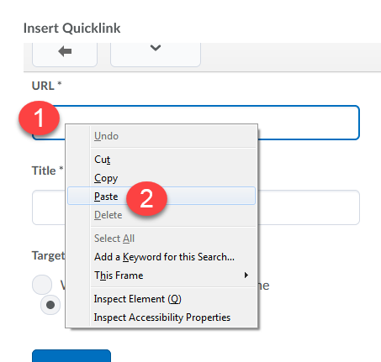
On Mac use keyboard and click Command + V key.
8. Enter a title (Introductions) and click the Insert key.
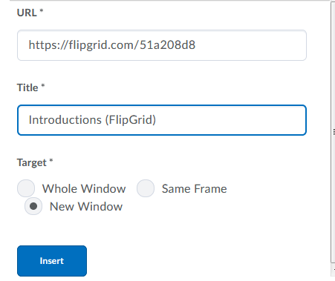
9. Click Update when done.
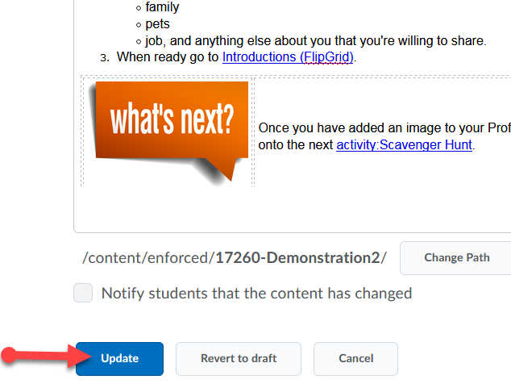
Suggestions for additional Flipgrid activities:
Flipgrid can be used for more than just Discussion questions, here are a few examples:
1) As part of the assignment for your Welcome to class topic or module.
2) After a reading of a chapter or article, have them respond to a question about their readings. Students can also comment on each other’s responses.
3) Debating on a topic.
4) Math problems-have them work the problem then explain how they got their answer and the process to get there.
5) Book or chapter reviews, explain what they learned.
6) Instructor videos such as updates about class, or welcome to class.
GRADING
Flipgrid is a standalone tool and not integrated with D2L. Any Flipgrid graded activities must be manually added to the D2L Gradebook.
1) Click on grid containing the topic you would like to grade.
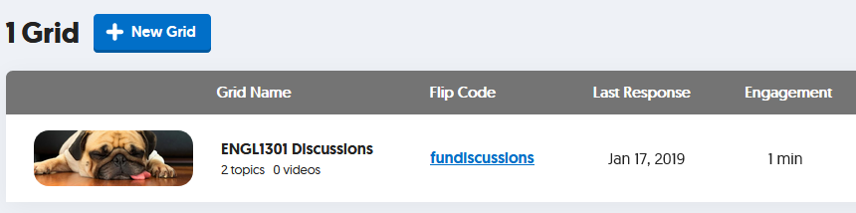
2) Click the topic you want to grade.
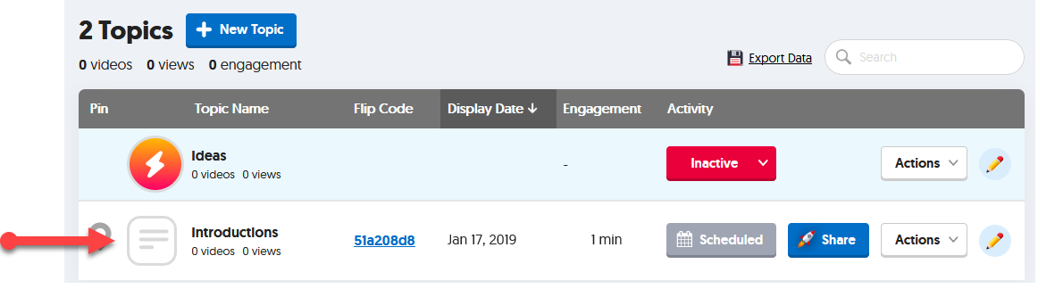
3) Scroll down to the available videos and click the first one.
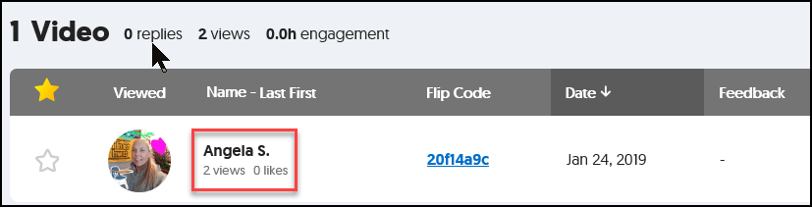
4) Click the play button located in the bottom left of the player (1) and watch video.
On the right under “Grading Rubric” (2) use the pull down menus and select a score for “Ideas” and “Performance”.
You can also choose to either leave a text based response in the Comments area (3) or select “Add Private Video Feedback” (4) and record it.
Once done with scoring and feedback, click the black X (5) in the upper left corner of the screen.
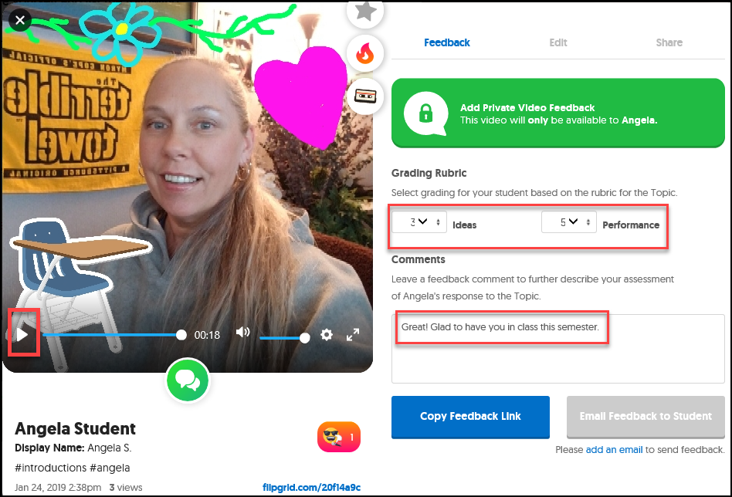
5
4
3
2
1
5) Once done you will see a feedback score column.
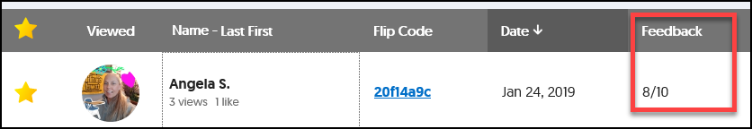

6) Take note of each student and associated grade or keep Flipgrid window open and log into D2L in a NEW browser tab.
Add Grade to D2L
1) Login to your course and go to Assessments and then Gradebook.
2) In an existing column for this item click on the down arrow and select the option for Grade All.
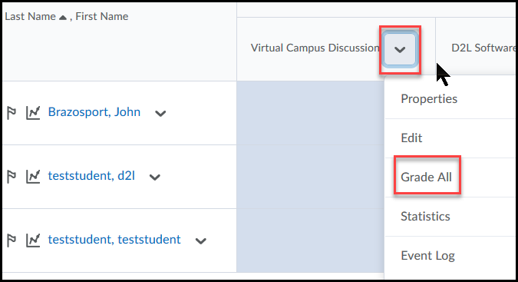
3) Type in grade from Flipgrid and when done, click the Save button at the bottom, then Save and Close if prompted.
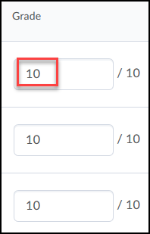

Resources
- Link to The Educator’s Guide to Flipgrid (includes printable pdf) (Version 3): https://drive.google.com/file/d/17e4zQLAPYWzqHNjFZVIO-ubZINvOaPxZ/view
- Link to The Educator’s Guide to Flipgrid (includes printable pdf) (Version 2): https://static.flipgrid.com/docs/Flipgrid_eBook_2nd_edition.pdf
- Link to quick Flipgrid walkthrough: https://player.vimeo.com/video/285354491
- Link to Flipgrid Help Center: https://help.flipgrid.com/hc/en-us
- Student Video on how to record, review and take a Selfie in Flipgrid: https://vimeo.com/293033551
- Get the app: www.flipgrid.com
Ways to use Flipgrid
Reading
- Book Recommendations-have students give a book recommendation to other students.
- Dramatic Reading-have student record themselves giving a dramatic reading of their favorite book and let peers comment. Builds confidence and fluency.
- Book Club Discussions
- Connections-have students record events or situations they have in common with the characters in the book. Makes the book more interesting to the students.
Live Commenting-Just like Twitter, create a grid to comment on what is happening live at the session or meeting or class, allowing others to post their views or questions.
Daily Class News
Question of the Day
Math-students can record their working a problem out for others to see and comment on. They can also create a problem for other students to work out and video their response.
Aha Moments
End of Semester Memories
Oral Speeches-up to 5 minute long short speeches for peer review and comments.

