You have the ability to add quiz questions to the videos you upload to MyMedisite for your students.

- Click on the video from MyMediasite that you want to add a quiz to.
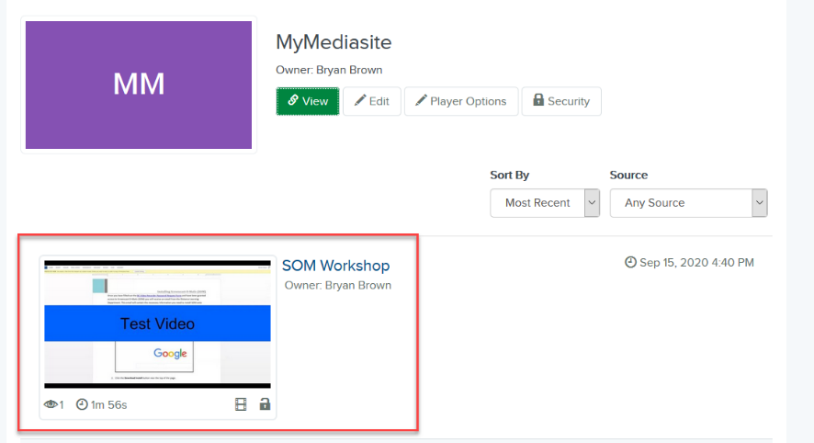

- Click on Edit Quizzes in the right column.
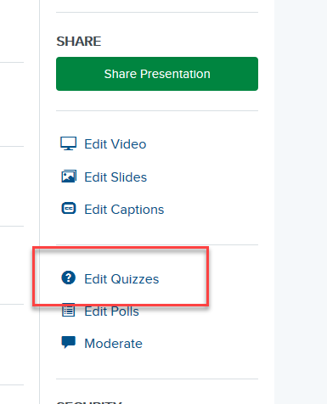
- Select a Quiz Type (1) and select the Settings you want for it (2):
  - Study guide: A study guide is an informal quiz that allows students to measure their understanding and practice with the concepts being presented. Students are not required to submit their quizzes. After completing a quiz, students can retake a quiz and change their answers.
  - Assessment: An assessment is a repeatable quiz that measures student comprehension, while allowing them multiple retake attempts. Students will only see their total scores after they submit their answers. They will not be able to see correct answers for questions or view quiz results for each quiz. After submitting all quizzes, students can reload the presentation to reset their answers and take all quizzes again.
  - Scored: A scored quiz is a non-repeatable quiz that measures student comprehension. Students will only see their total scores after they submit all quizzes. They will not be able to view correct answers or view individual quiz results. Students cannot change their answers or retake a quiz after submission.
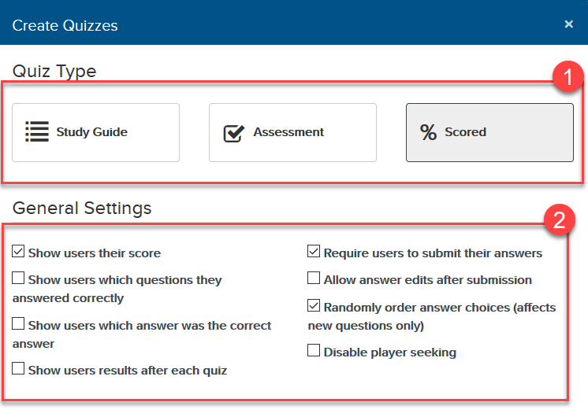
- Enter a Title (1) and Description (optional) (2) for the introduction screen that students will see before the video starts. Then click Next (3).
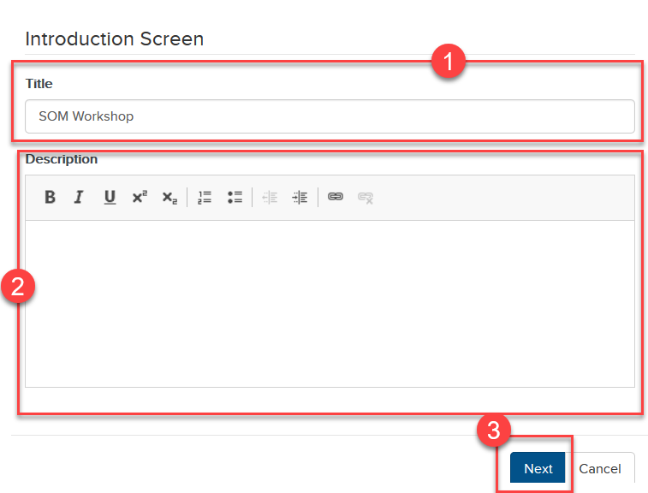

Create and Edit Quizzes
A Mediasite video may contain one or more quizzes that appear during playback at times you specify. Each quiz may contain one or more questions. Adding multiple quizzes is useful for breaking up presentations into segments and chunking learning content.
- Click the Play icon on the video preview.
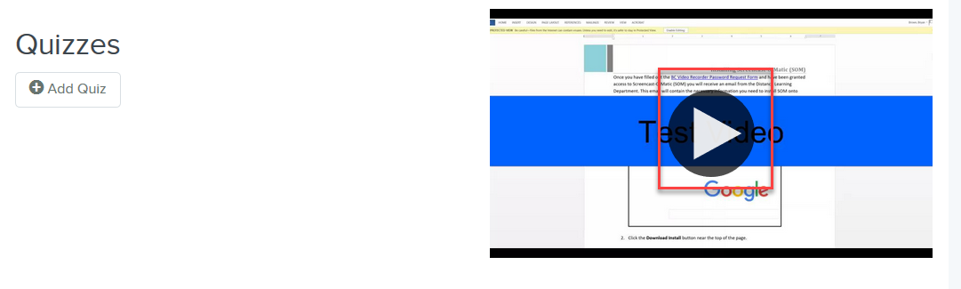
- Pause on the specific point in the video where you want the quiz to appear (1), and click the Add Quiz button (2).
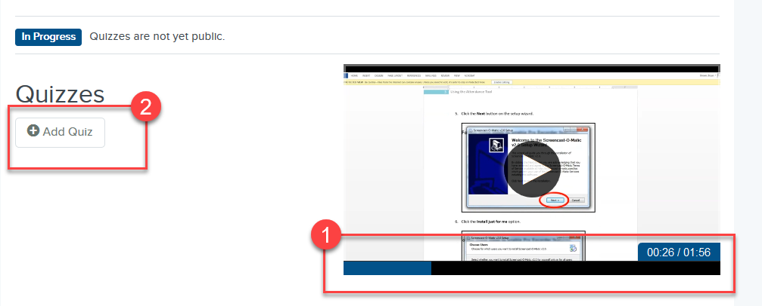
- Enter a Title (1) and Description (optional) (2) for the quiz. If needed, you can also manually adjust the position in time when the quiz appears (3). Click Done when finished (4).
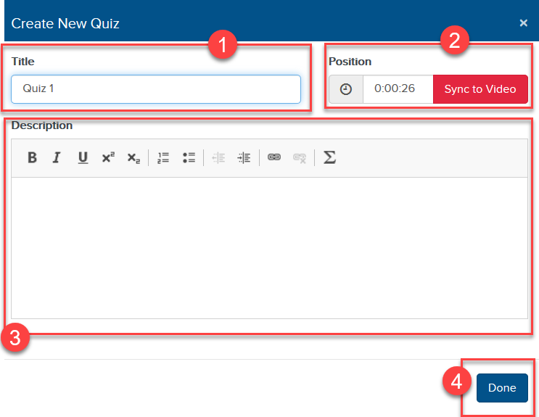
- The new quiz will appear in the list of quizzes. Under the quiz, select Add Question.
- Enter in the question (1). Choose the type of question (Multiple Choice/Single Answer, Multiple Choice/Many Answers, True/False) (2) and enter in the point value (3). Then fill in the necessary fields (3).
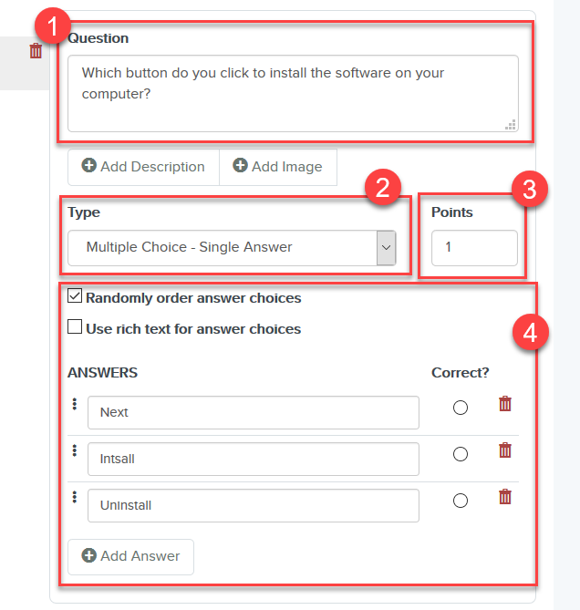
- Click Save at the top.
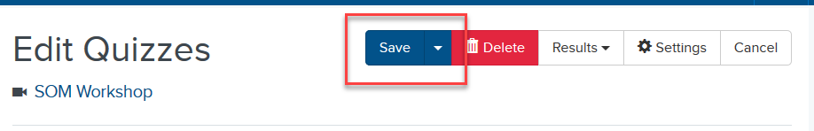

- Then question will appear in the left-side panel (1). To add an additional question to the quiz, click the Add Question button (2).
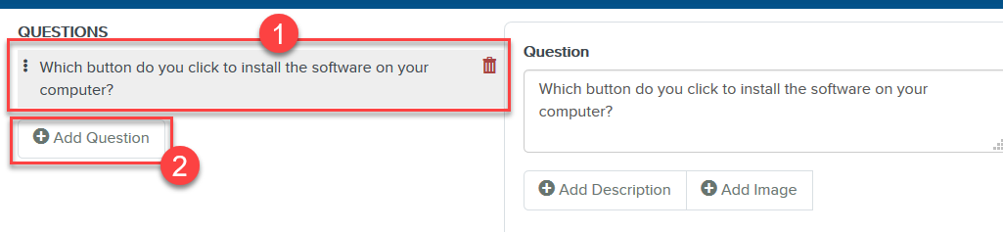
- Repeat the above process to add any additional quizzes throughout the video.

Preview Quizzes
If you like, you can preview your quizzes before publishing them. When you preview a quiz, you can submit answers in the same manner your students would.

- Once the quizzes have been saved, select Preview.
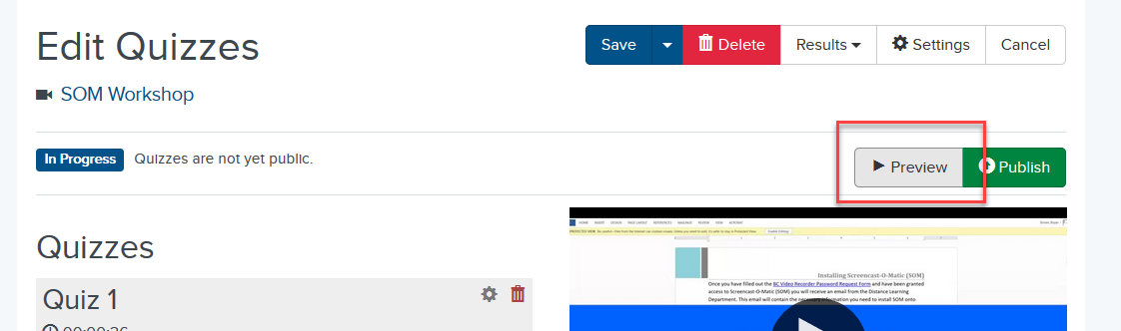

- The presentation will open in a new tab/window. Play through the presentation as a student would. Make any necessary adjustments in the quiz editor.

Publish Quizzes
After you have finished creating a quiz and adding questions, you must publish it to the presentation to make it available to your students.
IMPORTANT: Once you publish a quiz, you will be unable to update the general quiz settings or add new quiz questions and answers. You can select Unpublish to unpublish a quiz and make changes to it. However, unpublishing a quiz will delete all quiz results and affect the data available in quiz reports.
- Select Publish.
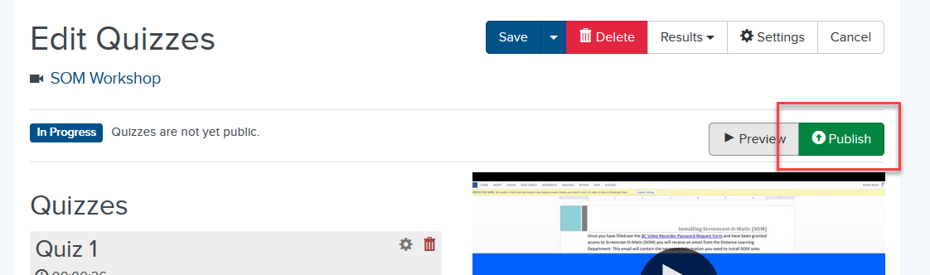

- Select OK to publish the quiz.
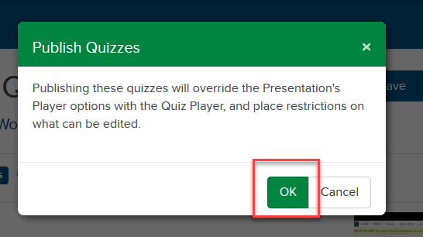

Adding a MyMediasite Quiz as a Dropbox Item
This process is so that you can export students’ grades on the quiz from MyMedisite to your Gradebook in D2L. It will create a Grade Item based on title of the Dropbox.
- After quiz has been added to a video, enter you D2L course and go to Content.
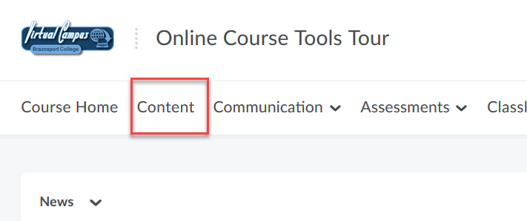
- Open the content module you want to add the MyMedisite video quiz to (1), click on the New button (2) and click on New Dropbox (3).
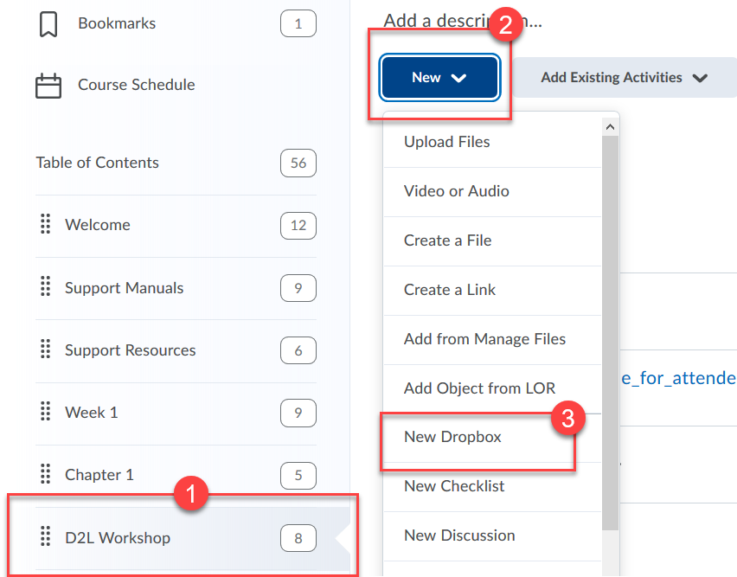
- Provide a title (1), for Submission type select Text Submission (2), and enter any directional information about the quiz under Instructions (3).
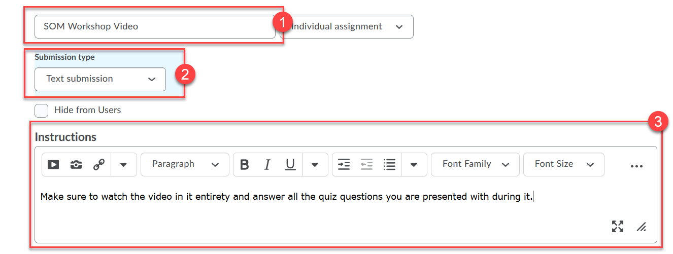
- Click on Insert Stuff icon (1), scroll down and click on Mediasite Quiz (2).
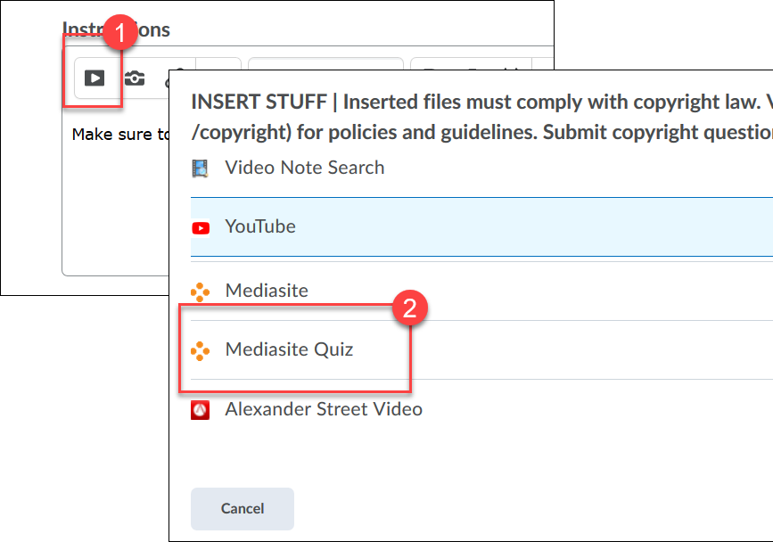
- Click on Presentation (1) and in the search box on the right type in name of video (2).
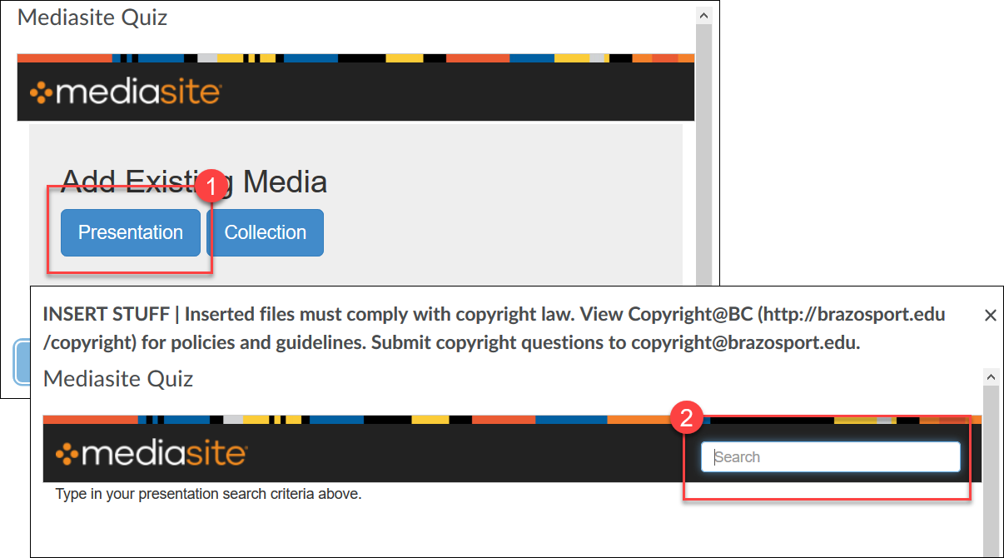
- Click Add to (name of course) (1) and select Player Only (2).
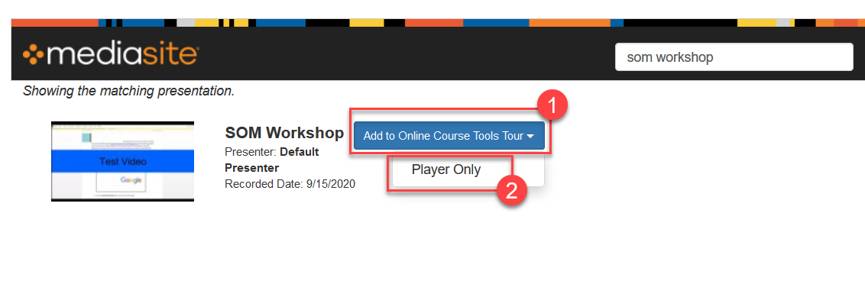
- Wait till video loads and click Insert.
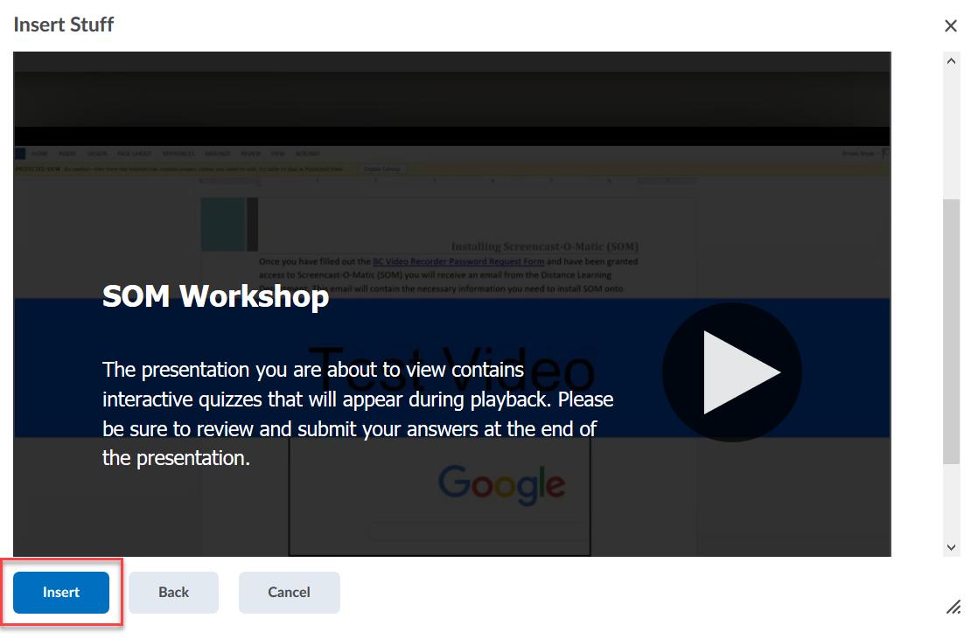
- Click Save.
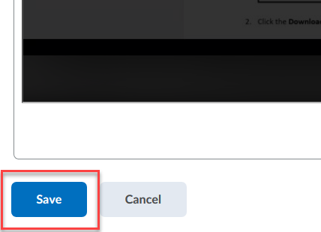
- You can Add dates and restrictions to Dropbox by scrolling down to Activity Details.
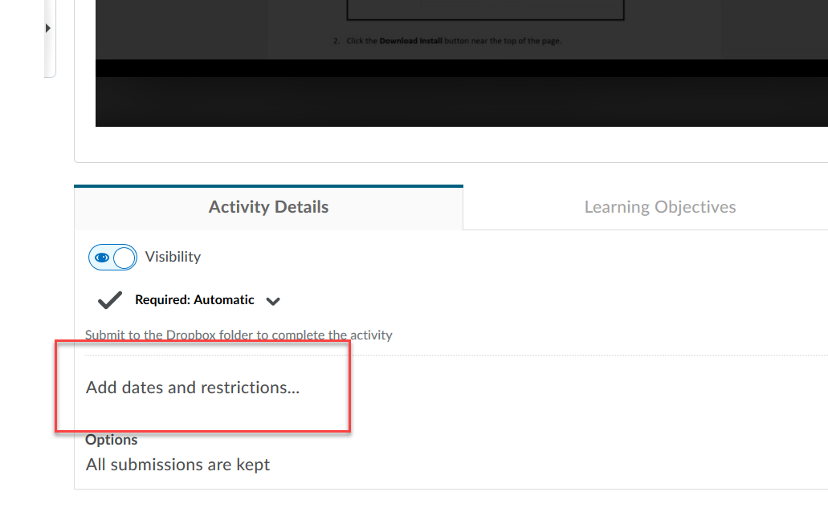
- Do not select to Add a Grade item, once the grades are exported from MyMediasite it will create a Grade item based on the Dropbox title.
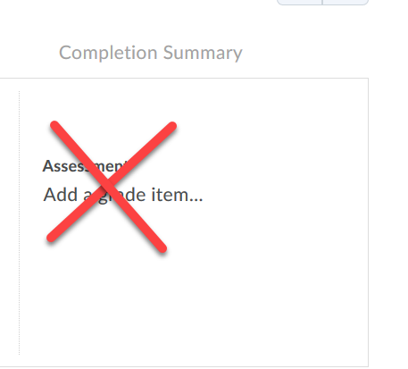
- Once student have taken the quiz or after the Due Date for it, go to MyMediasite, by clicking on the MyMediaiste link in D2L.
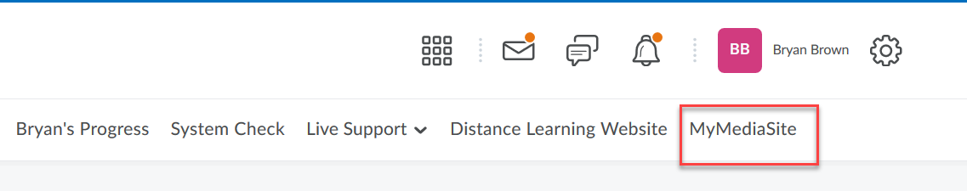
- Click on the Video.
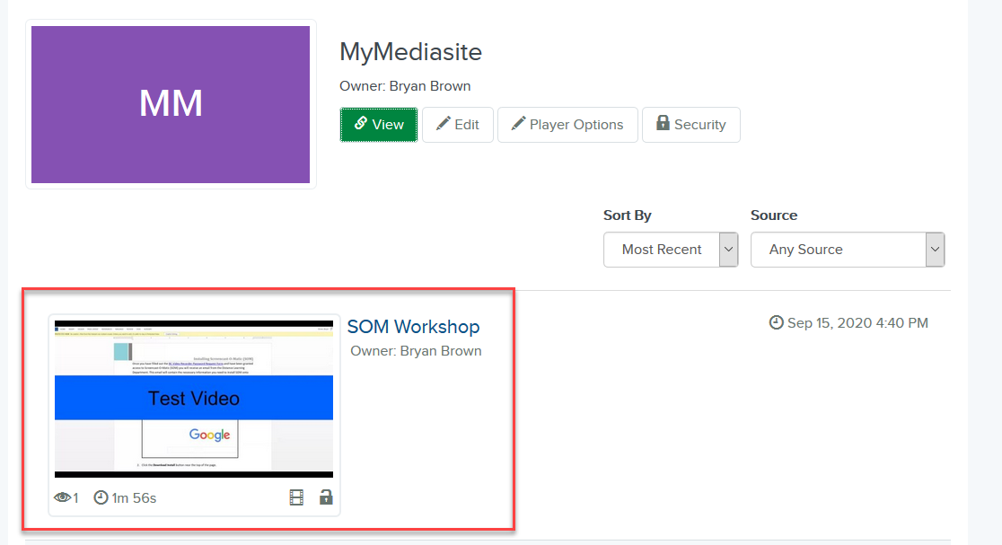
- Click on the View Analytics links (on the right of the video).
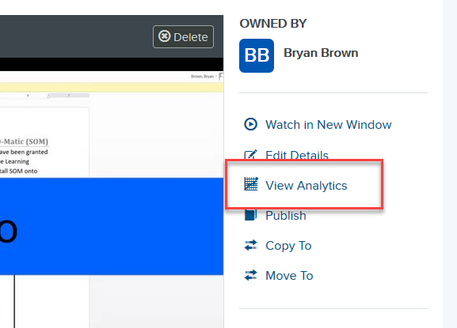

- Click on Quiz tab.
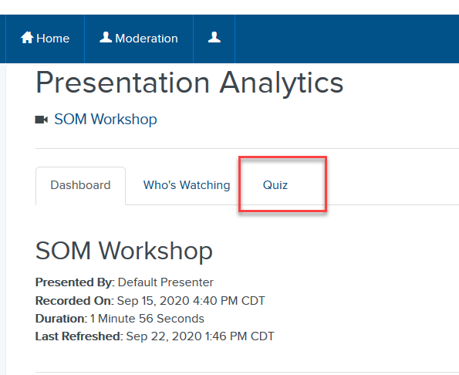

- Check each checkbox for the students who have taken the quiz (1) and click on Post Scores to Gradebook (2).
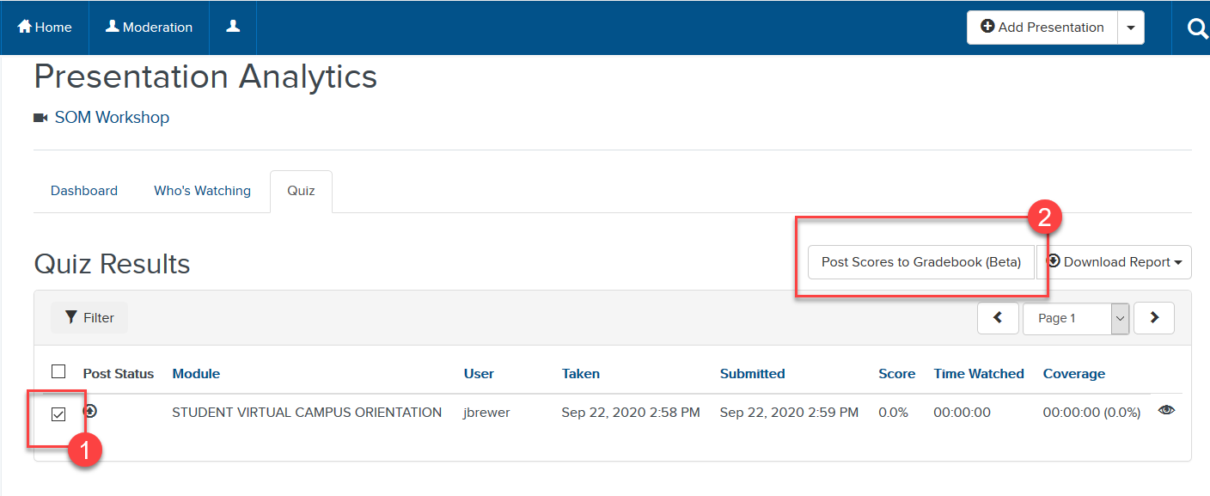

- Once it has completed processing you should receive an email notification. Keep in mind the gradebook will display point totals out of 100 (ex: 91/100).

Manage Grades:
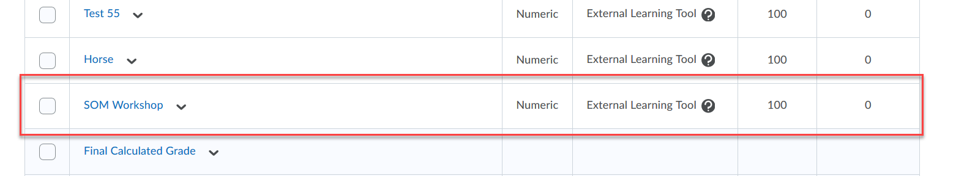

Enter Grades:
