Create a Publish to Go link for to download MyMediast video for Editing
In MyMediasite, if you want to download a video to edit using ScreenCast-o-Matic you will need to create a download link.

1. Go to MyMediasite.
2. Locate video you would like to download.
3. Click on video.
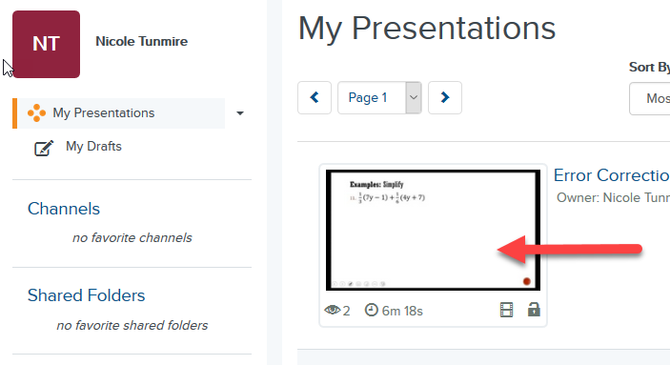

4. On the right, select Edit Details.
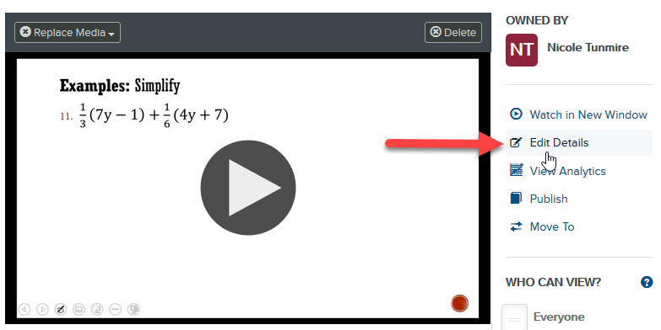

5. Click the Delivery tab.
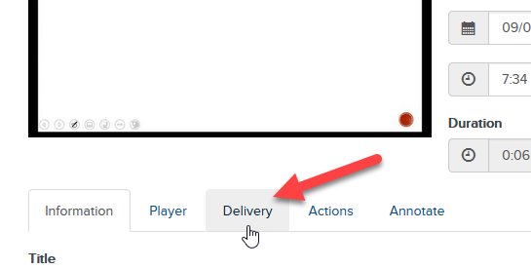

6. Click box for Publish to Go to select it and then click the Save button.
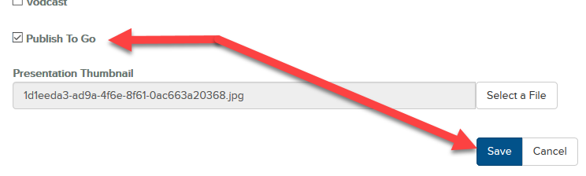

7. Scroll down and on the right, click Download to Computer
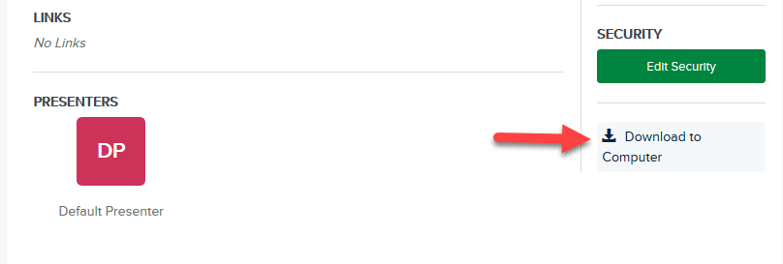

8. Click on Create Publish to Go.
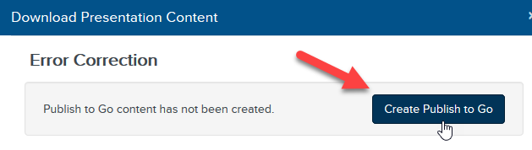

8. Depending on length of video it may take a bit to process, so you can go away and come back and select Download to Computer link again and then click Download Publish to Go once it has processed.
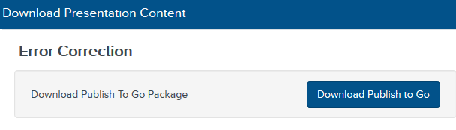

9. Once file has completed downloading you will need to open the zip file and extract the .mp4 video file. Once done it can then be imported back into ScreenCast-O-Matic for editing.

