MyMediasite is used to upload, store, and share videos with students, faculty, and staff.

Creating a MyMediasite Account

- Log into D2L at https://online.brazosport.edu using your BC credentials.

- Click on MyMediaSite in the Navigation bar at the top of page.
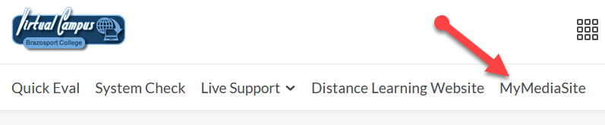
3. Click Continue when prompted (if needed click Continue again).
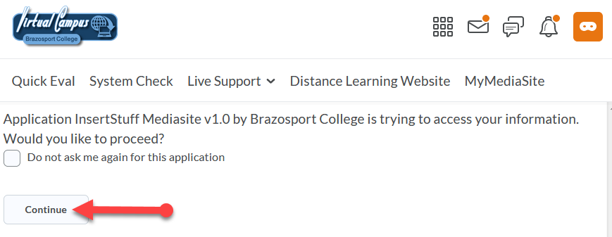
4. You have now created your account. Click on the Virtual Campus logo and return to D2L.
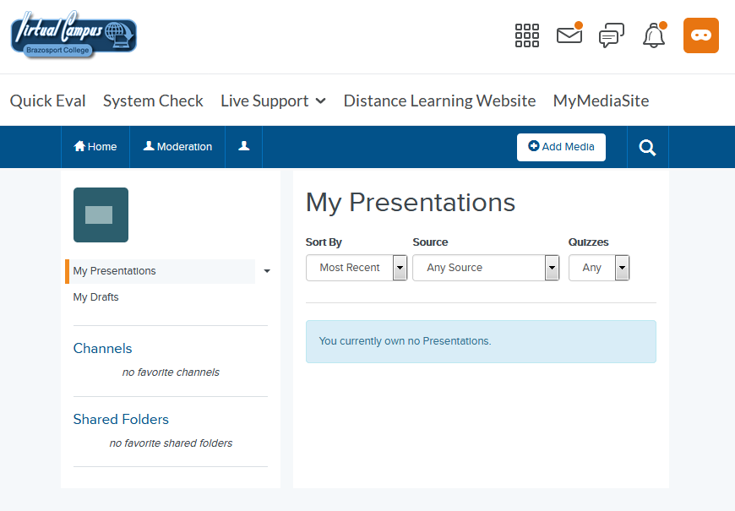

Accessing MyMediasite

- To access MyMediasite you will need to sign into the Virtual Campus (https://online.brazosport.edu) and click on MyMediasite from the Navigation bar at the top.
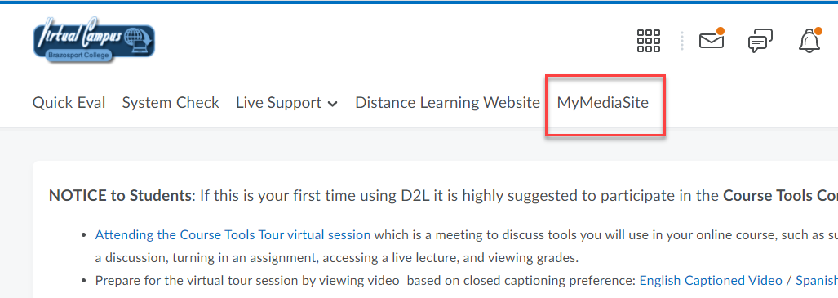

- You are now on your personal MyMediasite.
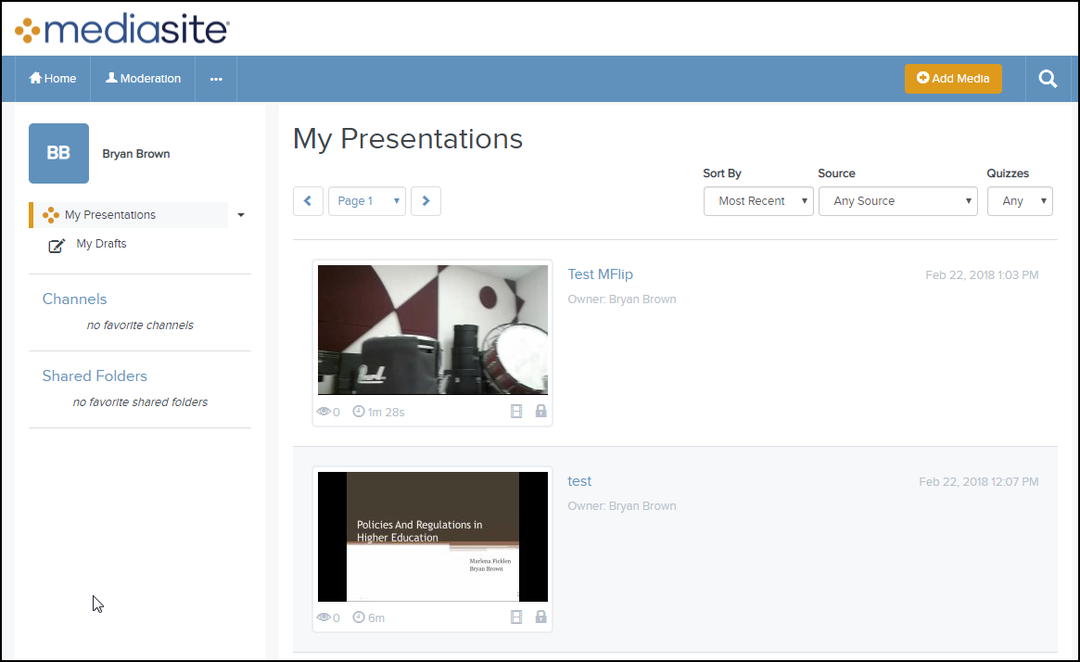

Accessing Shared Folders

Any folders you belong to or share with others can be accessed from the Shared Folders section of MyMediasite. On the left-side of the page of MyMediasite click on Browse Shared Folders.
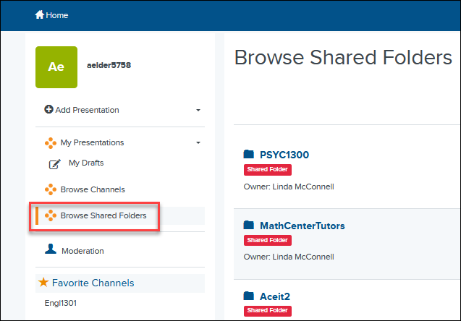

1. You will find a list of all your own video folders as well as ones that are shared. Click on a folder (1). On the right-side of the page, you will see all the videos contained within that folder (2).
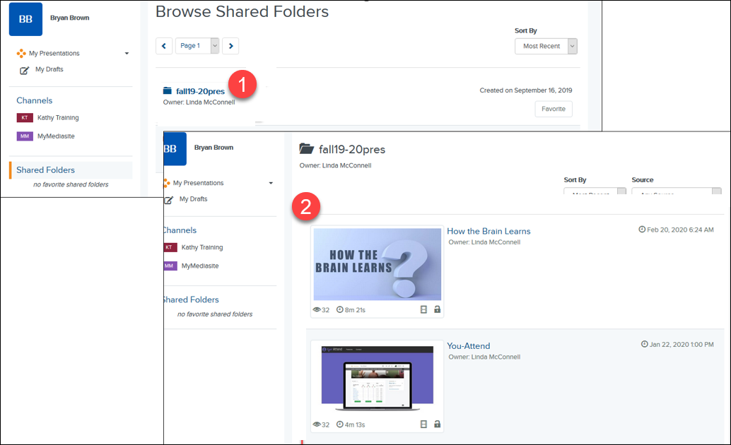

Creating a Channel

With MyMediasite you have the ability to create as many Channels as you would like to publish your videos to. Channels are similar to folders in that they allow you to easily organize and categorize your videos. Any channel you create can be shared as a whole with others, or you can distribute and share the videos within a channel individually with others. You can create a channel for each class you teach, etc.…
NOTE: If you intend to publish a video to a Channel, it is recommended that you create the Channel first. Doing so will make the process of adding the video to the channel faster and simpler.

1. To create a channel, click on Channels from the left-side of the page.
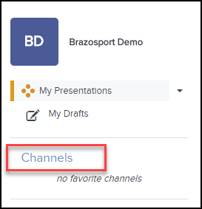
2. Click the Add Channel button in the top-right corner of the page.
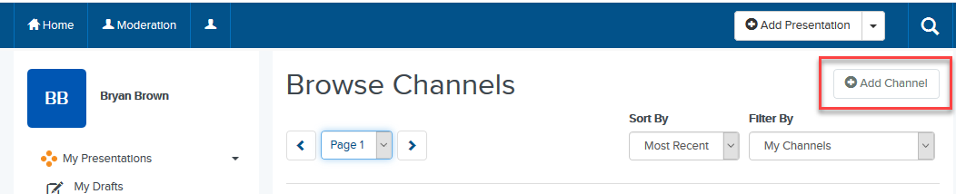

3. Enter in a Name for your channel (1). If you like you can enter a Friendly Name (2) and a Channel Description (3). When done click on the Create Channel button (4).
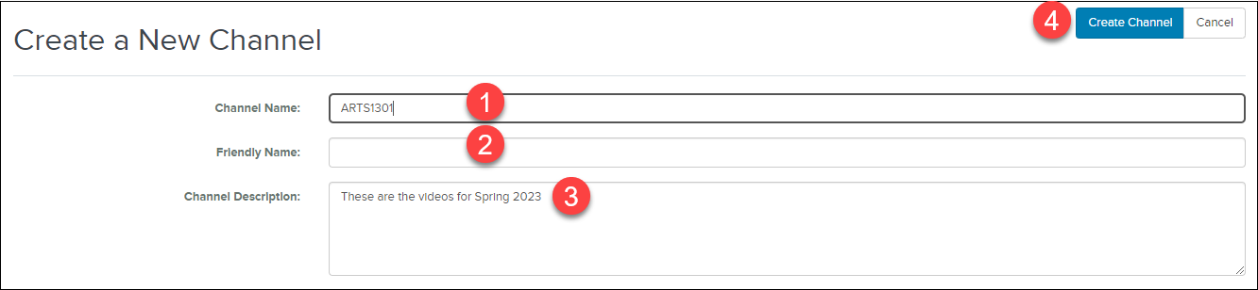
4. The channel is now created.
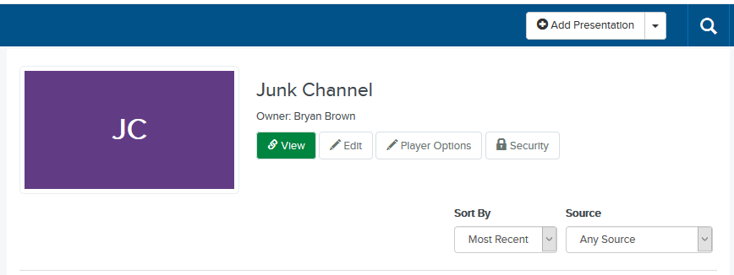
5. To see your channels, click on Channels on the left-side of the page.
6. You will now see the Browse Channels window with all the channels you have created. To add a channel to your favorites so it appears underneath you Channels on the left-side of the page, click the star button for it.
7. The channel will now appear under your Channels on the left.
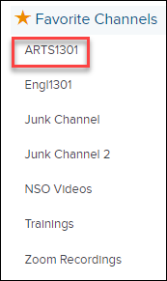

Editing a Channel

If necessary, you can edit the channels you create in MyMediasite.
1. To edit a channel view Channels on the left-side of the page (1) and then click the edit button (2).
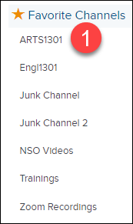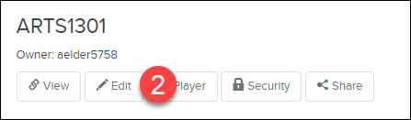
2. Edit the channel where necessary (1) and click the Save button when done (2).
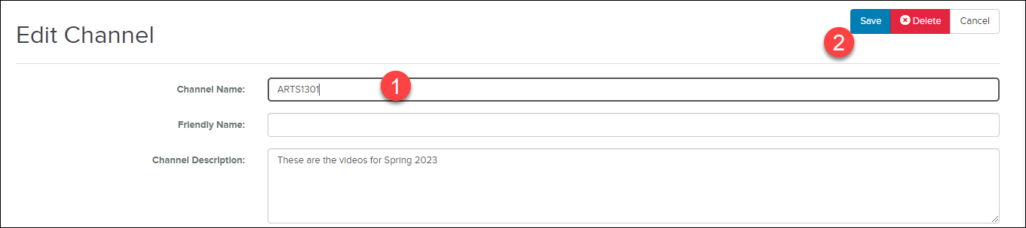
NOTE: You can also delete the channel, if necessary, by clicking the Delete button.

Uploading a Video to MyMediasite

You can upload video files to MyMediasite to share them with others. The process of uploading video files to MyMediasite consists of the following steps:
- Uploading a Video
- Sharing a Video

Uploading a Video
- From the homepage, click the Add Presentation 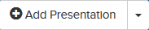 button.
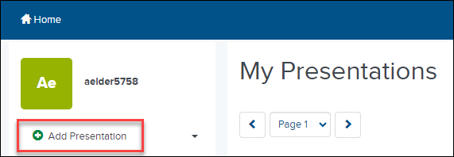

- Click on the Choose File button.
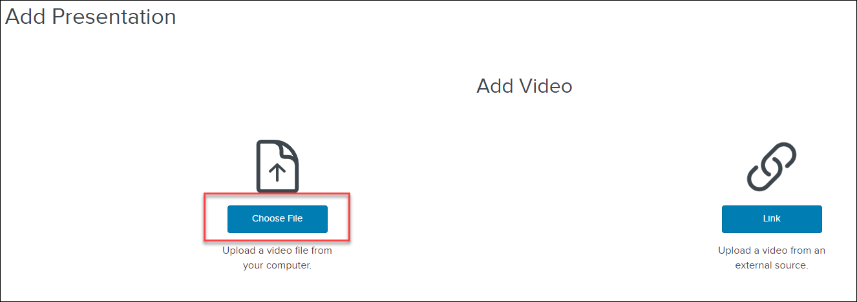

- Locate and select the video file wherever you have it saved on your computer.
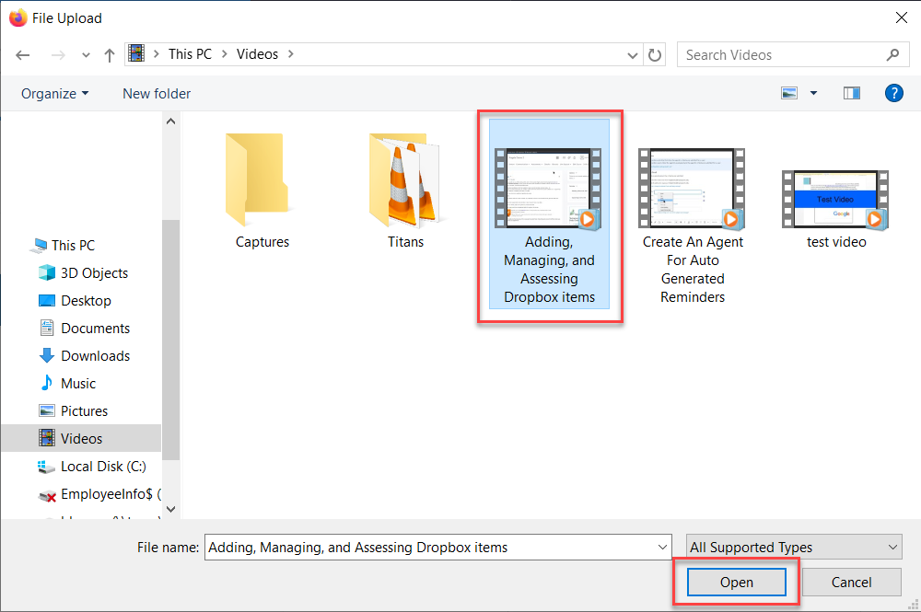

- Enter a Name for the video (1) and if you like, type in a Description for the video (2). To add the video to one of your existing channels, select the option underneath My Drafts (3) and click on the Change button (4).
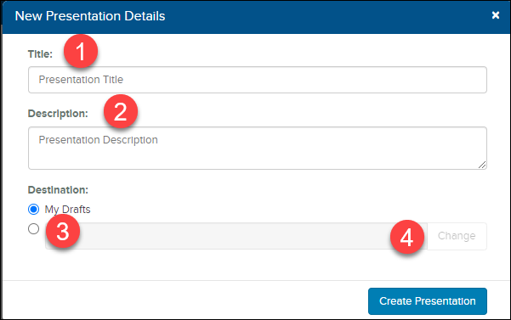

- Make sure User Channel is selected for the Destination Type (1) and then select the channel you want to add it to from the list of channels at the bottom of the window (2).
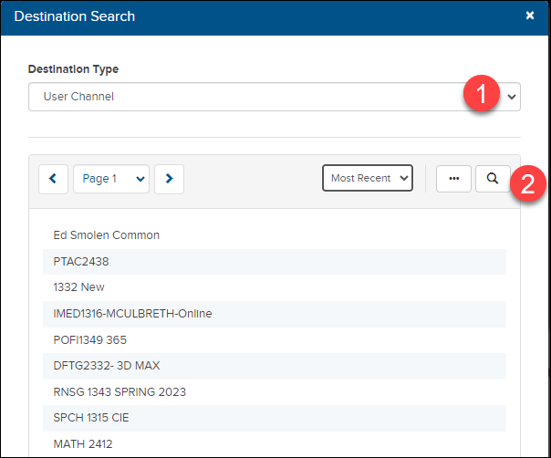

- Click the Create Presentation button.
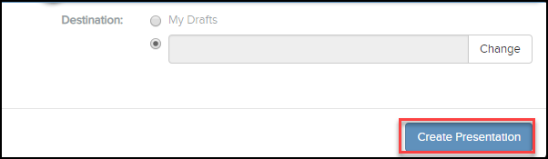

- IMPORTANT: When you upload a video to MyMediasite it will not be published right away. Instead it might say, “Queued for Processing”. This means the video is being automatically converted into a format that is suitable for optimized playback across multiple platforms (i.e.; cellphones, tablets, etc.).

Depending on the size of the video you uploaded and the number of other users uploading videos, this process can take up to an hour, so you will need to plan ahead. Once it is completed the video will be published and you should receive an email letting you know. NOTE: If your video does not process within an hour, contact the BC IT helpdesk (ext.3266||helpdesk@brazosport.edu)

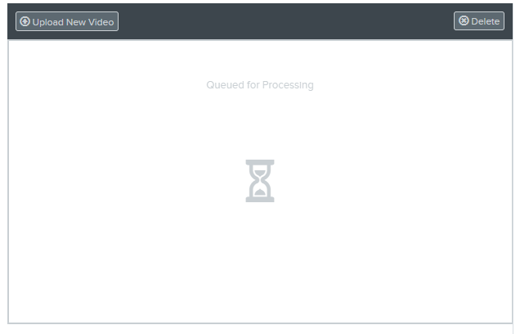

- Once a video has been processed, you will then have the option to Replace Media to replace the initial video you uploaded with a different one whenever needed (1), Delete (2), and/or Edit the details (3) of the video.
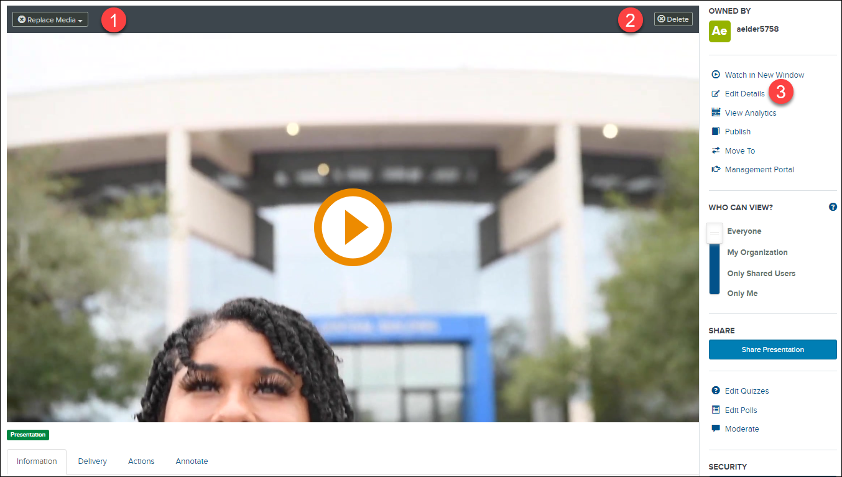

Edit
- When you click the Edit Details link for the video, The Edit Presentation mode will be enabled and you can edit the details of the video (i.e.; title, name, etc.). Click Save when done.
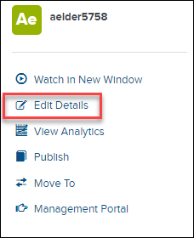

Changing the View Setting for a MyMediasite Video

In order for your students or anyone else to view your video you must make the video viewable to everyone. By default, this option should automatically be selected whenever you upload a video.
- Browse your channels (1) and locate and click on the video you want everyone to be able to view (2). A closed lock icon means the video is only viewable by you. An open lock icon means the video is viewable to everyone (3).
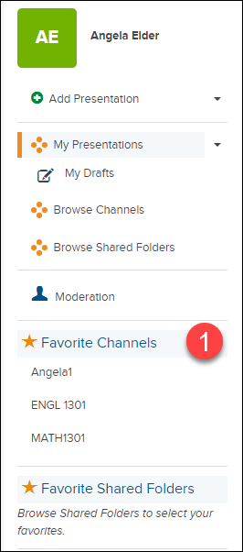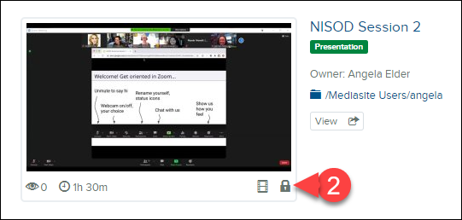
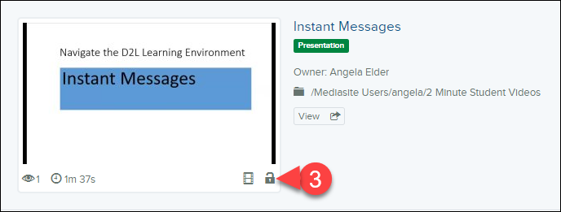

- Click on the video (1). Then from the Who Can View section in the right sidebar, verify the slider is on Everyone (2). If it is not, slide the slider up to it.
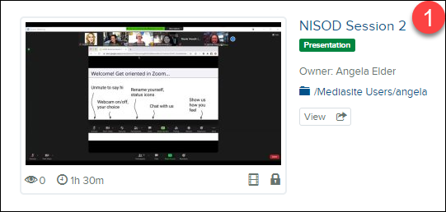
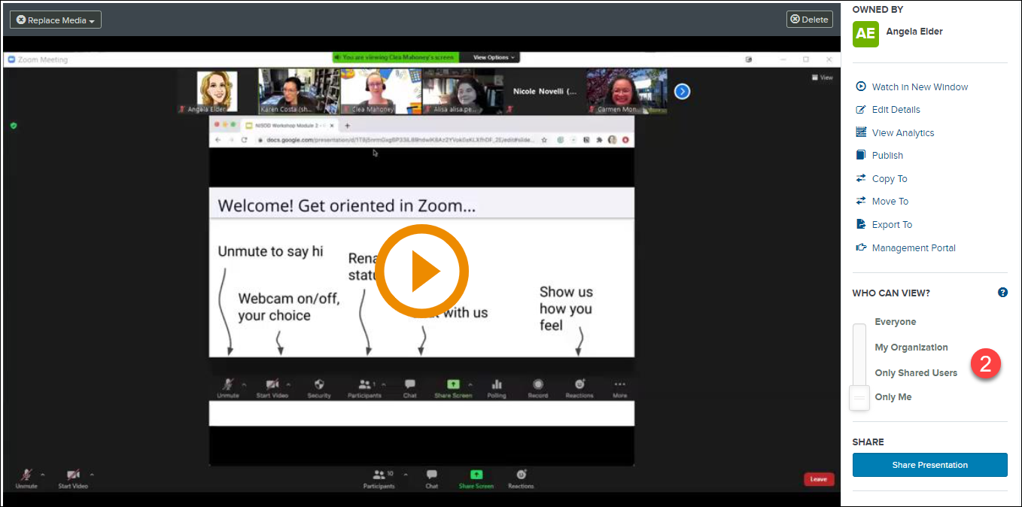

3. You will get a success message.

Sharing MyMediasite Videos with Students via D2L

Any video you upload to MyMediasite can be shared with students as an embedded video.

Although the following directions show how to paste a link into the Content area, you can paste anywhere that has a HTML text editor such as News, Discussions, and even in a quiz.

1. Click on Content from the navigation bar.
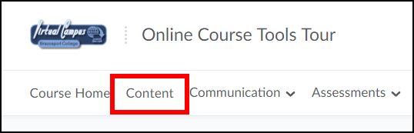
2. Click the New button (1) and select Create a File (2).
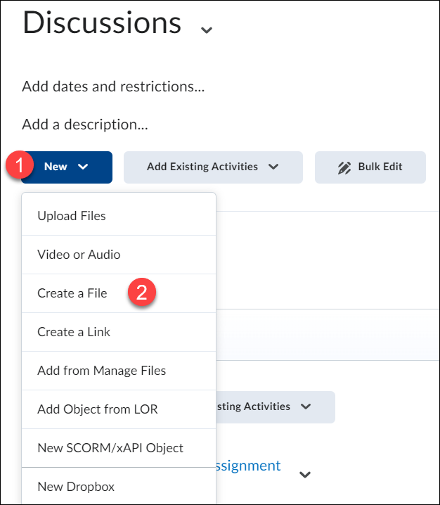
3. Enter an applicable title (1). Place your cursor inside the HTML Editor wherever you want to embed the video (2) and click the Insert Stuff button (3).
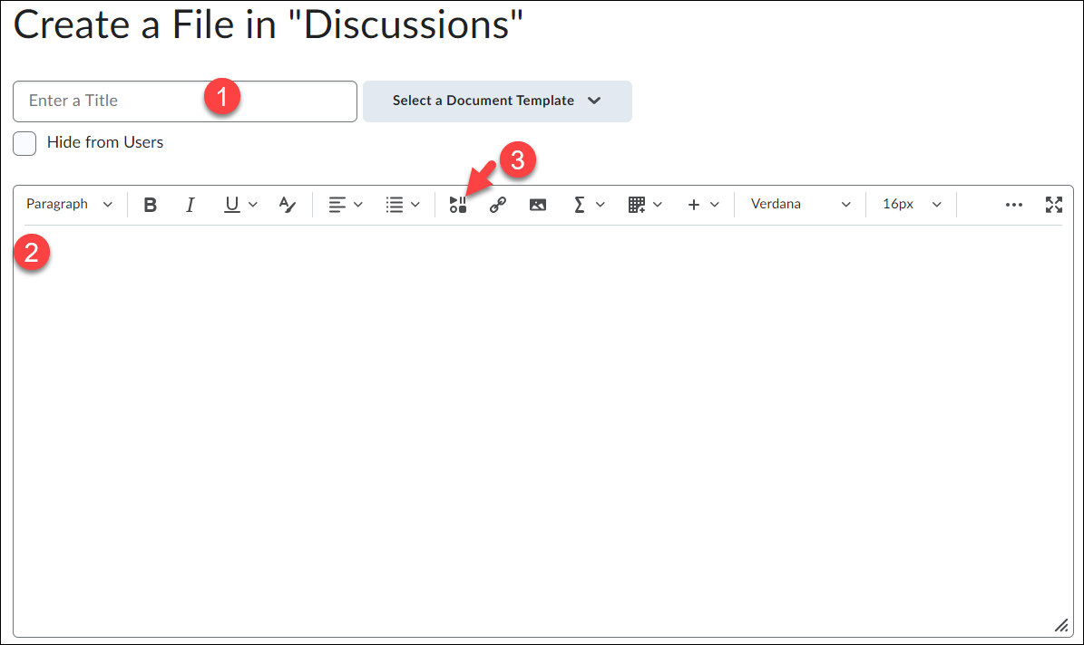
4. Scroll down and select Mediasite (1).
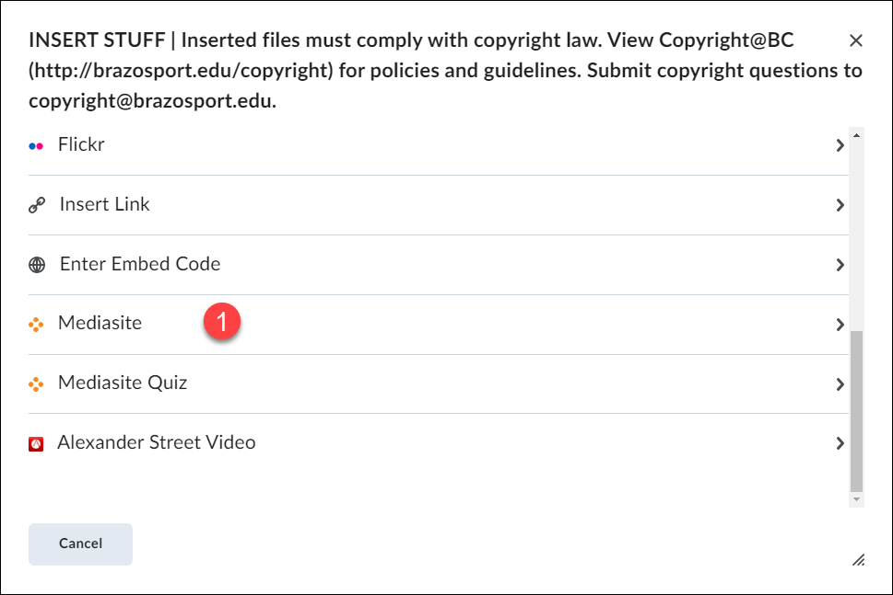
5. Click on Presentation.
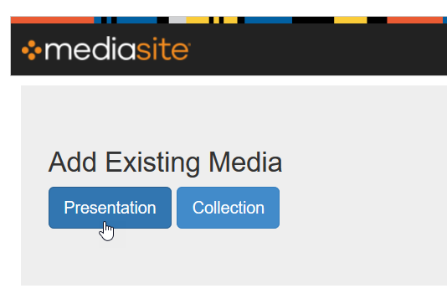
6. Type the title of presentation in the Search field on the right and click the Enter key.
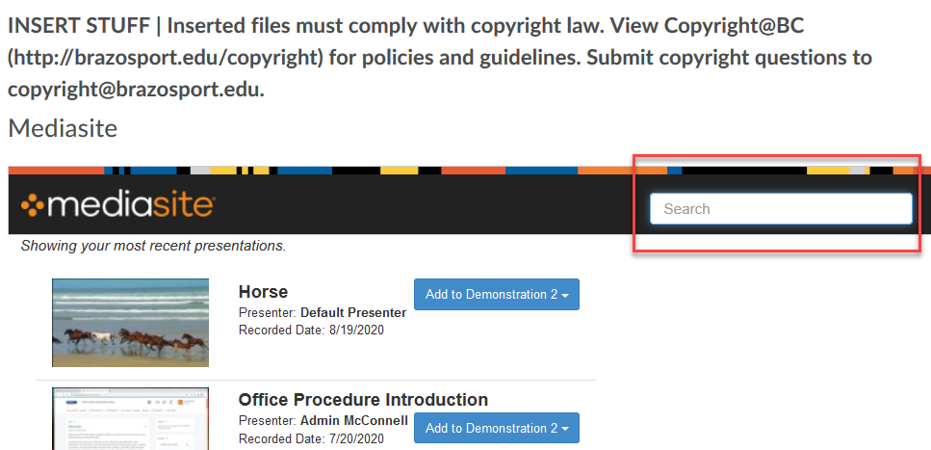

7. Once video pops up click on “Add to ….” (1) And select Player Only (2).
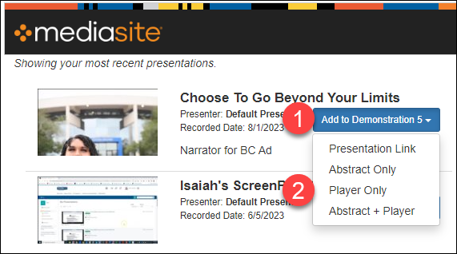

- 8. Once the video loads, click the Insert button.
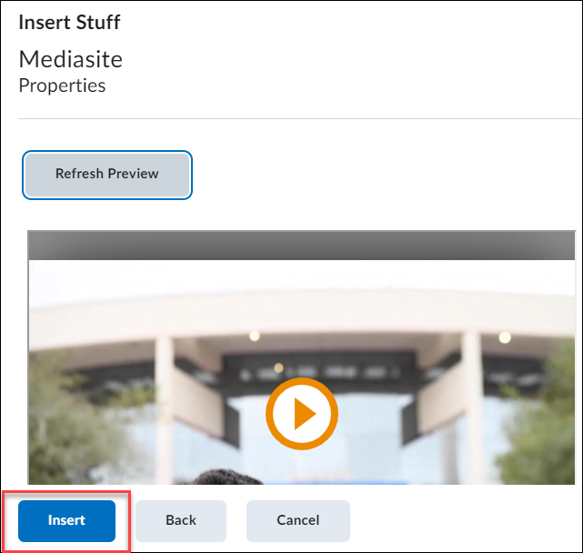

- 9. The video should now be embedded. Make sure to Save and Close when done.
