Edit videos without having to remake them if you have made a mistake, or just want to add more to existing videos directly in your Mediasite.

1. Log into D2L and from the homepage **click** MyMediasite.

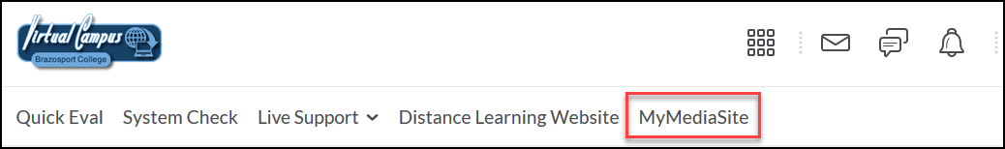

1. **Click** on a presentation which you would like to edit.

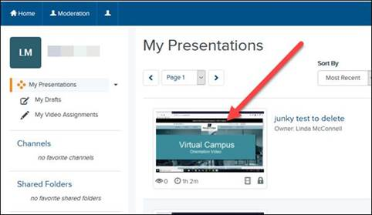

1. **Click** edit video.

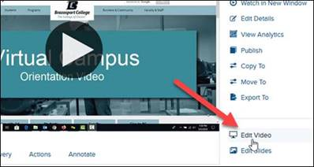

1. The video web editor opens. Turn on features to make it easier to edit by clicking Toggle Thumbnails.

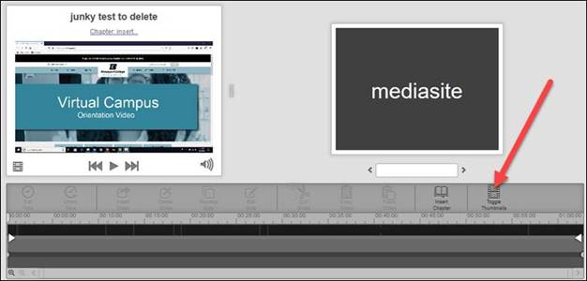

1. This step is only necessary if you have a webcam video embedded in the recording. To begin, **click** Video Source (if you have a dual video, meaning a webcam as well as a presentation). **Click** Video 1 (on the right video).

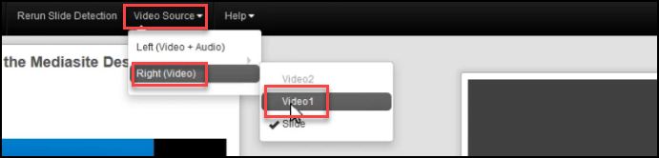

1. Click the play button to start playback.

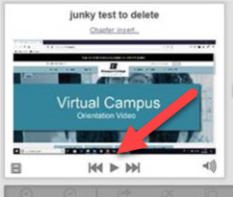

1. To cut out empty parts, or no sound, etc., **click** on a blank section, then **click** Cut Time.

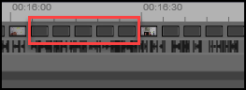 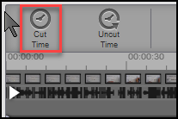

1. To add Chapter marks, perhaps when you change topics, **click** the place you want to insert it, then **click** Insert Chapter.

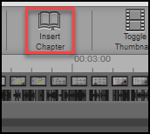

1. Name the chapter, then **click** Ok.

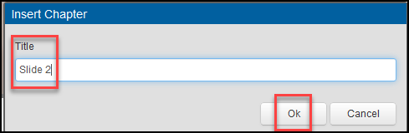

1. If you are editing a slide presentation instead of a video, you can move and replace slides. You will see all the slides at the bottom. To move one to a different location, **click** and drag it where it should be.

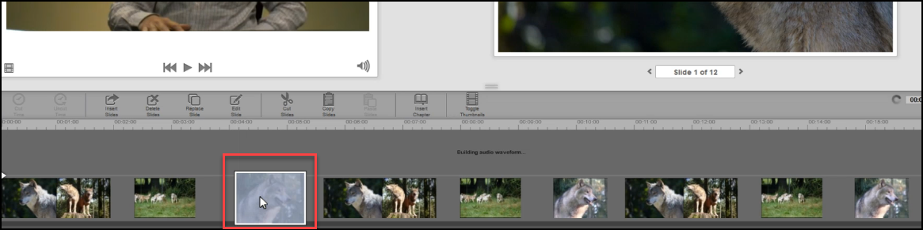

**15**. To cut, copy and paste, just **click** those buttons.

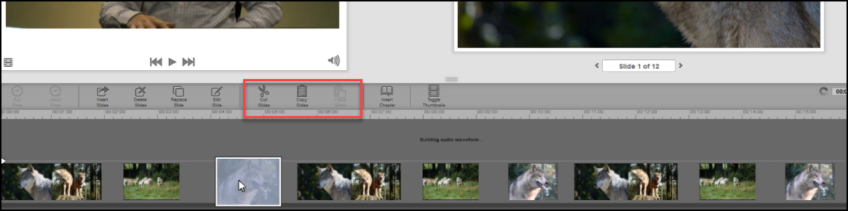

1. Edit a slide title and description by **clicking** on the Edit Slide button.

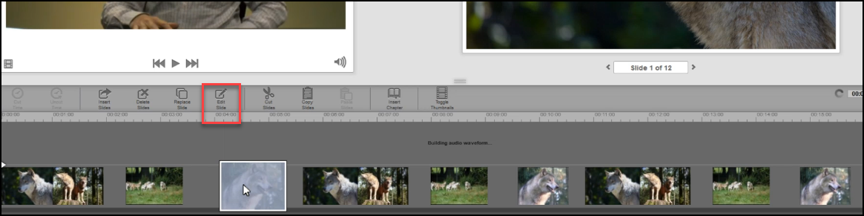

Fill in the information then **click** Ok.

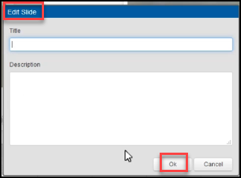

1. Replace a slide by **clicking** on the Replace Slide button. It will open a file explorer window to search for the new slide.

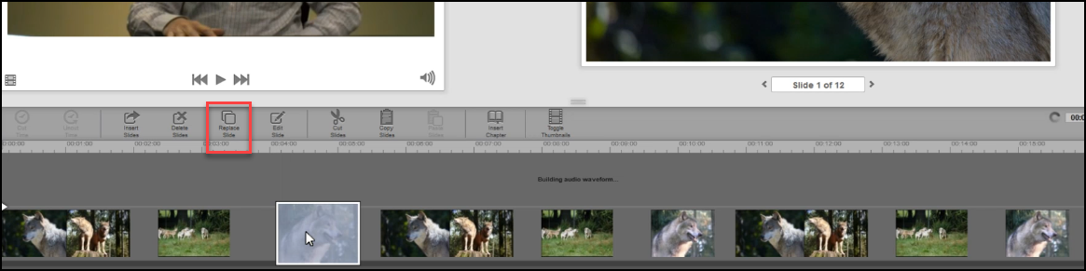

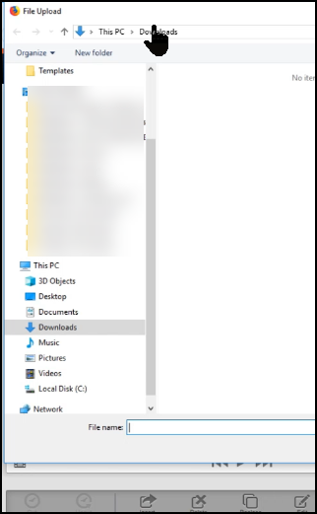

1. Delete a slide, or insert a slide at the current location by clicking on either Delete Slide, or Insert Slide.

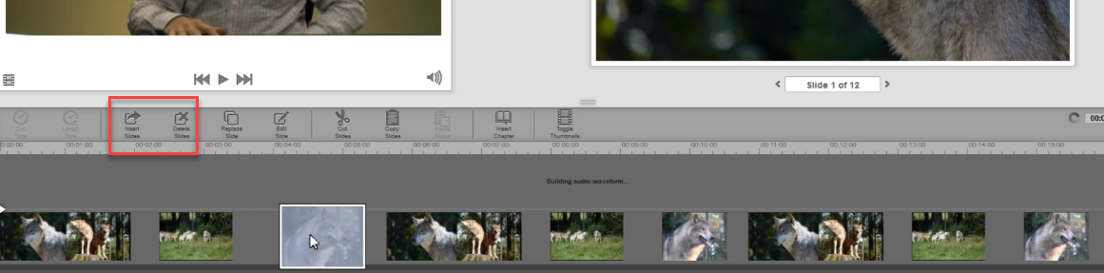

1. Save your edits. Any edits made in the web editor are automatically saved but you must commit the changes to apply them to the presentation. The three options are Commit to Current, Commit to New, and Commit to Existing.

**Commit to Current** overrides the current version. **Commit to New** works like a Save As, allowing you to save a new copy with all the edits applied. **Commit to Existing** allows you to edit and save a presentation to a blank presentation in My Mediasite.

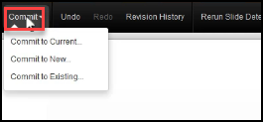

1. For any of these three options, **click** on one of them and give it a title. For instance, on Commit to New, you could name it the same name but perhaps add the word Final to it. **Click** Commit.

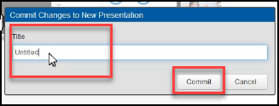

1. The Commit Jobs button can be clicked to see the progress of the editing you just did. It will show it is working, and the status bar will eventually fill in and show complete.

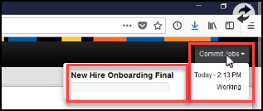

[Video on Editing in Mediasite](https://learn.mediasite.com/course/editing-your-video-presentation/)