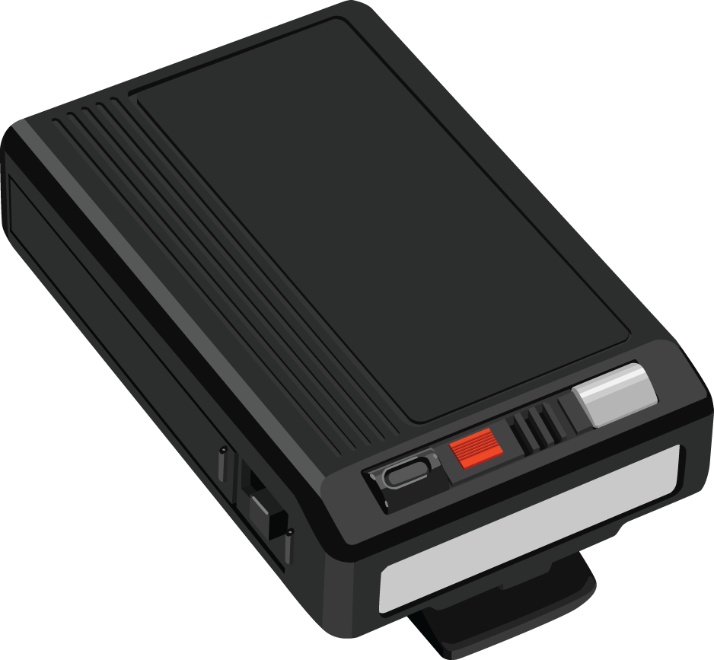

The Pager is a great tool that allows you to get in touch with anyone else who uses D2L. The Pager works almost like an instant messenger where you can send another user a page and they can respond back to you using the Pager tool.
- 1. Login to D2L (https://online.brazosport.edu).

- 2. Click the Message alerts icon above the navbar on right-hand side of the page (1) and then select Pager (2).

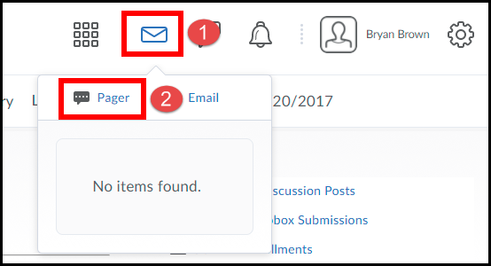
- 3. Click on the Classlist tab.

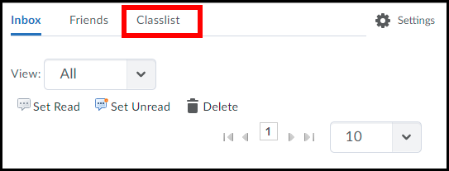
4. Select the User(s) you want to send a message to (1) and click on the Message icon (2).

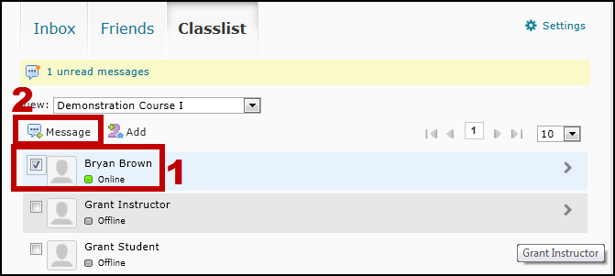
Indicates that you have unread messages. Click on the link to view them.
Use this drop-down menu to select a course to view a list of all the Users in it.
- 5. Enter in your message (1) and click the Save button (2).

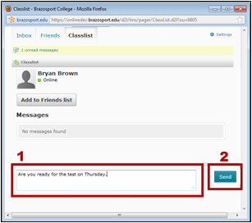

- 6. All pager messages between you and selected user(s) will be displayed here.

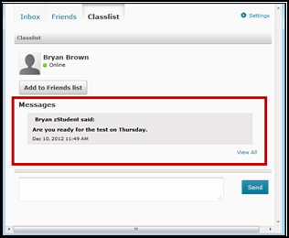
7. If you hear a beeping sound upon logging into D2L it probably means you have a new pager message. Click on the Messages alerts icon to check your page messages.

