The Email tool allows you to send and receive emails from others within the Virtual Campus.
Reading an Email message
- Click the Communication icon on the course navbar and select the Email link. You must be inside your course to access the Email link.

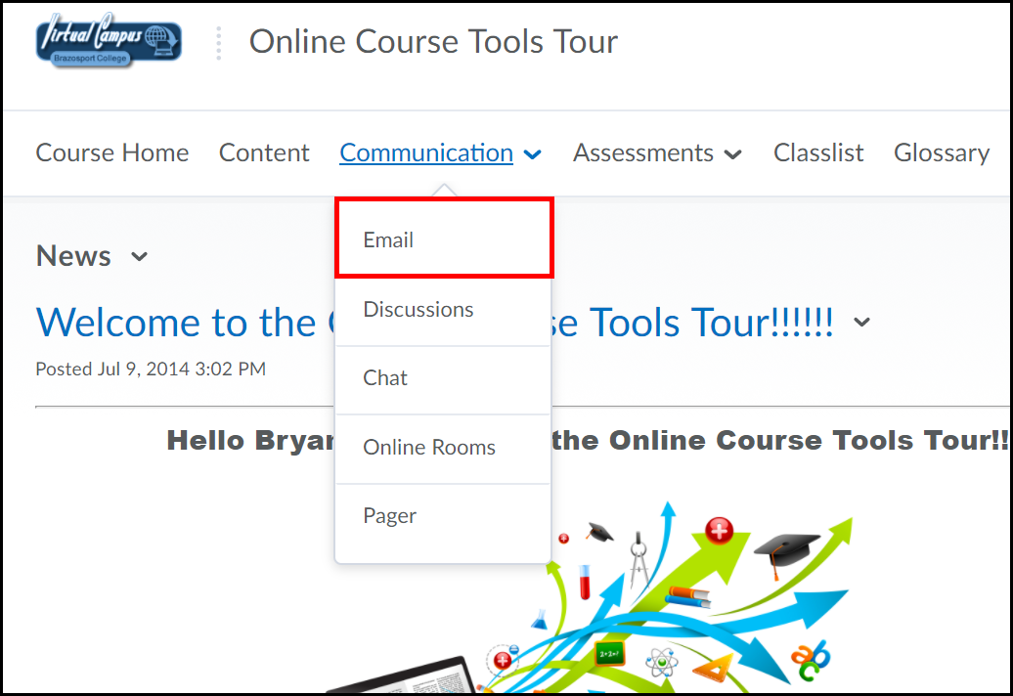

2. To view a mail message, click on the title in the Subject column.

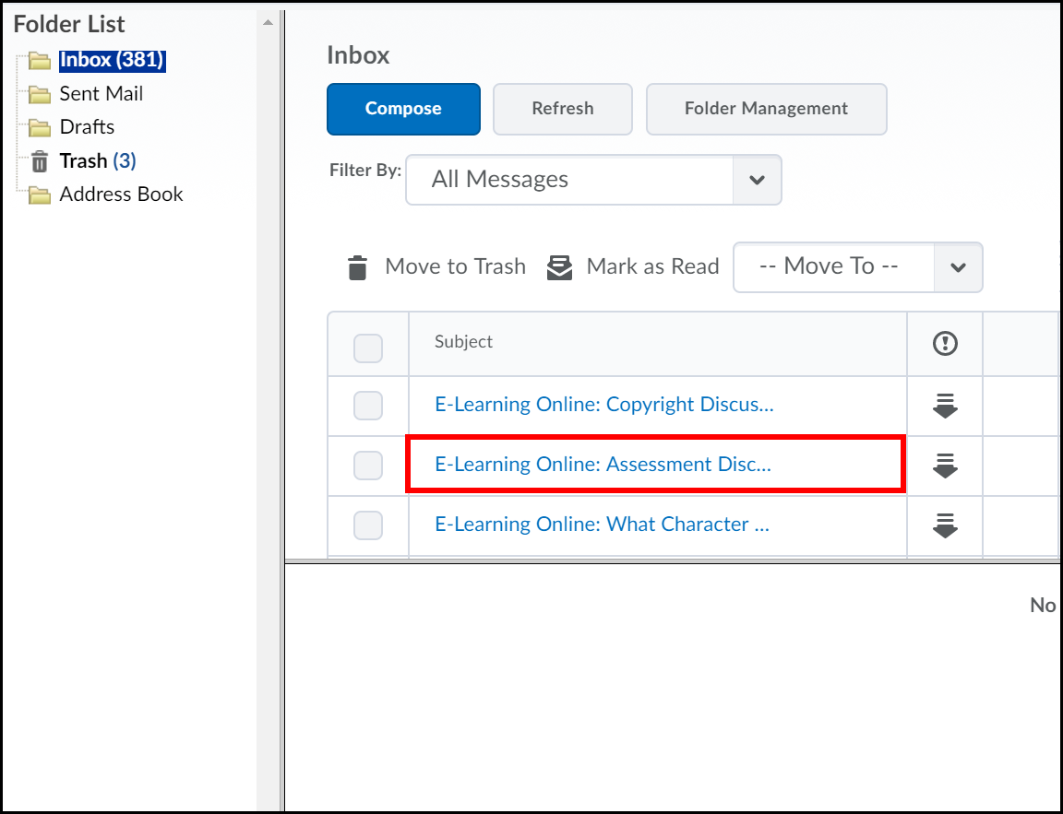

- The email message is viewable under the Message List. Use the Message Preview navmenu to Reply, delete, Mark (message as) Unread and print. You cannot Forward email.

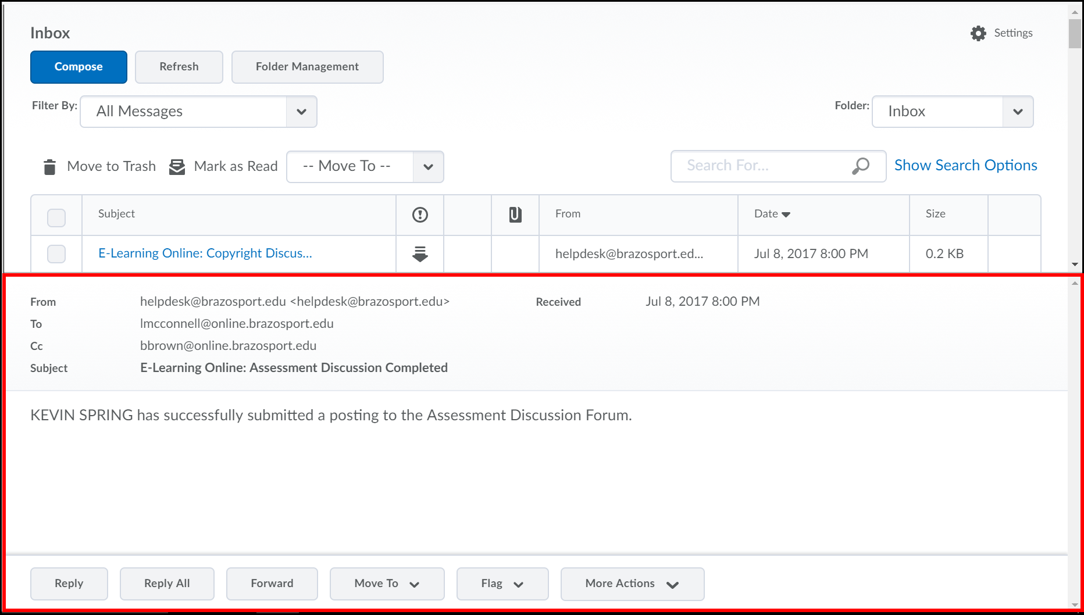

Compose an Email Message
1. Click the Compose button from the Inbox navmenu.

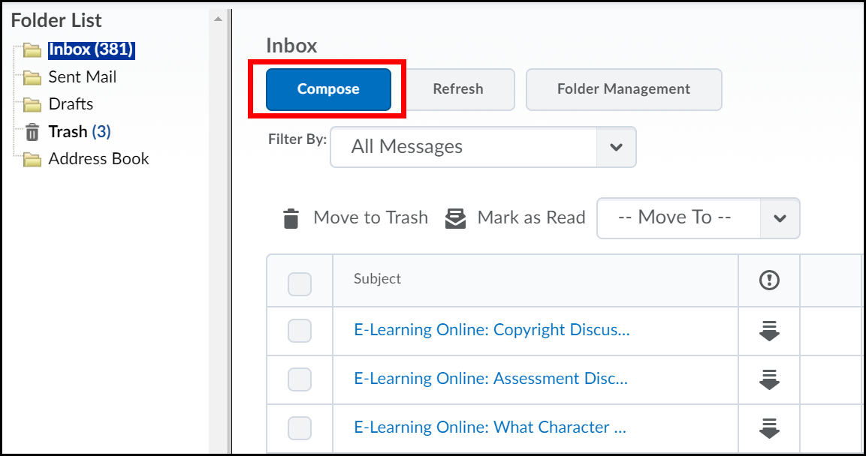

2. Click the Address Book button and search for the person you want to send the email to.

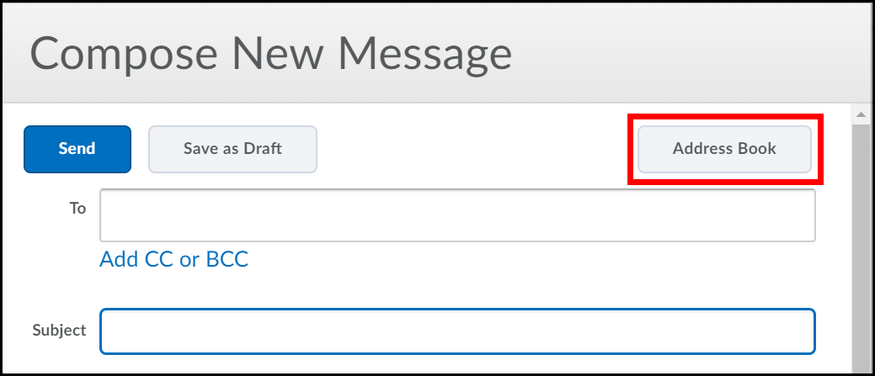

3. Select the checkbox next to the recipient, click the “To” text link (located on the top and bottom of the list) (1) and click the Add Recipients button (2).

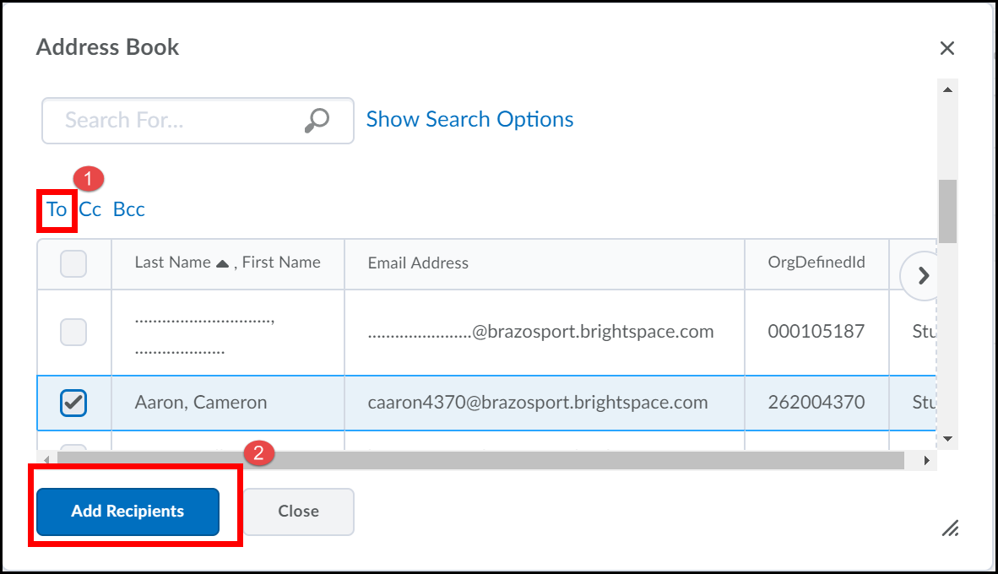

4. Type in a subject for the email (1) and enter your message in the Body text block (2).

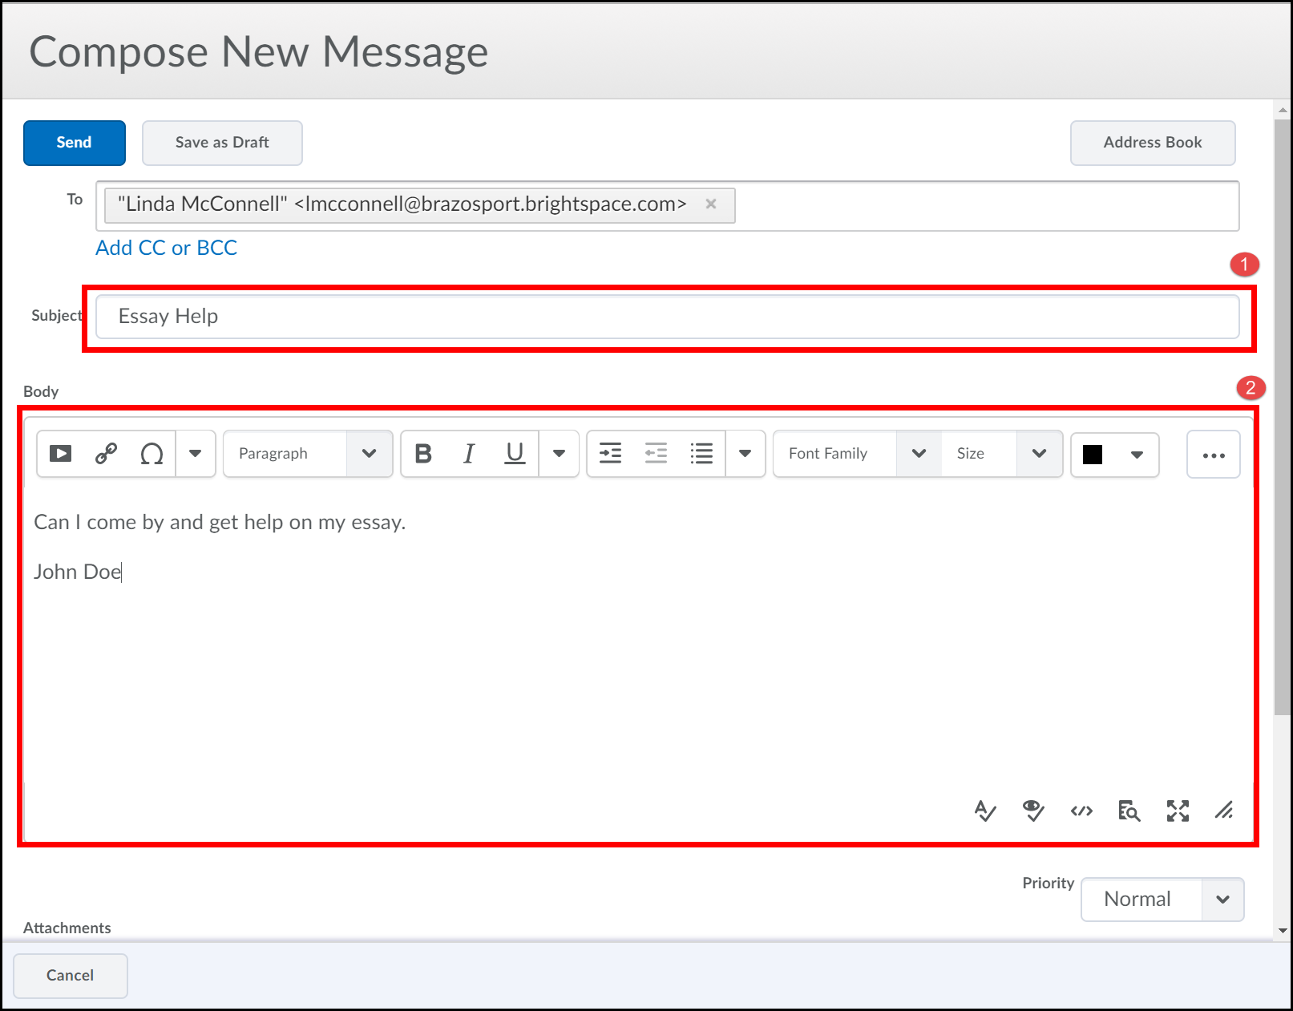
5. To add an attachment, click Upload (1), locate the file on your computer (2), click on it once to select it and click the Open button (3).
If using Firefox or Internet Explorer 10 (or higher) you can drag and drop the file into the specified outline area, instead of clicking the Browse or Upload button to add it.

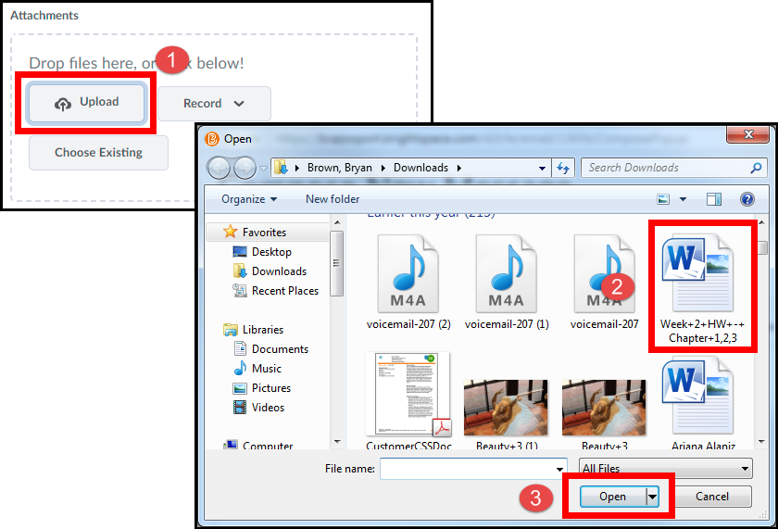
Adding Multiple Files
If you need to upload multiple files hold down the CTRL key and select each file you need to add. Then click the Open button.

6. Click the Send button.

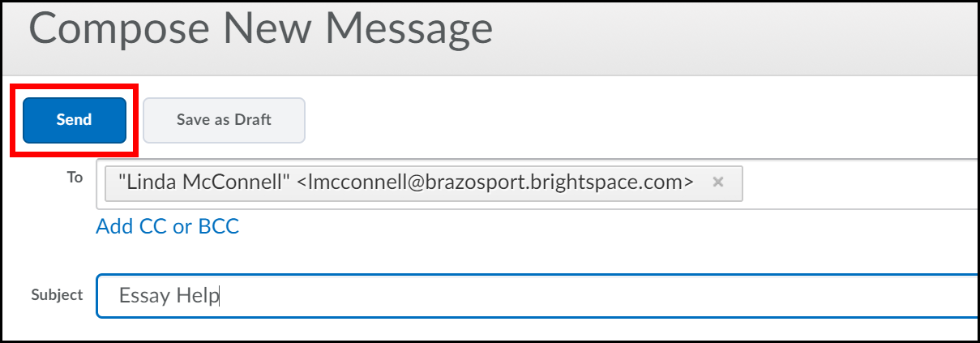

Replying to a message

1. Click on a message in the Message List and click the Reply button in the Message Preview navmenu.

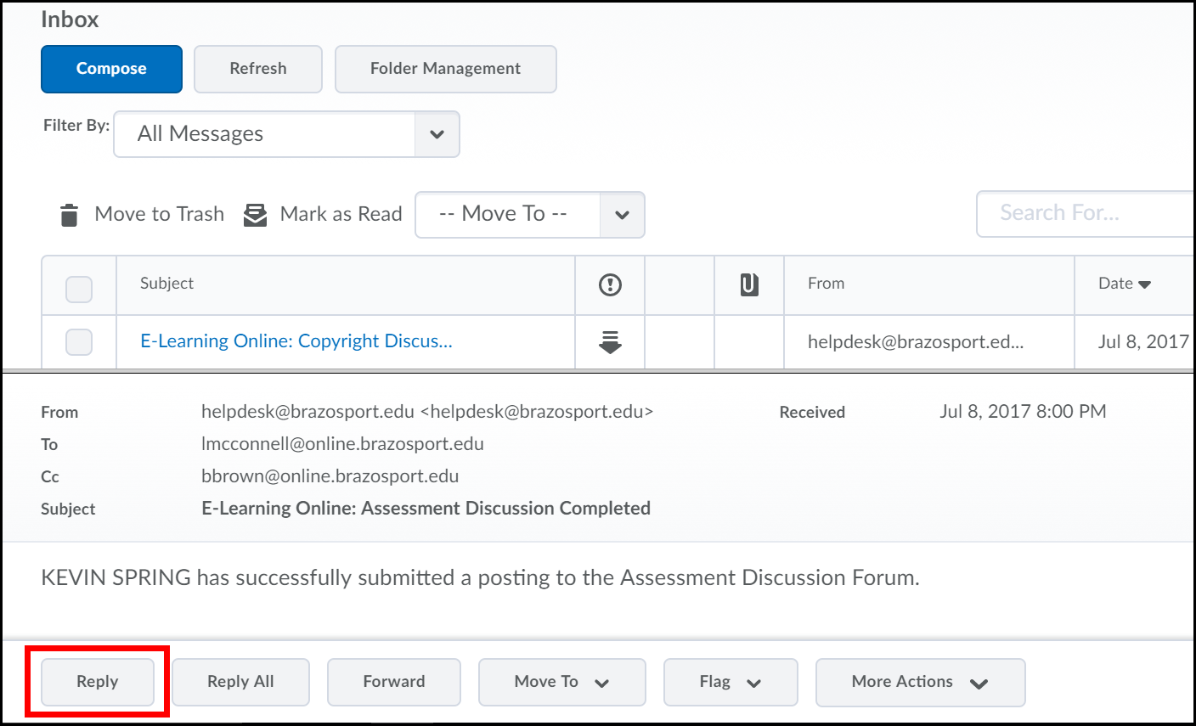

2. Type in your reply message in the Message text block and click the Send button.

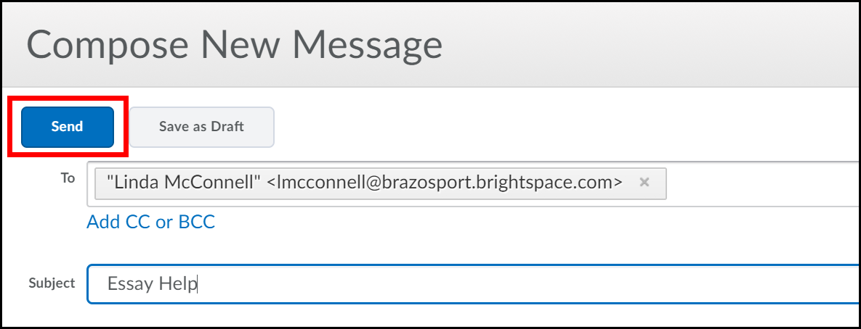
Deleting Messages

1. Check the box next to the message you want to remove and click on the Move to Trash icon.

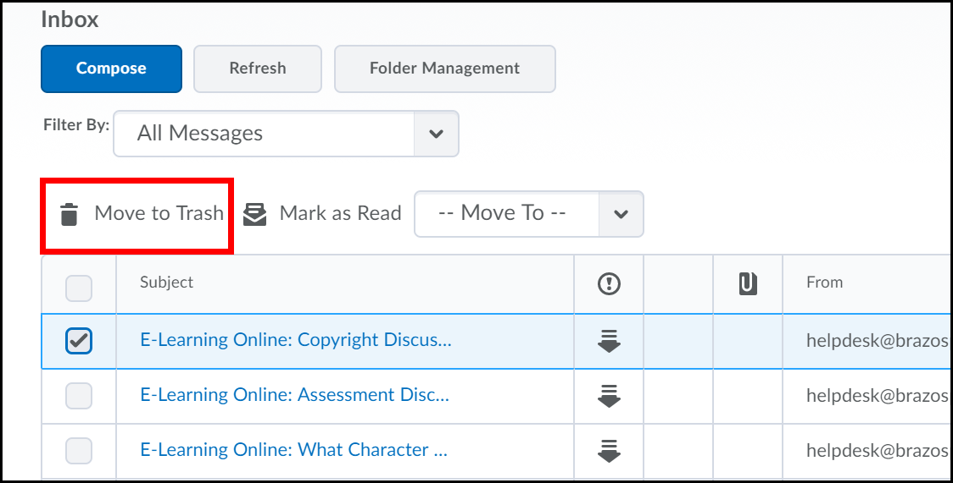

- You can also remove a message via Message Preview, just open a message and in the Message Preview navmenu click the Move To button and select Move to Trash from the drop-down menu.
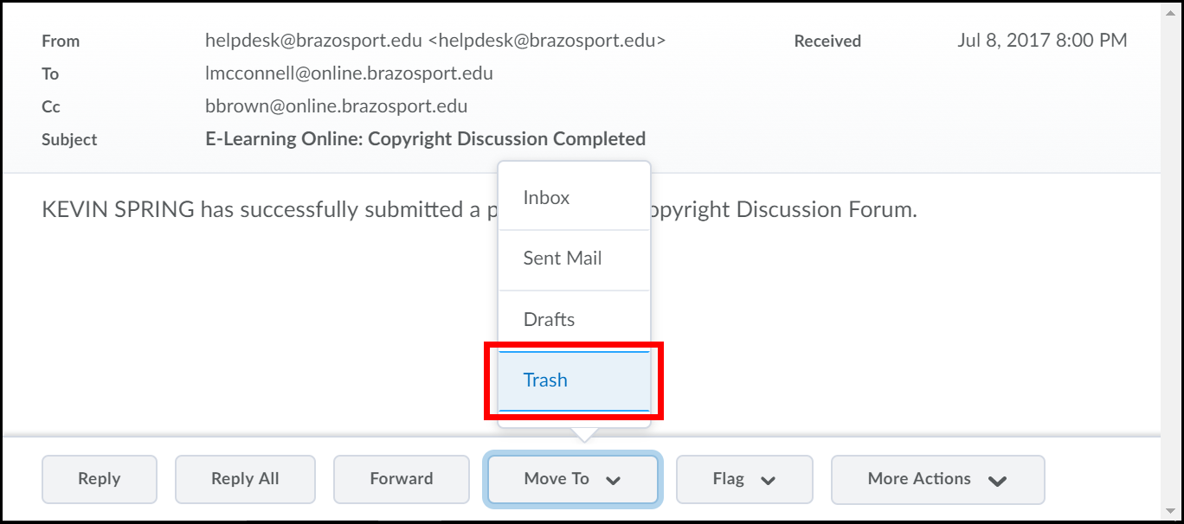

Printing a Message

1. Open a message and in the Message Preview navmenu click on More Actions and select Print.
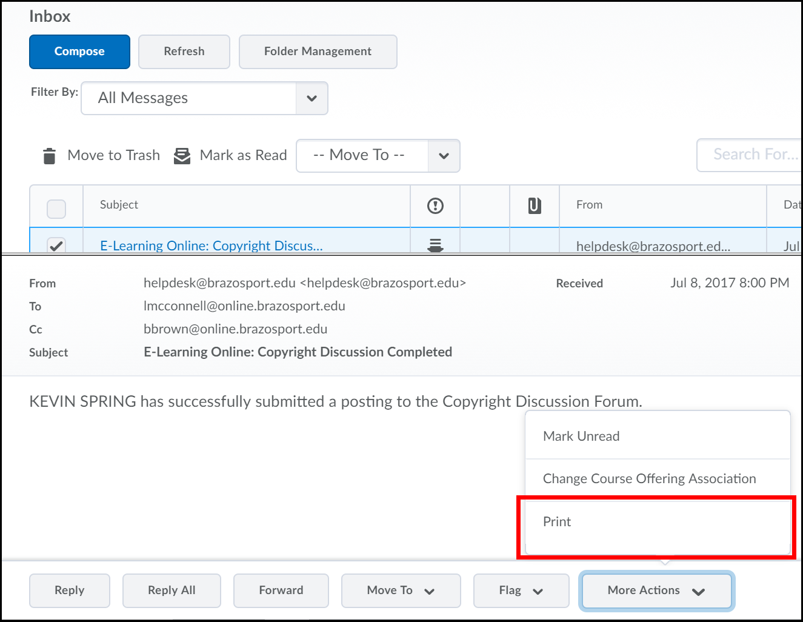

Forwarding Email Option

1. Click the Settings link near the top right-hand corner of the page.
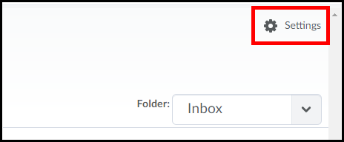

2. Scroll down the page and locate the Forwarding Options section.
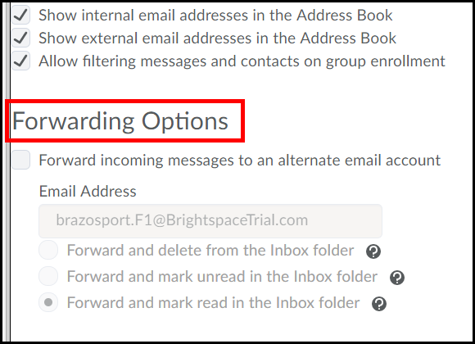
3. Check the Forward incoming messages to an alternate email account box (1). Enter the Email Address where you want your D2L emails to be forwarded to (2).
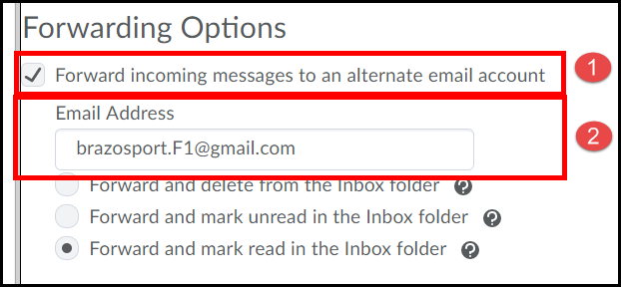
- 4. Choose one of the three options. The forward and delete from the Inbox folder option (1) will forward any email sent to your account to the address specified. The email will not be accessible through D2L. The forward and mark unread in the Inbox folder option (2) will forward any email sent to your account to the address specified. The email will also exist in your Inbox, and will be marked as unread. The forward and mark read in the Inbox folder option (3) will forward any email sent to your account to the address specified. The email will also exist in your Inbox, and will be marked as read. - This option is the best choice.

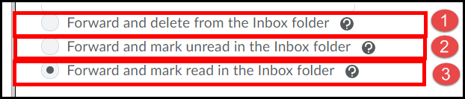

5. Click the Save button.
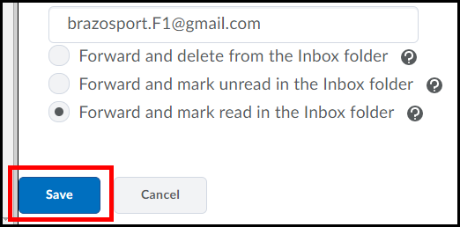
- 6. Any email you receive in Desire2learn will now be forwarded to your Alternative Email Address.

[Note: All Desire2Learn forwarded emails will display the username of the sender followed by @online.brazosport.edu in your inbox.] - You must log into D2L to reply to a forwarded message.

New Email Notification

If you have new email, the Mail icon will have an orange dot on it in the minibar. Click the icon to view new email(s) and access them through your Email.

