The quizzes tool is where you will go to access and take quizzes and/or exams for your online course.
Accessing a Quiz
1. Click Assessments (1) and click on Quizzes in the navbar (2).

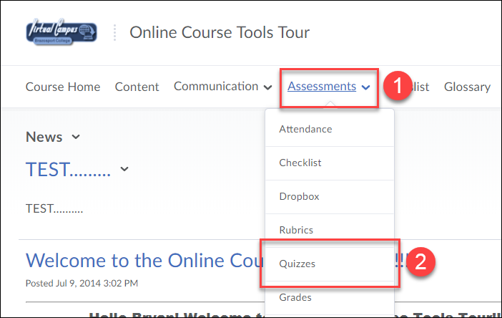

2. Click on an available quiz title in the Quiz List.

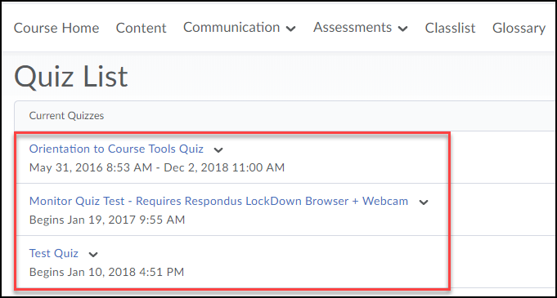
3. Information under the quiz title (on the left) indicates the availability date and Attempts (on the right) show how many times you can take the quiz.

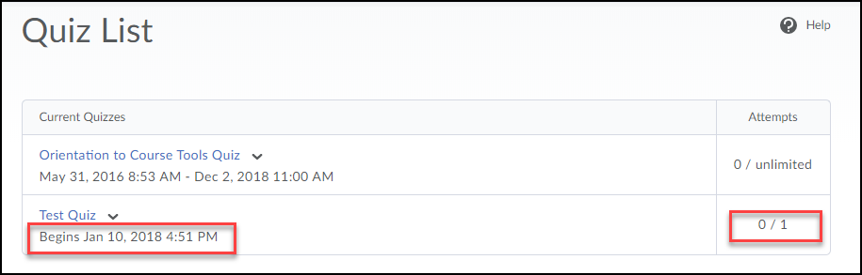

Starting a Quiz
1. Once you click on a quiz, carefully read quiz Description, Details and Instructions. Click Start Quiz button to begin quiz.

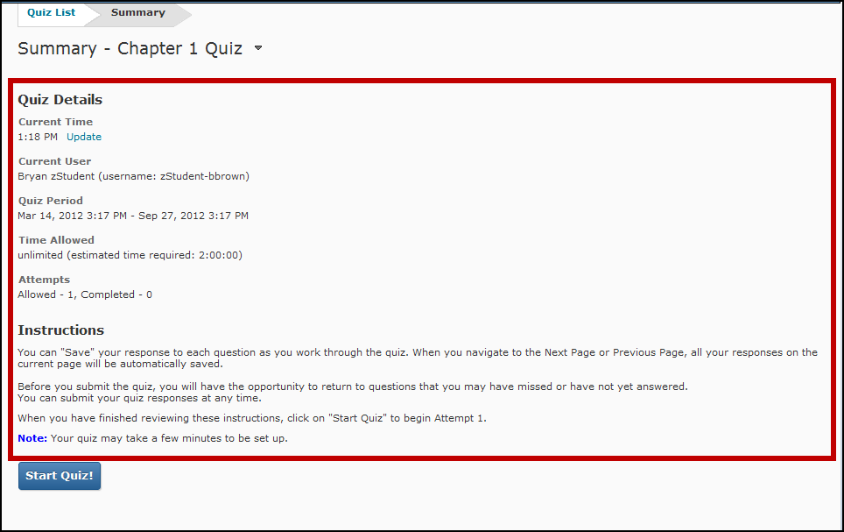

Depending on how the instructor set up the quiz, questions will be presented one at time and you have to click a Next button to move forward OR questions will be presented all at once.

2. Select the radio button(s) or checkboxes for the response(s) you believe to be the correct answer for each question. Some questions may have you enter a text response.

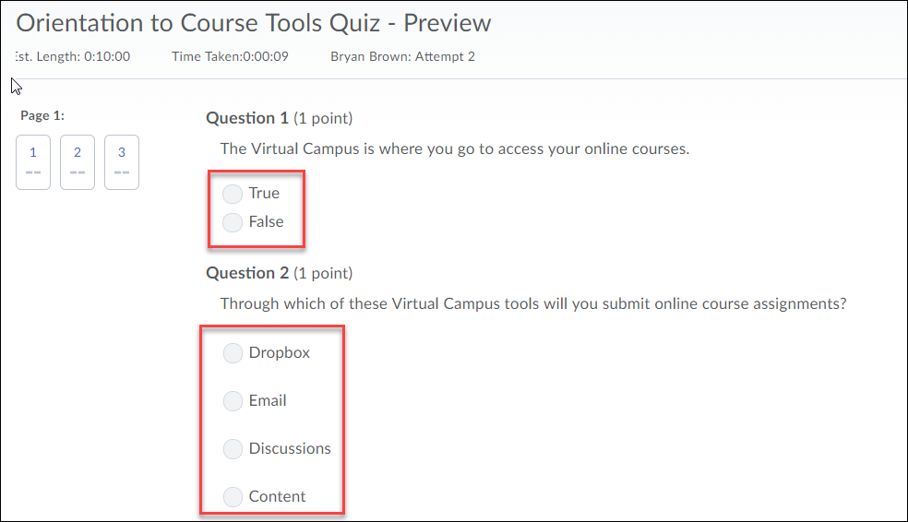

3. When you select a response for a question, your answer will automatically be saved as indicated by the checkmark under the question number in the Quiz Info area on the left.

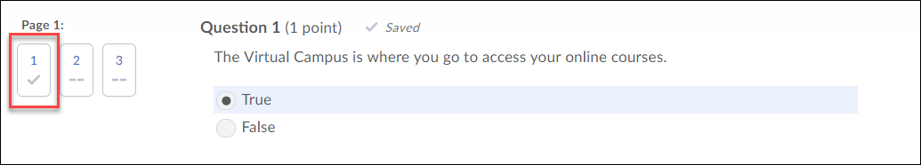

4. Once done answering all questions click on the Submit Quiz button.

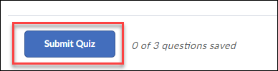

5. Confirm ALL questions have been saved and click the Submit Quiz button.

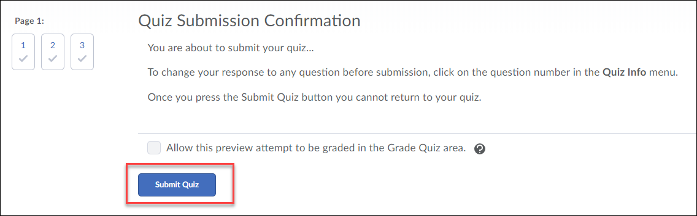

6. Depending on how the instructor set up the course, you can view the Score and Overall Feedback immediately on submission.

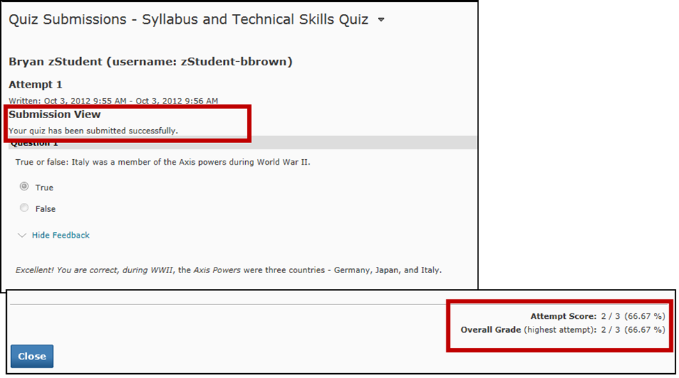

7. To view question specific feedback (if Feedback is provided), click on the View Feedback link under each question.
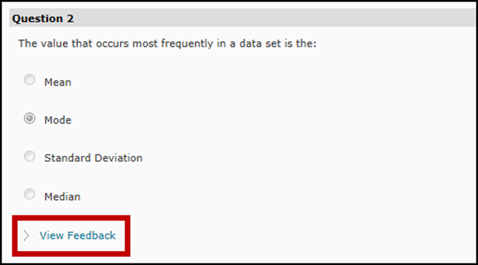

If the instructor specified feedback will be viewable at a later date, return to Submissions by going to Assessments in the course navbar and selecting Quizzes, then click on the down-ward facing triangle next to the quiz in the Quiz List and click on the Submissions icon.

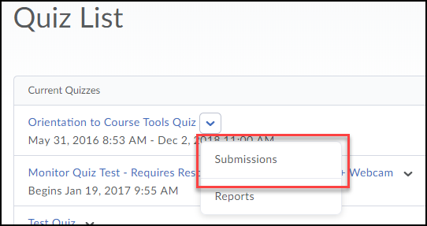

Respondus LockDown Browser

Some instructors require their quizzes to be taken using the Respondus LockDown Browser. The LockDown browser is an internet browser that increases security and decreases cheating while taking an online quiz in Desire2Learn. The LockDown Browser disables the ability to print, copy, go to another website, or access other applications. You will be locked into the quiz until you submit it for grading.

If your instructor requires you to take a quiz using the LockDown Browser you can either take it in one of the computer labs on campus, which have the LockDown Browser installed or you can download the browser onto your own personal computer.

Downloading Respondus LockDown Browser
NOTE: It is only necessary to download the browser once.

1. Enter the Quizzes section in D2L (using your regular internet browser).

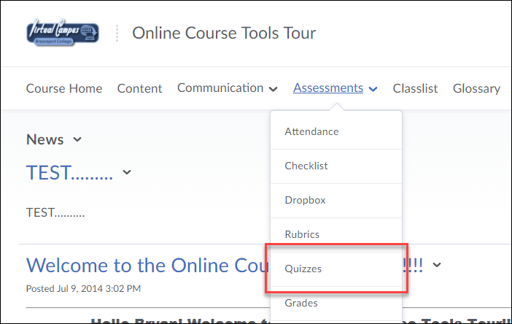

2. Click on the Quiz the instructor designated to be taken using the LockDown Browser.

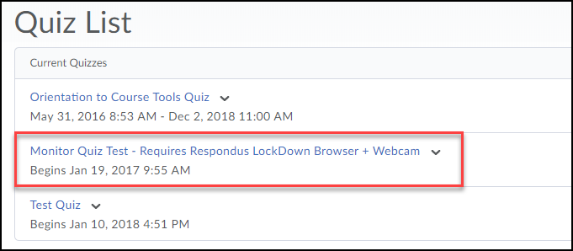
3. Click on the blue Download and install the latest version of LockDown Browser link.

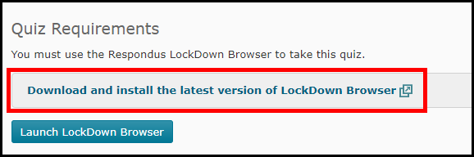

4. Click on the Install Now button.

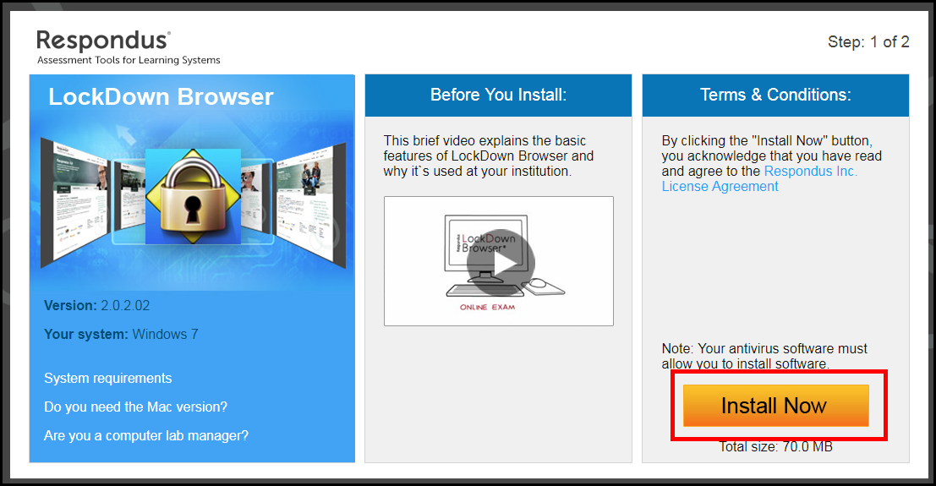

5. The browser will begin downloading on your computer as LockDownBrowser….exe.

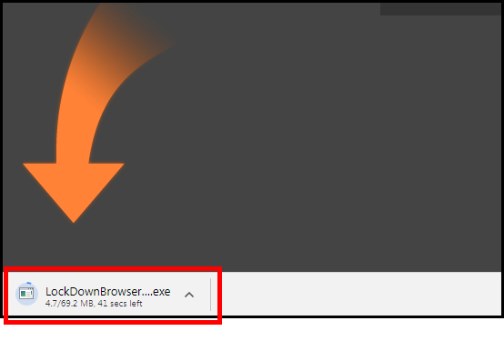
7. Once the browser is done downloading, click on it (1) and then click Open (2).

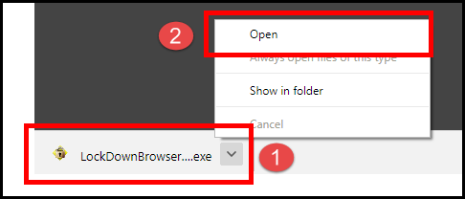

8. The file downloaded will have the name LockDownBrowser….exe. Locate and double-click the file to start the setup process and follow the onscreen instructions.

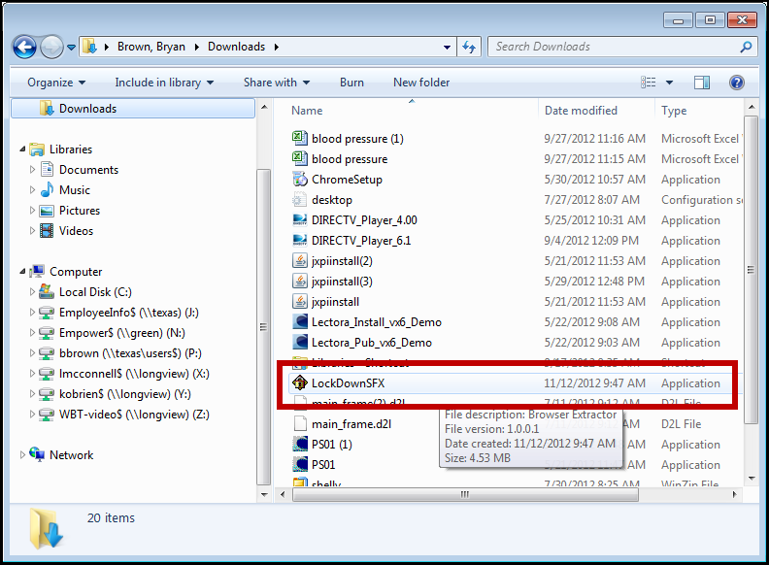
9. When successfully downloaded the LockDown Browser icon 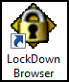 will appear on your desktop.

Taking a quiz in the Respondus LockDown Browser

1. First open the LockDown Browser, by double clicking on the 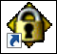 lock icon on your desktop.
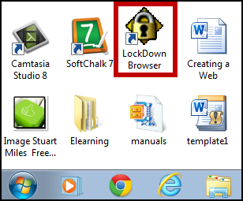

If you have any other applications or programs opened on your computer, the LockDown Browser will notify you about each individual program and ask if you would like for it to close it. If so click the Yes button.

The browser will take you directly to the Desire2Learn login page. Once you are logged in, you will be able to go to the quizzes section and take your quiz.

