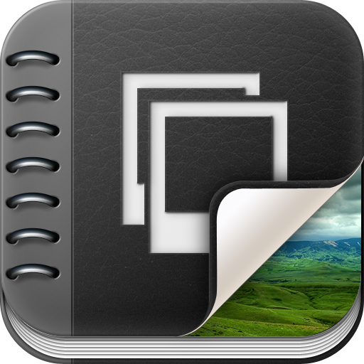

Your Instructor may include a PDF portfolio as a topic in the content section of your course. A PDF portfolio contains multiple files within it (typically pdfs files). To view a PDF Portfolio you will need to make sure to have a pdf reader installed on your computer.
A PDF portfolio can be identified in the content section of a course whenever you click on a topic and the following appears:
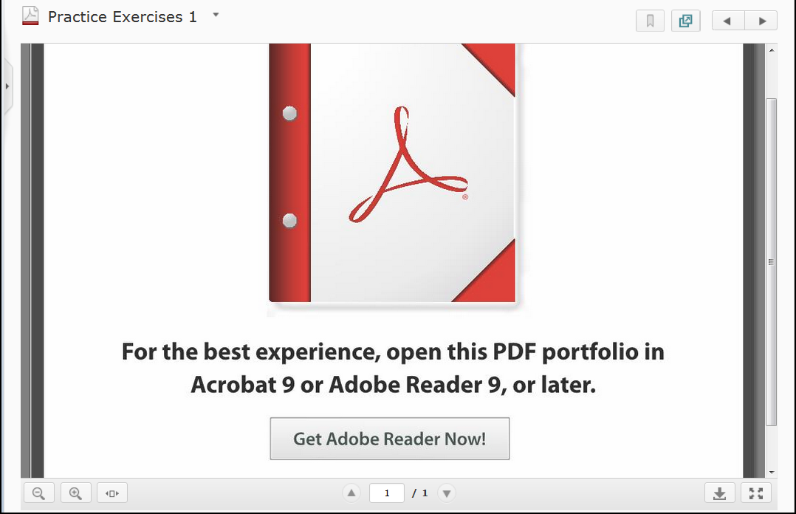
- To view the PDF Portfolio click the on the Download button .

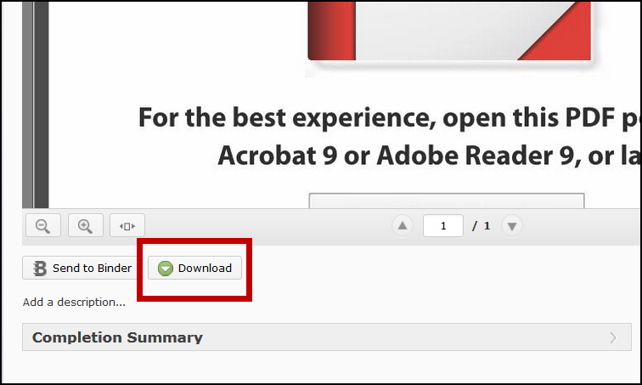
- From the prompt that appears select Open with (1) and then select OK (2).

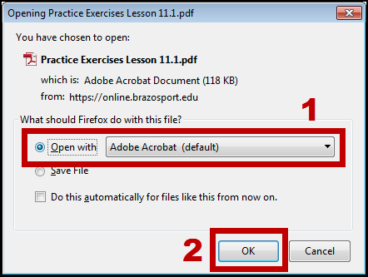
NOTE:
You will either need Adobe Acrobat Pro or a PDF reader to view the portfolio files on your computer.
- The PDF Portfolio will open and you will be able to access the files within it.

