Course-related material (syllabus, lecture notes, required reading, etc.) are typically located in the content area. The content area is comprised of various modules that actually contain related course materials, often referred to as topics.
- Click on Content from the navigation bar (navbar).

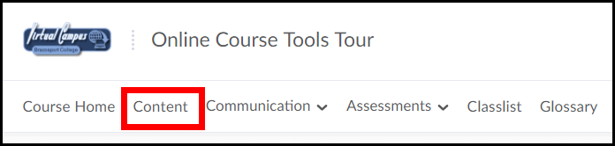

- To access course materials click on a module from the Table of Contents sections (located on the left-side of the page) (1) and then click on the course material topic you would like to access (2).

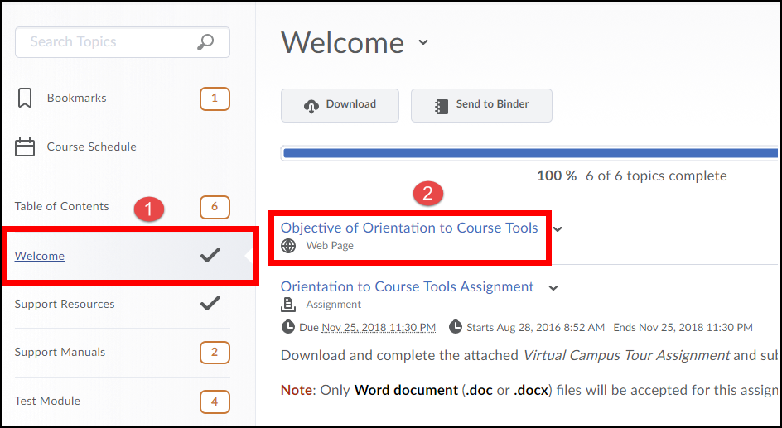

- The topic will open similar to the one shown below.

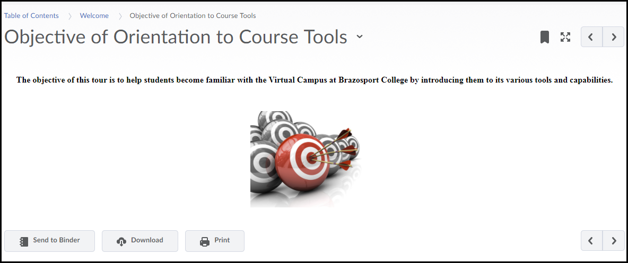

- Once the topic is open, use the Content navigation menu to move back/forward through topics (1), create bookmarks (2), and print if available. Use the drop-down menu next to the topic’s name to leave feedback on the topic, or to download it (3).

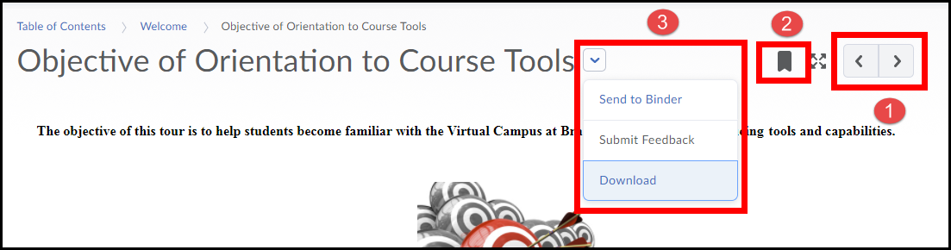

- Use the Side Panel (when viewing a topic) to jump quickly to another topic. Use the previous or next arrows to navigate between modules.

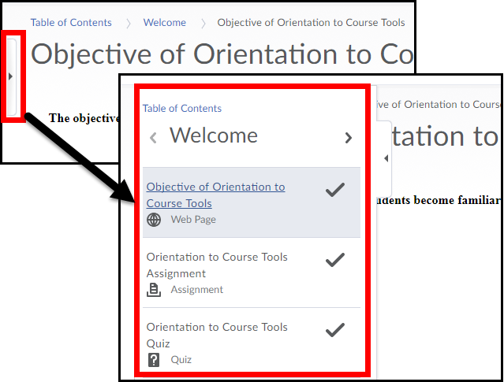

- If you need to print a topic click on the Print button located near the bottom of the page.

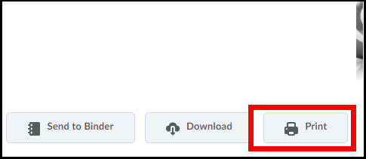

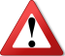 To print a content topic that is a Word Documents, PowerPoint, or Excel Spreadsheet it is reccomended that you download it to your computer, by clicking the Download button. Once you have downloaded it, open it and print it from within the program it opens in. This will ensure that the content will be viewable in the correct format as intended by your instructor.

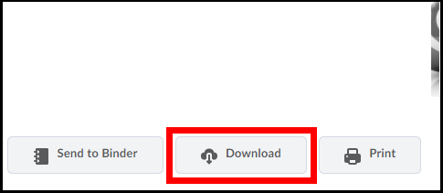

Progress Tracking
If applicable, D2L will keep track of the number of topics you have viewed in the content section of the course.
The progress bar shows your completion rate towards viewing all topics within a module.
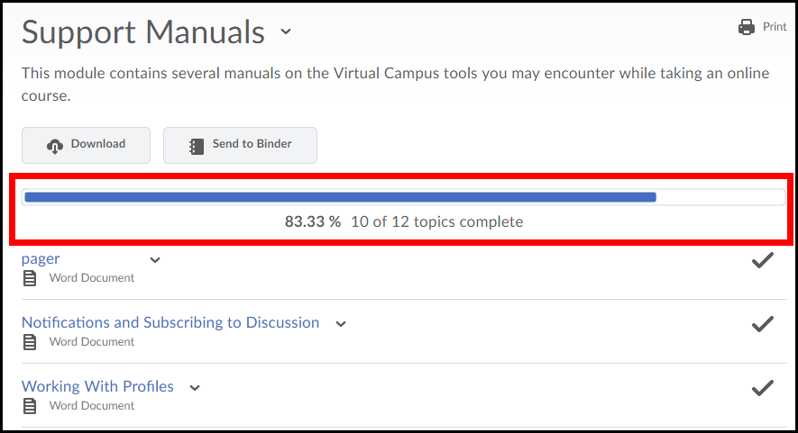

There are two types of tracking:
Automatic Tracking
If your instructor chooses to use automatic tracking any topic you view will be automatically marked as completed after you view it.

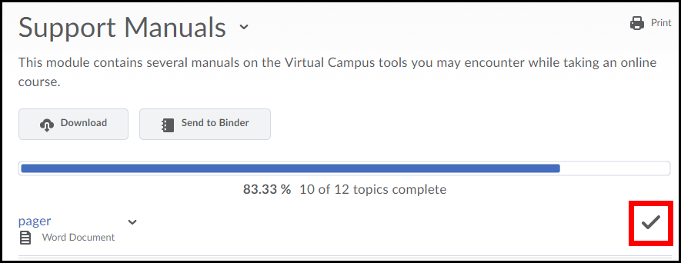

Any topic you have not visited will be marked as incomplete (in till you view it).

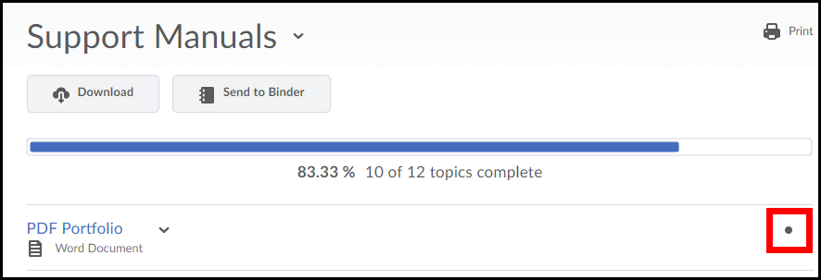

Manual Tracking
If your instructor chooses to use manual tracking you will need to manually check completed for any topic you view and/or complete. To do so click the completion box next to content topic to mark it as completed .

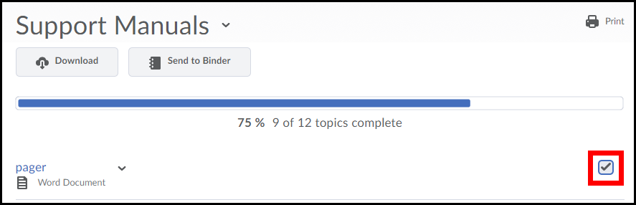

List all the topics you have bookmarked.
List the due dates, start dates, and end dates for course material and events for the next 7 days.
- Indicates a topic has been viewed.
Indicates a topic has not been viewed yet.

Displays the name of the module.

Allows you to download the content of a module or topic directly to your computer.
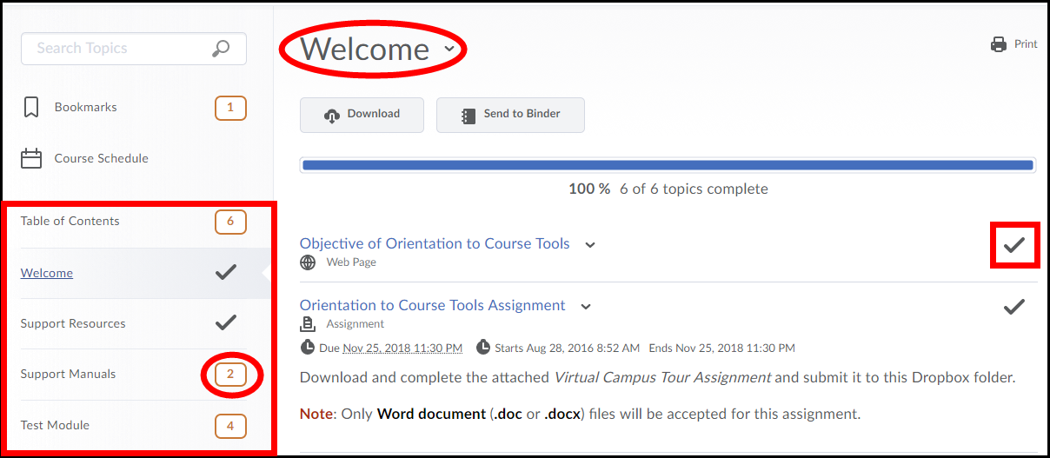
Displays the progress completed for a module (based on the number of topics you have visited).
Click on a topic to open it.
Shows the number of topics in a module.

Allows you to browse modules and access their topics.

