Zoom
Zoom is a tool that allows you to access virtual meetings with your instructors.

Note: Students do not need to sign up for a Zoom account to be able to attend meetings in D2L.
Attending a Scheduled Meeting
1. Click on Communication from the navigation bar (1) and click on Zoom Meeting (2).
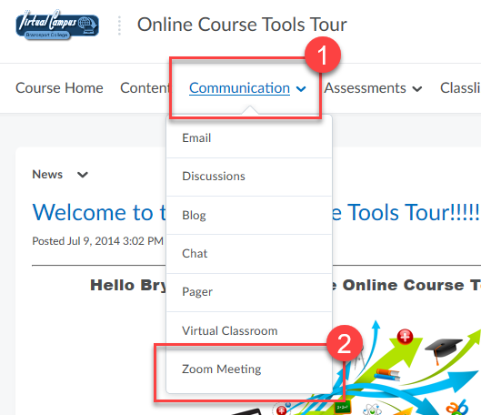

2. Click Join.
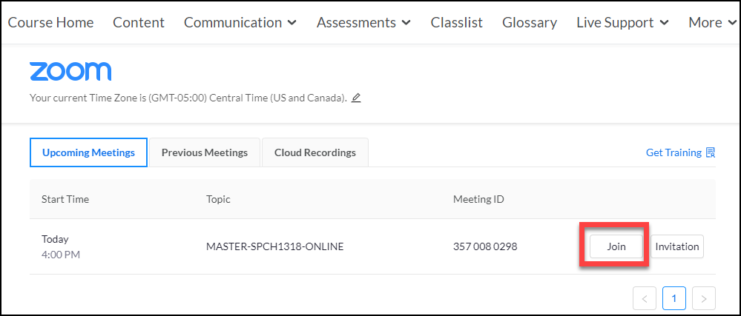
3. Another option to join would be thru a link provided by your instructor either thru email, Content, or on the home page of the course in the News section. Just click the link and you will be directed to either open Zoom or download Zoom.
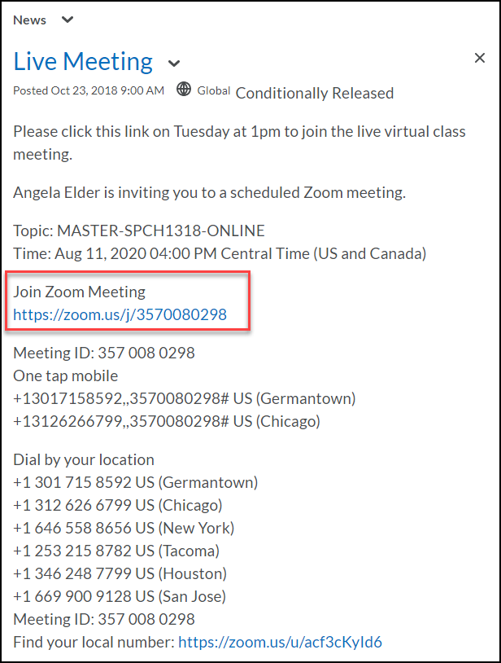
4. Depending on the device you are using and if you have already installed Zoom or not, you may get this prompt. Just follow the directions.
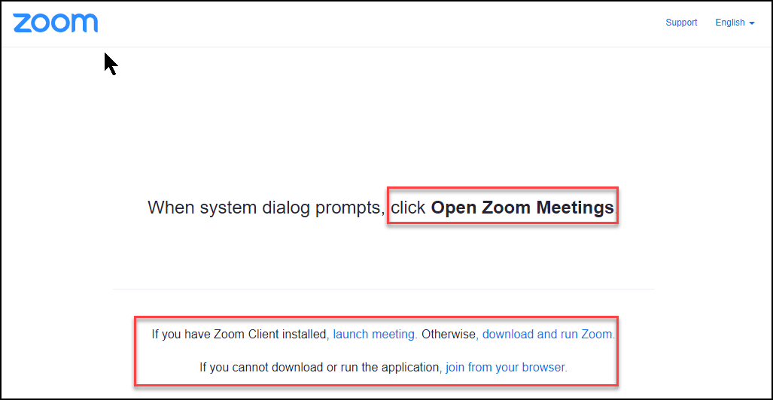
5. If the meeting has not started yet you may see the waiting room screen.
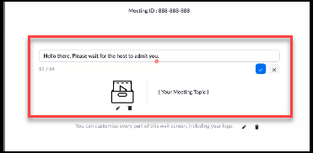
6. You may also see the message waiting for the host to start this meeting. This means the instructor has not started the meeting yet, but you will automatically be in once they do. While you wait you can test your audio by clicking Test Computer Audio.
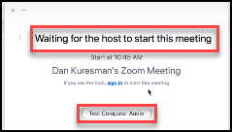
7. Once the meeting starts, the first screen you see is the live meeting window. Your controls are at the bottom.
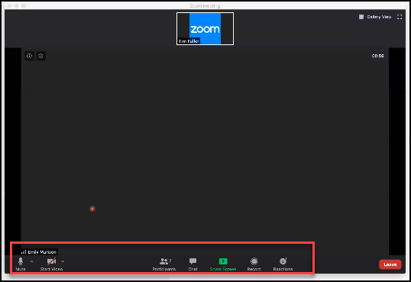
8. Depending on what your instructor allows you to do in the meeting, you may have these options available to you.
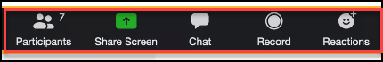
To View a Recorded Zoom Meeting
1. Click on Communication from the navigation bar (1) and click on Zoom Meeting (2).
2. Click on the tab for Cloud Recordings.
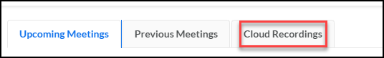
3. Click the meeting title.
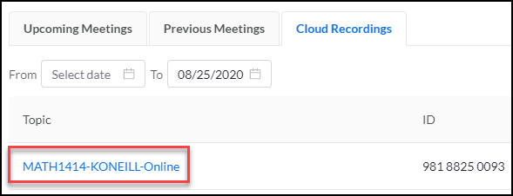
4. Click the meeting you want to watch.
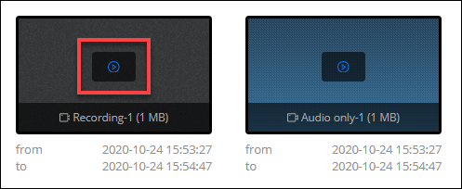
5. The browser auto copies the passcode when you click to play the recording. The message Copy Passcode to Clipboard will pop up.
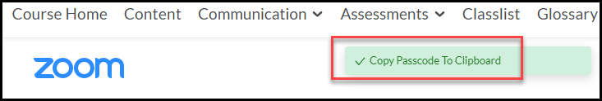
6. Put the cursor in the empty password field. Using the keyboard press, CTRL + v (for PC’s) or Cmd + v (for MAC) to paste the code into the field.
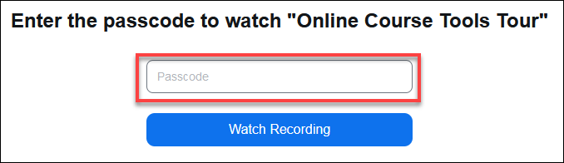
7. Click the Watch Recording button.
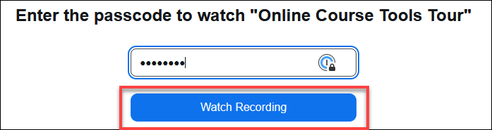
8. The video will populate. Press the Play button.
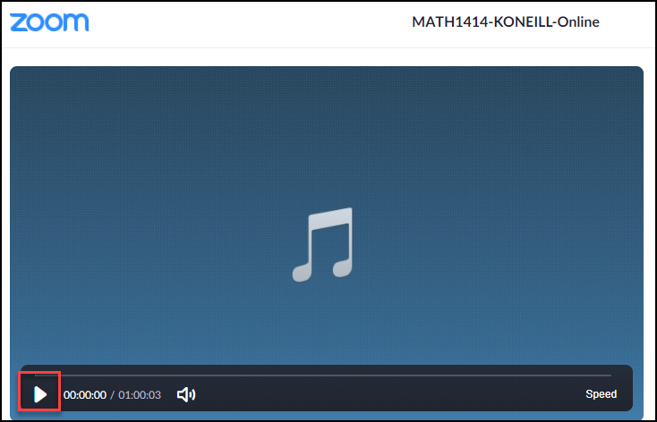
Resources:
Quick video on how to join a meeting, as well as links to specific operating systems for Android, IOS, Computers, etc.
https://support.zoom.us/hc/en-us/articles/201362193-How-Do-I-Join-A-Meeting-
Test your internet connection by joining a test meeting.
https://zoom.us/test

