The Pager is a great tool that allows you to get in touch with anyone else who uses D2L. The Pager works almost like an instant messenger where you can send another user a page and they can respond back to you using the Pager tool.
Using the Pager Tool
- Login to D2L (https://online.brazosport.edu).

- Click the Message alerts icon above the navbar on right-hand side of the page (1) and then select Pager (2).
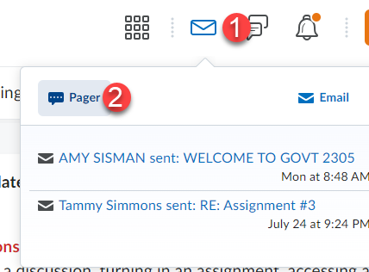

- Click on the Classlist tab.
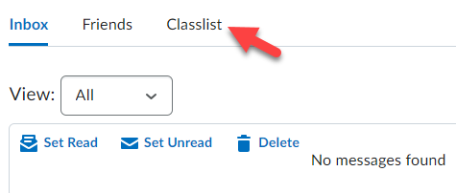

- Select the User(s) you want to send a message to (1) and click on the Message icon (2).
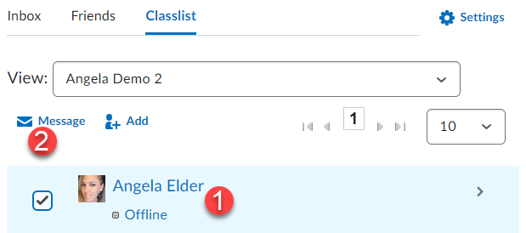

- Enter in your message (1) and click the Send button (2).
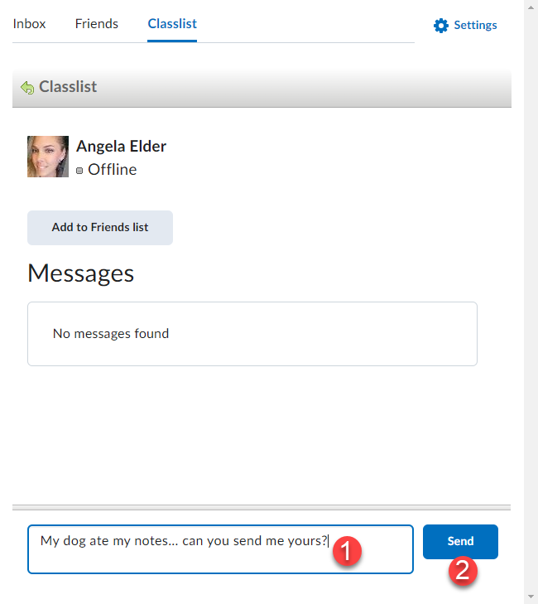

- All pager messages between you and selected user(s) will be displayed here.
