The Discussions tool is a collaboration area where you post, read, and reply to messages on different topics, share thoughts, ask questions or work with others on assignments.
Working with Discussions
Reading Messages
- Click on Communication on the navbar and select Discussions.
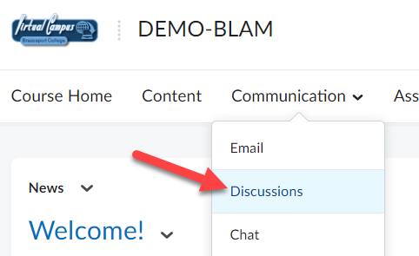

- To enter a discussion topic, click on the Topic’s title.
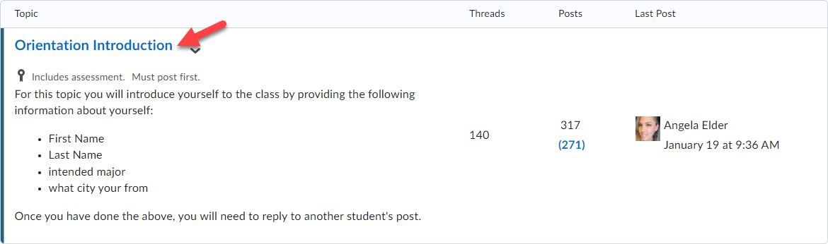

- Use the Discussion navmenu, at the top of the first posted discussion thread, to filter and sort the way the discussion threads are viewed for the discussion topic.
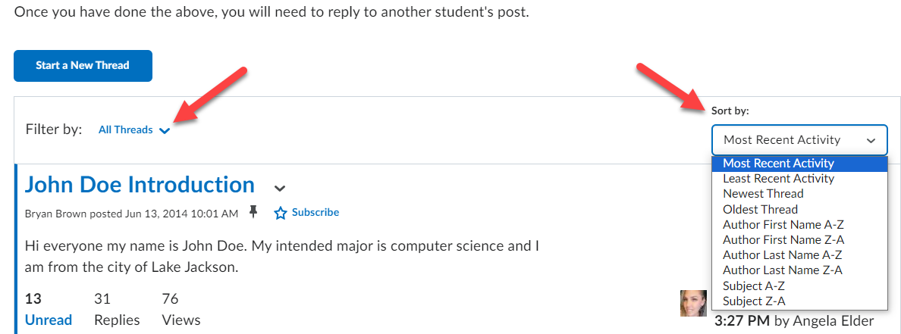

- Discussion threads are listed in a long scrolling page or a Reading Style. You will need to scroll down the page to see all the threads that have been posted to it. To view the replies contained within a discussion thread click on its title.
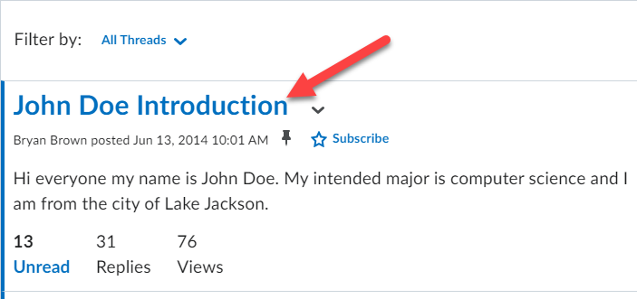

- All the replies made to that discussion thread will be displayed.
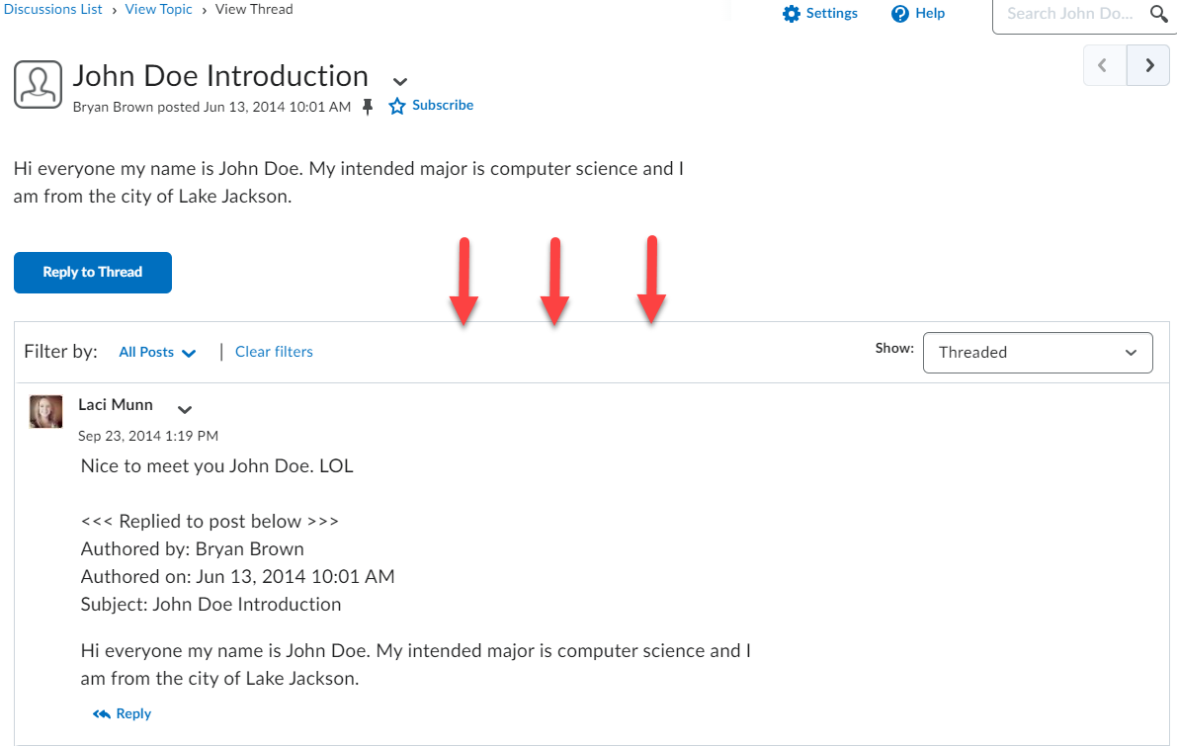

Composing a Discussion Thread
You must be inside a discussion topic to compose a message.
- To post a discussion thread, click on the Start a New Thread button below the discussion topic’s instructions.
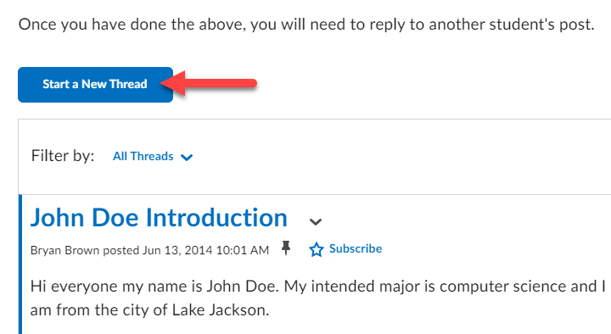

- Enter a Subject or title for your message. It is best to use short, specific titles that indicate what the message is about.
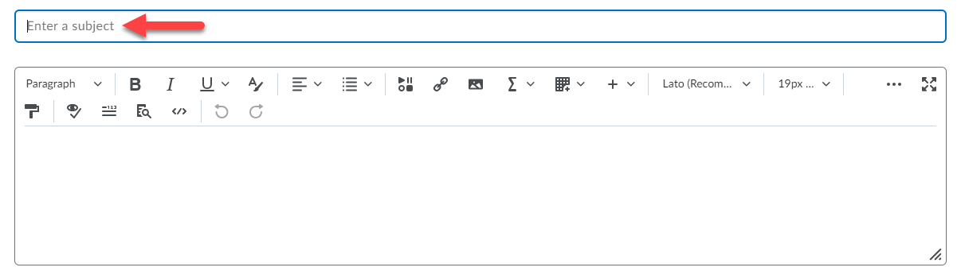

- Type your message in the message text block. Use the formatting menu at the top to personalize your message (bold, italicize, bullet, insert images). Click the three dots to expand the menu.

- Attach a file by clicking the Add attachments link (1) and then click the Upload button (2).
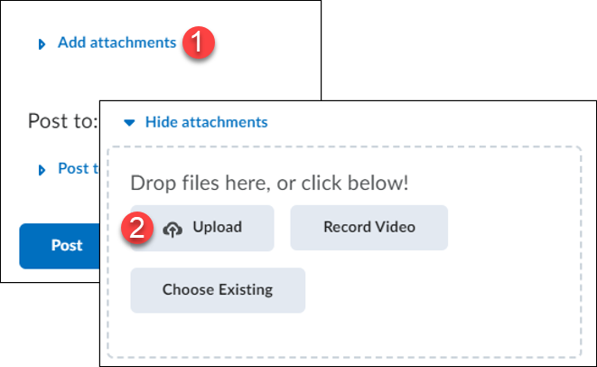

- Locate the file where it is saved on your computer, click on it once to select it (1) and click the Open button (2).
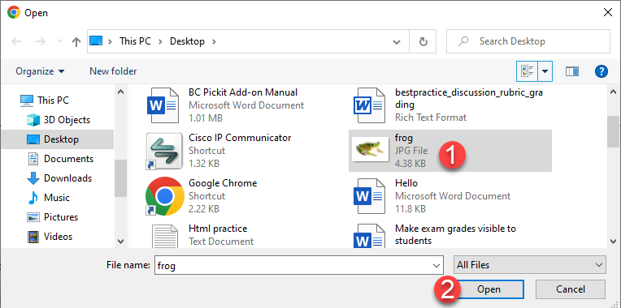

- To delete an attached file, click the grey X icon next to the attachment. Click Post to add your message to the Discussion board.
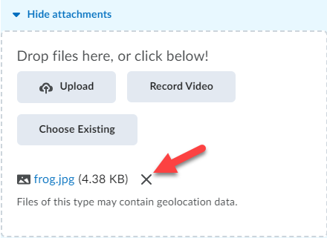

Reply to a Discussion Thread
- To reply to a message, click on the discussion thread’s title.
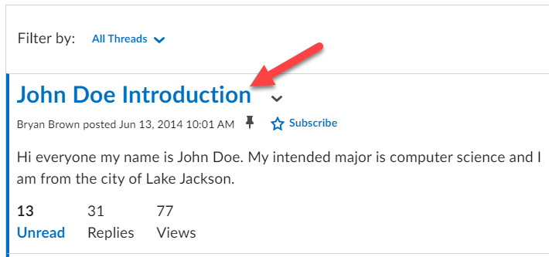

- Click the Reply button (1); compose your reply message (2) and then post it (3).
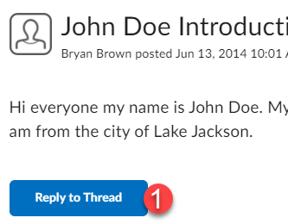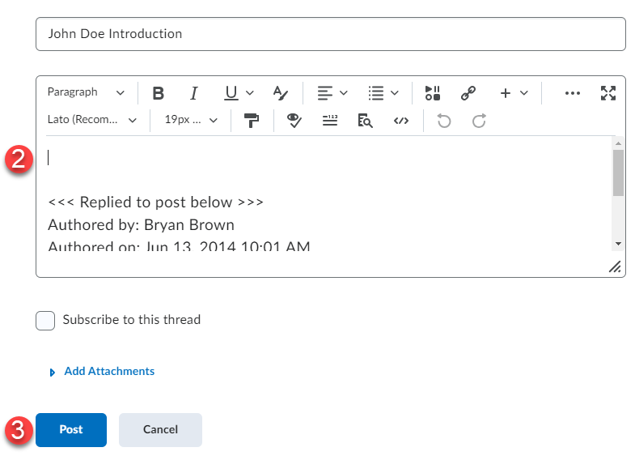

Edit your posted thread/message (if allowed by instructor)
- Click the drop-down menu next to the title of your message.
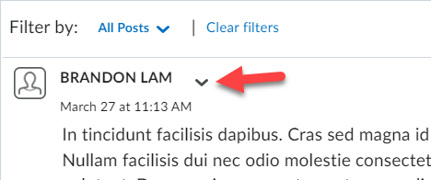

- From the menu, click the dropdown and choose Edit Post, make desired changes and click Update.
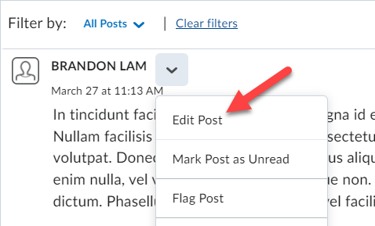

Viewing Graded Feedback from the Discussion Tool
Overall feedback, detailed rubric feedback, and your score on a discussion posting can be viewed from the discussions tool. This same information will be displayed when you click on a link to a discussion topic from the Content tool if you have a grade for it.

- Click on the discussion topic in which you have posted a response to.
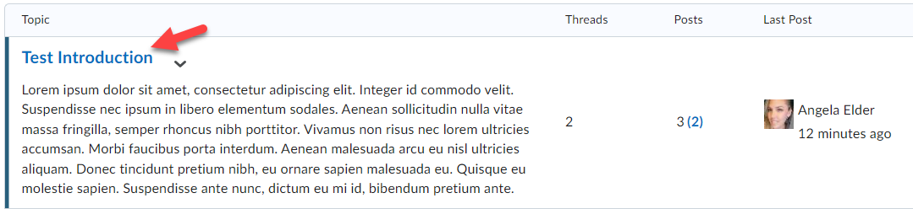

- If your instructor has graded your posting(s) for the discussion topic your grade, any feedback, and a link to the graded rubric (if used by your instructor) will be displayed.
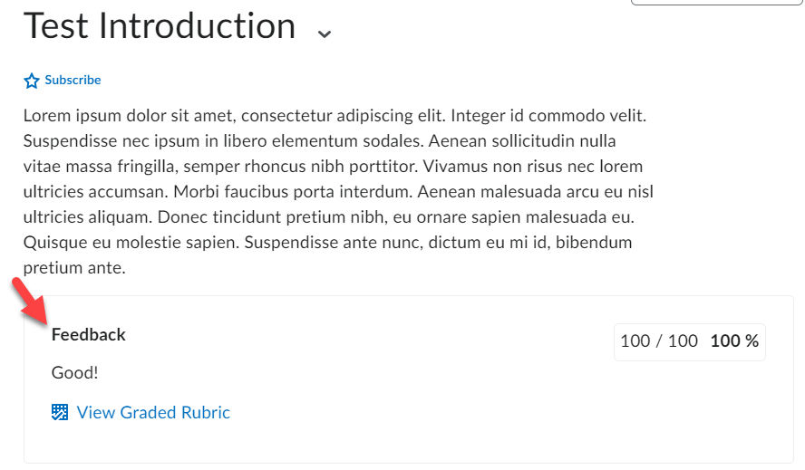

- You can view your graded rubric feedback for a discussion via your gradebook by clicking the View Graded Rubric link for it (if your instructor used a rubric to grade your discussion).
