The Dropbox tool allows you to submit assignments by uploading them to the appropriate Dropbox folder.
Submitting Assignments using the Dropbox

Accessing a Dropbox Folder
- Click Assessments (1) on the course navbar and select Dropbox (2) from the dropdown menu.
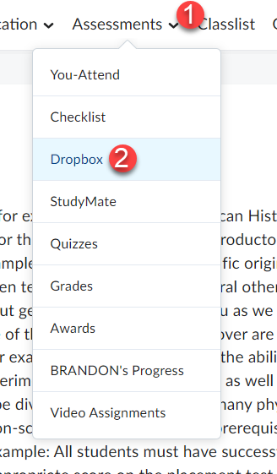

- To access a folder, click on the Dropbox title in the Folder List (on the left). When a Dropbox is available for submissions, they become text links. Note the Due Date column (under the name of the folder) which indicates the last day you can submit an assignment to a folder.
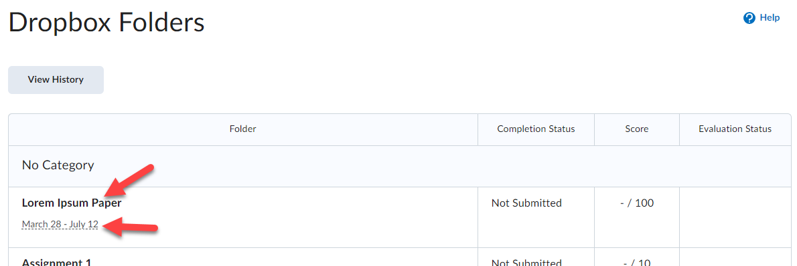

Upload an assignment file
Your assignment must already be completed and saved as a file somewhere on your computer.
- Enter a Dropbox folder and click on the Add a File button.
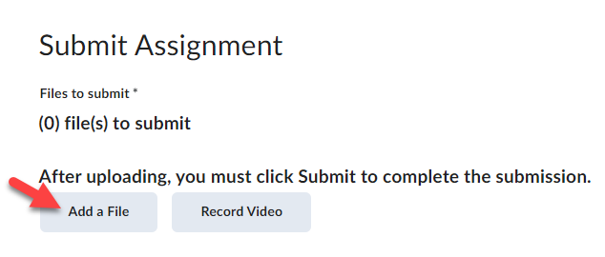

- Click on My Computer (1) and then click the Upload button (2).
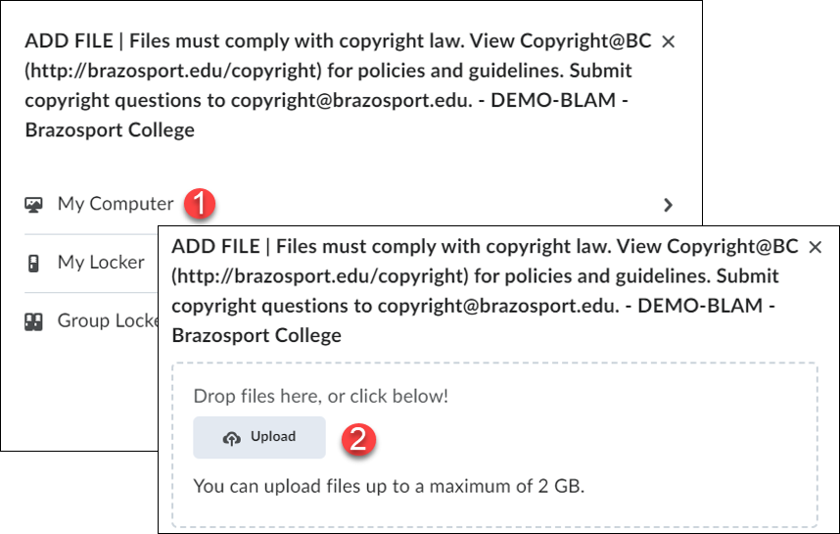

- Locate your saved file (1), click on it once to select it, and then click the Open button (2).
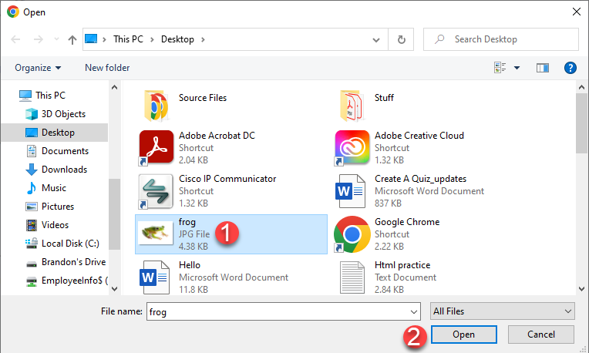

- Click the Add button.
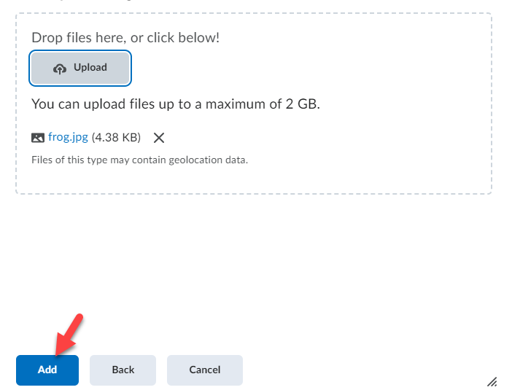

- Add additional comments about the assignment in the Comments text block (1) and click the Submit button (2). To remove an attached file, click on the X icon next to the file name.
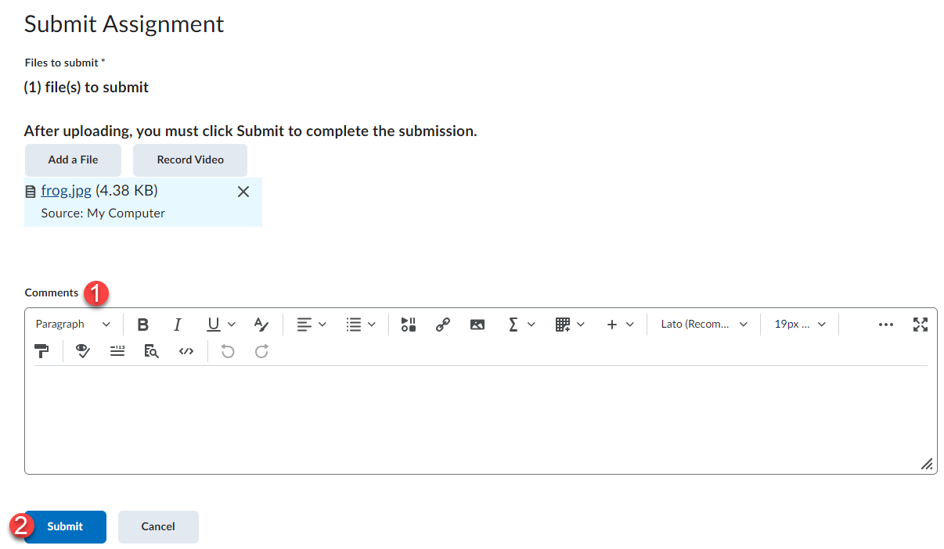

- Upon submission, a confirmation email will be sent to your Desire2Learn Email. You can also click on the View History button to further confirm that your assignment has been submitted.
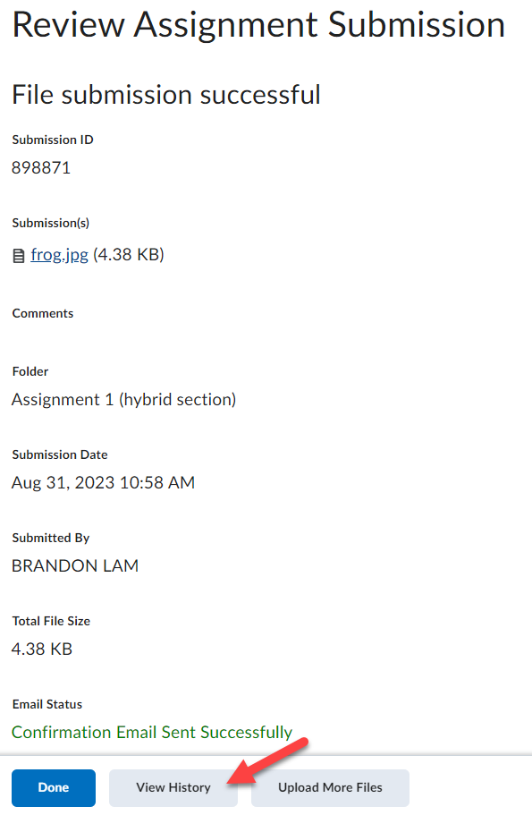

Viewing Score and Feedback
Once the instructor has graded your assignment, return to the Dropbox area by clicking on Assessments from the course navbar and selecting Dropbox from the menu.
- To view your grade for the assignment, look in the Score column. To read you instructor’s feedback or view your graded rubric feedback (if available) click on the View Feedback link in the Evaluation Status column.
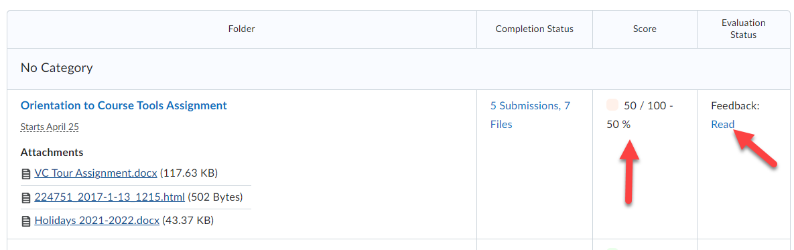

- You can view your graded rubric feedback for a dropbox assignment via your gradebook by clicking the View Graded Rubric link for it (only if your instructor used a rubric to grade your dropbox assignment).
