The quizzes tool is where you will go to access and take quizzes and/or exams for your online course.
Taking a Quiz
CHROMEBOOK USERS: If the instructor is using LockDown Browser pop-ups MUST be allowed or enabled in Chrome otherwise you may get stuck on the "Start Quiz" page (how to enable pop-ups in Chrome).
IPAD USERS: if the instructor set the option for ipads to be used when taking a quiz/exam view skip to page 10.
Accessing a Quiz
- Click Assessments (1) and click on Quizzes in the navbar (2).
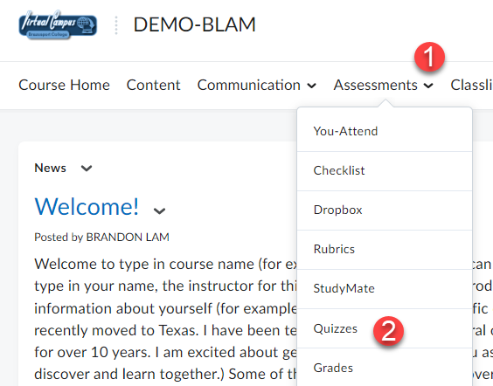

- Click on an available quiz title in the Quiz List.
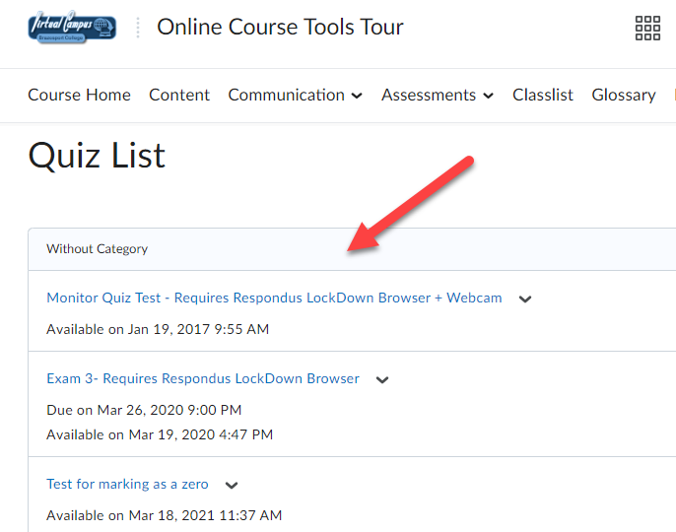

- Information under the quiz title (on the left) indicates the availability date and Attempts (on
the right) show how many times you can take the quiz.

Starting a Quiz
- Once you click on a quiz, carefully read quiz Description, Details and Instructions. Click Start
Quiz button to begin quiz.
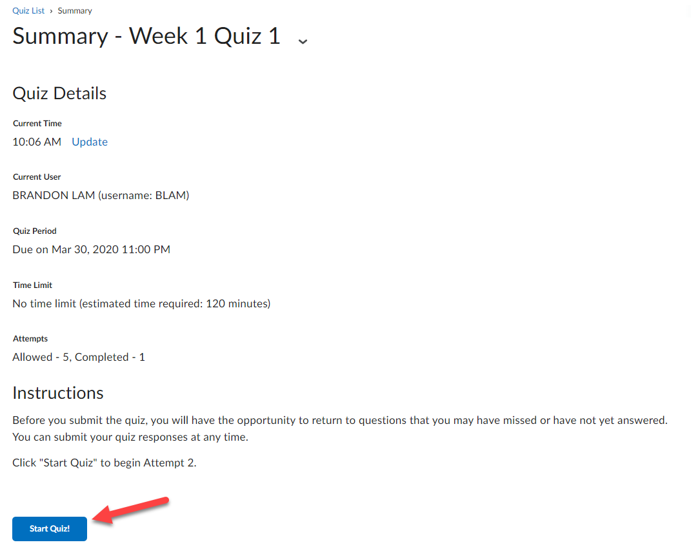
Depending on how the instructor set up the quiz, questions will be presented one at time and you must click the Next button to move forward OR questions will be presented all at once.

- Select the radio button(s) or checkboxes for the response(s) you believe to be the correct
answer for each question. Some questions may have you enter a text response.
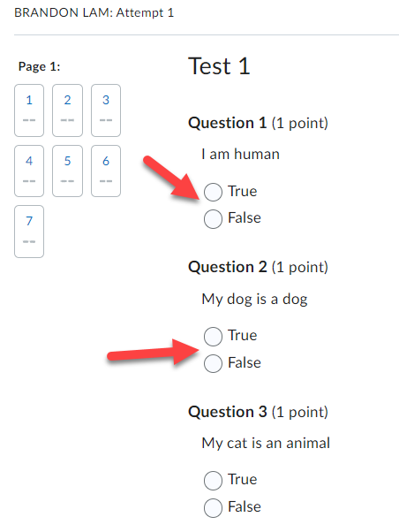

- When you select a response for a question, your answer will automatically be saved as indicated by the checkmark under the question number in the Quiz Info area on the left and next to the question number to the right.
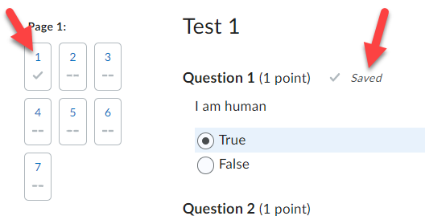

- Once done answering all questions click on the Submit Quiz button.

- Confirm ALL questions have been saved and click the Submit Quiz button.
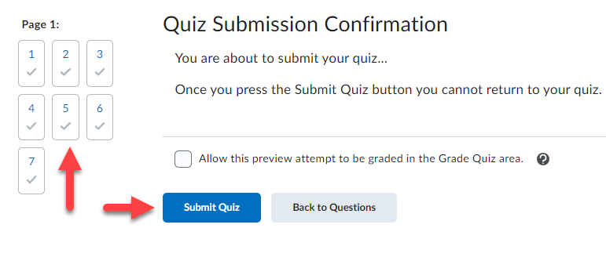

- Depending on how the instructor set up the course, you can view the Score and Overall Feedback immediately on submission.
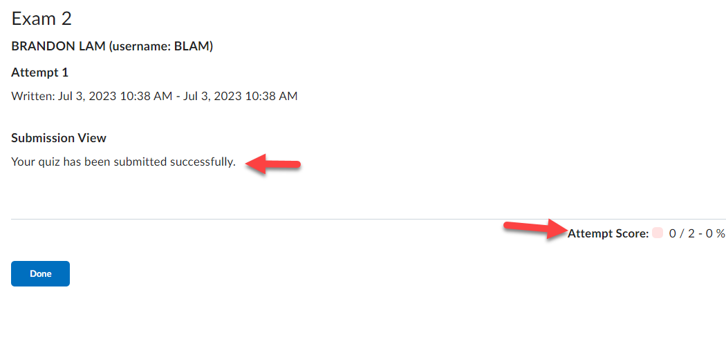

- To view question specific feedback (if Feedback is provided), click on the View Feedback link under each question.
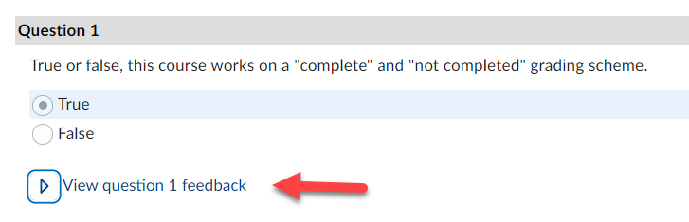

If the instructor specified feedback will be viewable later, return to Submissions by going to Assessments in the course navbar and selecting Quizzes, then click on the down-ward facing triangle next to the quiz in the Quiz List and click on the Submissions icon.
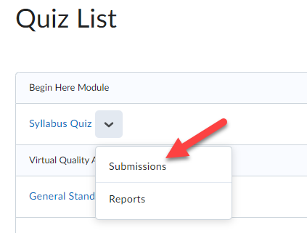

Respondus LockDown Browser
Some instructors require quizzes to be taken using the Respondus LockDown Browser and/or Monitor. The LockDown Browser disables the ability to print, copy, go to another website, or access other applications. You will be locked into the quiz until you submit it for grading.

To start a quiz that has LockDown Browser enabled:
- Enter the Quizzes section in D2L (using your regular internet browser).
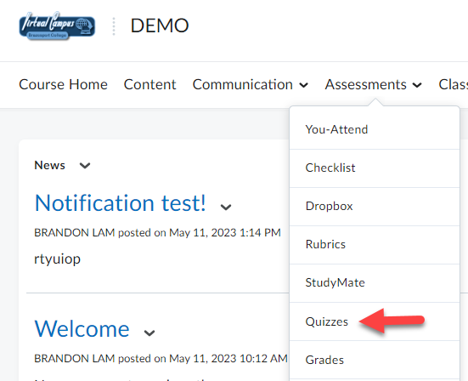

- Click on the Quiz.
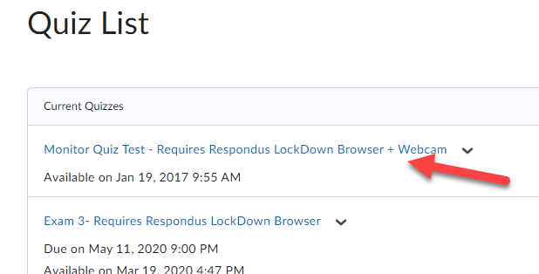

- Click on the blue Download and install the latest version of LockDown Browser link.
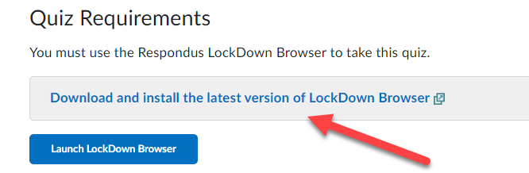

- Click on the Install Now button.
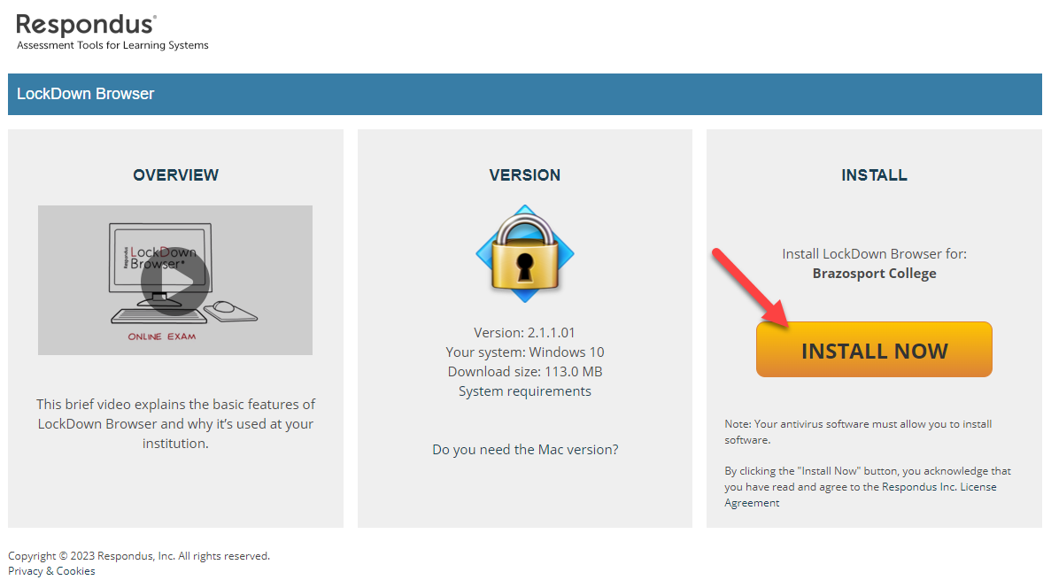

- The browser will begin downloading on your computer as LockDownBrowser….exe.
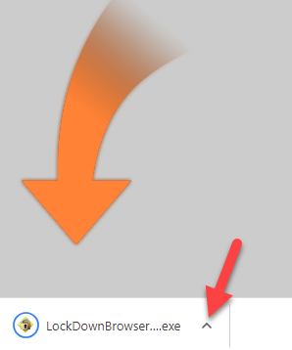

- Once the browser is done downloading, click on it (1) and then click Open (2).
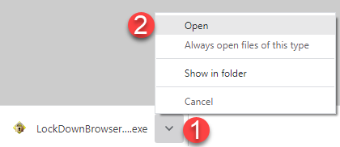

- When successfully downloaded the LockDown Browser icon will appear on your desktop.
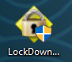

- You can now return to the quiz and click on the “Launch Lockdown Browser” button and start the quiz.
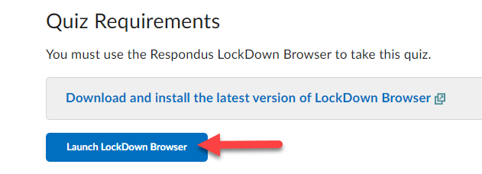
NOTE: If you will be using an iPad to take a quiz that requires Lockdown Browser and Monitor, please make sure to follow these recommendations:

iPad LockDown Browser Guide
- Download and install the "LockDown Browser" app from the Apple App Store to the iPad. (Requires iOS 11 or higher.)
- Open your mobile browser (Safari, Chrome, etc.), log into your learning system, and navigate to the quiz. Start the quiz; the LockDown Browser app will automatically launch.
- When you start a quiz that requires LockDown Browser, you should see the following message. You must click "Yes" to open the LockDown Browser app.
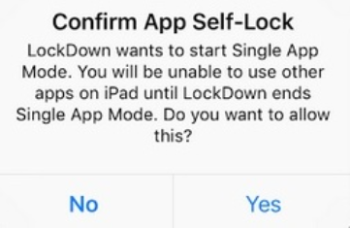

- Once you click "Yes" to confirm "app self-lock,", you will see a message confirming that your iPad is now locked to LockDown Browser.

- After you submit the exam, you'll see confirmation that your iPad is no longer locked to LockDown Browser.

- You can now either take another exam, or exit the LockDown Browser app.
NOTE: It's important that you don't start Apple's Guided Access feature (by triple clicking the home button) and then enter LockDown Browser. If you do, you'll see this warning message at the top of LockDown Browser.

You should immediately triple click the home button and exit Guided Access before proceeding with your exam. If you do not, you'll see this error message when trying to start your exam:
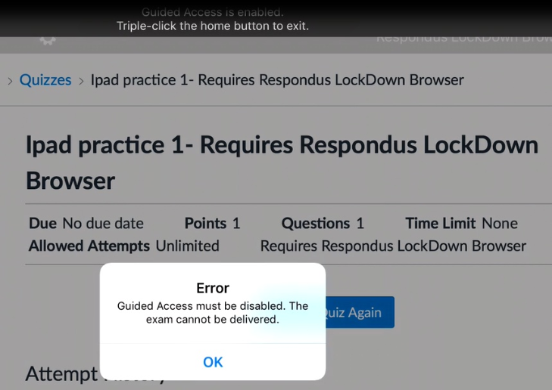
You can permanently disable Guided Access on your iPad by going to "settings">"general">"accessibility">"guided access".

To view Scoring Details on a Submitted Quiz
This capability is only available if instructor enabled quiz to be reviewed in this manner.
- Click on Assessments and select your “Progress”.
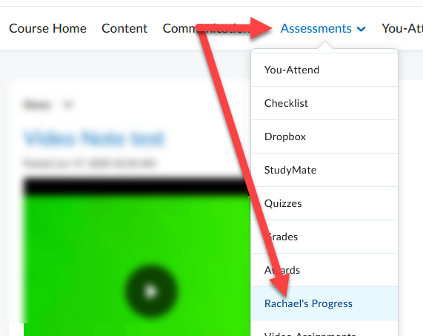

- Use Table of Contents on left of page and click Quizzes, under a specific quiz on the right, click Details.
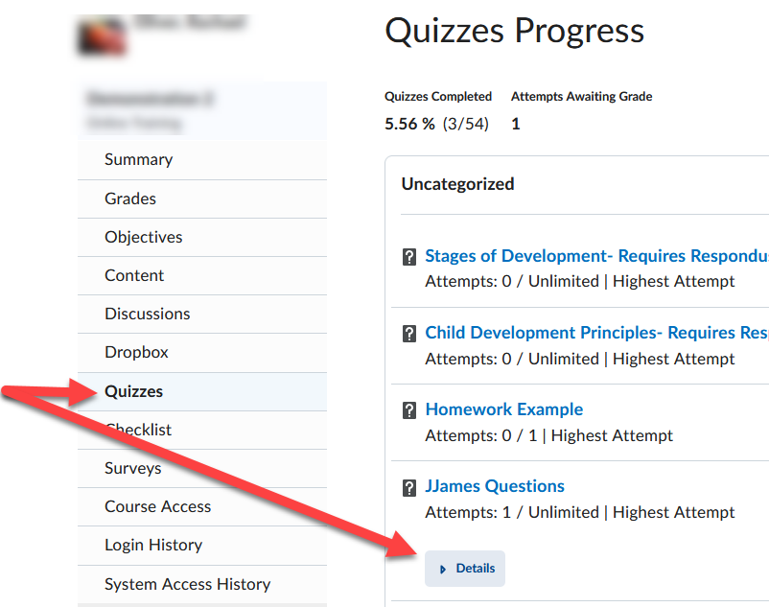

- Under Details select “Attempt 1” to reenter submitted quiz and view specific results.
