Virtual Classroom

The Virtual Classroom tool allows you to access and participate in any online class meetings or sessions scheduled by your instructor.
- Click on Communication (1) and select Virtual Classroom (2) from the drop-down menu.
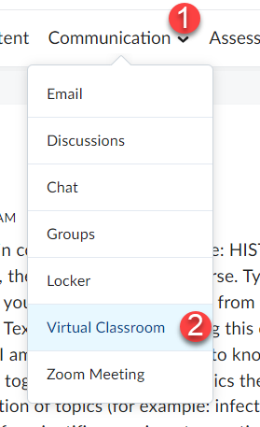

- If you receive the message below, click on the Continue button, if not continue to the next step.
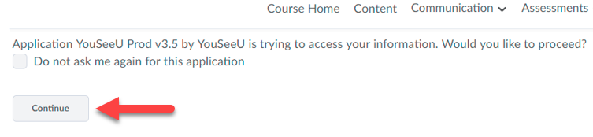

- You will see a list of scheduled meetings. Click on Launch for the specific meeting you wish to enter.
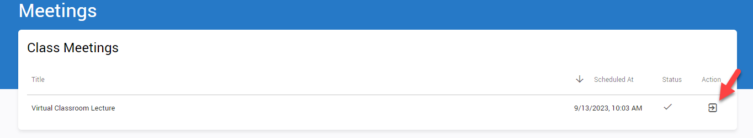

- Click JOIN to enter the meeting.
NOTE: You will not be allowed to enter the room in till the exact time it is scheduled to start and only when your instructor has joined the meeting.
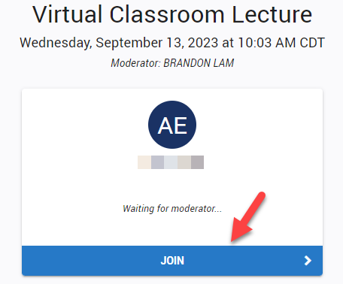

- Choose how you would like to participate in the room, with Audio (listen and speak) or Listen only.
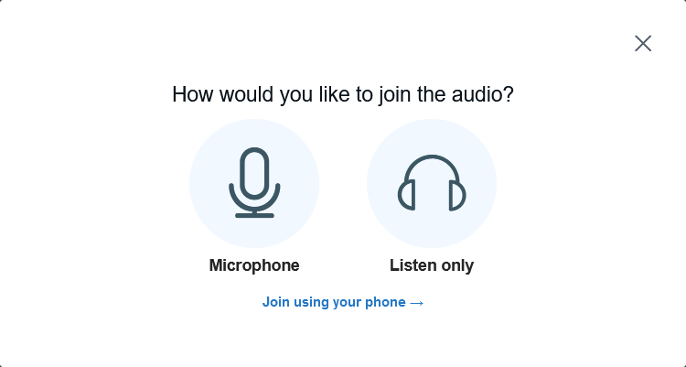
- If joining the meeting using audio, allow your microphone to be shared during it.
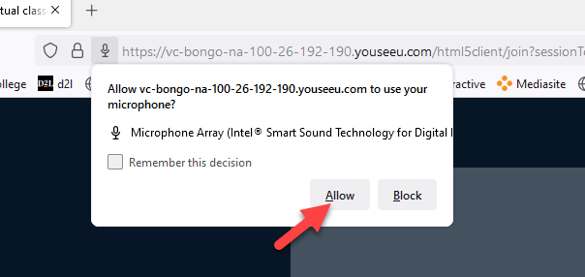

- You will now be inside the virtual Classroom where the scheduled meeting will take place.
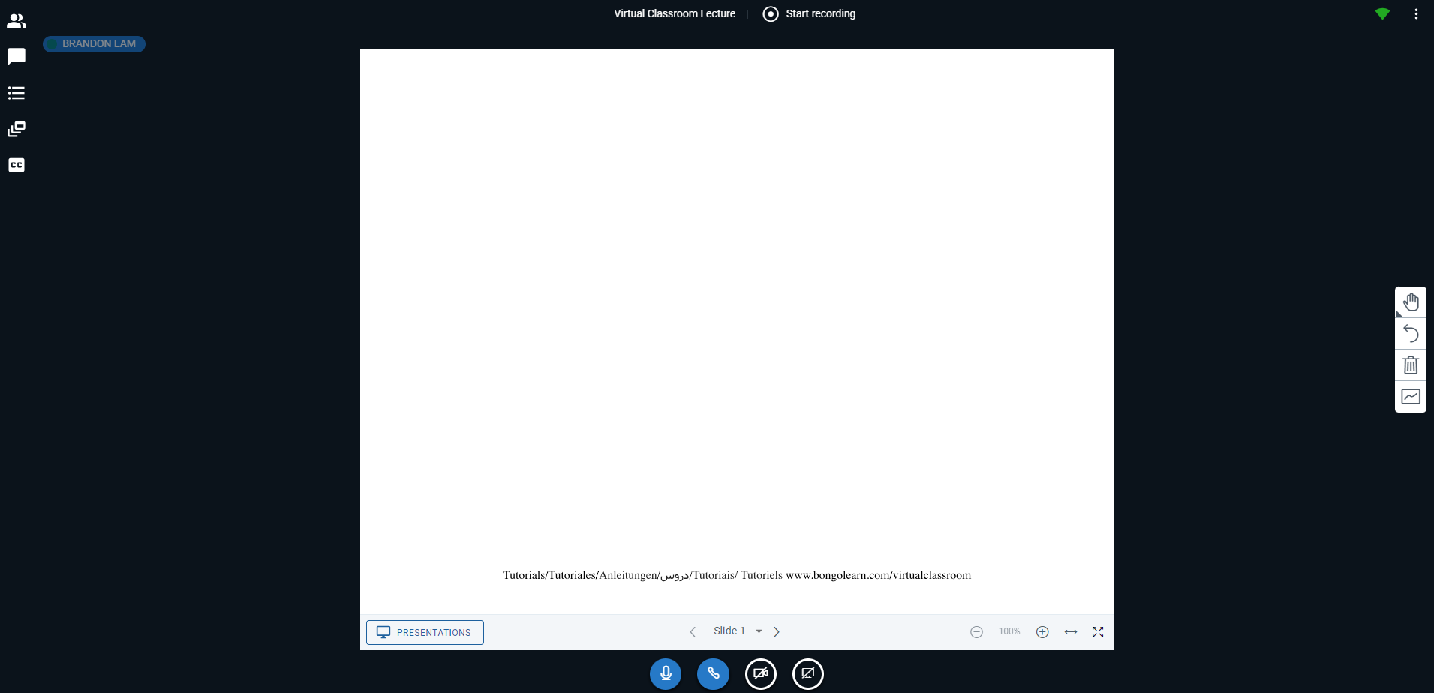

Working Inside the Virtual Classroom
User List:
Displays the names of everyone currently in the virtual classroom. Clicking on a user’s name will allow you to start a private chat with them.
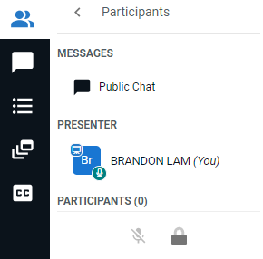

Chat:
Allows you to chat with the participants of the virtual classroom.
Manage Your Connection
Using these buttons allow you to control your connections during the session including, your audio, webcam, *sharing your desktop.
*Only granted access to if made a presenter by your instructor

Presenter Content
This is the whiteboard where the content you present during the session will be displayed.
IMPORTANT: You will only have access to the whiteboard if granted permissions to be a
presenter by your instructor.

Settings
Clicking on the 3 dots in the upper right corner of the presentation window will allow access settings such as Ending the Meeting and Leaving the room.
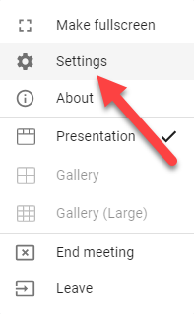

Uploading a Presentation
If and only if you are made a presenter, you can upload a file during a session to present to participants. The file can be in the form of a PDF, Word document, PowerPoint, or image (NO videos).
NOTE: Some files when uploaded and used for a presentation may be converted into a different format to make is easier for YouSeeU to display it.

- Click on Presentations button located in the lower left of white presentation screen.
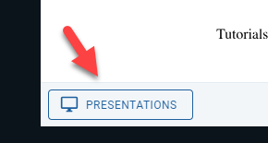

- Click on “or browse for files” (or drag and drop your file).
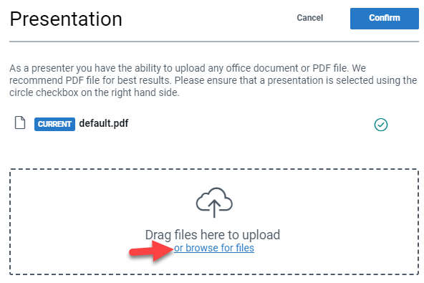

- Locate the file on your computer and click on it once (1) and then click the Open button (2).
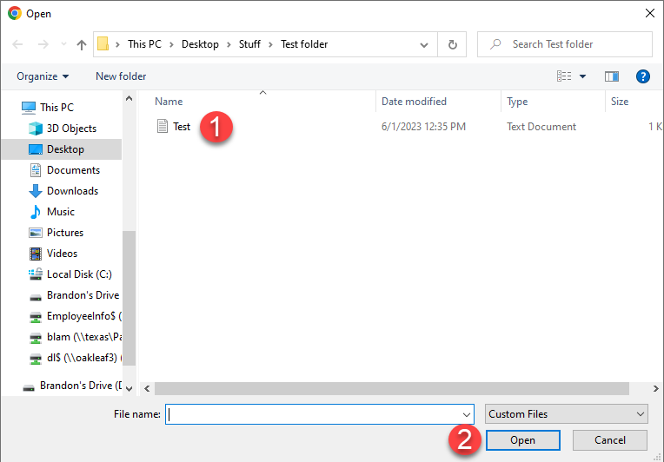

- The file from under the presentation list is auto selected (1) and click the Upload button (2).
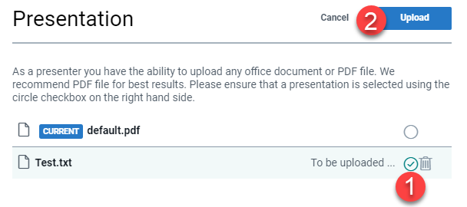

- The file will convert to a PDF. Once it is finished you will now see the document displayed on the whiteboard for everyone to see (1). Use the navigation button to display the different pages of the document (2).
Initiating a Poll
If and only if you are made a presenter, during a presentation you can initiate a poll to obtain participants’ answers to a question.
IMPORTANT: The question to the poll must either be verbally asked or be included in the presentation
itself. Initiating a poll in the Virtual Classroom only allows you to select the poll answer type.
- Click the 3 dots/lines icon on the right of the presentation window Initiate a poll.
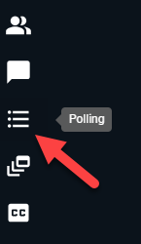

- Choose a Poll type (1) or create a custom poll (2).
NOTE: When Custom Poll … is clicked, you will be prompted to enter polling choices. You
may enter up to six answer choices for students to choose from.
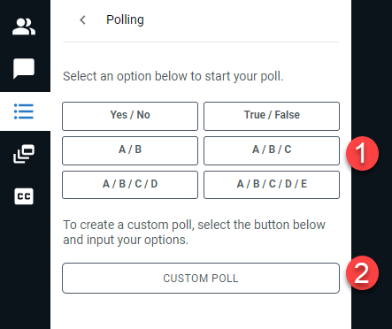

- The poll will be initiated and the live results for the poll will be displayed to you.
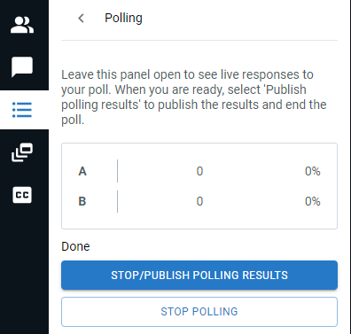

- To display the results of the poll to participants during the presentation click the Stop Poll and Publish Results button.
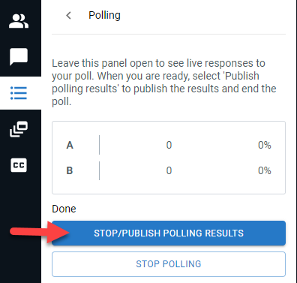

Sharing your Screen
While in the virtual classroom, if and only if you are made a presenter, you can share the screen on your desktop so participants can see it.
IMPORTANT: If you run into issues attempting to share screen you might want to use Google Chrome if to share your desktop.
- Click the Share screen button.
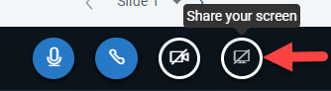

- You may need to install either the Firefox or Chrome extension (depending on which browser you are using) to share your screen by clicking any pop-up that appears.
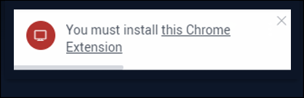

- Once you follow the necessary steps to download the extension, you will be able to share your screen. Select what you would like to share and click the Share button.
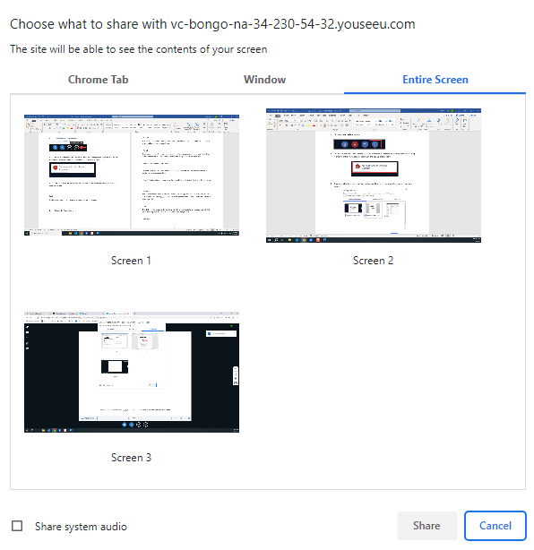

Tools
If made a presenter during a presentation, you can draw and annotate on the screen.
- View presentation Tools located to the right of the presentation screen. Click on the Hand icon.

- The annotation toolbar will open, and you will have several drawing tools to choose from:
Pan
The first tool that is automatically selected and provides you with a pointer on your cursor to draw emphasis to items you point to.
Pencil
The second tool which can be used to draw or write on the presentation. To use the tool, you will click down and drag your mouse to draw your image, or write what you wish.
Additional Pencil Annotation Tools
Drawing Thickness: This tool allows you to change the thickness of the pencil and of the
borders of the shapes you draw.
Colors: This tool allows you to change the color of the pencil and of the shapes that you draw.
Shapes
The next three tools allow you to draw a rectangle, triangle, or circle within the whiteboard or
presentation. To use the tool, you will click down and drag your mouse to make the size of the shape you wish.
Line
The sixth tool allows you to draw a line within the presentation. To use the tool, you will click down and drag your mouse to make the size of the line you wish.

Text box
The seventh tool allows you to draw a text box within the presentation. To use the tool, you will
click down and drag your mouse to make the size of the text box you wish. You will then be able to type within the box. You can change the size of the letters and the color in the menu above the text box. Note: Make sure to make the text box big enough for what you wish to write as you will not be able to resize it afterwards.

Undo Annotation
If made a presenter during a presentation, you can clear the last annotation action you made on the whiteboard or presentation space.
- Click on the Undo Annotation button.

- The last annotation you made on the whiteboard will be undone.

Clear All Annotations
If made a presenter during a presentation, you have the ability to clear/erase all annotations made on the whiteboard or presentation space. When you use this function, it will only clear the annotations within the page that you are on. This will not affect other pages of the whiteboard or presentation.
- Click on the Clear All Annotations button.

- All the annotations you made on the whiteboard will be erased.
Turn multi-user mode on
During a presentation you can allow all users to annotate on the whiteboard or presentation space. When a user makes annotations, their name will be displayed on the whiteboard or page to identify they are making the annotations.
- Click on the Multi-user mode button.

- Users will be able to make annotations on the whiteboard or page.
Accessing Recorded meetings.
If your instructor has recorded a meeting, you can view it from the Virtual Classroom Tool when needed.
- Click on Communication (1) and select Virtual Classroom (2) from the drop-down menu.
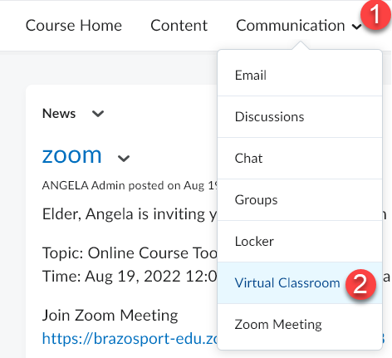

- From the list of Class Meetings, if a meeting has been recorded the Preview Recording icon will appear under the Action column for it. Click on this icon.

- From the Window that appears, click on the Full screen icon located near the middle of the screen.
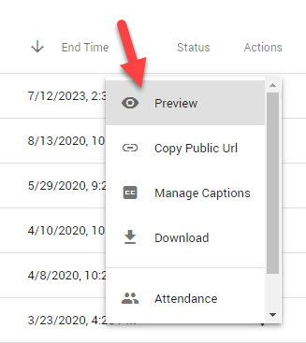

- The meeting will open in full screen mode, and you will be able to play it.
